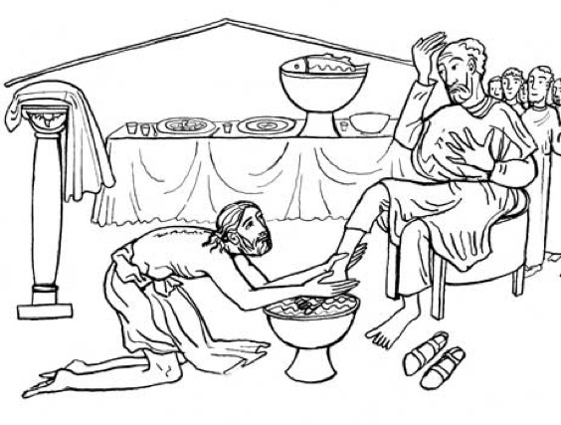

Zion Lutheran Church
‘Hearing, Sharing and Living the Gospel.’

Zion Lutheran Church
Our mission is to hear and share the good news of the risen Jesus and, with God’s help, to live the Gospel.

Maundy Thursday
April 9, 2020 7:00 p.m. Service

Zion Lutheran Church
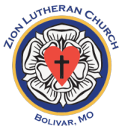
‘Hearing, Sharing and Living the Gospel’
Rev. Thomas A. Rhodes, Pastor
PO Box 5 • 600 East Aldrich Road • Bolivar, MO 65613
Phone: 417-326-5506 • www.zionlutheranbolivar.org
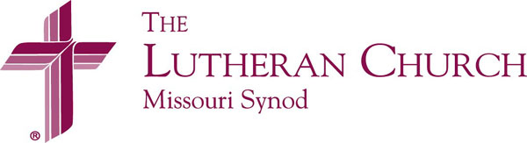
zionbolivar@windstream.net

Administrative Assistant – Sonya Gorman

You are invited to use the yellow prayer cards located in the pew for prayer requests.
Please hand this card to an usher or place it in the offering plate.
* Please turn off cellphones, thank you *

Pre-Service Meditation
Maundy Thursday (Maundy comes from the Latin, mandatum, meaning a new commandment- John 13:34 “A new command I give you: Love one another. As I have loved you, so you must love one another. By this all men will know that you are my disciple, if you love one another.”) Maundy Thursday or Holy Thursday begins a single service that spans three days, called the Triduum (TRI-dee-um). What is begun tonight is not concluded until the end of Easter Vigil on Easter Sunday.

The Triduum is one story told in three parts over three days. Because it is seen as one service in three parts, no benediction is spoken at the conclusion of the Thursday service. Good Friday has neither entrance rite nor benediction; it is a day of repentance over sin and restrained joy and praise for the redemption Christ accomplished for us on the cross. Good Friday is not observed as a funeral for Christ.

The Triduum starts with Passover, the last of the Passovers Jesus would celebrate and the last of the Passovers appointed by God. As of that night, things are changing. This final Passover becomes the introduction to the New Covenant meal of Jesus' body and blood. The joy of this most sacred meal is tinged with sadness. Someone will betray Jesus---someone close to Him. But this sadness is transformed into joy because this meal points to the eternal banquet which Jesus will eat with us and all His saints in heaven. The betrayal is for a purpose. Jesus will use the events of the next three days to end the reign of sin and death and prepare a whole new future for us, His people. This Holy Supper connects us to what Jesus did and sustains us until we are with Him in heaven for all eternity.

MAUNDY THURSDAY

“Jesus, Servant Stripped of All But Love”
Divine Service – Setting Three
April 9, 2020 7:00 p.m.

Welcome

Stand
+ PREPARATION + LSB 184
The sign of the cross may be made by all in remembrance of their Baptism.
P We begin in the name into which we are baptized; In the name of the Father and of the  Son and of the Holy Spirit.
C Amen.

P Our help is in the name of the Lord,
C who made heaven and earth. Psalm 124:8

Sit

Hymn “Lord, Help Us Walk Your Servant Way” LSB 857 sts. 1-4
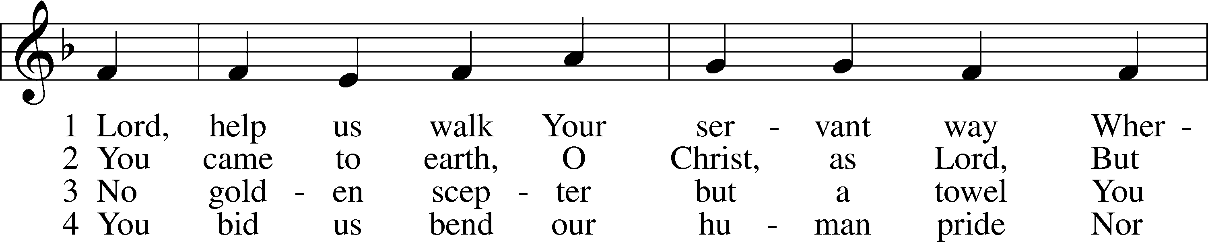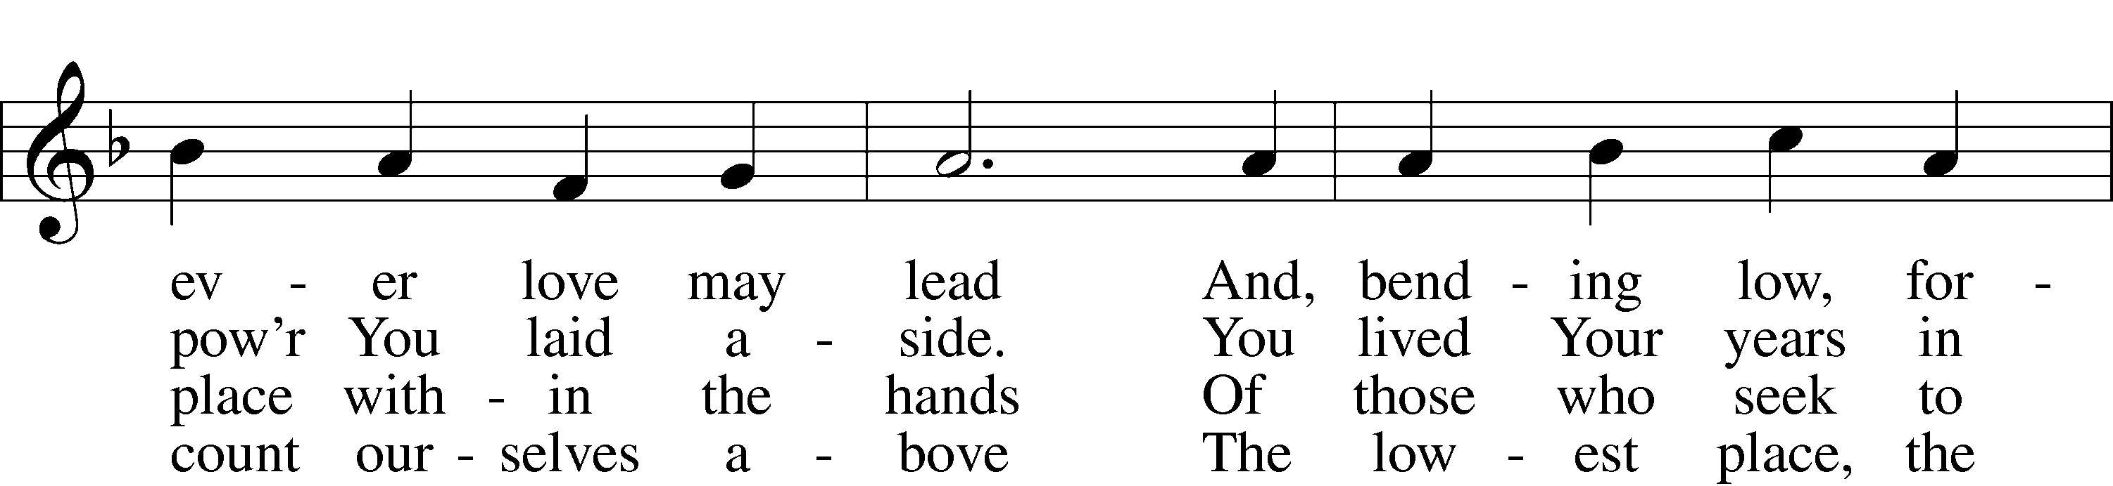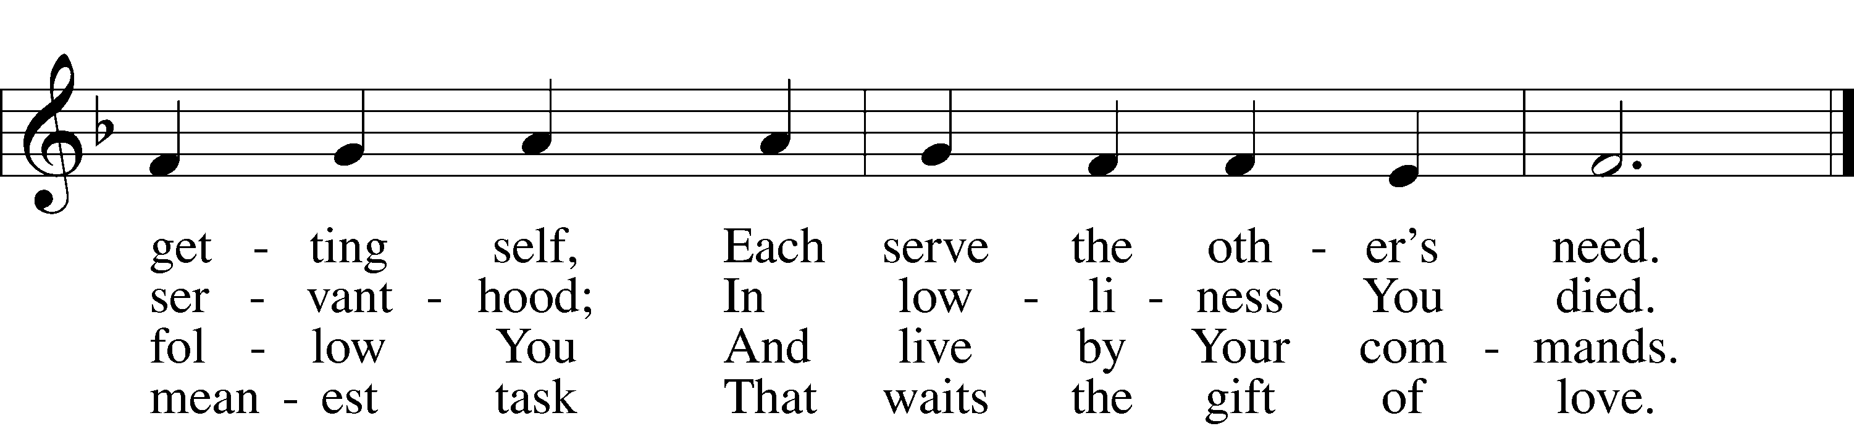
© 1997 GIA Publications, Inc. Used by permission: LSB Hymn License .NET, no. 100011462.

Christian Questions and Answers
(adapted from The Small Catechism, (c) 1991 Concordia Publishing House, p. 40ff.)

P Do you believe that you are a sinner?
C Yes, I believe it. I am a sinner.

P How do you know this?
C From the Ten Commandments, which I have not kept.

P Are you sorry for your sins?
C Yes. I am sorry that I have sinned against God.

P What have you deserved from God because of your sins?
C His wrath and displeasure, temporal death, and eternal damnation.

P Do you hope to be saved?
C Yes, that is my hope.

P In whom then do you trust?
C In my dear Lord Jesus Christ.

P Who is Christ?
C The Son of God, true God and man.

P What has Christ done for you that you trust in Him?
C He died for me and shed His blood for me on the cross for the forgiveness of sins.

P Did the Father also die for you?
C He did not. The Father is God only, as is the Holy Spirit; but the Son is both true God and true man. He died for me and shed His blood for me.

P Do you believe, then, that the true body and blood of Christ are in the Sacrament?
C Yes, I believe it.

P What convinces you to believe this?
C The word of Christ: Take, eat, this is My body; drink of it, all of you, this is My blood.

P What should we do when we eat His body and drink His blood, and in this way receive His pledge?
C We should remember and proclaim His death and the shedding of His blood, as He taught us: This do, as often as you drink it, in remembrance of Me.

P Why should we remember and proclaim His death?
C First, so we may learn to believe that no creature could make satisfaction for our sins. Only Christ, true God and man, could do that. Second, so we may learn to be horrified by our sins, and to regard them as very serious. Third, so we may find joy and comfort in Christ alone, and through faith in Him be saved.

P What motivated Christ to die and make full payment for your sins?
C His great love for His Father and for me and other sinners.

P Finally, why do you wish to go to the Sacrament?
C That I may learn to believe that Christ, out of great love, died for my sin, and also learn from Him to love God and my neighbor.

Stand
Confession and Absolution LSB 213
P Having learned about the Holy Sacrament and our unworthiness, let us now confess our sins:
C O almighty God, merciful Father, I, a poor, miserable sinner, confess unto You all my sins and iniquities with which I have ever offended You and justly deserved Your temporal and eternal punishment. But I am heartily sorry for them and sincerely repent of them, and I pray You of Your boundless mercy and for the sake of the holy, innocent, bitter sufferings and death of Your beloved Son, Jesus Christ, to be gracious and merciful to me, a poor, sinful being.
P God be merciful to you and strengthen your faith. LSB 292
C Amen.

P Do you believe that my forgiveness is God’s forgiveness? LSB 293
C Yes.
P Let it be done for you as you believe.
P Upon this your confession, I, LSB 214
by virtue of my office as a called
and ordained servant of the Word, announce the grace of God unto all of you, and in the stead and by the command of my Lord Jesus Christ I forgive you all your sins in the name of the Father and of the  Son and of the Holy Spirit.
C Amen.

P With this declaration of God’s absolution, our Lenten season comes to a close. We enter now into the Triduum – the 3 days of Christ’s Passover from death to life, from captivity to freedom.

Prayer of the Day LSB 189
P The Lord be with you.
C And with thy spirit.
P Let us pray. O Lord, in this wondrous Sacrament You have left us a remembrance of Your passion. Grant that we may so receive the teaching of the sacred mystery of Your body and blood that the fruits of Your redemption may continually be manifest in us; for You live and reign with the Father and the Holy Spirit, one God, now and forever.
C Amen.

Hymn “The Death of Jesus Christ, Our Lord” LSB 634 sts. 1-5
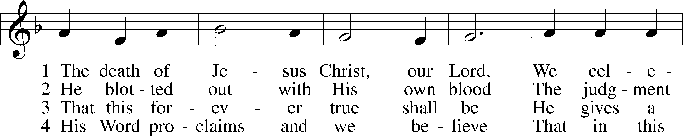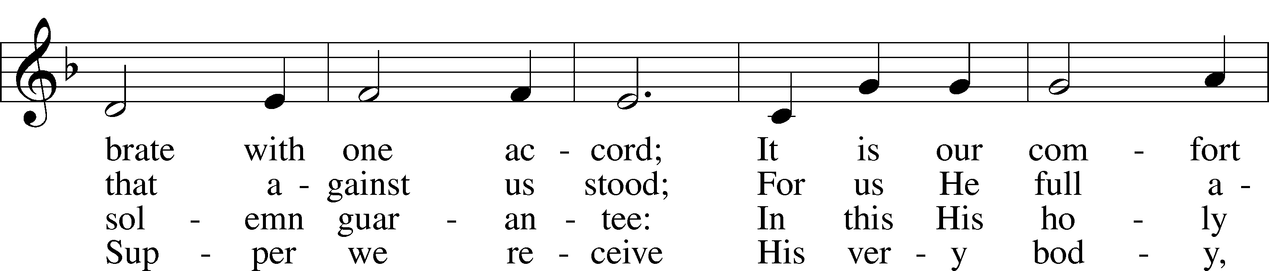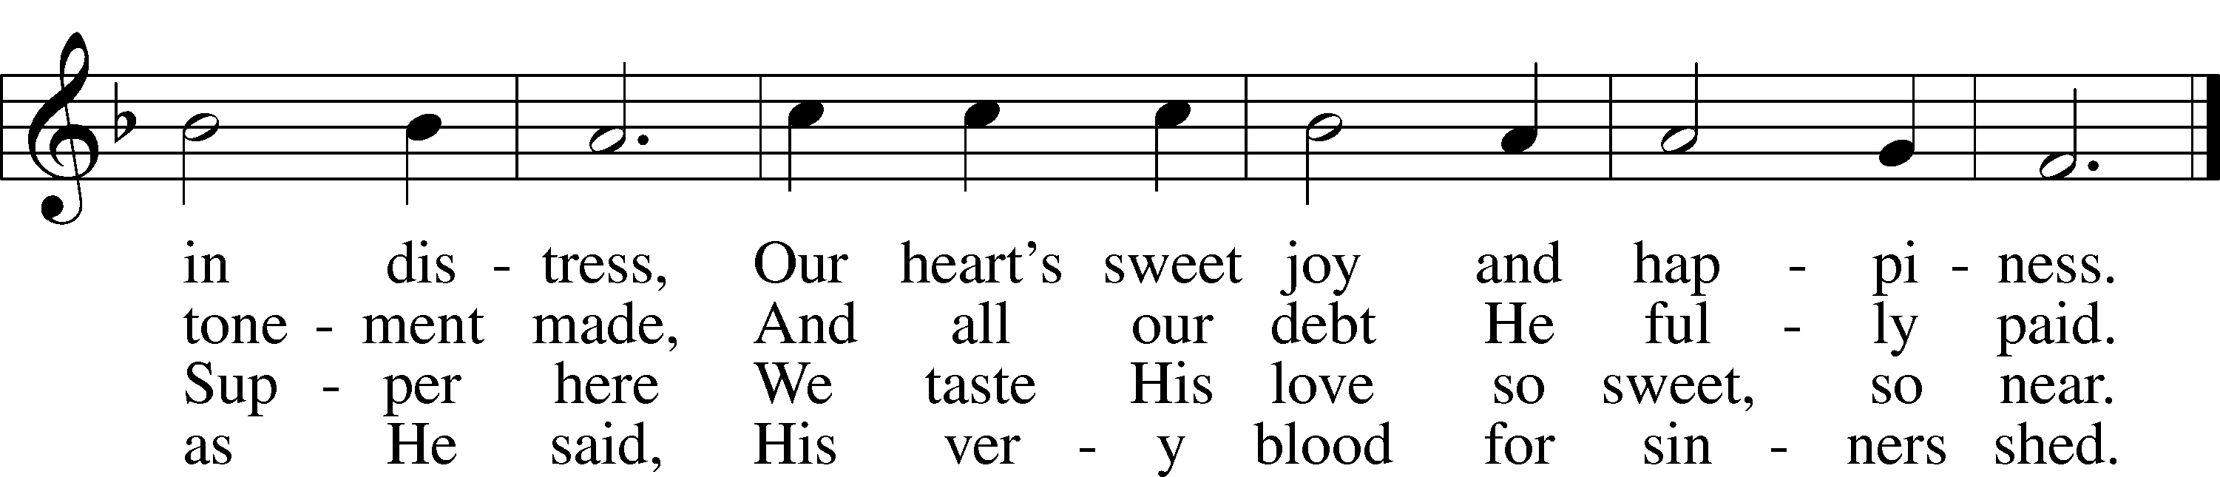
5 We dare not ask how this can be, And trust this word where life begins:
But simply hold the mystery “Given and shed for all your sins.”
Public domain

As we are constrained by the current conditions in the world from meeting together to receive the Holy Sacrament as one body as we have been taught, we will take this time to strengthen our hearts minds and souls with the teaching from scripture by Dr. Luther as we have learned it from the Small Catechism.
In so doing may our hunger and thirst for this Holy Food be sharpened and may our desire to commune together around this altar again create in us a proper and right longing to be reunited. Until that time we continue to trust in His promises of reconciliation and peace with God through the total forgiveness for all our sin delivered to us in our baptism and delivered to us also the last time we partook of Holy Communion. Those promises do not fade or lose their power in us merely by the passage of time. We do, however, pray our separation from gathering together before the altar, be not long.

The Small Catechism on
the Sacrament of the Altar LSB 326
P What is the Sacrament of the Altar?
C It is the true body and blood of our Lord Jesus Christ under the bread and wine, instituted by Christ Himself for us Christians to eat and to drink.

P Where is this written?
C The holy Evangelists Matthew, Mark, Luke, and St. Paul write: Our Lord Jesus Christ, on the night when He was betrayed, took bread, and when He had given thanks, He broke it and gave it to the disciples and said: “Take, eat; this is My body, which is given for you. This do in remembrance of Me.” In the same way also He took the cup after supper, and when He had given thanks, He gave it to them, saying: “Drink of it, all of you; this cup is the new testament in My blood, which is shed for you for the forgiveness of sins. This do, as often as you drink it, in remembrance of Me.”

P What is the benefit of this eating and drinking?
C These words, “Given and shed for you for the forgiveness of sins,” show us that in the Sacrament forgiveness of sins, life, and salvation are given us through these words. For where there is forgiveness of sins, there is also life and salvation.

P How can bodily eating and drinking do such great things?
C Certainly not just eating and drinking do these things, but the words written here: “Given and shed for you for the forgiveness of sins.” These words, along with the bodily eating and drinking, are the main thing in the Sacrament. Whoever believes these words has exactly what they say: “forgiveness of sins.”

P Who receives this Sacrament worthily?
C Fasting and bodily preparation are certainly fine outward training. But that person is truly worthy and well prepared who has faith in these words: “Given and shed for you for the forgiveness of sins.” But anyone who does not believe these words or doubts them is unworthy and unprepared, for the words “for you” require all hearts to believe.

Distribution Hymn “When You Woke That Thursday Morning” LSB 445 sts. 1-5
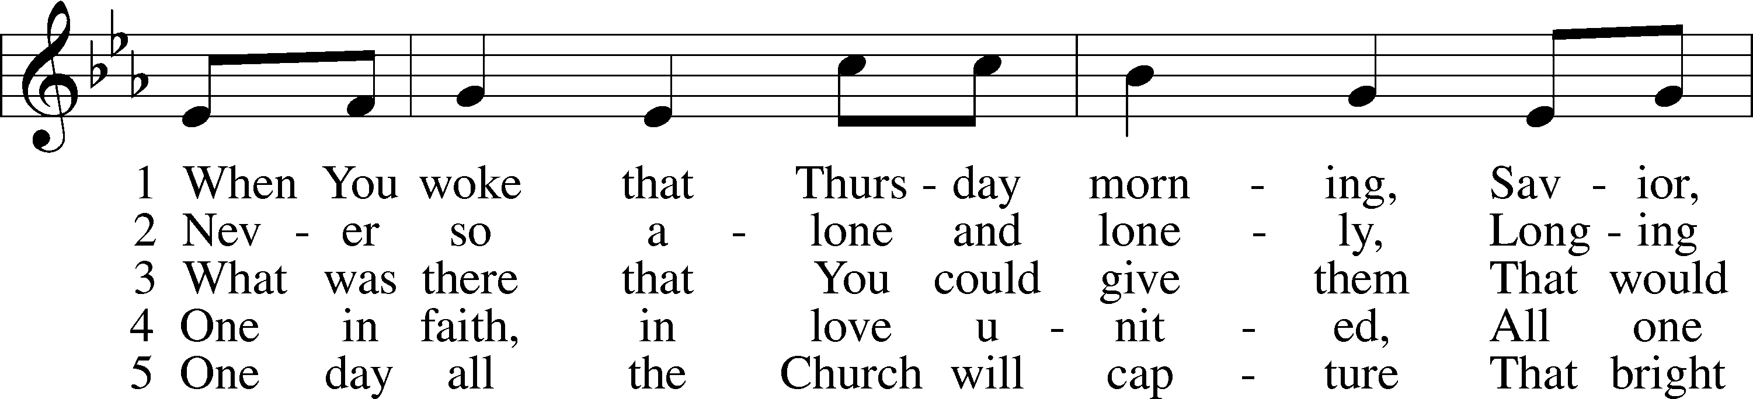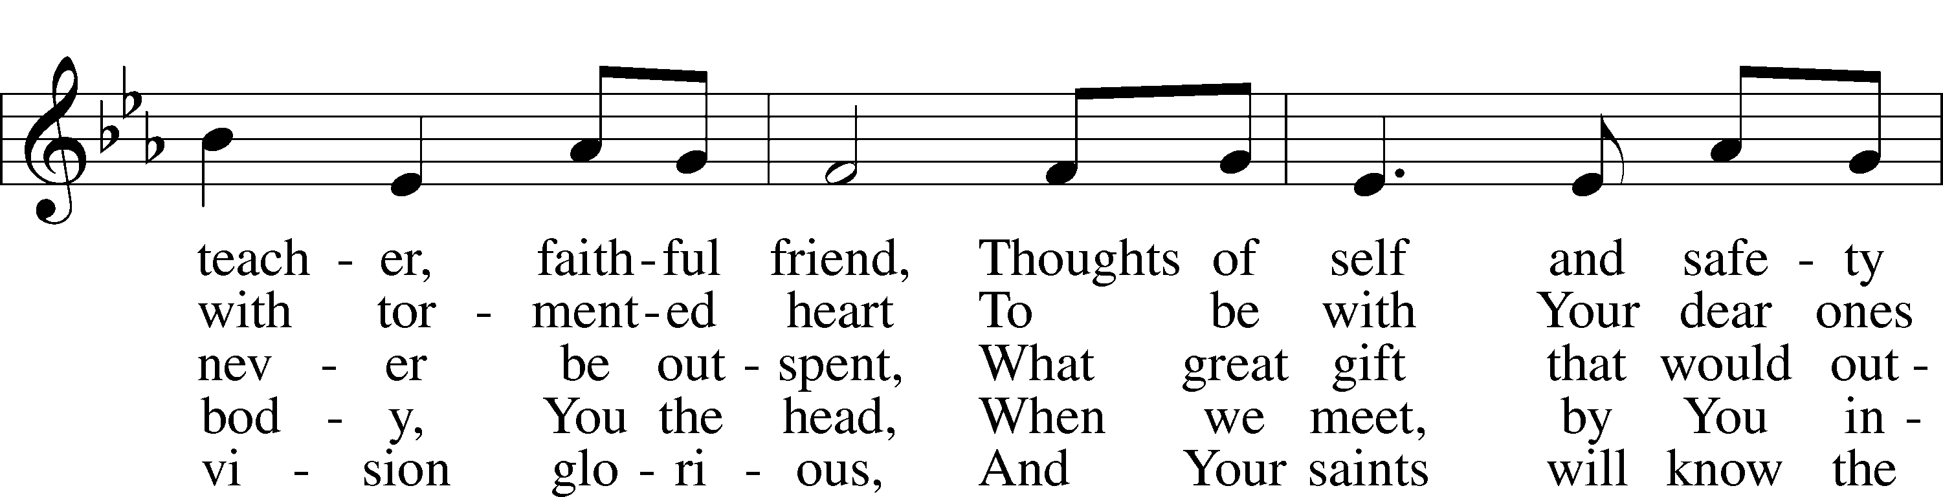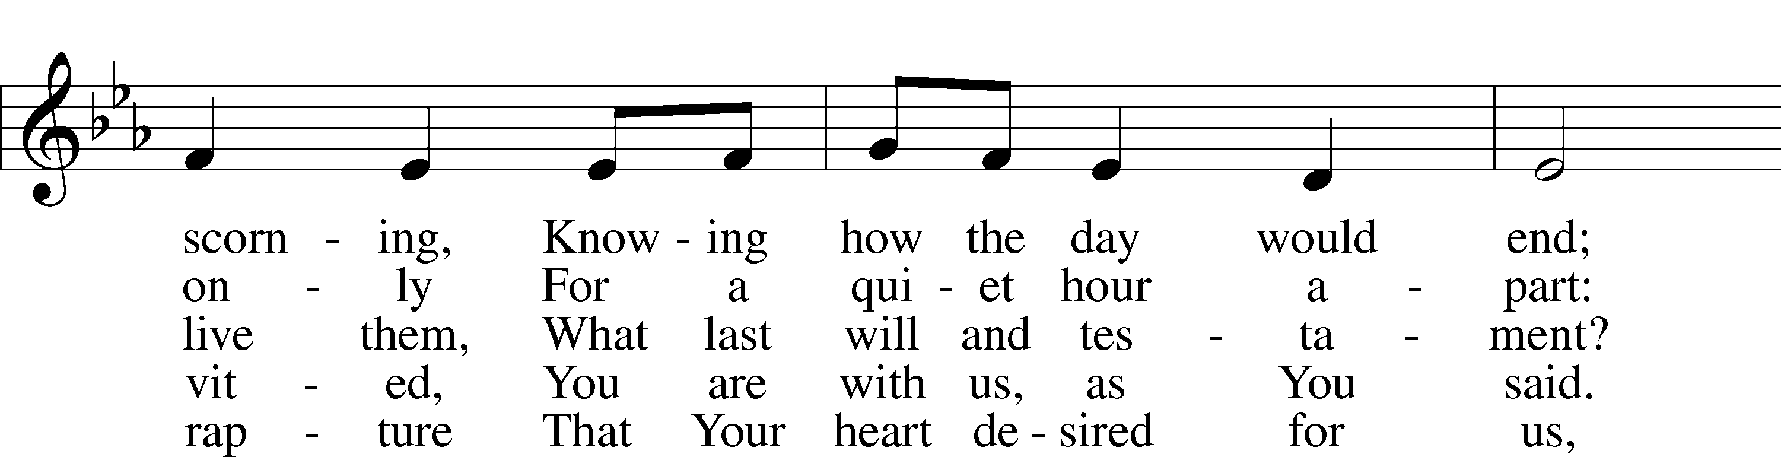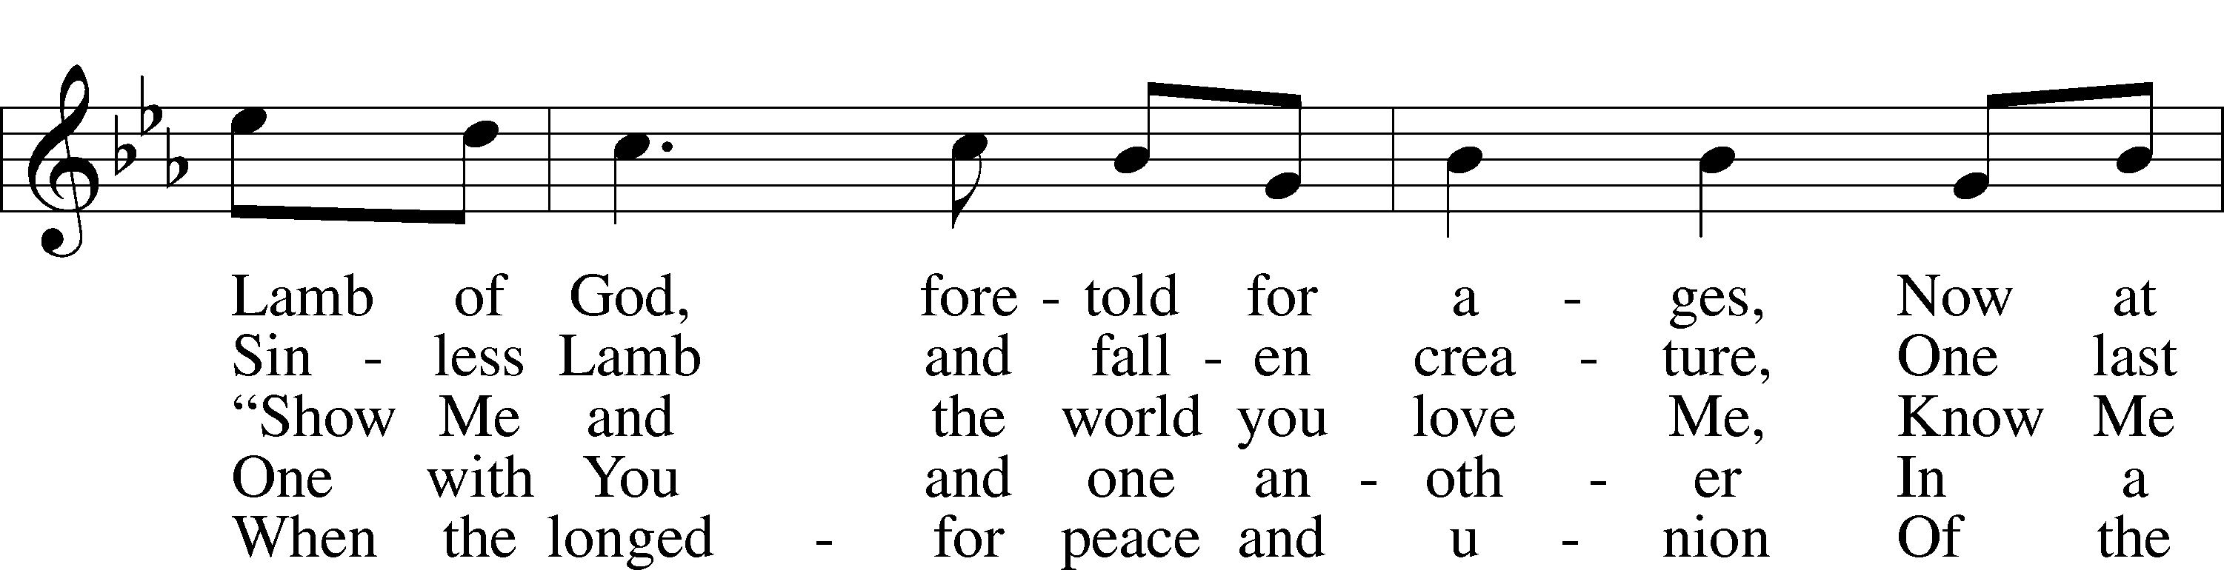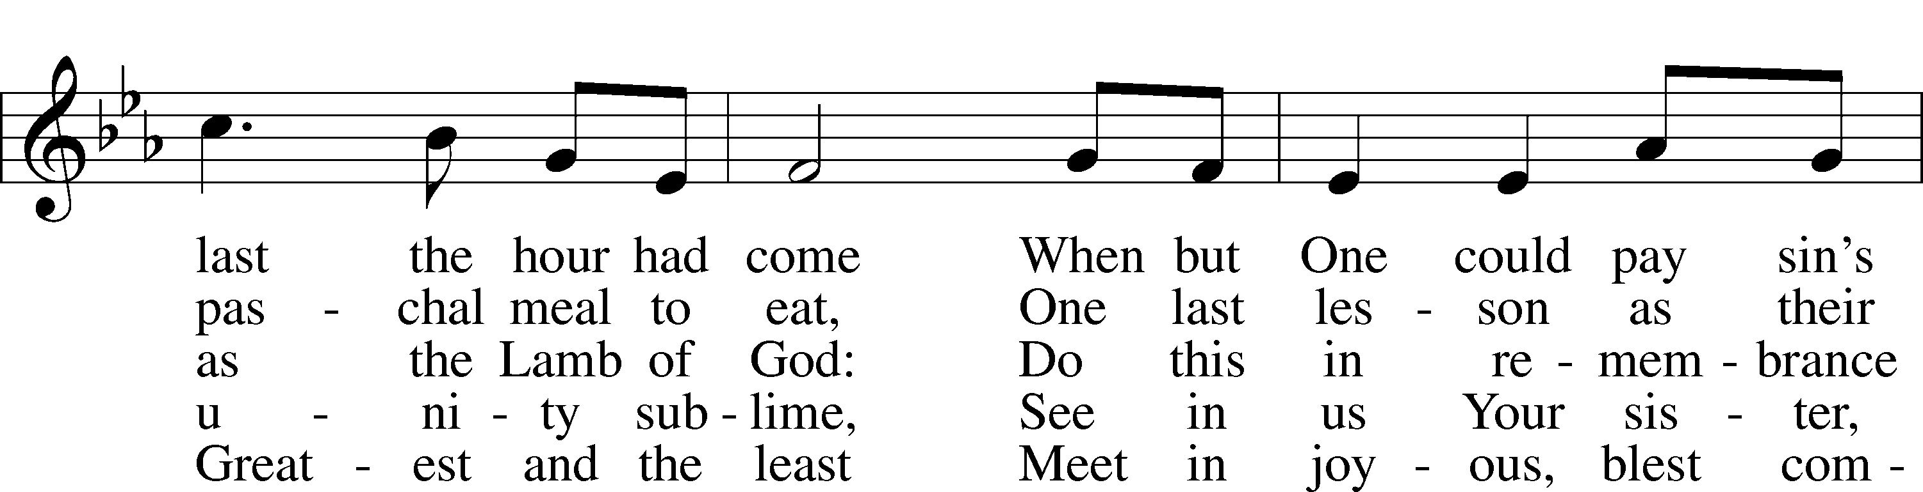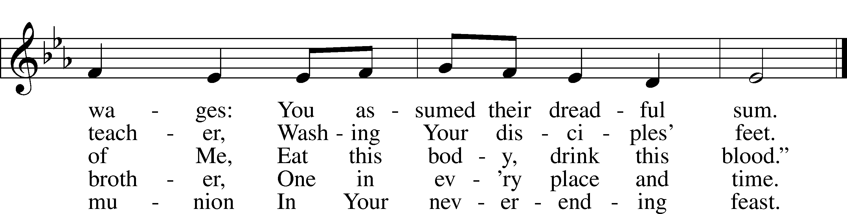
© 1991 Concordia Publishing House. Used by permission: LSB Hymn License .NET, no. 100011462.

Prayer
P Blessed Savior, Jesus Christ, Keep us in Your gift of faith and in Your favor that we may live in You even as You live in us. May Your body and blood, as we have received it in the past, continue to preserve us in the true faith to life everlasting. Hear us for the sake of Your name.
C Amen.

+ WORD + LSB 190
Old Testament Reading
Exodus 12:1-14, selected
12 The Lord said to Moses and Aaron in Egypt…
3 Tell the whole community of Israel that on the tenth day of this month each man is to take a lamb for his family, one for each household.
4 If any household is too small for a whole lamb, they must share one with their nearest neighbor, having taken into account the number of people there are…
5 The animals you choose must be year-old males without defect, and you may take them from the sheep or the goats. 6 Take care of them until the fourteenth day of the month, when all the members of the community of Israel must slaughter them at twilight. 7 Then they are to take some of the blood and put it on the sides and tops of the doorframes of the houses where they eat the lambs. 8 That same night they are to eat the meat roasted over the fire, along with bitter herbs, and bread made without yeast…
11 This is how you are to eat it: with your cloak tucked into your belt, your sandals on your feet and your staff in your hand. Eat it in haste; it is the Lord’s Passover.
12 “On that same night I will pass through Egypt and strike down every firstborn of both people and animals, and I will bring judgment on all the gods of Egypt. I am the Lord. 13 The blood will be a sign for you on the houses where you are, and when I see the blood, I will pass over you. No destructive plague will touch you when I strike Egypt.
14 “This is a day you are to commemorate; for the generations to come you shall celebrate it as a festival to the Lord—a lasting ordinance.

A This is the Word of the Lord.
C Thanks be to God.

Gradual (read responsively)
Hebrews 9:12a, c, 15a; Psalm 111:9a
A [Christ] entered once for all into the holy places by means of His own blood,
C thus securing an eternal redemption.

A Therefore He is the mediator of a new covenant,
C so that those who are called may receive the promised eternal inheritance.

A He sent redemption to His people;
C He has commanded His covenant forever.

Second Reading 1 Corinthians 11:23-26
23 For I received from the Lord what I also passed on to you: The Lord Jesus, on the night he was betrayed, took bread, 24 and when he had given thanks, he broke it and said, “This is my body, which is for you; do this in remembrance of me.” 25 In the same way, after supper he took the cup, saying, “This cup is the new covenant in my blood; do this, whenever you drink it, in remembrance of me.” 26 For whenever you eat this bread and drink this cup, you proclaim the Lord’s death until he comes.

A This is the Word of the Lord.
C Thanks be to God.

Stand
Holy Gospel John 13:1-17, 31b-35
P The Holy Gospel according to St.
John, the thirteenth chapter. LSB 190
C Glory be to Thee, O Lord.

13 It was just before the Passover Festival. Jesus knew that the hour had come for him to leave this world and go to the Father. Having loved his own who were in the world, he loved them to the end.
2 The evening meal was in progress, and the devil had already prompted Judas, the son of Simon Iscariot, to betray Jesus. 3 Jesus knew that the Father had put all things under his power, and that he had come from God and was returning to God; 4 so he got up from the meal, took off his outer clothing, and wrapped a towel around his waist. 5 After that, he poured water into a basin and began to wash his disciples’ feet, drying them with the towel that was wrapped around him.
6 He came to Simon Peter, who said to him, “Lord, are you going to wash my feet?”
7 Jesus replied, “You do not realize now what I am doing, but later you will understand.” 8 “No,” said Peter, “you shall never wash my feet.”
Jesus answered, “Unless I wash you, you have no part with me.”
9 “Then, Lord,” Simon Peter replied, “not just my feet but my hands and my head as well!” 10 Jesus answered, “Those who have had a bath need only to wash their feet; their whole body is clean. And you are clean, though not every one of you.” 11 For he knew who was going to betray him, and that was why he said not everyone was clean.
12 When he had finished washing their feet, he put on his clothes and returned to his place. “Do you understand what I have done for you?” he asked them. 13 “You call me ‘Teacher’ and ‘Lord,’ and rightly so, for that is what I am. 14 Now that I, your Lord and Teacher, have washed your feet, you also should wash one another’s feet. 15 I have set you an example that you should do as I have done for you. 16 Very truly I tell you, no servant is greater than his master, nor is a messenger greater than the one who sent him. 17 Now that you know these things, you will be blessed if you do them.
…Jesus said, “Now the Son of Man is glorified and God is glorified in him. 32 If God is glorified in him, God will glorify the Son in himself, and will glorify him at once.
33 “My children, I will be with you only a little longer. You will look for me, and just as I told the Jews, so I tell you now: Where I am going, you cannot come.
34 “A new command I give you: Love one another. As I have loved you, so you must love one another. 35 By this everyone will know that you are my disciples, if you love one another.”

P This is the Gospel of the Lord. LSB 191
C Praise be to Thee, O Christ.

Together We Confess our Common Faith Using the Nicene Creed LSB 191
P C I believe in one God, the Father Almighty, maker of heaven and earth and of all things visible and invisible.

And in one Lord Jesus Christ,
the only-begotten Son of God,
begotten of His Father before all worlds,
God of God, Light of Light,
very God of very God,
begotten, not made,
being of one substance with the Father,
by whom all things were made;
who for us men and for our salvation came
down from heaven
and was incarnate by the Holy Spirit of the
virgin Mary
and was made man;
and was crucified also for us under
Pontius Pilate.
He suffered and was buried.
And the third day He rose again according
to the Scriptures and ascended into
heaven
and sits at the right hand of the Father.
And He will come again with glory to
judge both the living and the dead,
whose kingdom will have no end.

And I believe in the Holy Spirit,
the Lord and giver of life,
who proceeds from the Father
and the Son,
who with the Father and the Son together is worshiped and glorified,
who spoke by the prophets.
And I believe in one holy Christian and apostolic Church,
I acknowledge one Baptism for the remission of sins,
and I look for the resurrection of the dead and the life  of the world to come. Amen.

Prayer of the Church LSB 193
P On this holy night in which our Lord gathered His disciples in the Upper Room, we come to You, O Lord, in His name with the concerns of our hearts for ourselves and all people.

Brief silence

P Grant to us zeal for Your house, O Lord, and love for the things of Your Kingdom. Preserve those who are unable to gather together as they wish, and grant them their desire quickly. Give Your Church harmony and peace to confess Your Word with one voice before the world. Cover us with the blood of Christ, and grant us Your Spirit, that we may walk in Your ways and do the good You desire. Lord, in Your mercy,
C hear our prayer.

P O Lord, give to us faithful pastors who will preach Your Word in season and out, and give us ears and hearts willing to hear and heed Your voice. Bless those preparing for full-time church work in our colleges and seminaries. Do not let the world’s fears turn them from a faithful and devoted ministry. Lord, in Your mercy,
C hear our prayer.

P In the midst of plagues and enemies that threaten, and a world filled with conflict and terror, give us wise leaders, O Lord, that we may be preserved from harm. Guide those who make and administer our laws to act in timely and prudent ways and give to all judges knowledge to render justice with mercy. Bless all military, emergency and medical workers, and others whose vocations call them into harm’s way in order to help our world both here and abroad. Lord, in Your mercy,
C hear our prayer.

P Have mercy, Lord, spare Your people and turn this pandemic away! Preserve the sick, comfort the fearful and grant to the dying Your peace. Hear us on behalf of all those who have asked us to pray [especially _____________]. Give us healing in accordance with Your will, strength to bear up under the burdens of this mortal life, and comfort and hope in this and every trial. Lord, in Your mercy,
C hear our prayer.

P Heavenly Father, Your Son Jesus instituted the blessed Sacrament to eat and to drink, that what is promised in His testament is received by all who trust in His name. Have mercy on all who are kept from Your table in extraordinary circumstances with the knowledge that they are not shut out of Your Supper altogether. Let the words of this testament echo in their ears and hearts and, in true faith, trust that they spiritually receive exactly what Your Son has both won and declared: the forgiveness of sins. Stir up in us a desire to commune with our fellow Christians on Your true body and blood and restore us soon to the table together. Lord, in Your mercy,
C hear our prayer.

P You know, O Lord, what we need, and You have promised never to abandon us. Help us to endure in faith and, with a joyful countenance, receive the blessings of Your grace and the answers to our prayers; through Jesus Christ, our Lord, who taught us to pray:
C Our Father who art in heaven, LSB 196
hallowed be Thy name,
Thy kingdom come,
Thy will be done on earth
as it is in heaven;
give us this day our daily bread;
and forgive us our trespasses
as we forgive those
who trespass against us;
and lead us not into temptation,
but deliver us from evil.
For Thine is the kingdom
and the power and the glory
forever and ever. Amen.

We Return To God Our Offerings LSB 193
(This is just as it says: An offering to God through His church.

Stewardship Prayer
P C As generously as You have given to us, O Lord, teach us to be generous in giving, that the poor may not suffer want nor Your Church be deprived of the resources to serve Your purpose both here and across the world. In Jesus Name, Amen.

Sit
Hymn “Jesus, Greatest at the Table” LSB 446 sts. 1-5
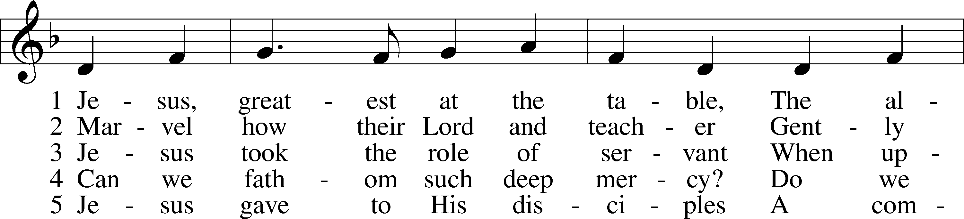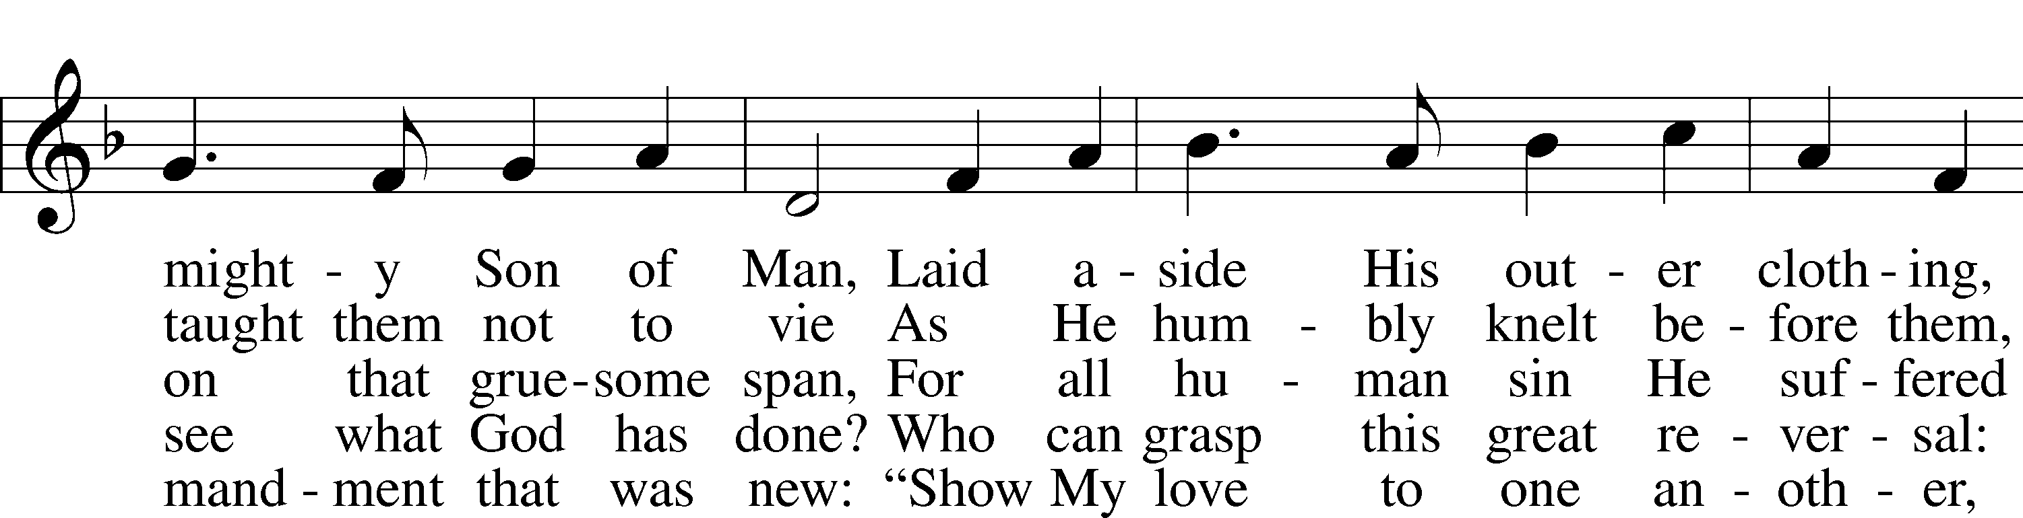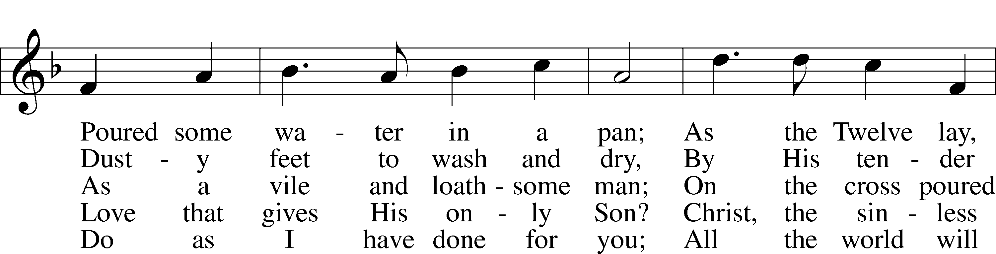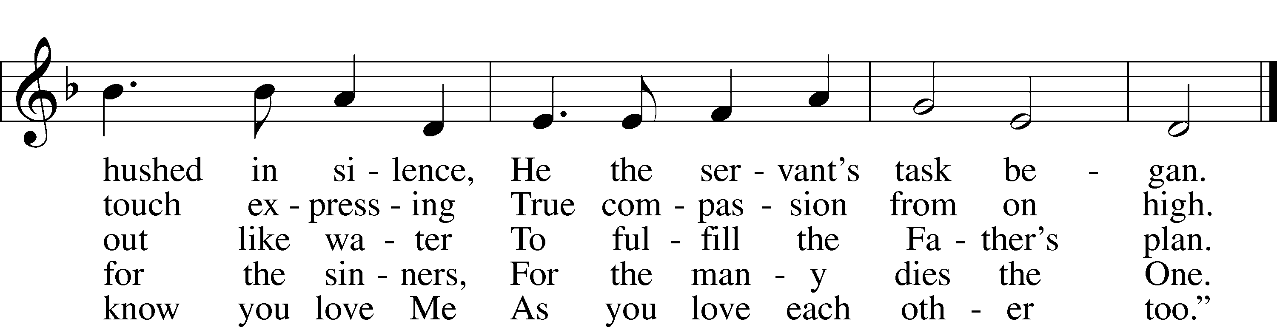
© 2001 Stephen P. Starke. Used by permission: LSB Hymn License .NET, no. 100011462.

Sermon “Stripped for Work”
Pastor Tom Rhodes

+ STRIPPING OF THE ALTAR +

[You may read the Psalm as I remove linens, paraments, ornaments, and candles from the altar. The altar symbolizes Christ and His sacrifice; removing its usual adornments recalls for us the abuse our Lord endured this night. After the altar is stripped, I will read verses 22-31. There is no Benediction; our three days of continual worship moves forward with the Service of Tenebrae [darkness] tomorrow.]

Psalm 22
1 My God, my God, why have you forsaken me?
Why are you so far from saving me, so far from the words of my groaning?
2 O my God, I cry out by day, but you do not answer, by night, and am not silent.
3 Yet you are enthroned as the Holy One; you are the praise of Israel.
4 In you our fathers put their trust; they trusted and you delivered them.
5 They cried to you and were saved; in you they trusted and were not disappointed.
6 But I am a worm and not a man, scorned by men and despised by the people.
7 All who see me mock me; they hurl insults, shaking their heads:
8 "He trusts in the LORD; let the LORD rescue him. Let him deliver him, since he delights in him."
9 Yet you brought me out of the womb; you made me trust in you even at my mother's breast.
10 From birth I was cast upon you; from my mother's womb you have been my God.
11 Do not be far from me, for trouble is near and there is no one to help.
12 Many bulls surround me; strong bulls of Bashan encircle me.
13 Roaring lions tearing their prey open their mouths wide against me.
14 I am poured out like water, and all my bones are out of joint. My heart has turned to wax; it has melted away within me.
15 My strength is dried up like a potsherd, and my tongue sticks to the roof of my mouth; you lay me in the dust of death.
16 Dogs have surrounded me; a band of evil men has encircled me, they have pierced my hands and my feet.
17 I can count all my bones; people stare and gloat over me.
18 They divide my garments among them and cast lots for my clothing. …
19 But you, O LORD, be not far off; O my Strength, come quickly to help me.
20 Deliver my life from the sword, my precious life from the power of the dogs.
21 Rescue me from the mouth of the lions; save me from the horns of the wild oxen.

22 I will declare your name to my brothers; in the congregation I will praise you.
23 You who fear the LORD, praise him! All you descendants of Jacob, honor him! Revere him, all you descendants of Israel!
24 For he has not despised or disdained the suffering of the afflicted one; he has not hidden his face from him but has listened to his cry for help.
25 From you comes the theme of my praise in the great assembly; before those who fear you will I fulfill my vows.
26 The poor will eat and be satisfied; they who seek the LORD will praise him—may your hearts live forever!
27 All the ends of the earth will remember and turn to the LORD, and all the families of the nations will bow down before him,
28 for dominion belongs to the LORD and he rules over the nations.
29 All the rich of the earth will feast and worship; all who go down to the dust will kneel before Him — those who cannot keep themselves alive.
30 Posterity will serve him; future generations will be told about the Lord.
31 They will proclaim his righteousness to a people yet unborn—for he has done it.

(Please observe silence for a few moments and then continue as you may, knowing with joy that the sacrifice of Christ is done out of love for you. )

