Zion Lutheran Church
‘Hearing, Sharing and Living the Gospel.’

Zion Lutheran Church
Our mission is to hear and share the good news of the risen Jesus and, with God’s help, to live the Gospel.

Good Friday/ Tenebrae Vespers
April 10, 2020 7:00 p.m. Service

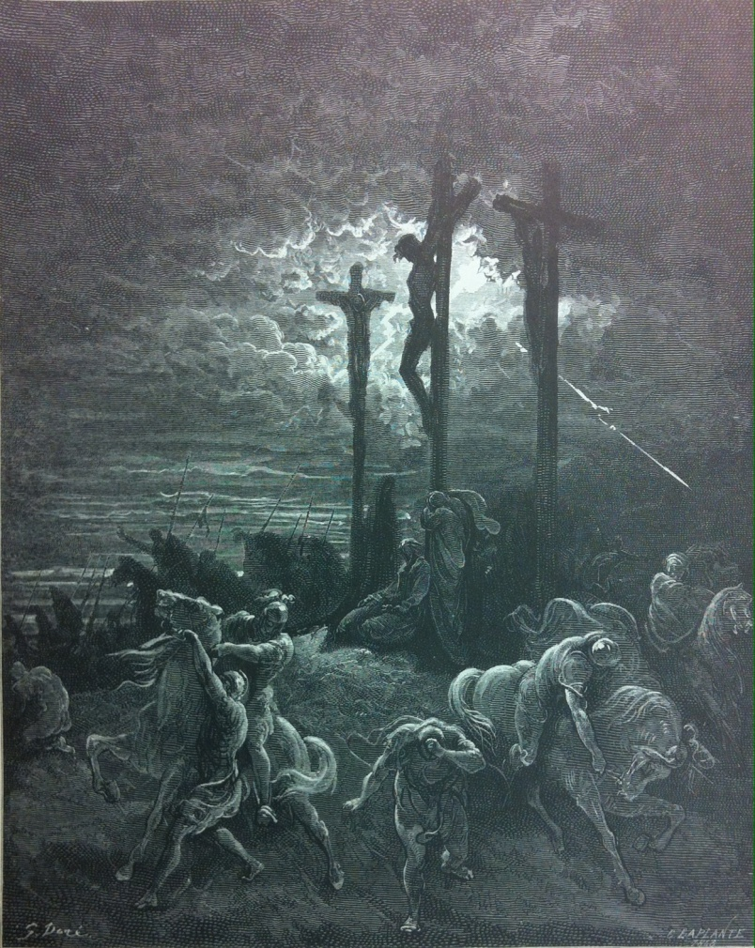

Zion Lutheran Church

‘Hearing, Sharing and Living the Gospel’
Rev. Thomas A. Rhodes, Pastor
PO Box 5 • 600 East Aldrich Road • Bolivar, MO 65613
Phone: 417-326-5506 • www.zionlutheranbolivar.org
zionbolivar@windstream.net



Administrative Assistant – Sonya Gorman

You are invited to use the yellow Prayer Cards located in the pew for prayer requests. Please hand this card to an usher or place it in the offering plate.
* Please turn off cellphones*

[Worshipers enter in silence]
(Offerings may be placed in the baskets by the door)

As We Gather (Tenebrae – Service of Darkness)
The worship service begun yesterday, Maundy Thursday, when we reviewed the teachings of Christ's institution of the Lord's Supper, continues today, Good Friday. On this most solemn day, we worship our Lord for His tremendous sacrifice. We also remember that this was the death of a righteous man, The Righteous Man. Today's liturgy is an order of Tenebrae (Latin for "darkness") because we begin with candles lit and gradually extinguish them as our Lord nears His death on that Friday afternoon. It ends with the removal of the Christ candle and the strepitus, a loud sound signifying the closing of Christ in the tomb. That’s the decisive moment our sins have been paid for with His innocent death. And then the Christ Candle is returned to the altar; as we know that Jesus now lives to all eternity, and we remain eager to celebrate His Easter resurrection.

TENEBRAE VESPERS
GOOD FRIDAY
April 10, 2020 7:00 p.m.

[All enter in silence]

Stand
Opening Versicles
P O Lord, open my lips,
C and my mouth will declare Your praise.
P Make haste, O God, to deliver me;
C make haste to help me, O Lord.
P C Praise to You, O Christ, Lamb of our salvation.

Sit
Psalm 2:1-12
1 Why do the nations rage
and the peoples plot in vain?
2 The kings of the earth set themselves,
and the rulers take counsel together,
against the Lord and against his Anointed,
saying,
3 “Let us burst their bonds apart
and cast away their cords from us.”
4 He who sits in the heavens laughs;
the Lord holds them in derision.
5 Then he will speak to them in his wrath,
and terrify them in his fury, saying,
6 “As for me, I have set my King
on Zion, my holy hill.”
7 I will tell of the decree:
The Lord said to me, “You are my Son;
today I have begotten you.
8 Ask of me, and I will make the nations your
heritage, and the ends of the earth your
possession.
9 You shall break them with a rod of iron
and dash them in pieces like a potter's vessel.”
10 Now therefore, O kings, be wise;
be warned, O rulers of the earth.
11 Serve the Lord with fear,
and rejoice with trembling.
12 Kiss the Son, lest he be angry,
and you perish in the way,
for his wrath is quickly kindled.
Blessed are all who take refuge in him.

Hymn LSB 451 sts. 1, 4
“Stricken, Smitten, and Afflicted”
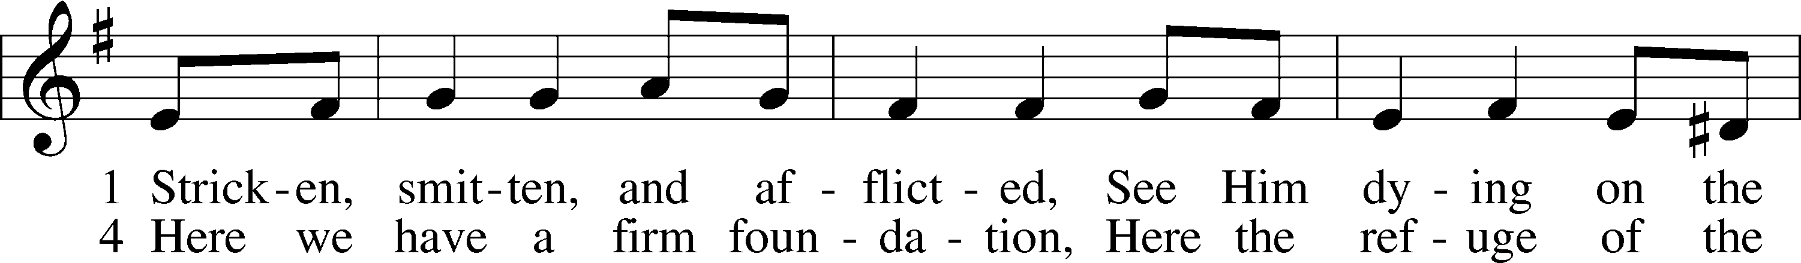
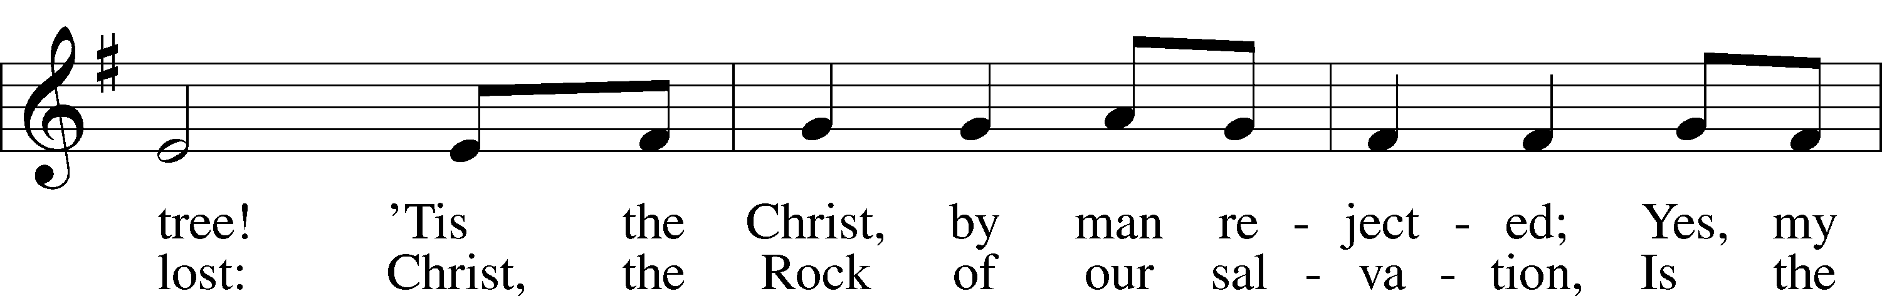
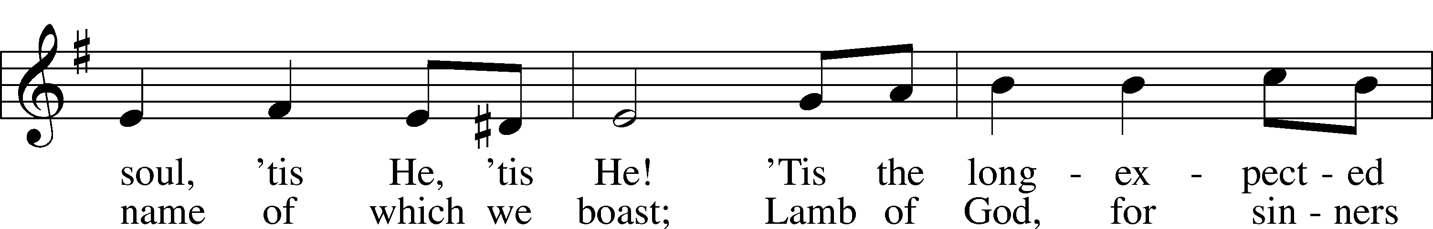
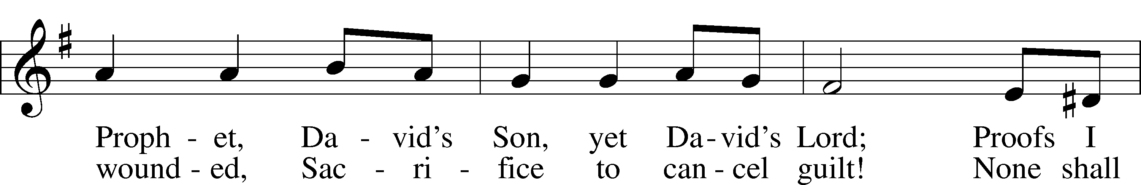
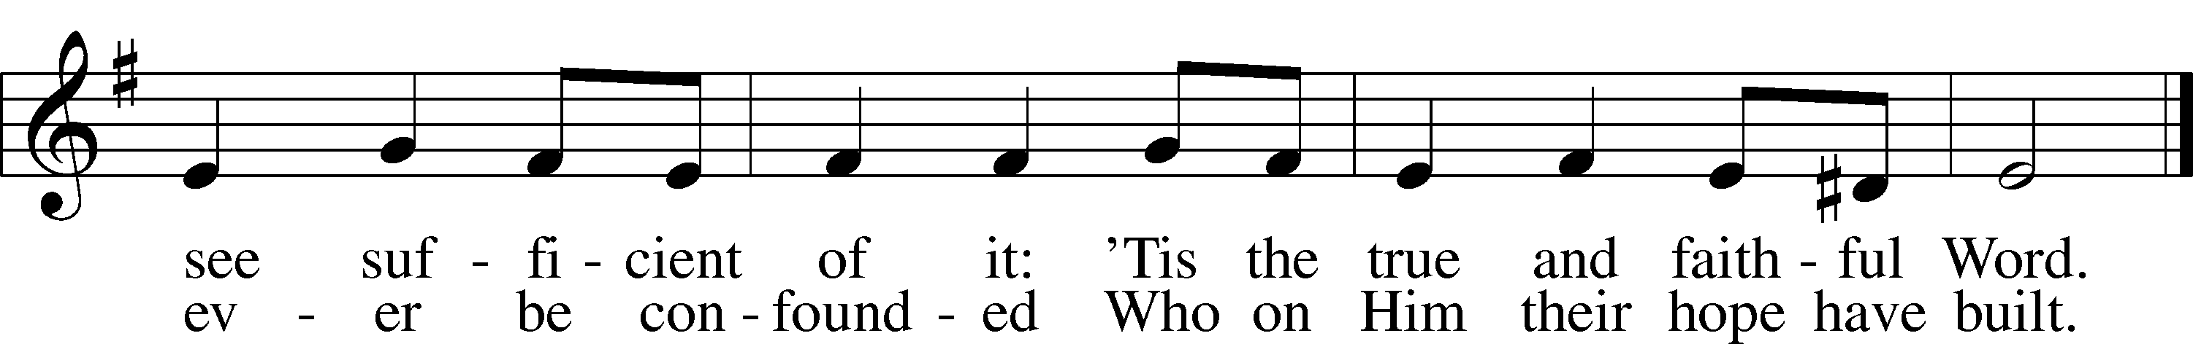

Public domain

★ A candle is extinguished.

Isaiah 53:1-12
1 Who has believed our message and to whom has the arm of the LORD been revealed?
2 He grew up before him like a tender shoot, and like a root out of dry ground. He had no beauty or majesty to attract us to him, nothing in his appearance that we should desire him.
3 He was despised and rejected by men, a man of sorrows, and familiar with suffering. Like one from whom men hide their faces he was despised, and we esteemed him not.
4 Surely he took up our infirmities and carried our sorrows, yet we considered him stricken by God, smitten by him, and afflicted.
5 But he was pierced for our transgressions, he was crushed for our iniquities; the punishment that brought us peace was upon him, and by his wounds we are healed.
6 We all, like sheep, have gone astray, each of us has turned to his own way; and the LORD has laid on him the iniquity of us all.
7 He was oppressed and afflicted, yet he did not open his mouth; he was led like a lamb to the slaughter, and as a sheep before her shearers is silent, so he did not open his mouth.
8 By oppression and judgment he was taken away. And who can speak of his descendants? For he was cut off from the land of the living; for the transgression of my people he was stricken.
9 He was assigned a grave with the wicked, and with the rich in his death, though he had done no violence, nor was any deceit in his mouth.
10 Yet it was the LORD's will to crush him and cause him to suffer, and though the LORD makes his life a guilt offering, he will see his offspring and prolong his days, and the will of the LORD will prosper in his hand.
11 After the suffering of his soul, he will see the light of life and be satisfied; by his knowledge my righteous servant will justify many, and he will bear their iniquities.
12 Therefore I will give him a portion among the great, and he will divide the spoils with the strong, because he poured out his life unto death, and was numbered with the transgressors. For he bore the sin of many, and made intercession for the transgressors.

★ A candle is extinguished.

Hymn LSB 456 sts. 1-2
“Were You There”
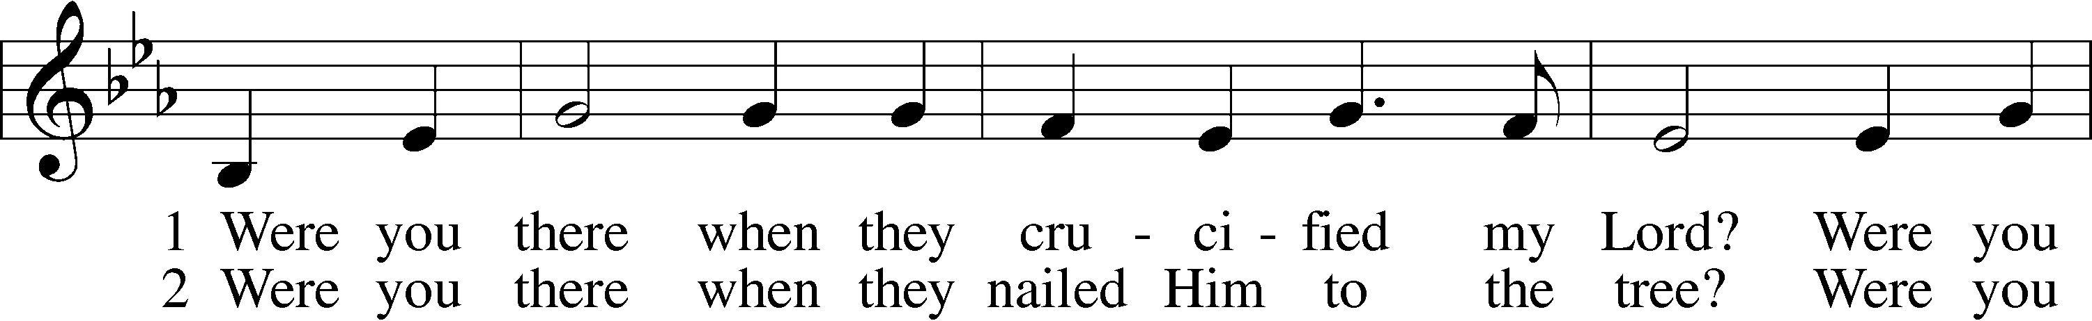
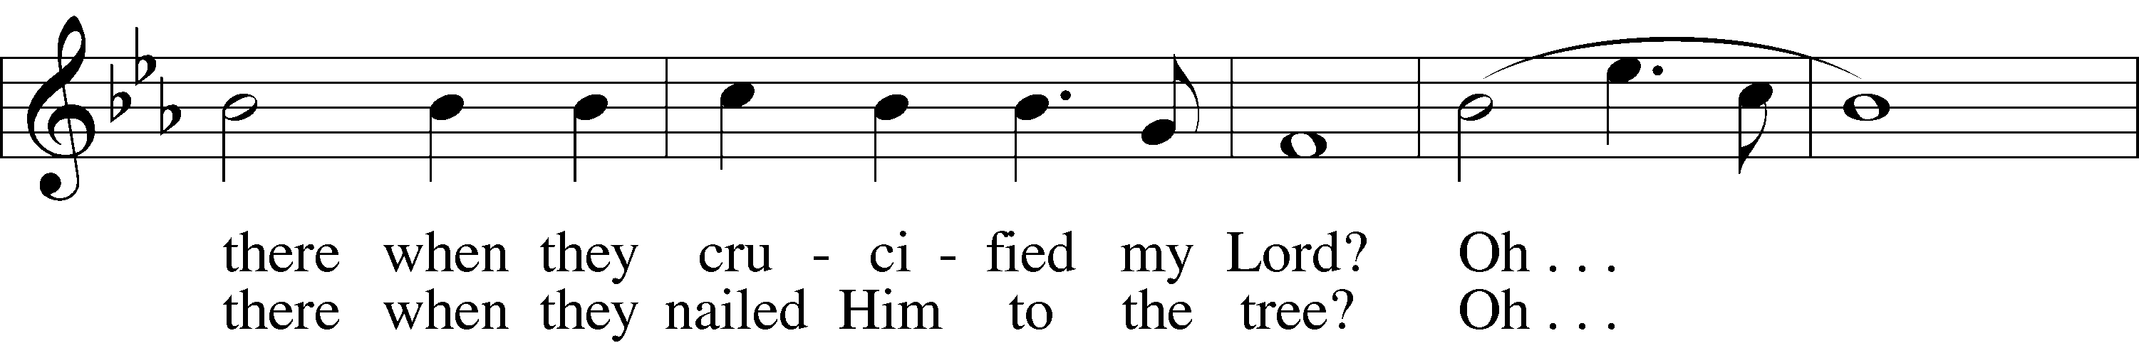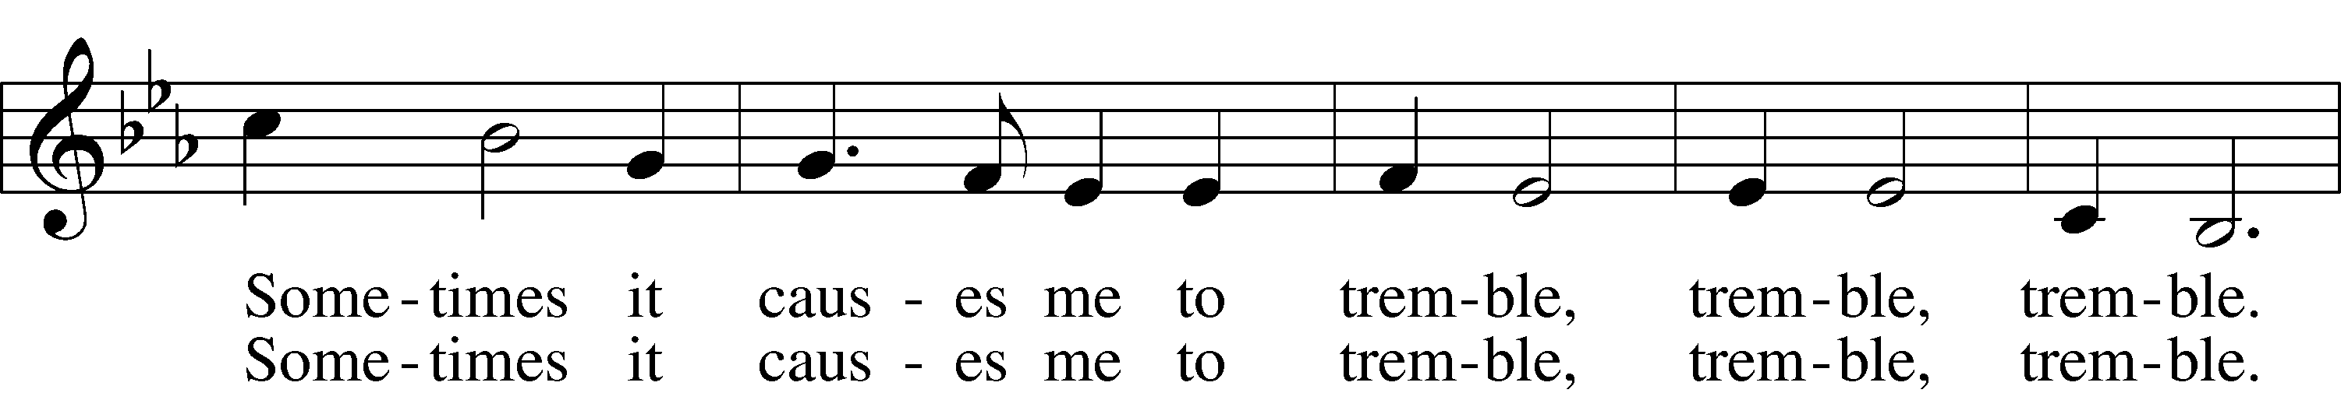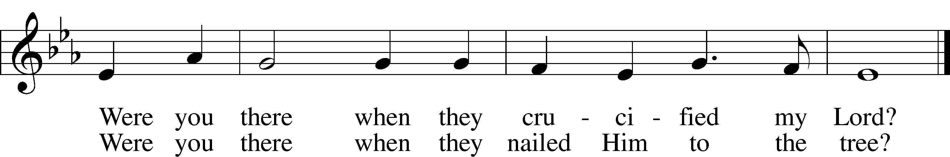
Public domain

The Passion of Our Lord Jesus Christ
John 19:1-16a
P The Passion of Our Lord Jesus Christ according to St. John, the nineteenth chapter.

1 Then Pilate took Jesus and had him flogged.
2 The soldiers twisted together a crown of thorns and put it on his head. They clothed him in a purple robe 3 and went up to him again and again, saying, "Hail, king of the Jews!" And they struck him in the face.
4 Once more Pilate came out and said to the Jews, "Look, I am bringing him out to you to let you know that I find no basis for a charge against him." 5 When Jesus came out wearing the crown of thorns and the purple robe, Pilate said to them, "Here is the man!"
6 As soon as the chief priests and their officials saw him, they shouted, "Crucify! Crucify!"
But Pilate answered, "You take him and crucify him. As for me, I find no basis for a charge against him."
7 The Jews insisted, "We have a law, and according to that law he must die, because he claimed to be the Son of God."
8 When Pilate heard this, he was even more afraid,
9 and he went back inside the palace. "Where do you come from?" he asked Jesus, but Jesus gave him no answer. 10 "Do you refuse to speak to me?" Pilate said. "Don't you realize I have power either to free you or to crucify you?"
11 Jesus answered, "You would have no power over me if it were not given to you from above. Therefore the one who handed me over to you is guilty of a greater sin."
12 From then on, Pilate tried to set Jesus free, but the Jews kept shouting, "If you let this man go, you are no friend of Caesar. Anyone who claims to be a king opposes Caesar."
13 When Pilate heard this, he brought Jesus out and sat down on the judge's seat at a place known as the Stone Pavement (which in Aramaic is Gabbatha). 14 It was the day of Preparation of Passover Week, about the sixth hour.
"Here is your king," Pilate said to the Jews.
15 But they shouted, "Take him away! Take him away! Crucify him!"
"Shall I crucify your king?" Pilate asked.
"We have no king but Caesar," the chief priests
answered.
16 Finally Pilate handed him over to them to be crucified.

★ A candle is extinguished.

Hymn LSB 449 sts. 1-2
“O Sacred Head, Now Wounded”
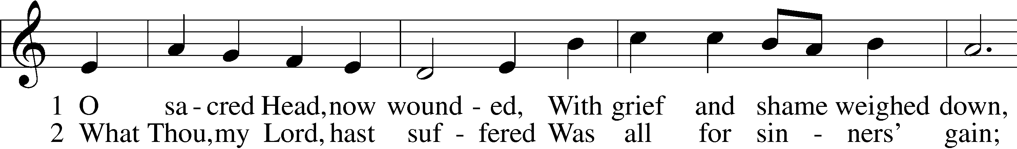
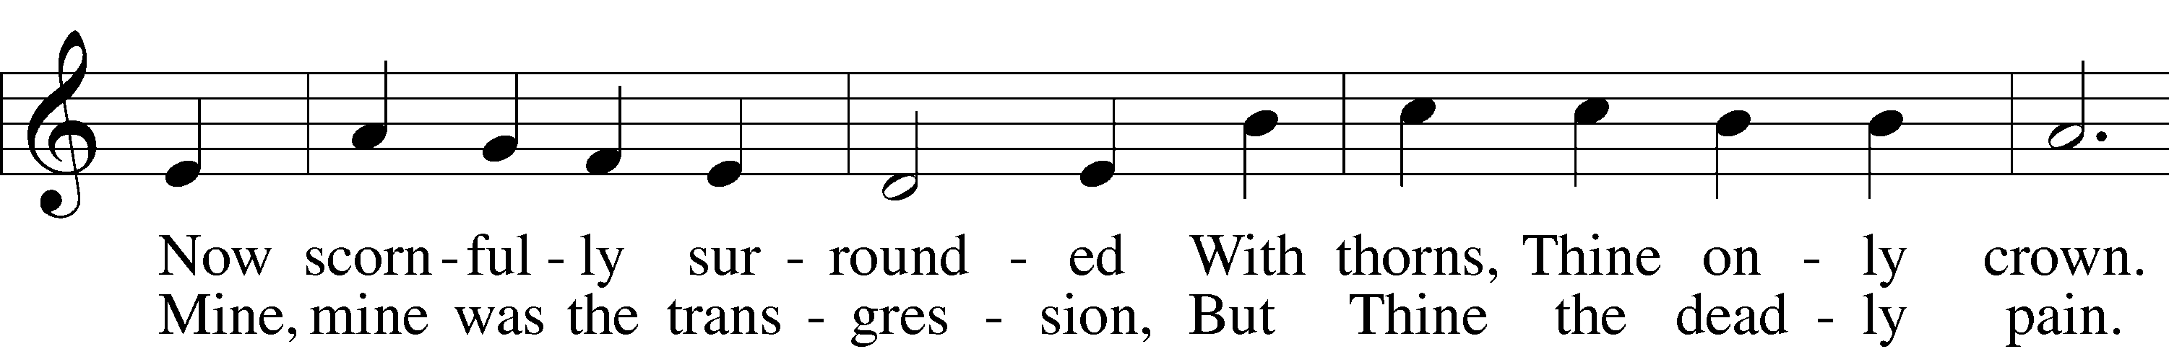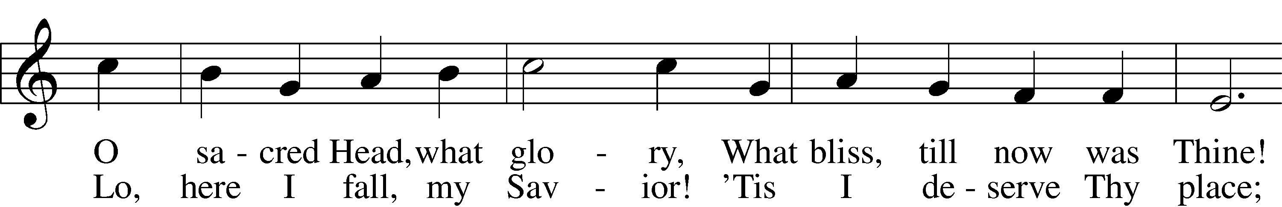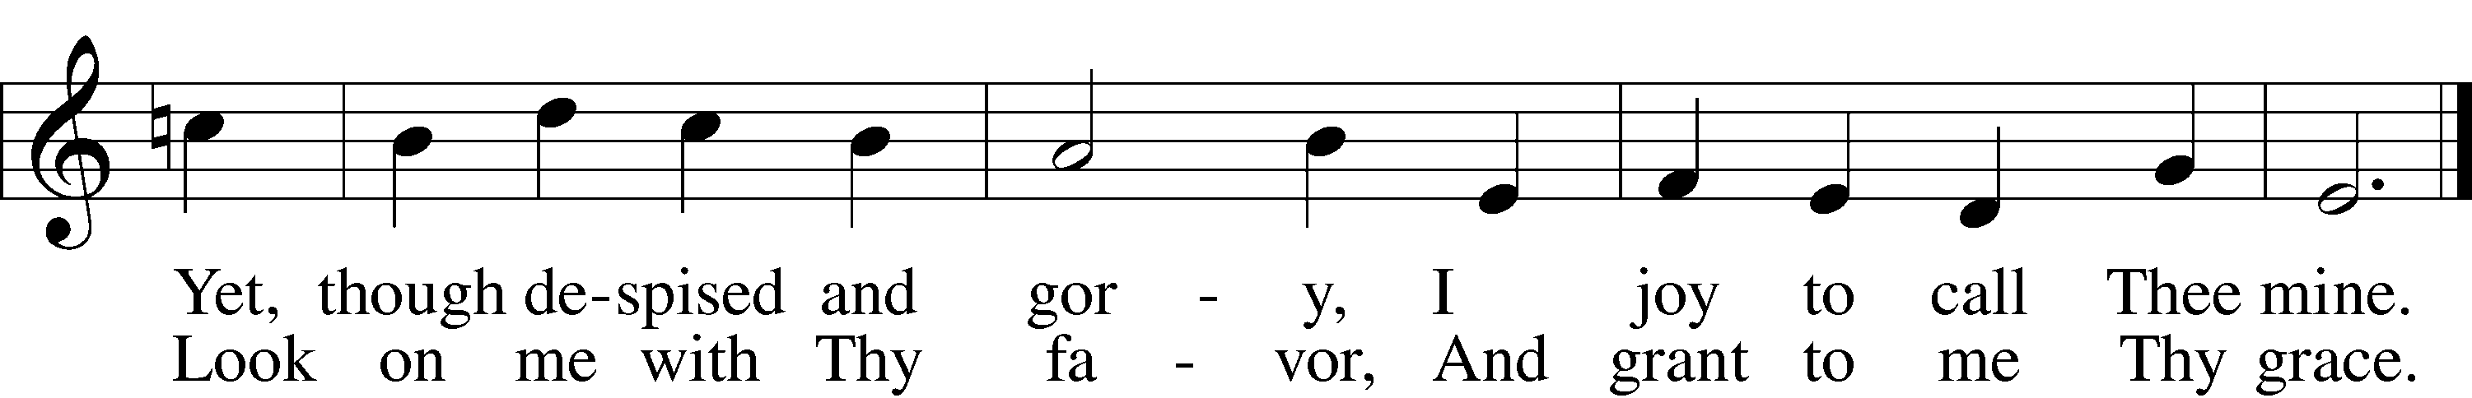
Text: © 1941 Concordia Publishing House Used by permission: LSB Hymn License .NET, number 100011462.
Music: Public domain. Created by Lutheran Service Builder © 2006 Concordia Publishing House.

Stand
John 19:16b-42
So the soldiers took charge of Jesus. 17 Carrying his own cross, he went out to the place of the Skull (which in Aramaic is called Golgotha).
18 Here they crucified him, and with him two others—one on each side and Jesus in the middle.
19 Pilate had a notice prepared and fastened to the cross. It read: JESUS OF NAZARETH, THE KING OF THE JEWS. 20 Many of the Jews read this sign, for the place where Jesus was crucified was near the city, and the sign was written in Aramaic, Latin and Greek. 21 The chief priests of the Jews protested to Pilate, "Do not write 'The King of the Jews,' but that this man claimed to be king of the Jews."
22 Pilate answered, "What I have written, I have written."
23 When the soldiers crucified Jesus, they took his clothes, dividing them into four shares, one for each of them, with the undergarment remaining. This garment was seamless, woven in one piece from top to bottom.
24 "Let's not tear it," they said to one another. "Let's decide by lot who will get it."
This happened that the scripture might be fulfilled which said, "They divided my garments among them and cast lots for my clothing." So this is what the soldiers did.
25 Near the cross of Jesus stood his mother, his mother's sister, Mary the wife of Clopas, and Mary Magdalene. 26 When Jesus saw his mother there, and the disciple whom he loved standing nearby, he said to his mother, "Dear woman, here is your son," 27 and to the disciple, "Here is your mother." From that time on, this disciple took her into his home.
28 Later, knowing that all was now completed, and so that the Scripture would be fulfilled, Jesus said, "I am thirsty." 29 A jar of wine vinegar was there, so they soaked a sponge in it, put the sponge on a stalk of the hyssop plant, and lifted it to Jesus' lips. 30 When he had received the drink, Jesus said, "It is finished." With that, he bowed his head and gave up his spirit.
31 Now it was the day of Preparation, and the next day was to be a special Sabbath. Because the Jews did not want the bodies left on the crosses during the Sabbath, they asked Pilate to have the legs broken and the bodies taken down. 32 The soldiers therefore came and broke the legs of the first man who had been crucified with Jesus, and then those of the other. 33 But when they came to Jesus and found that he was already dead, they did not break his legs. 34 Instead, one of the soldiers pierced Jesus' side with a spear, bringing a sudden flow of blood and water. 35 The man who saw it has given testimony, and his testimony is true. He knows that he tells the truth, and he testifies so that you also may believe. 36 These things happened so that the scripture would be fulfilled: "Not one of his bones will be broken," 37 and, as another scripture says, "They will look on the one they have pierced."
38 Later, Joseph of Arimathea asked Pilate for the body of Jesus. Now Joseph was a disciple of Jesus, but secretly because he feared the Jews. With Pilate's permission, he came and took the body away.
39 He was accompanied by Nicodemus, the man who earlier had visited Jesus at night. Nicodemus brought a mixture of myrrh and aloes, about seventy-five pounds. 40 Taking Jesus' body, the two of them wrapped it, with the spices, in strips of linen. This was in accordance with Jewish burial customs. 41 At the place where Jesus was crucified, there was a garden, and in the garden a new tomb, in which no one had ever been laid. 42 Because it was the Jewish day of Preparation and since the tomb was nearby, they laid Jesus there.

P O Lord, have mercy on us.
C Thanks be to God.

★ A candle is extinguished.

Responsory 1 John 2:1-2
P We have an advocate with the Father;
Jesus is the propitiation for our sins.
Blessed is he whose transgression is
forgiven and whose sin is put away.
We have an advocate with the Father; Jesus
is the propitiation for our sins.
C He was delivered up to death; He was
delivered for the sins of the people.

Sermon “The Place of Burial”
Pastor Tom Rhodes

Hymn LSB 439 sts. 1-2, 4-5
“O Dearest Jesus, What Law Hast Thou Broken”
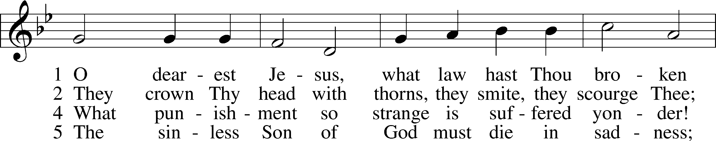
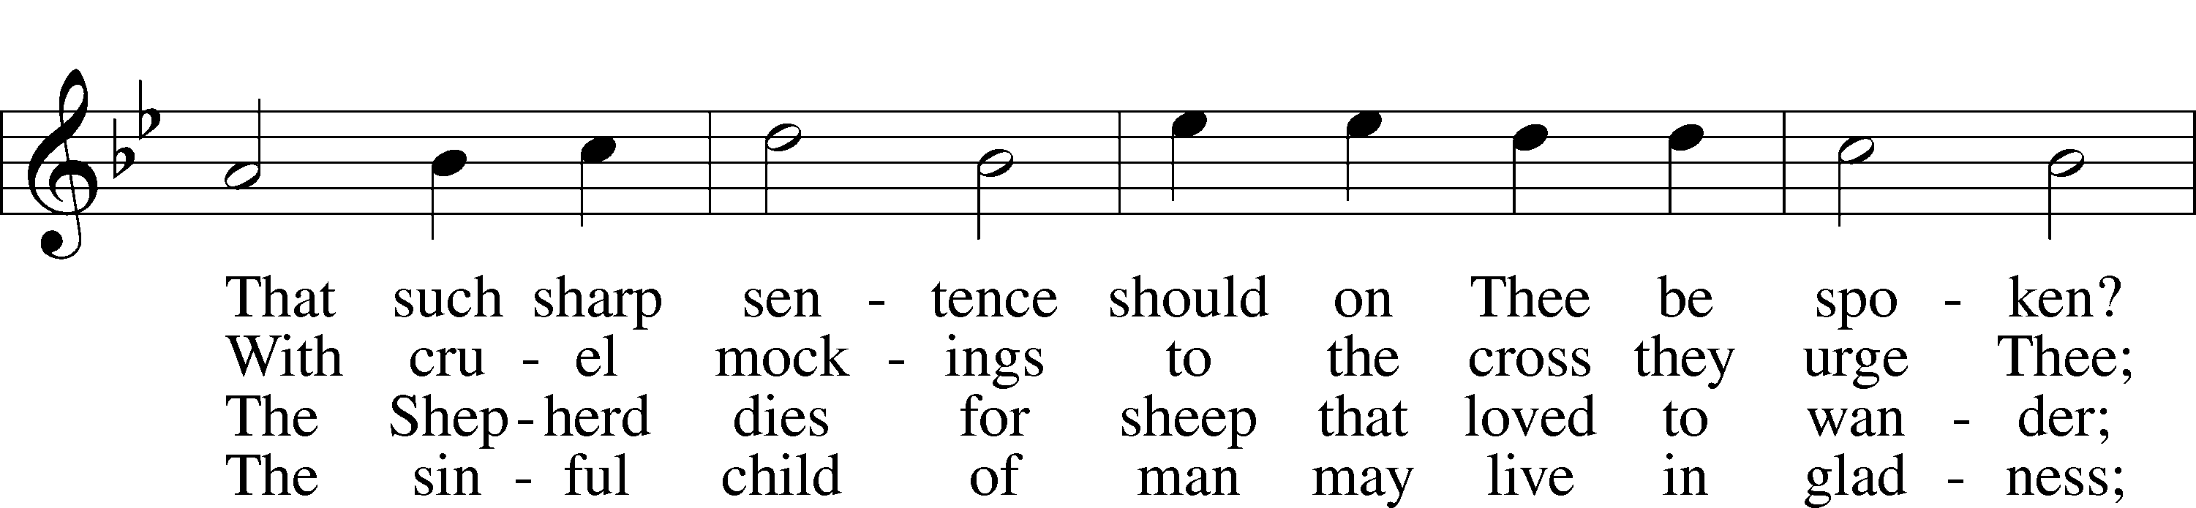
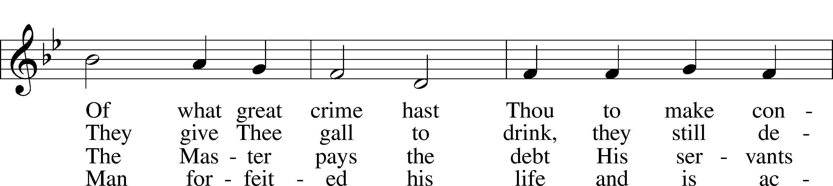
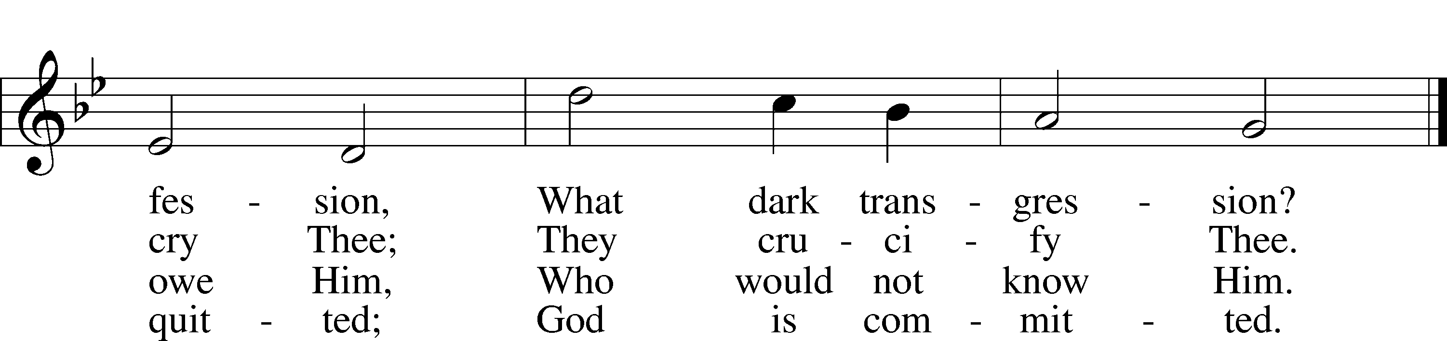
Public domain

Stand

★ A candle is extinguished.

Reproaches
P Thus says the Lord: What have I done to you, O My people, and wherein have I offended you? Answer Me. Though I have raised you up out of the prison house of sin and death, you have delivered up your Redeemer to be scourged. Though I have redeemed you from the house of bondage, you have nailed your Savior to the cross. O My people. (Micah 6:3-4)
C Holy Lord God, holy and mighty God, holy and most merciful Redeemer; God eternal, leave us not to bitter death. O Lord, have mercy.

P Thus says the Lord: What have I done to you, O My people, and wherein have I offended you? Answer Me. Though I have conquered all your foes, you have given Me over and delivered Me to those who persecute Me. Though I have fed you with My Word and refreshed you with living water, you have given Me gall and vinegar to drink. O My people. (Jeremiah 2:6-7)
C Holy Lord God, holy and mighty God, holy and most merciful Redeemer; God eternal, allow us not to lose hope in the face of death and hell. O Lord, have mercy.

P Thus says the Lord: What have I done to you, O My people, and wherein have I offended you? Answer Me. What more could have been done for My vineyard than I have done for it? When I looked for good grapes, why did it yield only bad? My people, is this how you thank your God? O My people. (Isaiah 5:2-4)
C Holy Lord God, holy and mighty God, holy and most merciful Redeemer; God eternal, keep us steadfast in the true faith. O Lord, have mercy.

Sit

Hymn LSB 436 sts. 1-4
“Go to Dark Gethsemane”
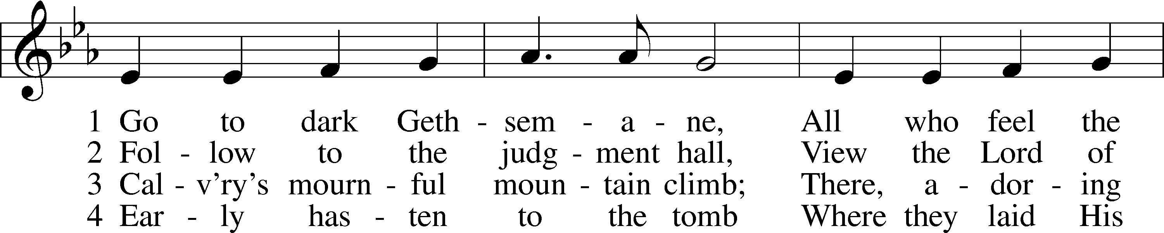
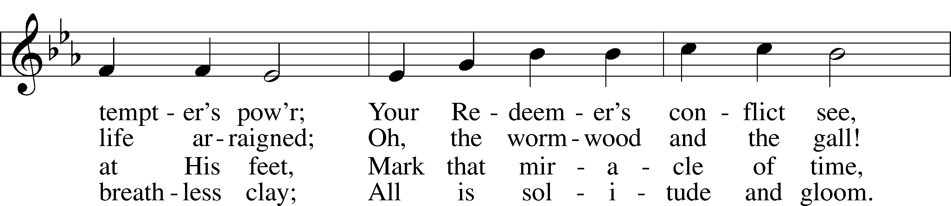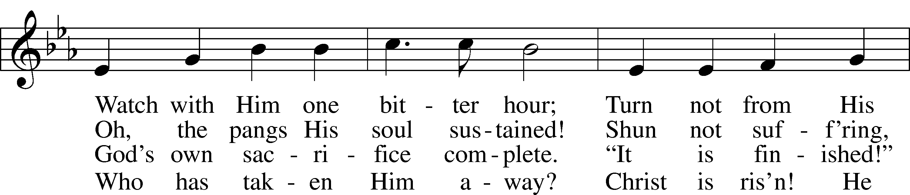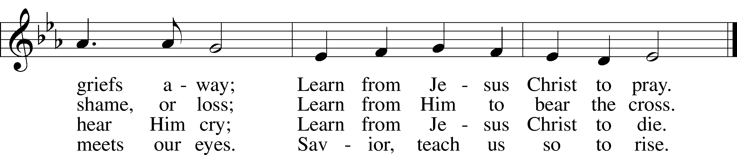
Public domain
★ A candle is extinguished.
Stand
Prayers
P Let us pray. Almighty God, graciously behold this Your family for whom our Lord Jesus Christ was willing to be betrayed and delivered into the hands of sinful men to suffer death upon the cross. Lord, in Your mercy,
C hear our prayer.

P Lighten our darkness, O Lord, and by Your great mercy defend us from all perils and dangers. Lord, in Your mercy,
C hear our prayer.

P Heavenly Father, God of all grace, govern our hearts that we may never forget Your blessings but steadfastly thank and praise You for all your goodness in this life until, with all Your saints, we praise You eternally in Your heavenly kingdom. Lord, in Your mercy,
C hear our prayer.

P Almighty God, heavenly Father, give us grace to trust You during this time of illness and distress. In mercy put an end to the epidemic that afflicts us. Grant relief to those who suffer, and comfort all that mourn. Sustain all medical personnel in their labors, and cause Your people ever to serve You in righteousness and holiness. Lord, in Your mercy,
C hear our prayer.

P O Lord, You are our dwelling place and our peace, You have compassion on our weakness. Put far from us all worry and fearfulness that, knowing in You our sins are forgiven and commending ourselves to Your gracious mercy, we may, commit ourselves, our work, and all we love into Your keeping. Lord, in Your mercy,
C hear our prayer.

P Almighty and everlasting God, You willed that Your Son should bear for us the pains of the cross and so remove from us the power of the adversary. Help us so to remember and give thanks for our Lord’s passion that we may receive forgiveness of sin and redemption from everlasting death; through Jesus Christ, our Lord.
C Amen.

P Lord, have mercy. Mark 10:47
C Lord, have mercy.

P Christ, have mercy.
C Christ, have mercy.

P Lord, have mercy.
C Lord, have mercy.

★ The final candle is extinguished.

P Lord, remember us in Your kingdom, and teach us to pray:
C Our Father who art in heaven,
hallowed be Thy name,
Thy kingdom come,
Thy will be done on earth
as it is in heaven;
give us this day our daily bread;
and forgive us our trespasses
as we forgive those
who trespass against us;
and lead us not into temptation,
but deliver us from evil.
For Thine is the kingdom
and the power and the glory
forever and ever. Amen.

The Paschal Candle is removed from the chancel to remind us that Christ died – that the Light of God had gone out in the world. The sounding of the strepitus (a loud, sudden noise) after the candle is removed recalls the closing of Jesus’ tomb with a large stone. The candle is then returned to remind us that Easter is coming with Christ’s promised resurrection following His three days in the tomb.

The Story and our worship is not yet over.
Watch and share the Good News at our
Easter celebration at 10:30 a.m. on Sunday.

[We close now in silence]

