Zion Lutheran Church
‘Hearing, Sharing and Living the Gospel.’

Zion Lutheran Church
Our mission is to hear and share the good news of the risen Jesus and, with God’s help, to live the Gospel.

The Resurrection of Our Lord - Easter Sunday
April 12, 2020 10:30 a.m.

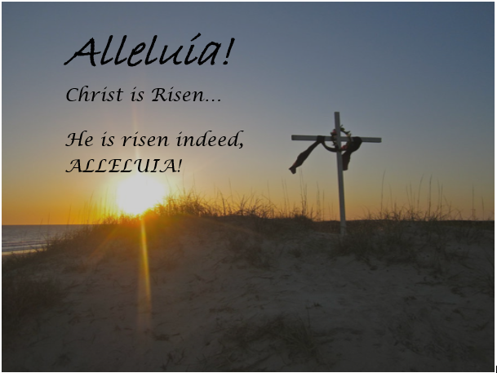

Zion Lutheran Church

‘Hearing, Sharing and Living the Gospel’
Rev. Thomas A. Rhodes, Pastor
PO Box 5 • 600 East Aldrich Road • Bolivar, MO 65613
Phone: 417-326-5506 • www.zionlutheranbolivar.org

zionbolivar@windstream.net


Administrative Assistant – Sonya Gorman
You are invited to use the yellow Prayer Cards located in the pew for prayer requests. Please hand this card to an usher or place it in the offering plate.
* Please turn off cellphones*

AS WE GATHER
"Alleluia! Christ is risen. He is risen indeed. Alleluia!" That Easter greeting, proclaimed throughout the ages of the Church, takes root in our hearts so that we understand that the resurrected life is now our own. Alleluia, meaning "praise ye the Lord," infects our hymns and anthems as we tell others the Good News that our Lord is risen, risen indeed.

We begin quietly in the narthex

+ benediction +
P Beloved in the Lord, we are gathered here to close our triduum of worship begun Thursday evening - remember, it didn't look like much of a victory when the limp, dead body of Jesus was sealed in the tomb on Friday. So now, on this most holy morning, in which our Lord Jesus passed over from death into life we say:

P The almighty and merciful Lord, the Father, the  Son, and the Holy Spirit, bless and preserve us all.
C Amen.

+ PREPARATION +
P As we come together to celebrate Jesus' resurrection, we have gathered outside of the sanctuary following the ancient custom of the Church, which for 2,000 years has gathered at the entrance of Christ's tomb at Easter sunrise to marvel at His resurrection. We will walk into the sanctuary, as Jesus' followers walked to the tomb on the first Easter morning. None of those who were there were celebrating. And now on this first day of the week, this first Easter, they walked to the tomb not yet knowing who would roll away the stone for them. And certainly not yet knowing the joy that was to come to them upon hearing the news from the angel that Jesus “has risen, as He said.” And most certainly not yet knowing that, as they leave the tomb, the place of death, Jesus, risen from the dead, will greet them!



THE RESURRECTION OF OUR LORD – EASTER SUNDAY
Divine Service – Setting Three
April 12, 2020 10:30 a.m.
WELCOME

Rise
+ INVOCATION + LSB 184
The sign of the cross may be made by all in remembrance of their Baptism.
P We begin in the name into which we are baptized; In the name of the Father and of the  Son and of the Holy Spirit. Matthew 28:19b; [18:20]
C Amen.

Easter Gospel Part I Matthew 28:1-6a
(The angel announces Christ's resurrection)

P The Holy Gospel according to St.
Matthew, the twenty-eight chapter.
C Glory be to Thee, O Lord.

P Now after the Sabbath, toward the dawn of the first day of the week, Mary Magdalene and the other Mary went to see the tomb. And behold, there was a great earthquake, for an angel of the Lord descended from heaven and came and rolled back the stone and sat on it. His appearance was like lightning and his clothing white as snow. And for fear of him the guards trembled and became like dead men. But the angel said to the women,
C "Do not be afraid, for I know that you seek Jesus who was crucified. He is not here, for He has risen, as He said!"

Easter Response
P Alleluia! Christ is risen.
C He is risen indeed, alleluia!

P Alleluia! Christ is risen.
C He is risen indeed, alleluia!

P Alleluia! Christ is risen.
C He is risen indeed, alleluia!

Processional Hymn LSB 457 sts. 1-4
“Jesus Christ Is Risen Today”
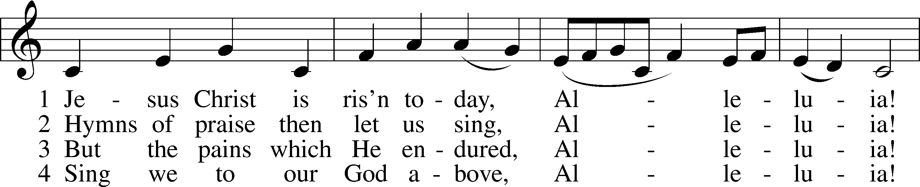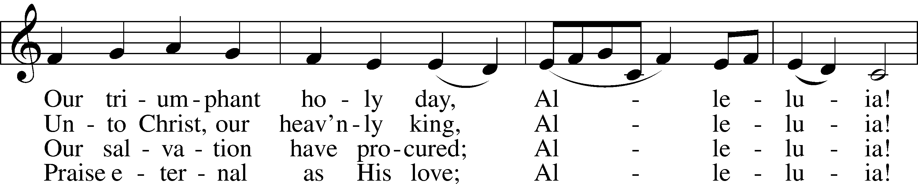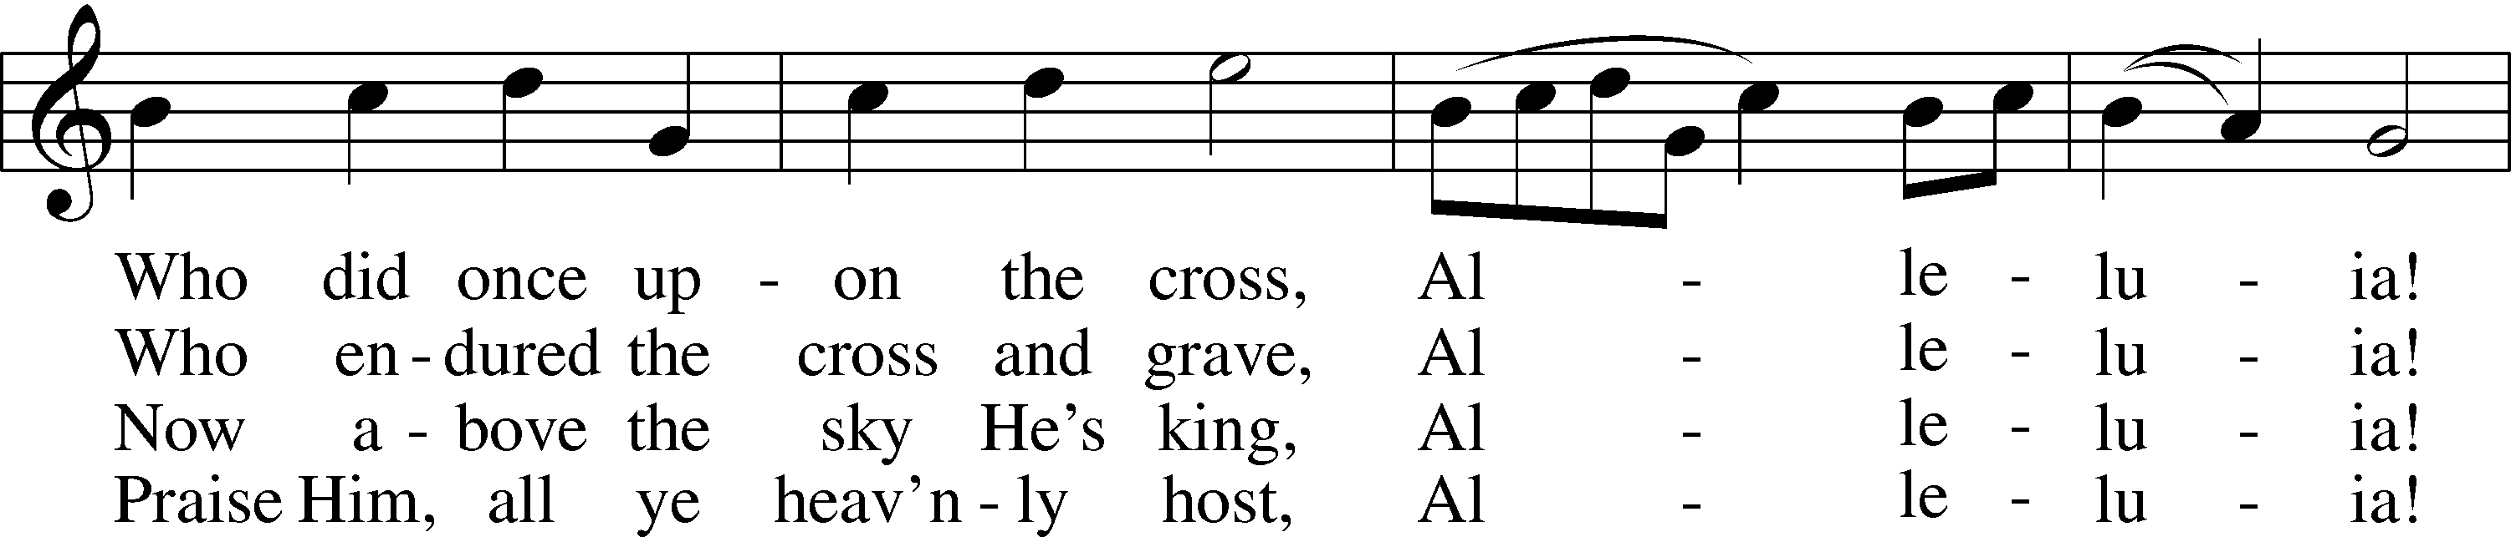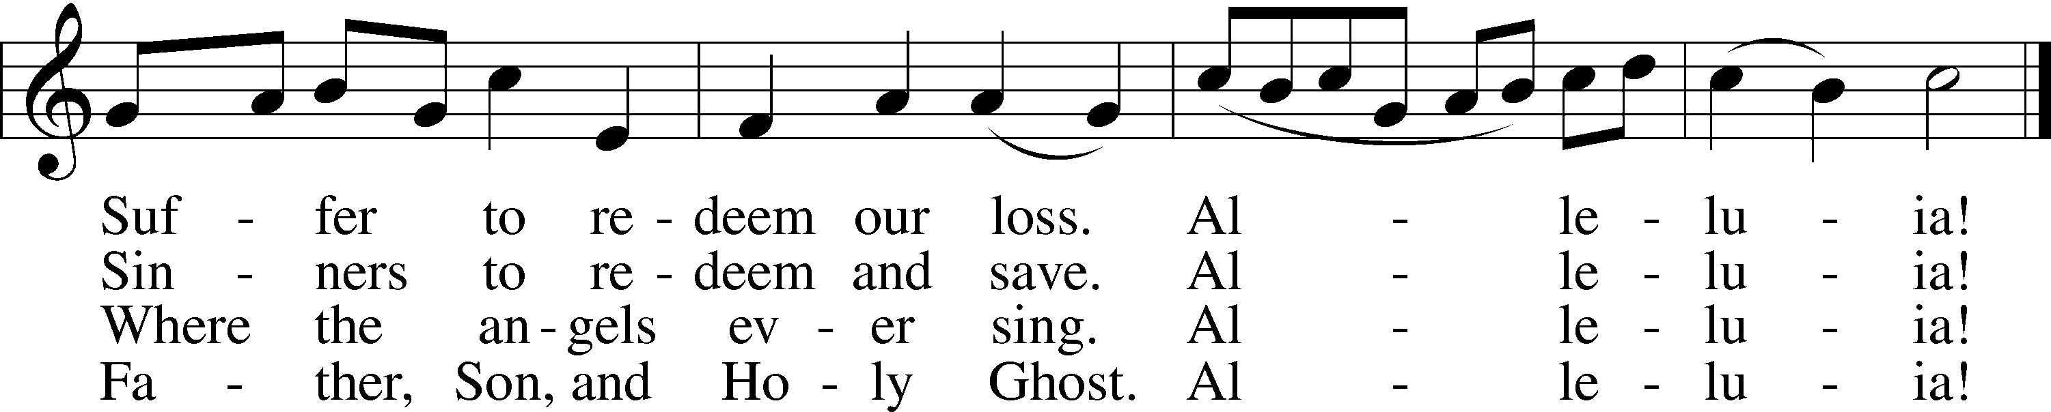

Public domain

+ CONFESSION AND ABSOLUTION + LSB 184
P Beloved in the Lord! Let us draw near with a true heart and confess our sins unto God our Father, beseeching Him in the name of our Lord Jesus Christ to grant us forgiveness. Hebrews 10:22

P Our help is in the name of the Lord,
C who made heaven and earth.
Psalm 124:8

P I said, I will confess my transgressions unto the Lord,
C and You forgave the iniquity of my sin. Psalm 32:5

(Silence for reflection on God's Word and for self-examination in light of the Ten Commandments.)

P Almighty God, our maker and redeemer, we poor sinners confess unto You that we are by nature sinful and unclean and that we have sinned against You by thought, word, and deed. Wherefore we flee for refuge to Your infinite mercy, seeking and imploring Your grace for the sake of our Lord Jesus Christ.
C O most merciful God, who has given Your only-begotten Son to die for us, have mercy upon us and for His sake grant us remission of all our sins; and by Your Holy Spirit increase in us true knowledge of You and of Your will and true obedience to Your Word, to the end that by Your grace we may come to everlasting life; through Jesus Christ, our Lord. Amen.
P Do you believe that the forgiveness I speak is not my forgiveness but God’s?
C Yes. LSB 291
P Let it be done for you as you believe.
P Upon this your confession, LSB 185
I, by virtue of my office, as a
called and ordained servant of the Word, announce the grace of God unto all of you, and in the stead and by the command of my Lord Jesus Christ I forgive you all your sins in the name of the Father and of the  Son and of the Holy Spirit. John 20:19-23
C Amen.

Having heard God's Absolution declared, the people greet one another in the name of the Lord, saying, “Peace be with you,” as a sign of reconciliation and of the unity of the Spirit in the bond of peace (Matt. 5:22–24; Eph. 4:1–3).

+ SERVICE OF THE WORD + LSB 186
Introit
Exodus 15:2a, 6, 13, 17-18; Antiphon: Ex.15:1b
P "I will sing to the Lord, for He has triumphed gloriously; the horse and his rider He has thrown into the sea."
C The Lord is my strength and my song, and He has become my salvation;
P Your right hand, O Lord, glorious in power,
C Your right hand, O Lord, shatters the enemy.
P "You have led in Your steadfast love the people whom You have redeemed;
C You have guided them by Your strength to Your holy abode.
P You will bring them in and plant them on Your own mountain,
C the place, O Lord, which You have made for Your abode, the sanctuary, O Lord, which Your hands have established.
P The Lord will reign forever and ever."
P C Glory be to the Father and to the Son and to the Holy Spirit; as it was in the beginning, is now and will be forever. Amen.
P "I will sing to the Lord, for He has triumphed gloriously;
C the horse and his rider He has thrown into the sea."

Kyrie Mark 10:47, LSB 186
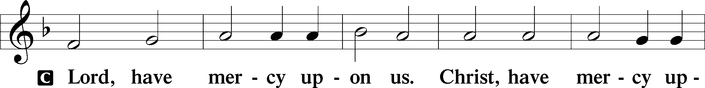
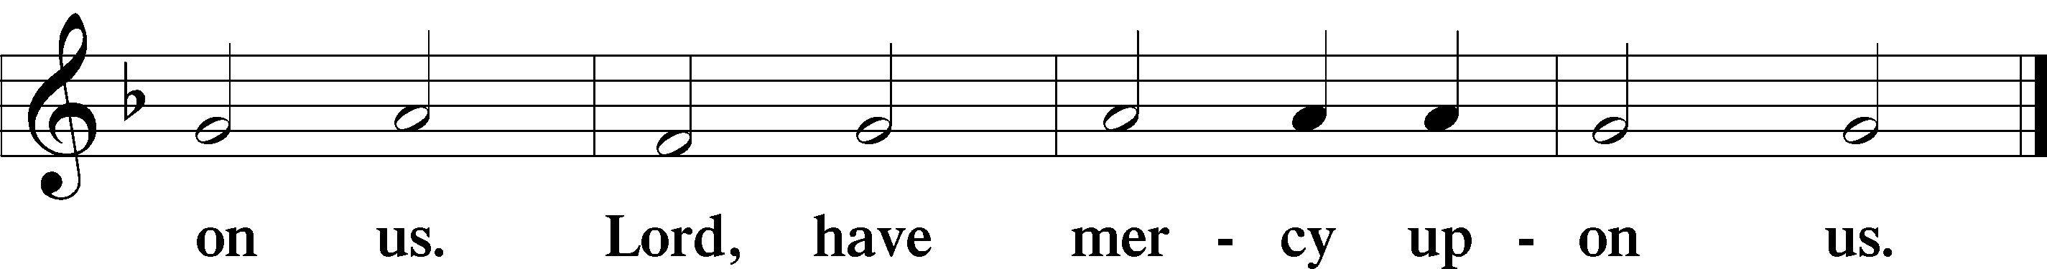

Hymn of Praise/Gloria in Excelsis LSB 187
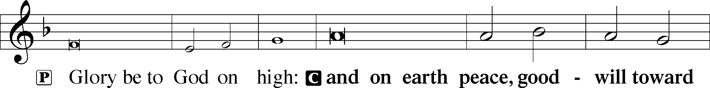
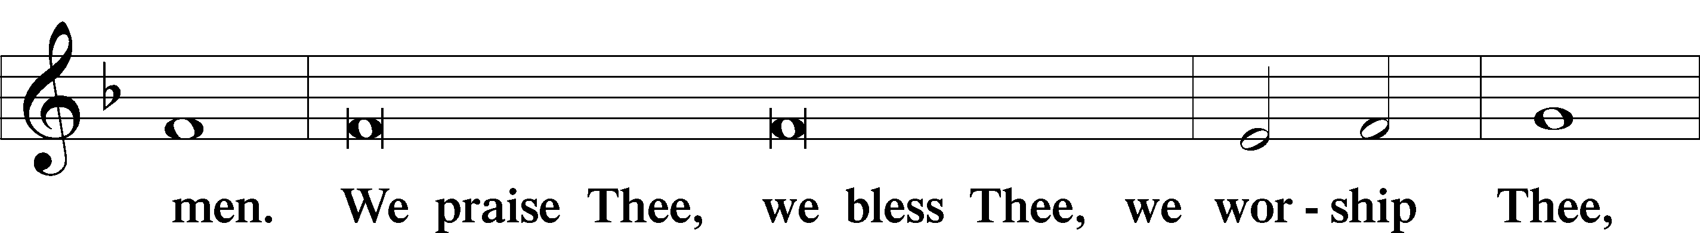
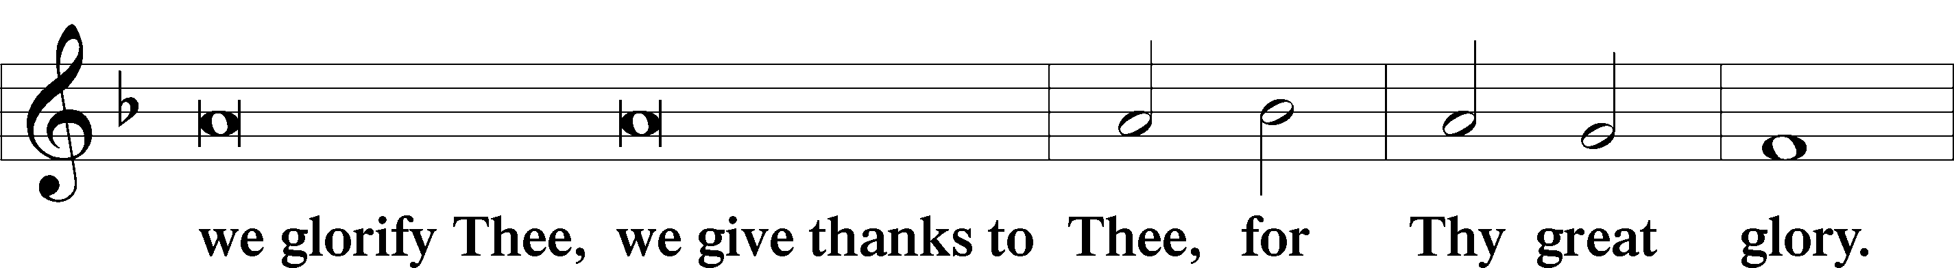
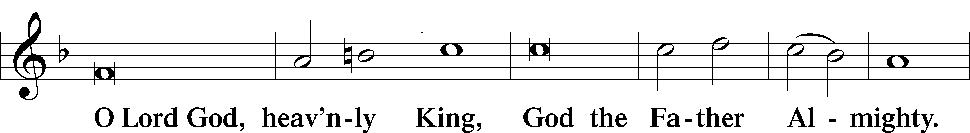
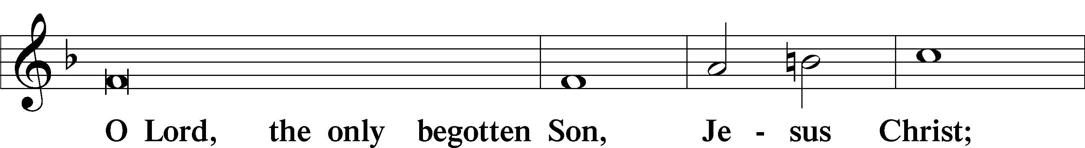
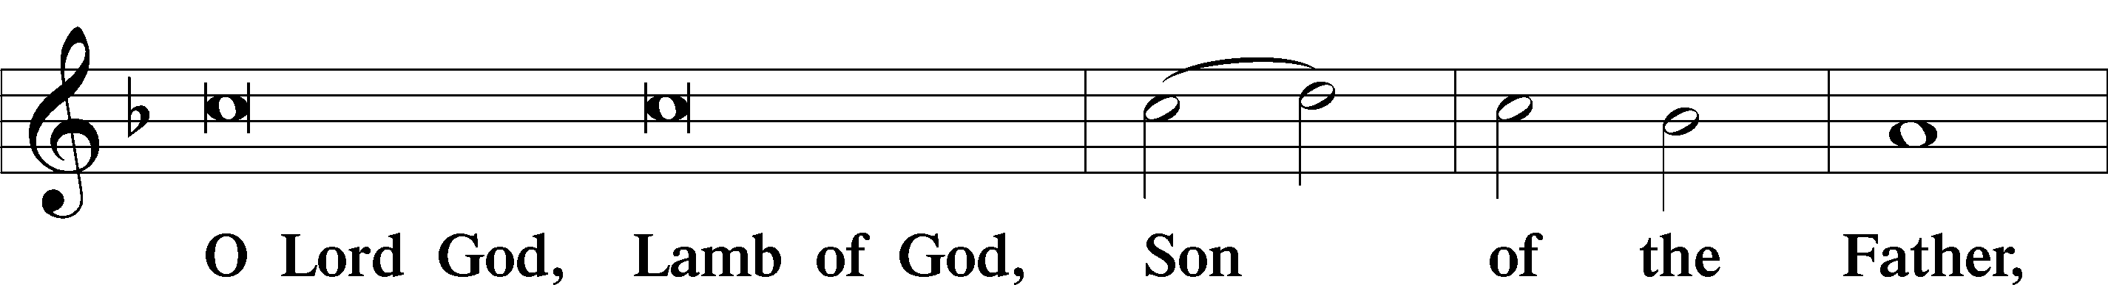
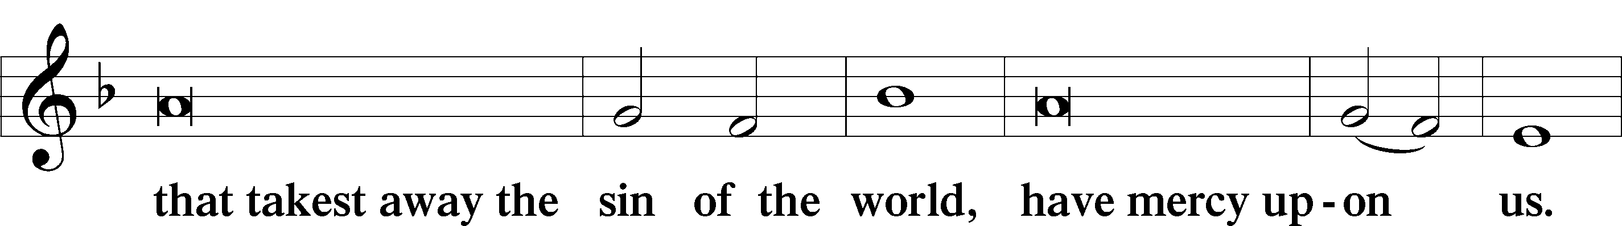
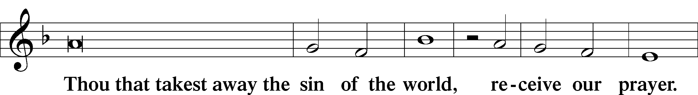
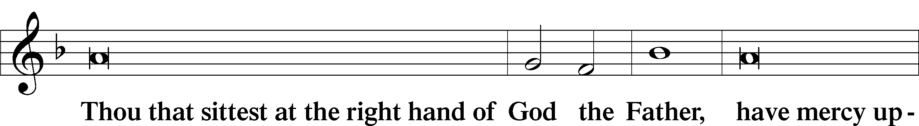
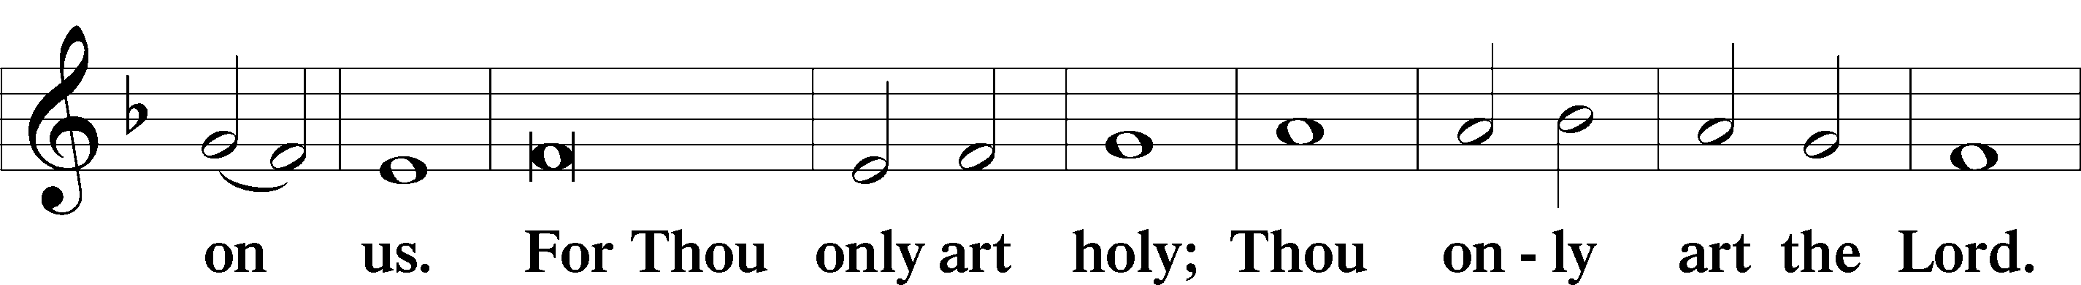
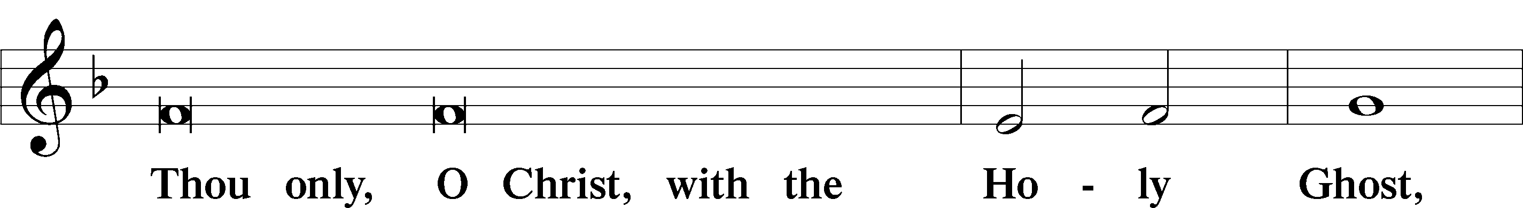
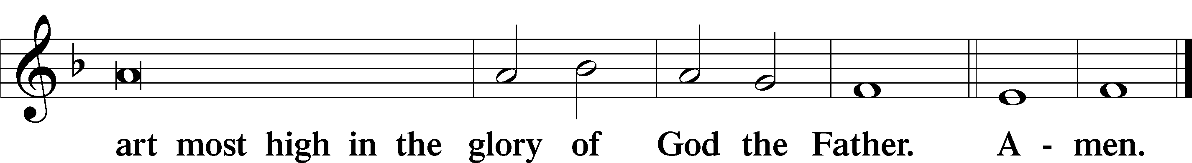

Salutation and Collect of the Day LSB 189
P The Lord be with you.
C And also with you.
P Let us pray. Almighty God the Father, through Your only-begotten Son, Jesus Christ, You have overcome death and opened the gate of everlasting life to us.
C Grant that we, who celebrate with joy the day of our Lord's resurrection, may be rescued from the death of sin by Your life-giving Spirit;
P through Jesus Christ, our Lord, who lives and reigns with You and the Holy Spirit, one God, now and forever.
C Amen.

Sit

First Reading Acts 10:34-43
﻿34﻿ Then Peter began to speak: “I now realize how true it is that God does not show favoritism ﻿35﻿ but accepts men from every nation who fear him and do what is right. ﻿36﻿ You know the message God sent to the people of Israel, telling the good news of peace through Jesus Christ, who is Lord of all. ﻿37﻿ You know what has happened throughout Judea, beginning in Galilee after the baptism that John preached— ﻿38﻿ how God anointed Jesus of Nazareth with the Holy Spirit and power, and how he went around doing good and healing all who were under the power of the devil, because God was with him.
39﻿ “We are witnesses of everything he did in the country of the Jews and in Jerusalem. They killed him by hanging him on a tree, ﻿40﻿ but God raised him from the dead on the third day and caused him to be seen. ﻿41﻿ He was not seen by all the people, but by witnesses whom God had already chosen—by us who ate and drank with him after he rose from the dead. ﻿42﻿ He commanded us to preach to the people and to testify that he is the one whom God appointed as judge of the living and the dead. ﻿43﻿ All the prophets testify about him that everyone who believes in him receives forgiveness of sins through his name.”
A This is the Word of the Lord.
C Thanks be to God.

Second Reading Colossians 3:1-4

(Seek the things above, where Christ is)

3 Since, then, you have been raised with Christ, set your hearts on things above, where Christ is seated at the right hand of God. ﻿2﻿ Set your minds on things above, not on earthly things. ﻿3﻿ For you died, and your life is now hidden with Christ in God. ﻿4﻿ When Christ, who is your life, appears, then you also will appear with him in glory.

A This is the Word of the Lord.
C Thanks be to God.

We welcome back Alleluia!
P Acknowledging that we again welcome the joy of Alleluia to our worship, we will wait to open the children’s eggs that they enclosed the Alleluia in on Transfiguration Sunday, till we can again gather together.

Easter Hymn LSB 463 sts. 1-4
“Christ the Lord Is Risen Today; Alleluia”
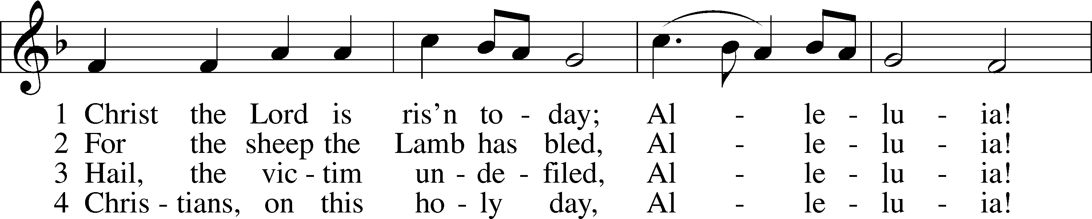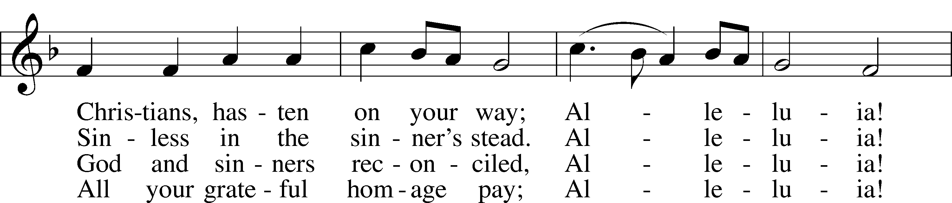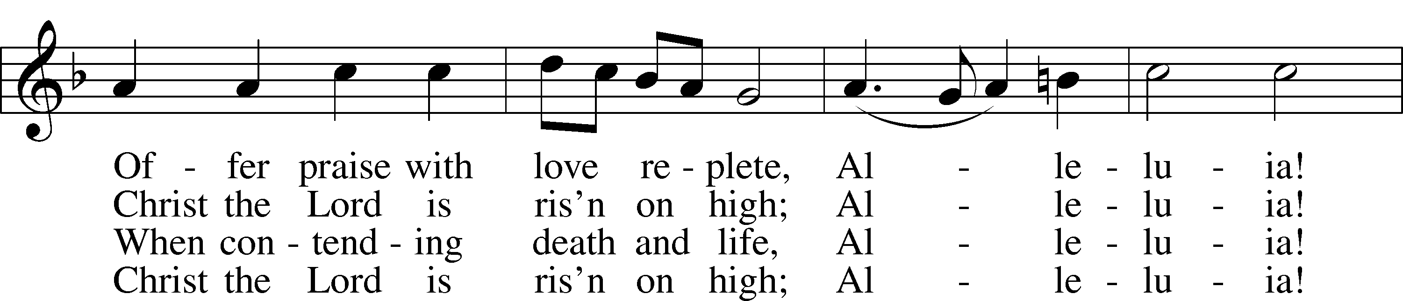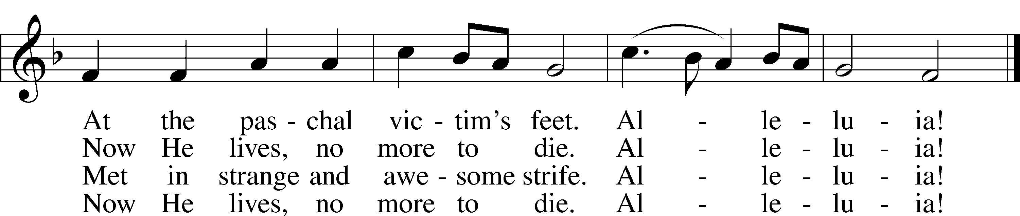
Public domain

Stand

Easter Gospel Part II Matthew 28:5-10

(The angel commands spreading the news)

P The Holy Gospel according to St.

Matthew, the twenty-eighth chapter.

C Glory be to Thee, O Lord.

P The angel said to the women,
C "Do not be afraid, for I know that you seek Jesus who was crucified. He is not here, for He has risen, as He said. Come, see the place where He lay. Then go quickly and tell His disciples that He has risen from the dead, and behold, He is going before you to Galilee; there you will see Him. See, I have told you."
P So they departed quickly from the tomb with fear and great joy, and ran to tell His disciples. And behold, Jesus met them and said, "Greetings!" And they came up and took hold of His feet and worshiped Him. Then Jesus said to them, "Do not be afraid; go and tell My brothers to go to Galilee, and there they will see Me."

P This is the Gospel of the Lord.
C Praise be to Thee, O Christ.

Easter Response
P Alleluia! Christ is risen.
C He is risen indeed, alleluia!

P Alleluia! Christ is risen.
C He is risen indeed, alleluia!

P Alleluia! Christ is risen.
C He is risen indeed, alleluia!

Sit
Hymn of the Day LSB 465 sts. 1-4
“Now All the Vault of Heaven Resounds”
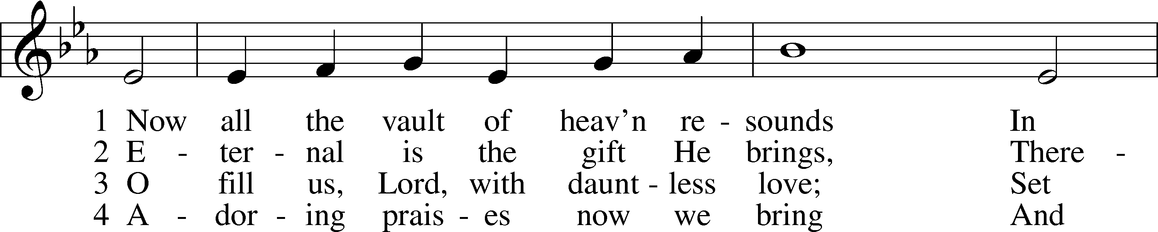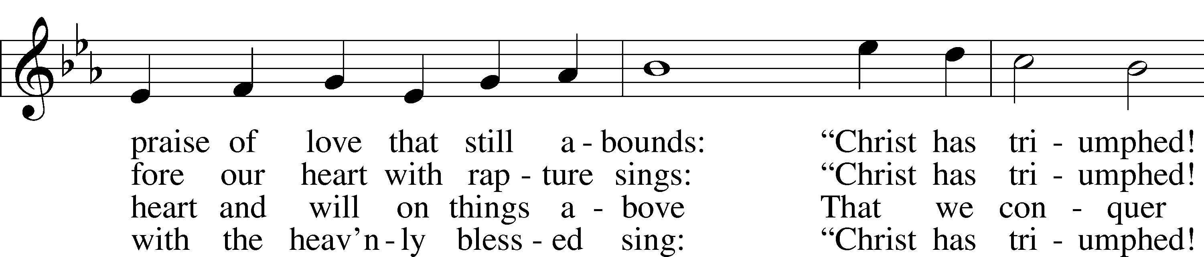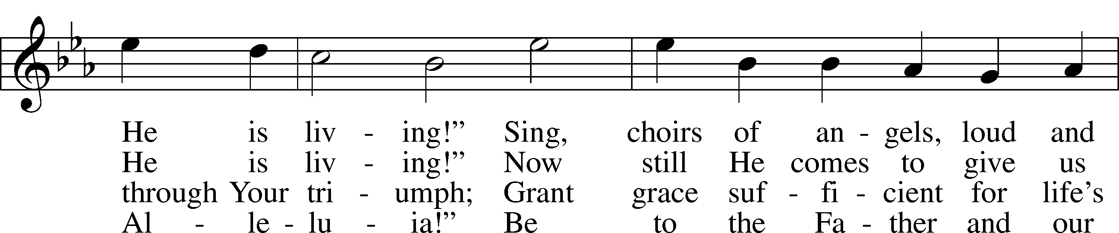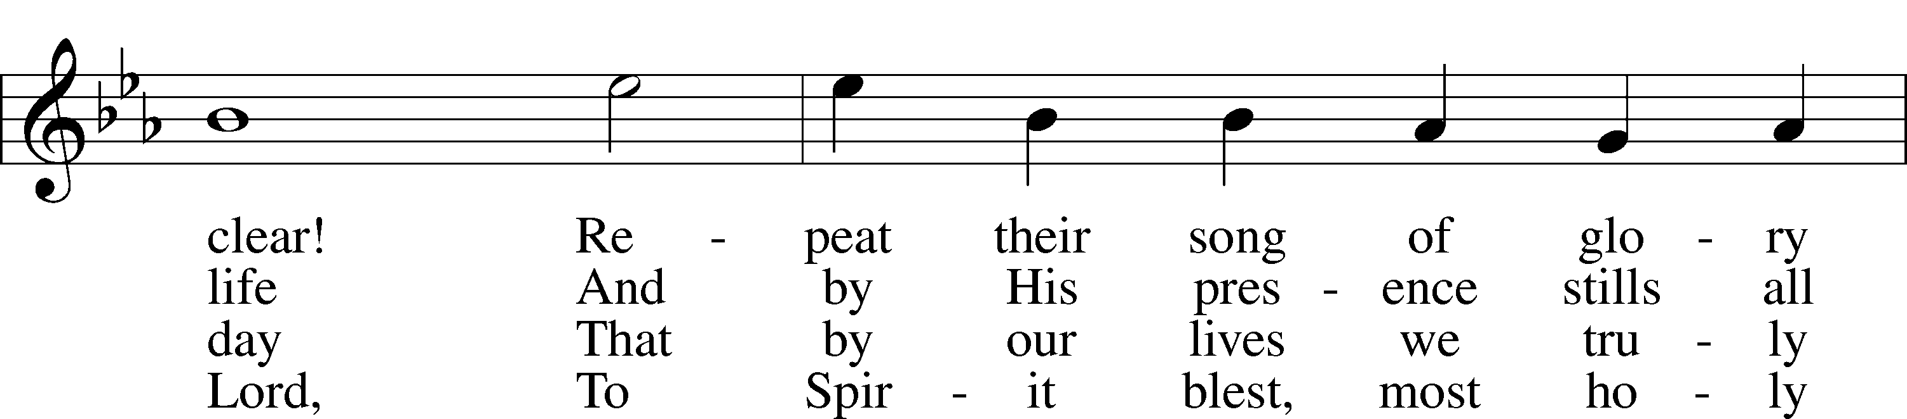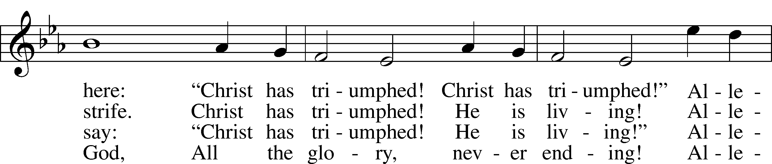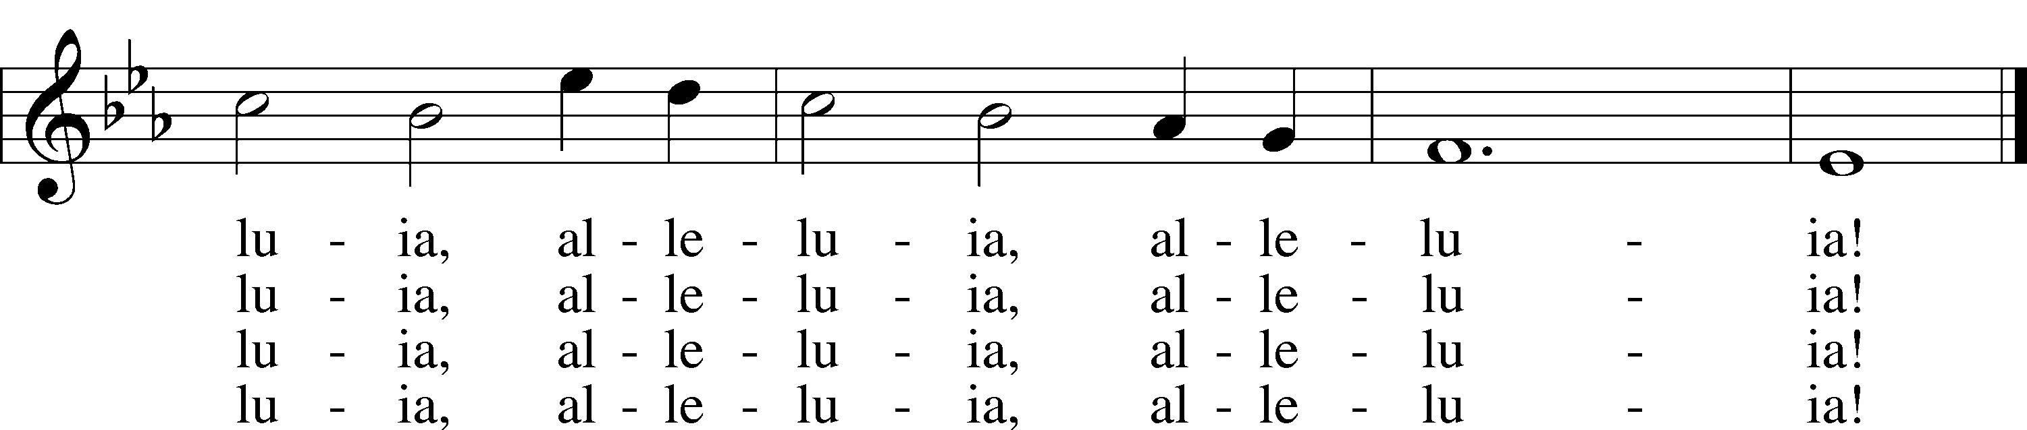
© 1958 Augsburg Publishing House. Used by permission: LSB Hymn License .NET, no. 100011462.

Sermon Pastor Tom Rhodes
“Come and See and Go and Tell”

Stand
Together We Confess Our Common Faith Using the Nicene Creed LSB 191
C I believe in one God,
the Father Almighty,
maker of heaven and earth
and of all things visible and invisible.

And in one Lord Jesus Christ,
the only-begotten Son of God,
begotten of His Father before all worlds,
God of God, Light of Light,
very God of very God,
begotten, not made,
being of one substance with the Father,
by whom all things were made;
who for us men and for our salvation came down from heaven
and was incarnate by the Holy Spirit of the virgin Mary
and was made man;
and was crucified also for us under Pontius Pilate.
He suffered and was buried.
And the third day He rose again according to the Scriptures
and ascended into heaven
and sits at the right hand of the Father.
And He will come again with glory to judge both the living and the dead,
whose kingdom will have no end.

And I believe in the Holy Spirit,
the Lord and giver of life,
who proceeds from the Father and the Son,
who with the Father and the Son together is worshiped and glorified,
who spoke by the prophets.
And I believe in one holy Christian and apostolic Church,
I acknowledge one Baptism for the remission of sins,
and I look for the resurrection of the dead
and the life  of the world to come. Amen.

Sit

We Return to God Our Offerings
(This is just as it says: An offering to God through His church. As a reassurance to those in worship today, especially our guests - this is not an obligation - the good news of Jesus is free to all!) (Please find the red pew pad and record your fellowship with us)

Stand
Stewardship Prayer
P C O risen Savior, accept the sacrifice of praise and thanksgiving from our lips and the tithes and offerings we bring this day. Increase in the hearts of Your people delight in Your mercy, gratitude for all Your benefits, and eagerness to support the mission of Your Church in word and deed. In the precious name of Jesus, Amen.

Offertory LSB 192
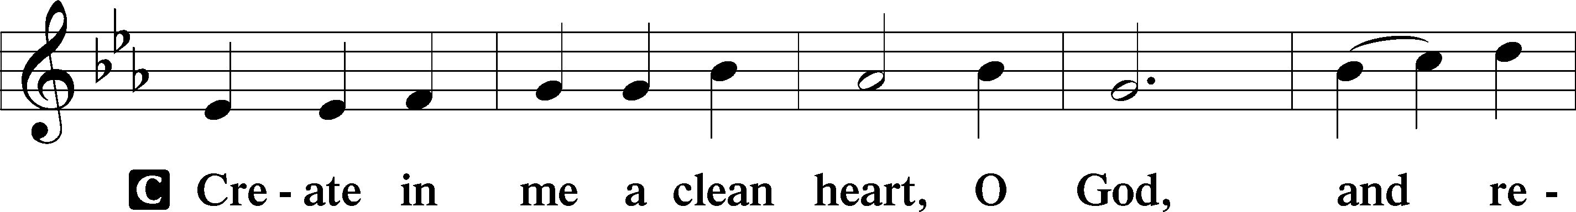
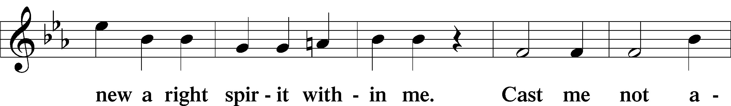
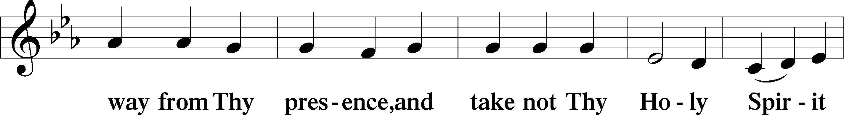
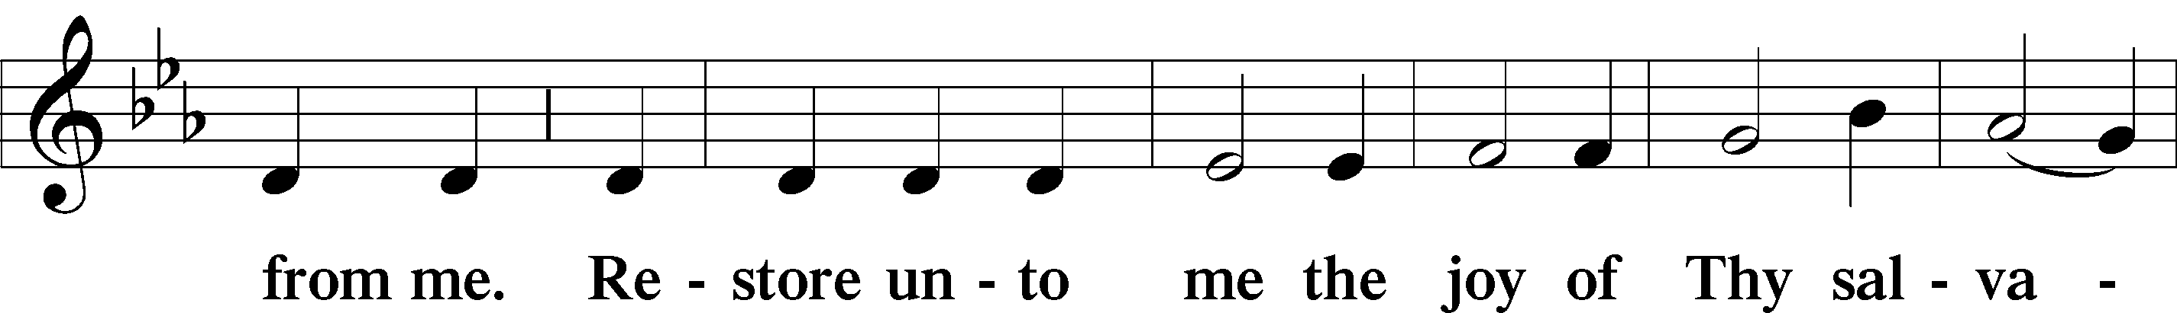
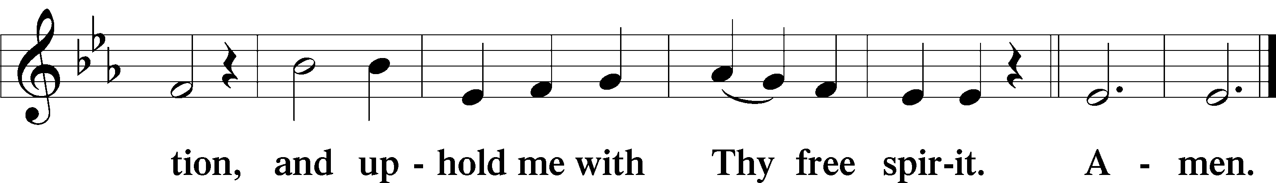

Prayer of the Church LSB 193
P Rejoicing in the resurrection of our Lord and sharing together in His peace, let us pray to the Lord on behalf of ourselves and all people as they have need.

Brief silence

P O risen Savior, set free our tongues to go and tell Your resurrection before a world still captive to sin and death. Give us courage to go to every place and to speak in every language the salvation won for us upon the cross and the hope granted to us of life in Christ that death cannot overcome. Lord, in Your mercy,
C hear our prayer.

P O risen Savior, make us to always come and see Your love in Your word, so that we may love You above all things and love our neighbors as ourselves. Deliver us from fear and relieve the anxiety of our hearts, that we may live out fully the hope planted within us and the new lives we received in the waters of our Baptism. Lord, in Your mercy,
C hear our prayer.

P O risen Savior, anoint the words of those who preach to us Your Gospel, and open our ears to hear with faith all that Jesus has done to save us. Raise us up in the various callings of Your Church that we may serve one another in Your name by Your Word and gifts. Lord, in Your mercy,
C hear our prayer.

P O risen Savior, hear us on behalf of Donald, our president; Mike, our governor; the Congress of the United States; and all state and local elected officials. Guide them according to Your Word, that their labors for our nation’s health and welfare may not be in vain, nor forgetful of the vulnerable, aging, and unemployed. Lord, in Your mercy,
C hear our prayer.

P O risen Savior, hear us on behalf of those who cry to You in any need, especially the sick, the suffering, the disabled, the wounded in spirit, those who suffer mental illness and those in their last days on earth [especially _____________]. Give them grace according to their need, and sustain them in their afflictions to the day when all suffering will be exchanged for glory in the life to come. Lord, in Your mercy,
C hear our prayer.

P All praise to You, dear Father in heaven, for You have opened up to us the way to eternal life in the resurrection of Your Son, our Lord Jesus Christ. We give You thanks for all those who have gone before us in the faith and now rest from their labors. Keep us in that same faith, and embolden us by Your resurrection to be fearless in the face of turmoil, disease, loneliness and every sorrow of this world. Give us the expectation to cheer us that our Redeemer lives, and we, too, shall be resurrected and glorified to live with Him in His eternal Kingdom; through the same Jesus Christ, Your Son, our resurrected Lord, who lives and reigns with You and the Holy Spirit, one God, now and forever.
C Amen.

Lord's Prayer Matthew 6:9-13, LSB 196
P Lord, remember us in Your kingdom and teach us to pray:
C Our Father who art in heaven,
hallowed be Thy name,
Thy kingdom come,
Thy will be done on earth
as it is in heaven;
give us this day our daily bread;
and forgive us our trespasses
as we forgive those
who trespass against us;
and lead us not into temptation,
but deliver us from evil.
For Thine is the kingdom
and the power and the glory
forever and ever. Amen.

Benediction Numbers 6:24-26, LSB 202
P The Lord bless you and keep you.
The Lord make His face shine upon you and be gracious unto you.
The Lord look upon you with favor and  give you peace.
C Amen.

Closing Hymn LSB 477 sts. 1-3
“Alleluia, Alleluia! Hearts to Heaven”
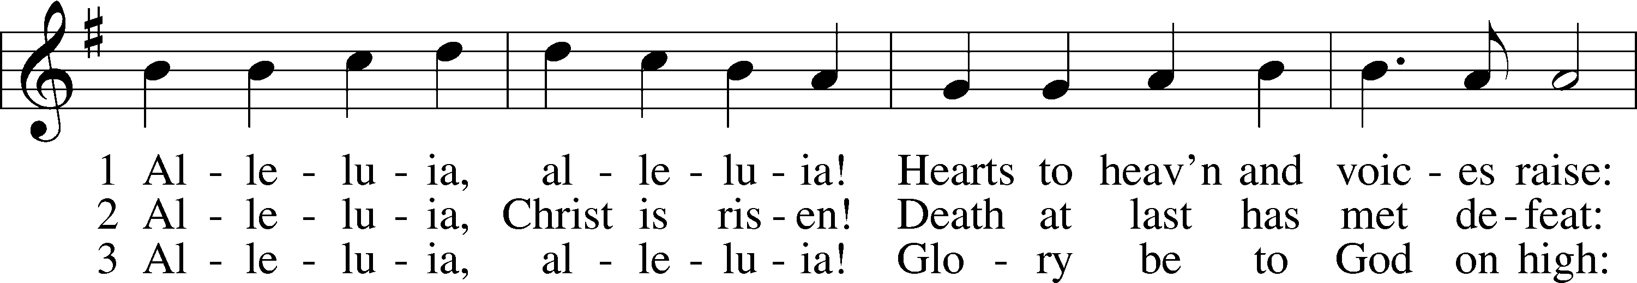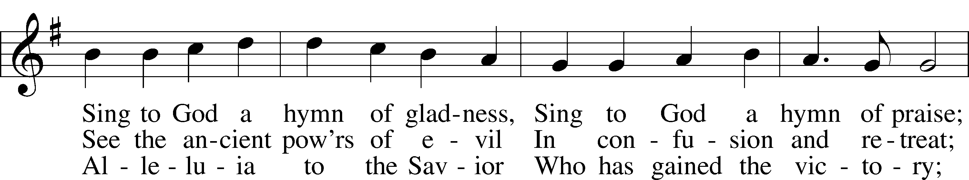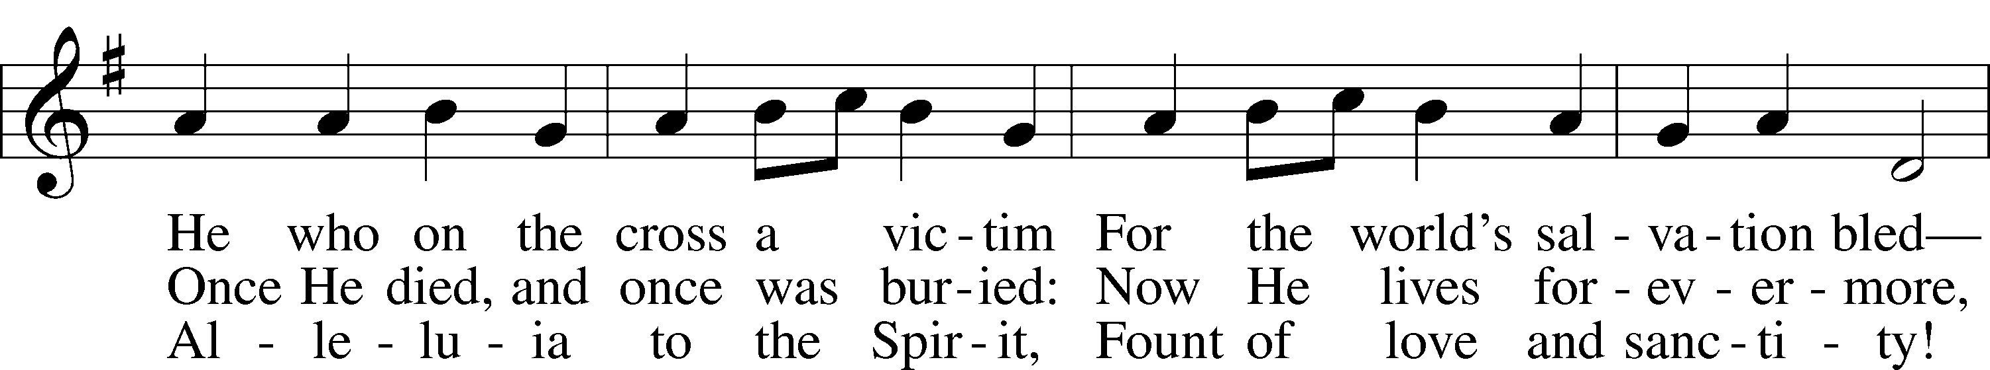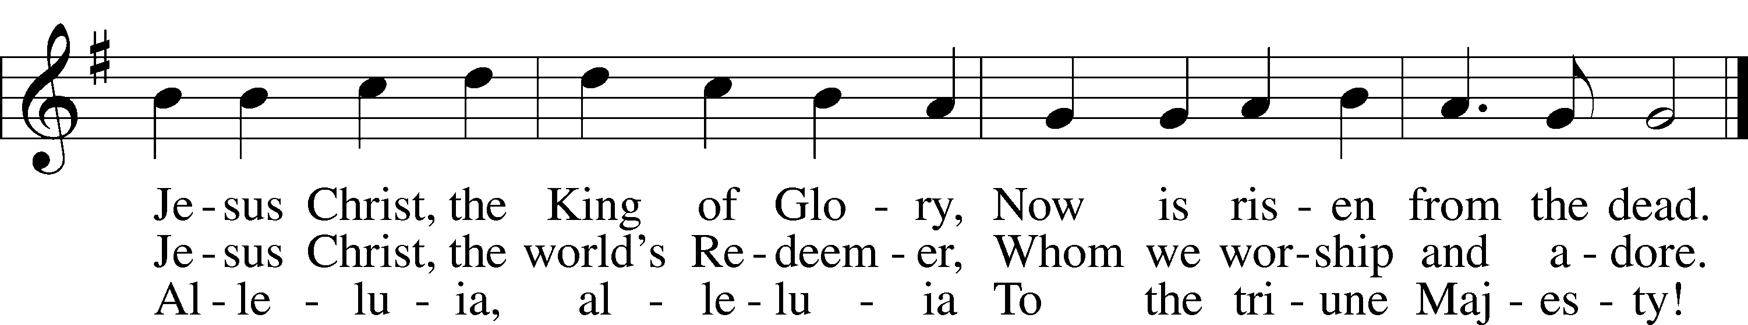
Public domain; admin. Hope Publishing Co. Used by permission: LSB Hymn License .NET, no. 100011462.;
© 1982 The Jubilate Group

