Zion Lutheran Church
‘Hearing, Sharing and Living the Gospel’

Zion Lutheran Church
Our mission is to hear and share the good news of the risen Jesus and, with God’s help, to live the Gospel.

Holy Trinity Sunday
June 7, 2020 10:30 a.m. Service

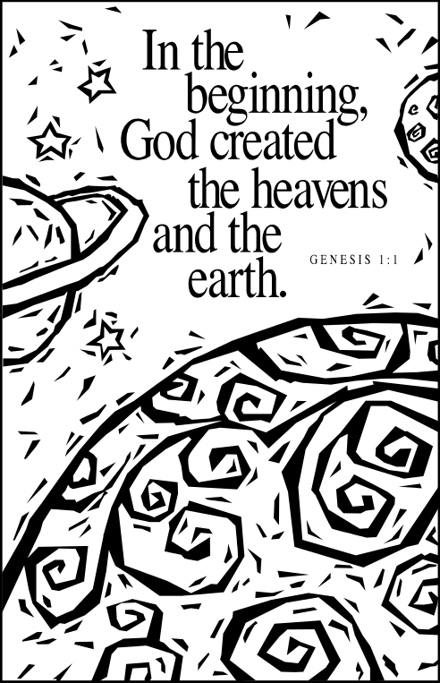

Zion Lutheran Church

‘Hearing, Sharing and Living the Gospel’
Rev. Thomas A. Rhodes, Pastor
PO Box 5 • 600 East Aldrich Road • Bolivar, MO 65613
Phone: 417-326-5506 • www.zionlutheranbolivar.org
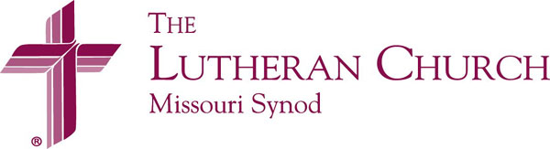
zionbolivar@windstream.net

Administrative Assistant – Sonya Gorman

You are invited to use the yellow prayer cards located in the pew for prayer requests.
Please hand this card to an usher or place it in the offering plate.
* Please turn off cellphones, thank you *

AS WE GATHER
The Holy Triune God Recreates Us in the Image and Likeness of Christ Jesus
Holy Trinity Sunday – last day of the high festival season of the church year in which we celebrate all the events surrounding Jesus earthly coming, His life, ministry, death, resurrection and ascension.
The Confession of Faith traditionally used in Christian churches around the world on Trinity Sunday is the Athanasian Creed. This is the longest of the three ecumenical creeds. The Athanasian Creed focuses on the doctrine of the Holy Trinity and on the doctrine of Jesus Christ, our Savior. We read the creed responsively as indicated in our service folder.
We enter next week into the Time of the Church, called the Season after Pentecost, and look at all the Lord has done and continues to do on this earth through the ministry of the church. Christ Himself established the church on earth to spread His good news, to properly administer His sacraments and to encourage His body of believers through fellowship.

Holy Communion is offered today:
The Lord’s Supper is a wonderful gift given to us by God. In the bread and wine, just as He says, Christ gives us His body and blood to forgive sins, renew faith, and cause Godly and brotherly love to grow. In this sacrament we proclaim Christ’s death on the cross to atone for the sins of the world and His triumphant resurrection over the grave, to the glory and praise of God. To receive this means of God's grace properly we should be able to positively answer the following: “Do I need forgiveness for sin?” “Do I believe in Christ as my Savior?” “Do I trust that Christ is truly present in the bread and wine?” “Do I desire to live anew to God and others in love and service?” In our ‘yes’ to these questions we join in a close and holy communion – a fellowship of faith.
Out of Pastoral concern and care, and taking to heart God's Word in 1 Corinthians 11:28-29:“A man ought to examine himself before he eats of the bread and drinks of the cup. For anyone who eats and drinks without recognizing the body of the Lord eats and drinks judgment on himself” – if you are unsure about what it means to take the Lord’s Supper, or if you are not certain you can confess these teachings or beliefs, please feel free to remain seated or speak to the Pastor or an Elder prior to the service.
If you need to receive the Sacrament at your seat, please tell an usher. For those who so desire, the cups in the center have water infused with a drop of wine. Also, non-communing children and adults are welcome to come to the altar rail and receive a blessing. (Please keep your hands folded to indicate this choice.)

HOLY TRINITY SUNDAY
Divine Service – Setting Two
June 7, 2020 10:30 a.m.

Welcome & Announcements

+ INVOCATION + LSB 167
The sign of the cross may be made by all in remembrance of their Baptism.
P We begin in the name into which we are baptized; In the name of the Father and of the  Son and of the Holy Spirit.
C Amen.

Opening Hymn LSB 825 sts. 1-4
“Rise, Shine, You People”
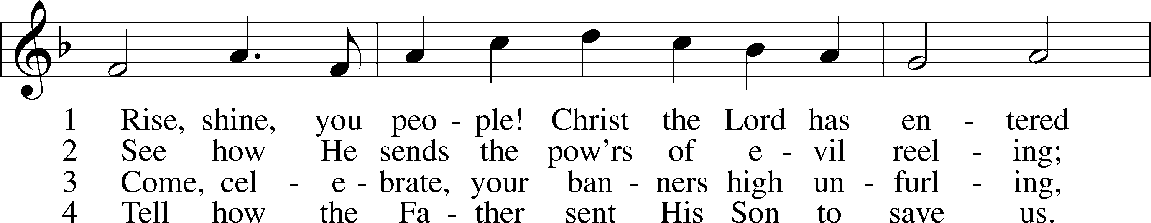
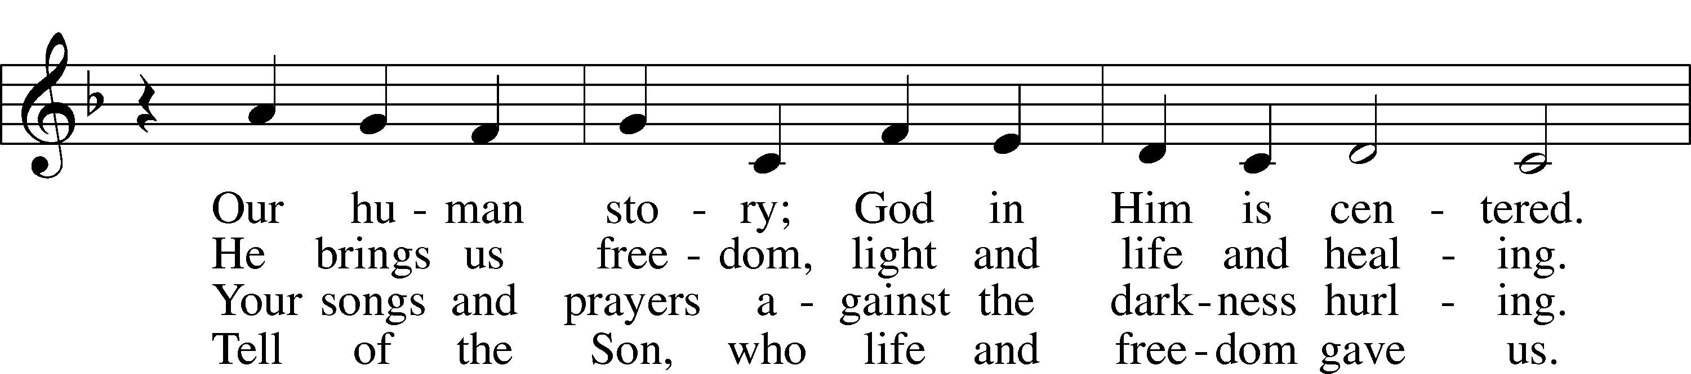
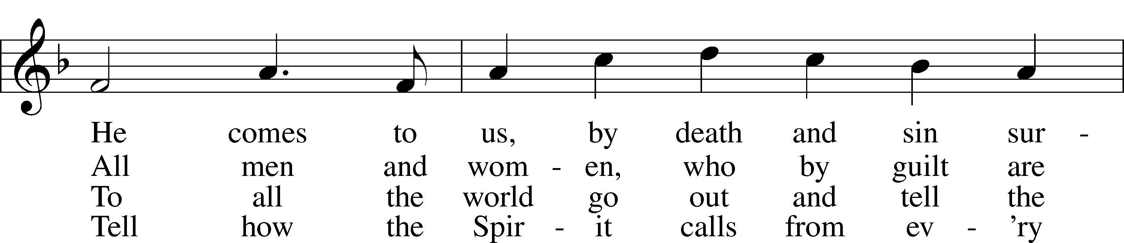
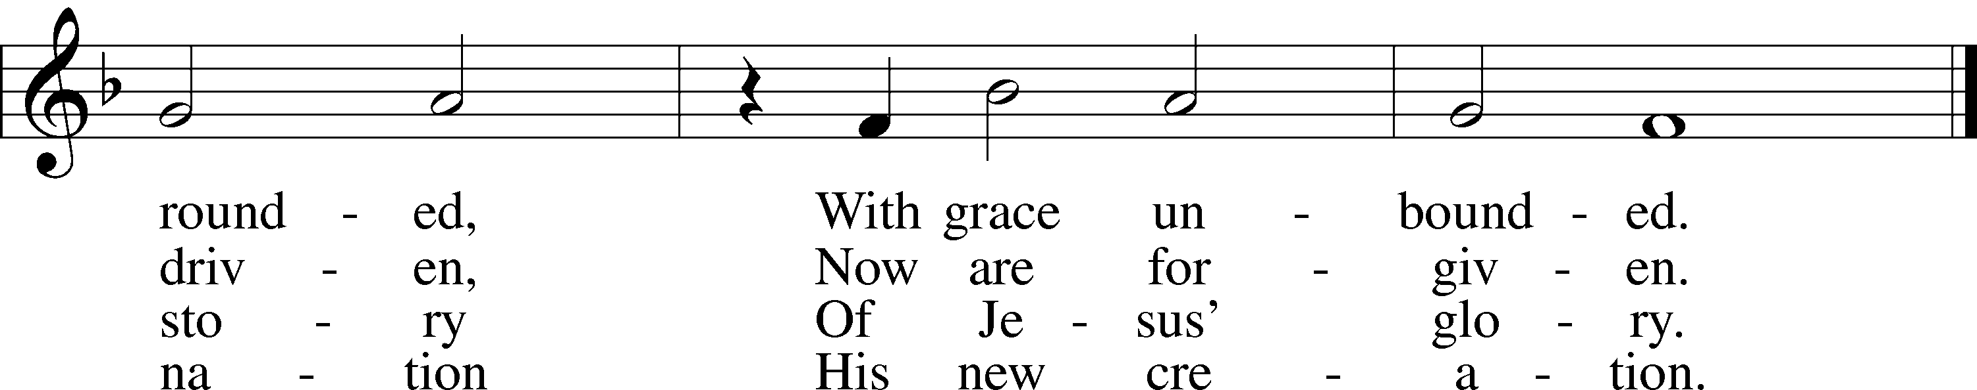

© 1974 Augsburg Publishing House; admin. Augsburg Fortress. Used by permission: LSB Hymn License .NET, no. 100011462.

+ CONFESSION AND ABSOLUTION + LSB 167
P If we say we have no sin, we deceive ourselves, and the truth is not in us.
C But if we confess our sins, God, who is faithful and just, will forgive our sins and cleanse us from all unrighteousness.

(Silence for reflection on God's Word and for self-examination in light of the Ten Commandments.)

P Let us then confess our sins to God our Father.
C Most merciful God, we confess that we are by nature sinful and unclean. We have sinned against You in thought, word, and deed, by what we have done and by what we have left undone. We have not loved You with our whole heart; we have not loved our neighbors as ourselves. We justly deserve Your present and eternal punishment. For the sake of Your Son, Jesus Christ, have mercy on us. Forgive us, renew us, and lead us, so that we may delight in Your will and walk in Your ways to the glory of Your holy name. Amen.
P God be merciful to you and strengthen your faith. LSB 292
C Amen.
P Do you believe that my forgiveness is
God’s forgiveness?
C Yes. LSB 293
P Let it be done for you as you believe.
P Almighty God in His LSB 167
mercy has given His Son
to die for you and for His sake forgives you all your sins. As a called and ordained servant of Christ, and by His authority, I therefore forgive you all your sins in the name of the Father and of the  Son and of the Holy Spirit.
C Amen.

+ SERVICE OF THE WORD + LSB 168
Introit Ps. 16:8-11; antiphon: Liturgical Text
P Blessed be the Holy Trinity and the undivided Unity. Let us give glory to him because he has shown his mercy to us.
C I have set the Lord always before me; because he is at my right hand, I shall not be shaken.
P Therefore my heart is glad, and my whole being rejoices; my flesh also dwells secure.
C For you will not abandon my soul to Sheol, or let your holy one see corruption.
P You make known to me the path of life; in your presence there is fullness of joy; at your right hand are pleasures forevermore.
P C Glory be to the Father and to the Son and to the Holy Spirit; as it was in the beginning, is now, and will be forever. Amen.
P Blessed be the Holy Trinity and the undivided Unity. Let us give glory to him because he has shown his mercy to us.

Kyrie LSB 168
P In peace let us pray to the Lord.
C Lord, have mercy.
P For the peace from above and for our salvation let us pray to the Lord.
C Lord, have mercy.
P For the peace of the whole world, for the well-being of the Church of God, and for the unity of all let us pray to the Lord.
C Lord, have mercy.
P For this holy house and for all who offer here their worship and praise let us pray to the Lord.
C Lord, have mercy.
P Help, save, comfort, and defend us, gracious Lord.
C Amen.
Hymn of Praise “This is the Feast”
Revelation 5:12-13, 19:5-9; LSB 171
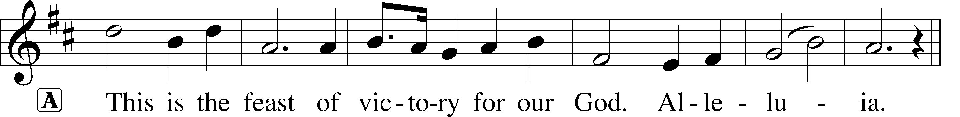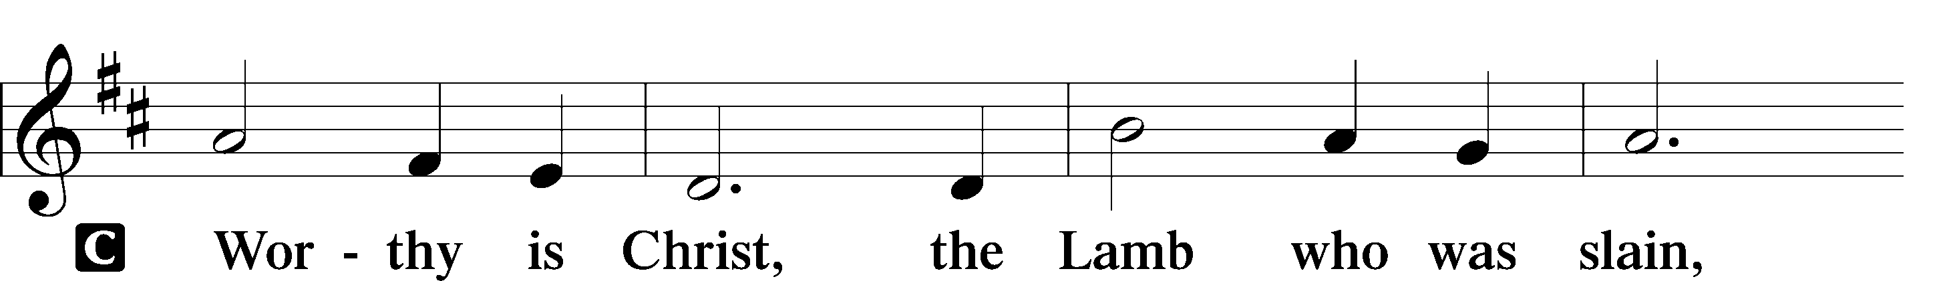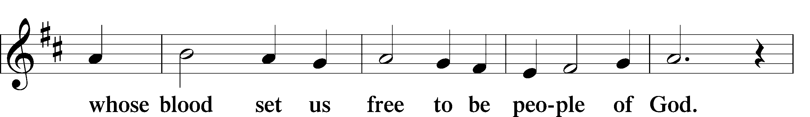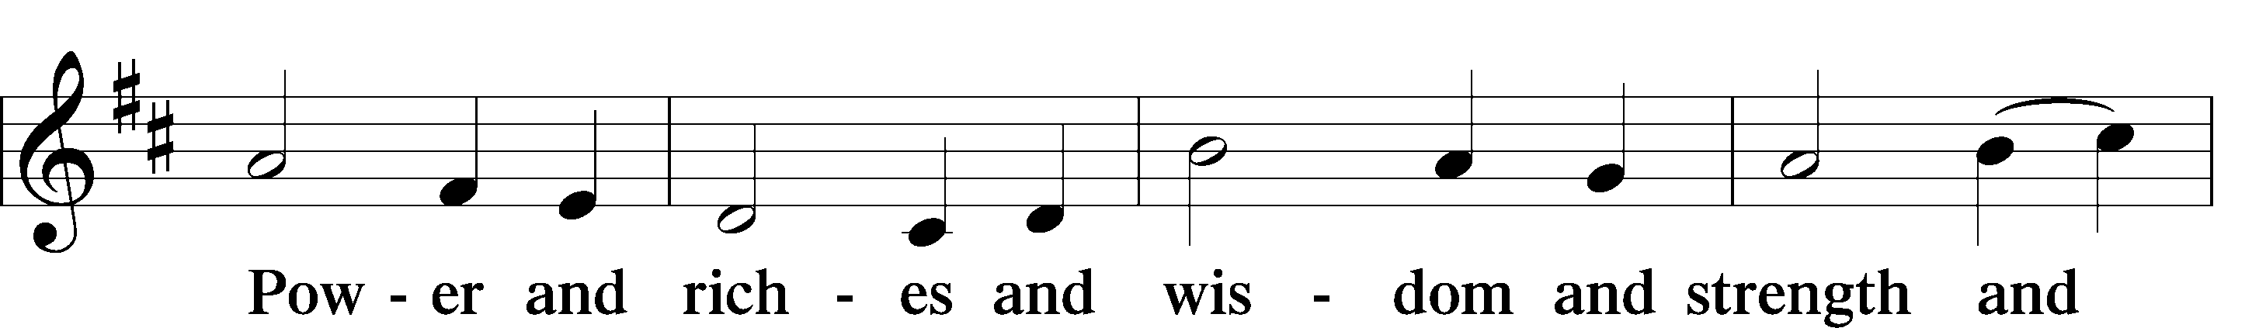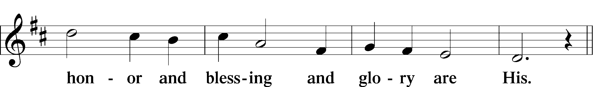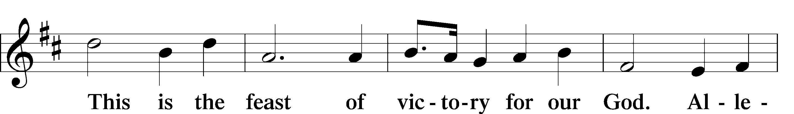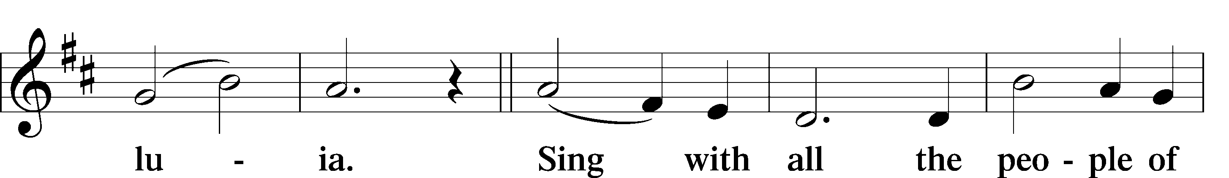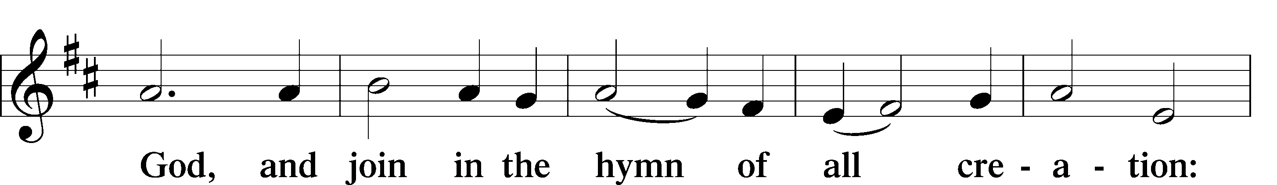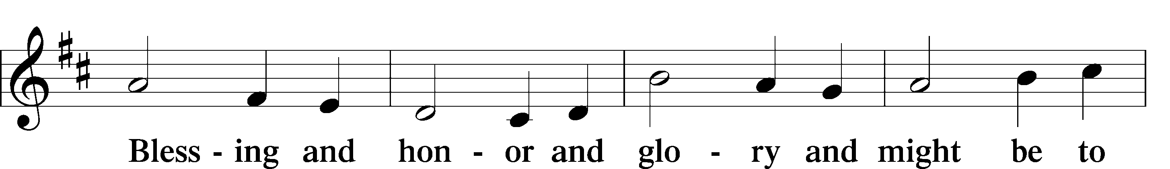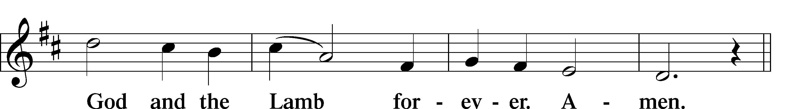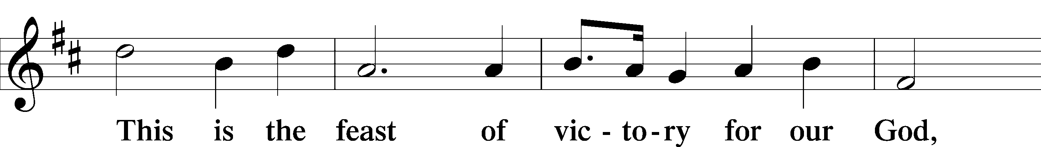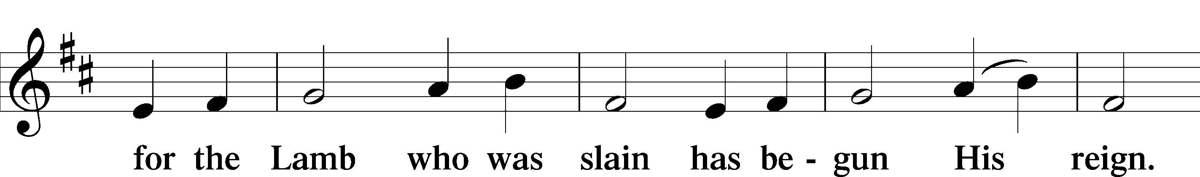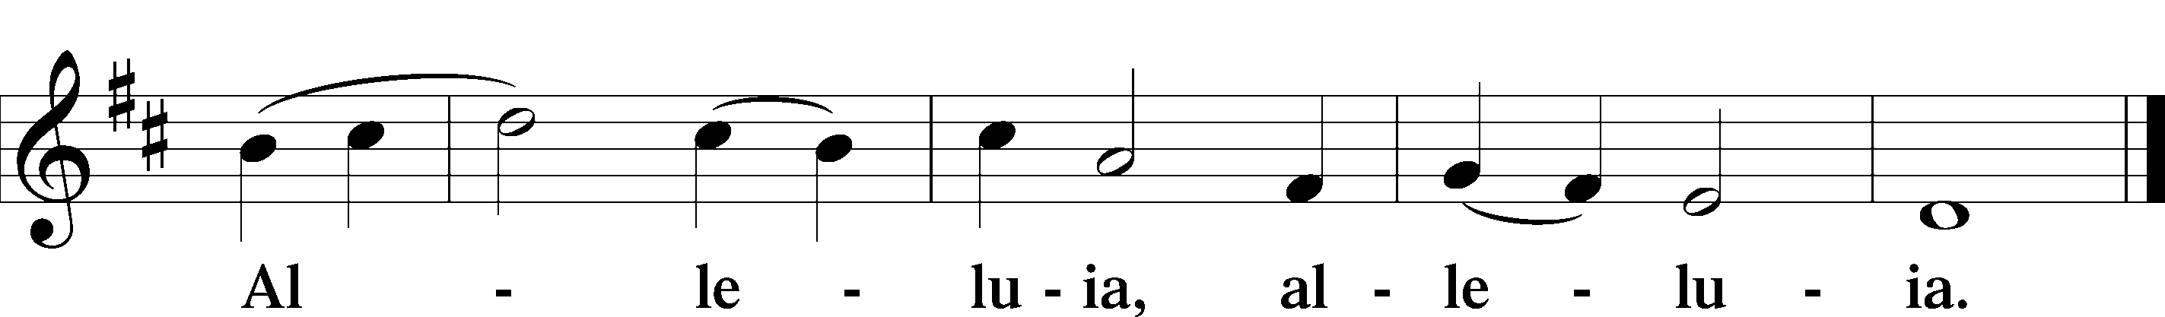

Salutation and Collect of the Day LSB 172
P The Lord be with you.
C And also with you.
P Let us pray. Almighty and everlasting God, You have given us grace to acknowledge the glory of the eternal Trinity by the confession of a true faith and to worship the Unity in the power of the Divine Majesty. Keep us steadfast in this faith and defend us from all adversities; for You, O Father, Son, and Holy Spirit, live and reign, one God, now and forever.
C Amen.

Sit
Old Testament Reading Genesis 1:1-2:4a
1 In the beginning God created the heavens and the earth. 2 Now the earth was formless and empty, darkness was over the surface of the deep, and the Spirit of God was hovering over the waters.
3 And God said, ‘Let there be light,’ and there was light. 4 God saw that the light was good, and he separated the light from the darkness. 5 God called the light ‘day’, and the darkness he called ‘night’. And there was evening, and there was morning – the first day.
6 And God said, ‘Let there be a vault between the waters to separate water from water.’ 7 So God made the vault and separated the water under the vault from the water above it. And it was so. 8 God called the vault ‘sky’. And there was evening, and there was morning – the second day.
9 And God said, ‘Let the water under the sky be gathered to one place, and let dry ground appear.’ And it was so. 10 God called the dry ground ‘land’, and the gathered waters he called ‘seas’. And God saw that it was good.
11 Then God said, ‘Let the land produce vegetation: seed-bearing plants and trees on the land that bear fruit with seed in it, according to their various kinds.’ And it was so. 12 The land produced vegetation: plants bearing seed according to their kinds and trees bearing fruit with seed in it according to their kinds. And God saw that it was good. 13 And there was evening, and there was morning – the third day.
14 And God said, ‘Let there be lights in the vault of the sky to separate the day from the night, and let them serve as signs to mark sacred times, and days and years, 15 and let them be lights in the vault of the sky to give light on the earth.’ And it was so. 16 God made two great lights – the greater light to govern the day and the lesser light to govern the night. He also made the stars. 17 God set them in the vault of the sky to give light on the earth, 18 to govern the day and the night, and to separate light from darkness. And God saw that it was good. 19 And there was evening, and there was morning – the fourth day.
20 And God said, ‘Let the water teem with living creatures, and let birds fly above the earth across the vault of the sky.’ 21 So God created the great creatures of the sea and every living thing with which the water teems and that moves about in it, according to their kinds, and every winged bird according to its kind. And God saw that it was good. 22 God blessed them and said, ‘Be fruitful and increase in number and fill the water in the seas, and let the birds increase on the earth.’ 23 And there was evening, and there was morning – the fifth day.
24 And God said, ‘Let the land produce living creatures according to their kinds: the livestock, the creatures that move along the ground, and the wild animals, each according to its kind.’ And it was so. 25 God made the wild animals according to their kinds, the livestock according to their kinds, and all the creatures that move along the ground according to their kinds. And God saw that it was good.
26 Then God said, “Let us make man in our image, in our likeness, and let them rule over the fish of the sea and the birds of the air, over the livestock, over all the earth, and over all the creatures that move along the ground.”
27 So God created man in his own image, in the image of God he created him; male and female he created them.
28 God blessed them and said to them, “Be fruitful and increase in number; fill the earth and subdue it. Rule over the fish of the sea and the birds of the air and over every living creature that moves on the ground.”
29 Then God said, “I give you every seed-bearing plant on the face of the whole earth and every tree that has fruit with seed in it. They will be yours for food. 30 And to all the beasts of the earth and all the birds of the air and all the creatures that move on the ground—everything that has the breath of life in it—I give every green plant for food.” And it was so.
31 God saw all that he had made, and it was very good. And there was evening, and there was morning—the sixth day.
1 Thus the heavens and the earth were completed in all their vast array.
2 By the seventh day God had finished the work he had been doing; so on the seventh day he rested from all his work. 3 And God blessed the seventh day and made it holy, because on it he rested from all the work of creating that he had done.

A This is the Word of the Lord.
C Thanks be to God.

Gradual Ps 145:3, 5b, 6b
A C Great is the Lord, and greatly to be praised, and his greatness is unsearchable. On your wondrous works, I will meditate, and I will declare your greatness.

Epistle Reading Acts 2:14a, 22-36
(selected verses)
14 Then Peter stood up with the Eleven, raised his voice and addressed the crowd: … 22 ‘Fellow Israelites, listen to this: Jesus of Nazareth was a man accredited by God to you by miracles, wonders and signs, which God did among you through him, as you yourselves know. 23 This man was handed over to you by God’s deliberate plan and foreknowledge; and you, with the help of wicked men, put him to death by nailing him to the cross. 24 But God raised him from the dead, freeing him from the agony of death, because it was impossible for death to keep its hold on him…
29 ‘Fellow Israelites, I can tell you confidently that the patriarch David died and was buried, and his tomb is here to this day. 30 But he was a prophet and knew that God had promised him on oath that he would place one of his descendants on his throne. 31 Seeing what was to come, he spoke of the resurrection of the Messiah, that he was not abandoned to the realm of the dead, nor did his body see decay. 32 God has raised this Jesus to life, and we are all witnesses of it. 33 Exalted to the right hand of God, he has received from the Father the promised Holy Spirit and has poured out what you now see and hear… 36 ‘Therefore let all Israel be assured of this: God has made this Jesus, whom you crucified, both Lord and Messiah.’

A This is the Word of the Lord.
C Thanks be to God.

Stand
Alleluia and Verse LSB 173
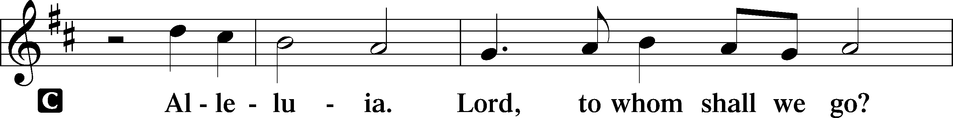
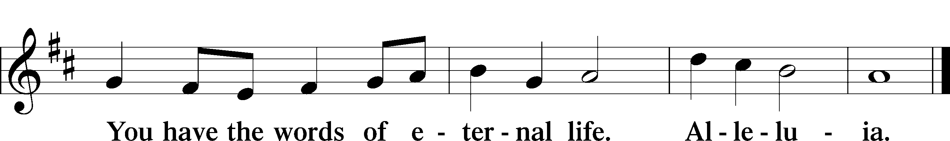

Holy Gospel Matthew 28:16-20
P The Holy Gospel according to St. Matthew, the twenty-eighth chapter.
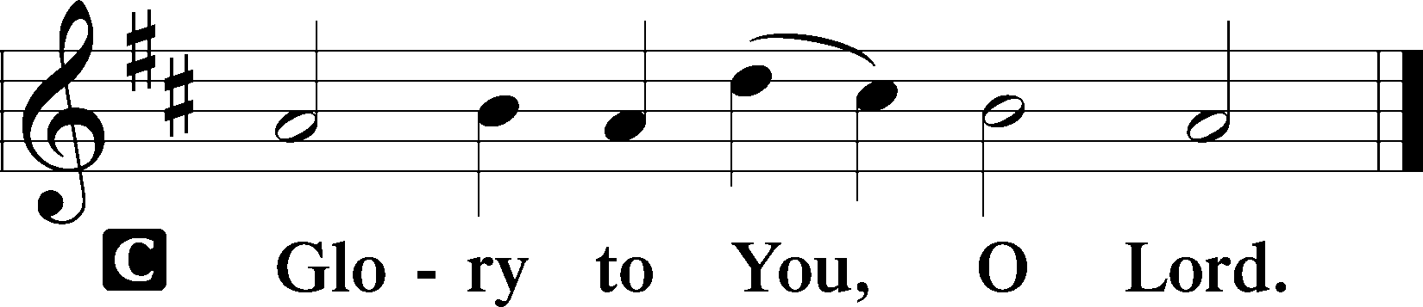

16 Then the eleven disciples went to Galilee, to the mountain where Jesus had told them to go. 17 When they saw him, they worshiped him; but some doubted. 18 Then Jesus came to them and said, “All authority in heaven and on earth has been given to me. 19 Therefore go and make disciples of all nations, baptizing them in the name of the Father and of the Son and of the Holy Spirit, 20 and teaching them to obey everything I have commanded you. And surely I am with you always, to the very end of the age.”

P This is the Gospel of the Lord.
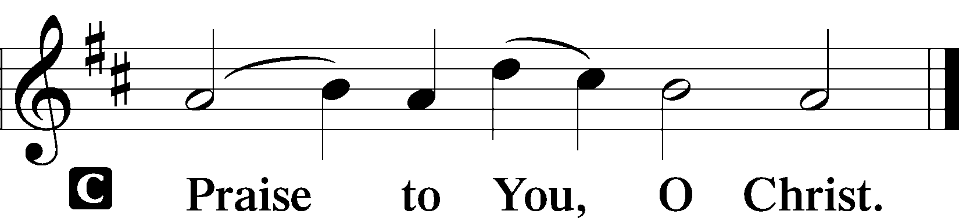

Sit
Hymn of the Day LSB 979 sts. 1-4
“God, Whose Almighty Word”
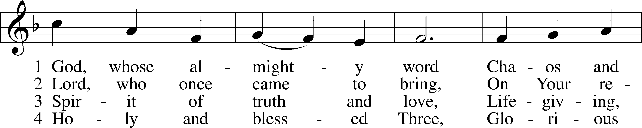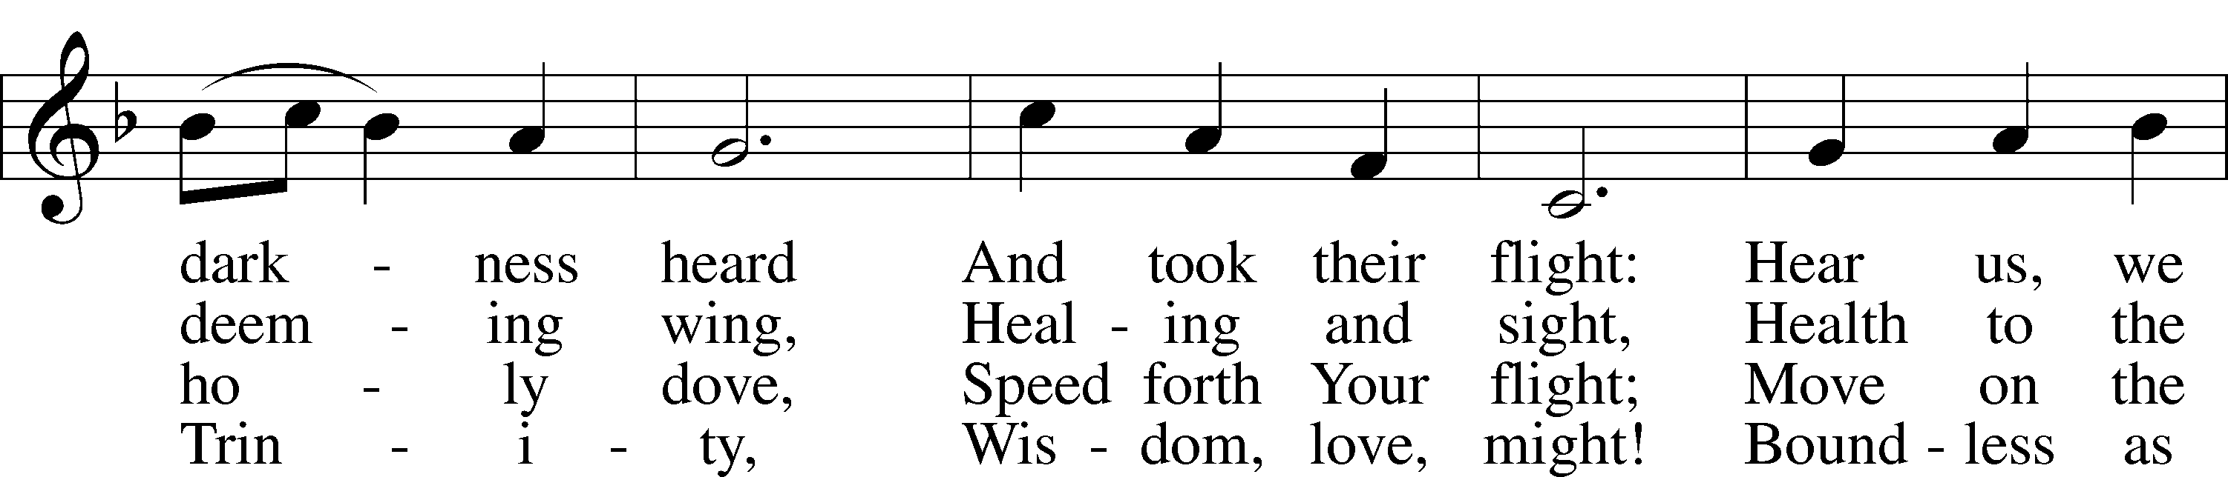
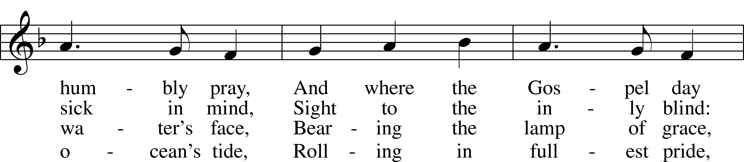
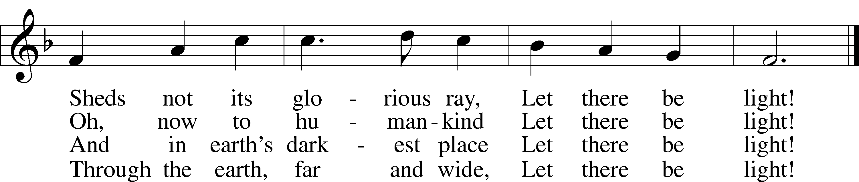
Public domain

Sermon “Words” Pastor Tom Rhodes

Stand
Athanasian Creed LSB 319
P Whoever desires to be saved must, above all, hold the catholic faith.
C Whoever does not keep it whole and undefiled will without doubt perish eternally.
P And the catholic faith is this,
C that we worship one God in Trinity and Trinity in Unity, neither confusing the persons nor dividing the substance.
P For the Father is one person, the Son is another, and the Holy Spirit is another.
C But the Godhead of the Father and of the Son and of the Holy Spirit is one: the glory equal, the majesty coeternal.
P Such as the Father is, such is the Son, and such is the Holy Spirit:
C the Father uncreated, the Son uncreated, the Holy Spirit uncreated;
P the Father infinite, the Son infinite, the Holy Spirit infinite;
C the Father eternal, the Son eternal, the Holy Spirit eternal.
P And yet there are not three Eternals, but one Eternal,
C just as there are not three Uncreated or three Infinites, but one Uncreated and one Infinite.

P In the same way, the Father is almighty, the Son almighty, the Holy Spirit almighty;
C and yet there are not three Almighties, but one Almighty.
P So the Father is God, the Son is God, the Holy Spirit is God;
C and yet there are not three Gods, but one God.
P So the Father is Lord, the Son is Lord, the Holy Spirit is Lord;
C and yet there are not three Lords, but one Lord.
P Just as we are compelled by the Christian truth to acknowledge each distinct person as God and Lord, so also are we prohibited by the catholic religion to say that there are three Gods or Lords.
C The Father is not made nor created nor begotten by anyone.

P The Son is neither made nor created, but begotten of the Father alone.
C The Holy Spirit is of the Father and of the Son, neither made nor created nor begotten, but proceeding.
P Thus, there is one Father, not three Fathers; one Son, not three Sons; one Holy Spirit, not three Holy Spirits.
C And in this Trinity none is before or after another; none is greater or less than another;
P but the whole three persons are coeternal with each other and coequal, so that in all things, as has been stated above, the Trinity in Unity and Unity in Trinity is to be worshiped.
C Therefore, whoever desires to be saved must think thus about the Trinity.
P But it is also necessary for everlasting salvation that one faithfully believe the incarnation of our Lord Jesus Christ.

C Therefore, it is the right faith that we believe and confess that our Lord Jesus Christ, the Son of God, is at the same time both God and man.
P He is God, begotten from the substance of the Father before all ages; and He is man, born from the substance of His mother in this age:
C perfect God and perfect man, composed of a rational soul and human flesh;
P equal to the Father with respect to His divinity, less than the Father with respect to His humanity.
C Although He is God and man, He is not two, but one Christ:
P one, however, not by the conversion of the divinity into flesh, but by the assumption of the humanity into God;
C one altogether, not by confusion of substance, but by unity of person.

P For as the rational soul and flesh is one man, so God and man is one Christ,
C who suffered for our salvation, descended into hell, rose again the third day from the dead,
P ascended into heaven, and is seated at the right hand of the Father, God Almighty, from whence He will come to judge the living and the dead.
C At His coming all people will rise again with their bodies and give an account concerning their own deeds.
P And those who have done good will enter into eternal life, and those who have done evil into eternal fire.
C This is the catholic faith; whoever
does not believe it faithfully and
firmly cannot be saved.

Prayer of the Church LSB 175
P O blessed and holy Trinity, the Father, Son and Holy Spirit, hear the prayers of Your people and grant to us all things according to Your Word and promise.

Brief silence

P In the beginning, Father, Your Word spoke all things into being and from nothing You made all that is. Help us to see the imprint of Your love in the goodness of creation and to exercise responsible care of all that You have entrusted to us. Lord, in Your mercy,
C hear our prayer.

P Throughout the ages, Father, Your Spirit filled the sin-stained world with hope and called us to repentance and faith. Help us to hear the voice of Your Word and to respond with faith, confessing You without fear before all manner of people and in every corner of the earth. Lord, in Your mercy,
C hear our prayer.

P In government and law, Father, You work to establish and preserve order, protect the weak and foster godly virtue. Bless our president; our governor; and all who make, administer, and judge our laws. Deliver the world from the threats of pandemic and tyranny, and preserve the nations in peace. Bless all who defend us in the armed forces and aid us in emergency and medical fields. Stop those who oppress any peoples by deceit, violence, or fear. Lord, in Your mercy,
C hear our prayer.

P In the hour of trial and trouble, You are there, Father. Hear us for the sake of Jesus on behalf of the sick, the troubled in mind, the wounded in heart and those who grieve, especially those on our prayer list and cards. Deliver them as You will, and sustain with patience and strength. Lord, in Your mercy,
C hear our prayer.

P In the company of the saints, Father, You have shown that You will not abandon Your people. Receive our thanks for those who have gone before us in faith and now rest from their labors, and bring us also with them in Your eternal presence. Lord, in Your mercy,
C hear our prayer.

P All these things and whatever else You know we need, we pray You to grant us, Father, for the sake of our Savior Jesus Christ, through whom, with whom and in whom, in the unity of the Holy Spirit, all honor and glory are Yours, almighty Father, both now and forevermore.
C Amen.

Offering LSB 176
In quiet devotion and responding in personal stewardship of God’s abundant provision to you, please use the offering plates in the back as you enter or exit. (This is just as it says: An offering to God through His church. As a reassurance to those in worship today, especially our guests - this is not an obligation - the good news of Jesus is free to all!)

Stewardship Prayer
P C O God, You have supplied Your people with many and rich resources with which to support the work of Your Church. Grant to Your Church all things needful, that Your saving purpose in Christ may be realized and Your Word may bring many into the fellowship of Your Church. Accept, we pray, the tithes and offerings we bring, that through these treasures Your work may not be hindered by any lack or need. Lord, in Your mercy, hear our prayer, Amen.

Offertory Psalm 116:12-13, 17-19; LSB 176
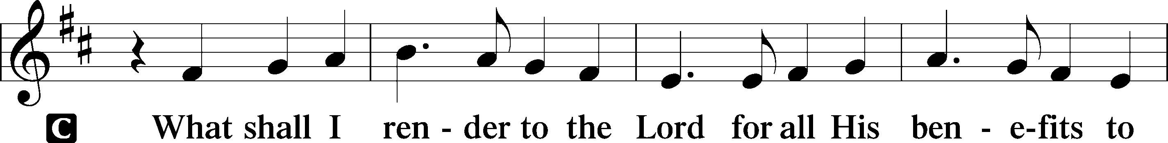
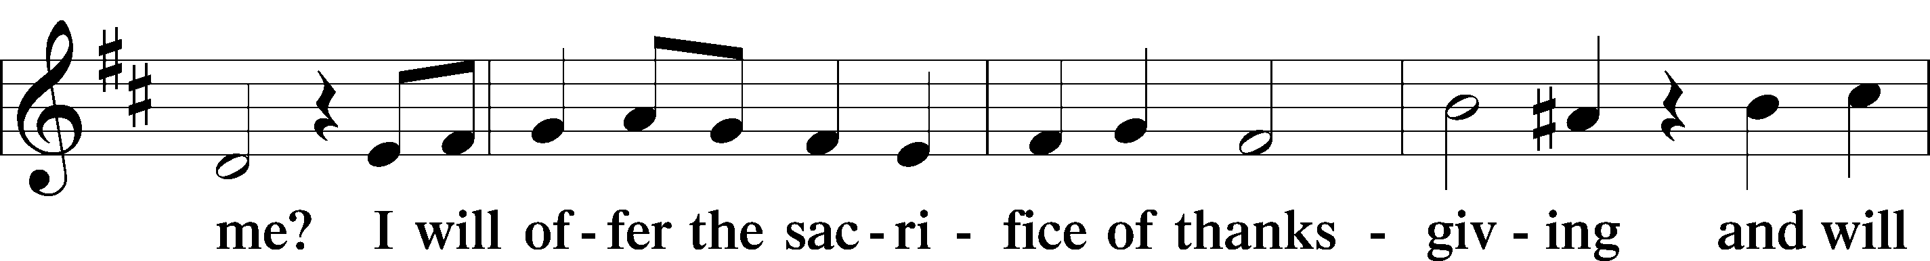
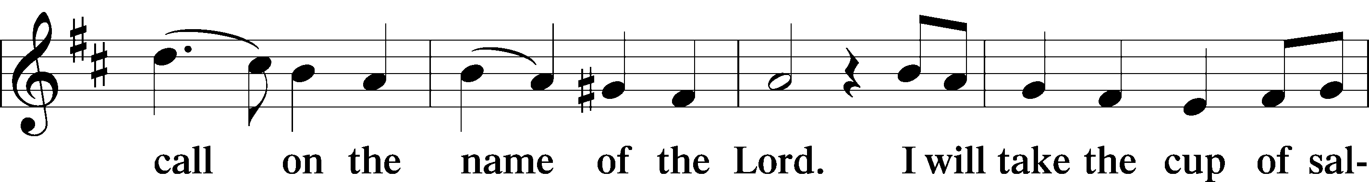
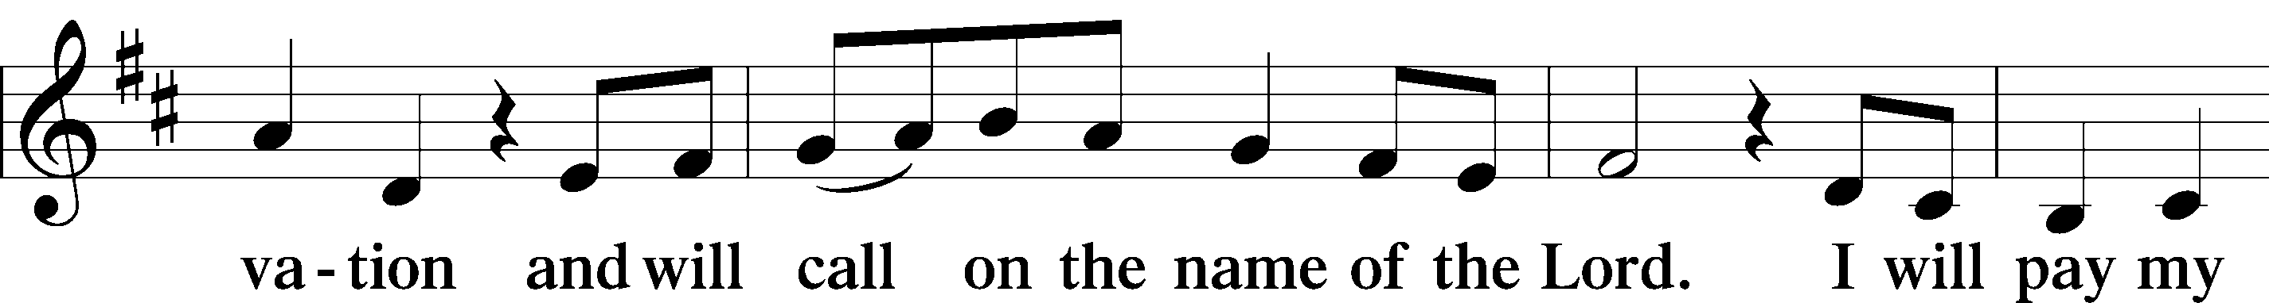
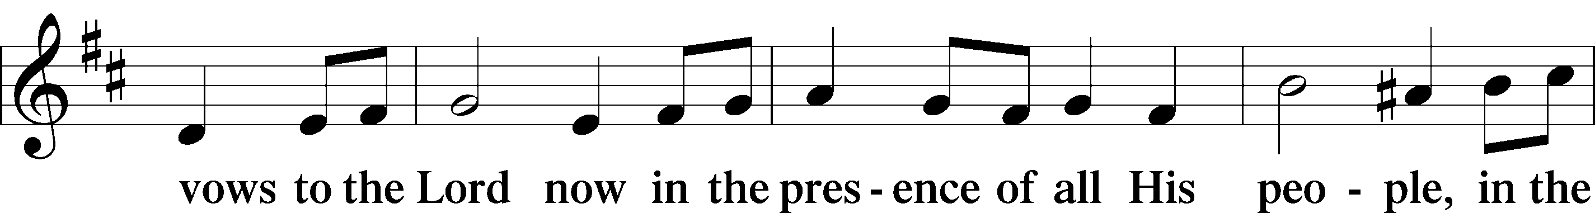
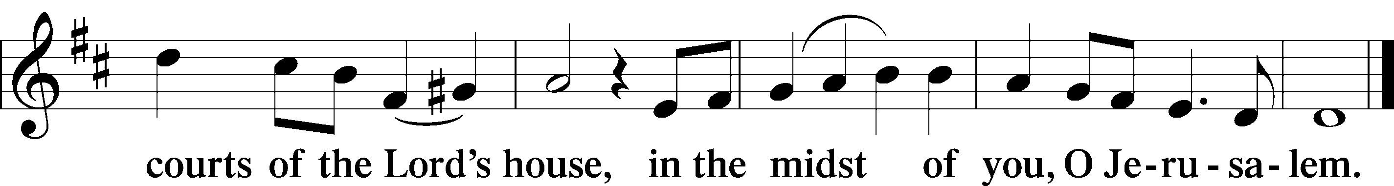

+ SERVICE OF THE SACRAMENT + LSB 177
Preface
P The Lord be with you.
C And also with you.

P Lift up your hearts.
C We lift them to the Lord.
P Let us give thanks to the Lord our God.
C It is right to give Him thanks and
praise.
P It is truly good, right, and salutary that we should at all times and in all places give thanks to You, holy Lord, almighty Father, everlasting God, who with Your only-begotten Son and the Holy Spirit are one God, one Lord. In the confession of the only true God, we worship the Trinity in person and the Unity in substance, of majesty coequal. Therefore with angels and archangels and with all the company of heaven we laud and magnify Your glorious name, evermore praising You and saying:

Sanctus Isaiah 6:3, Matthew 21:9; LSB 178
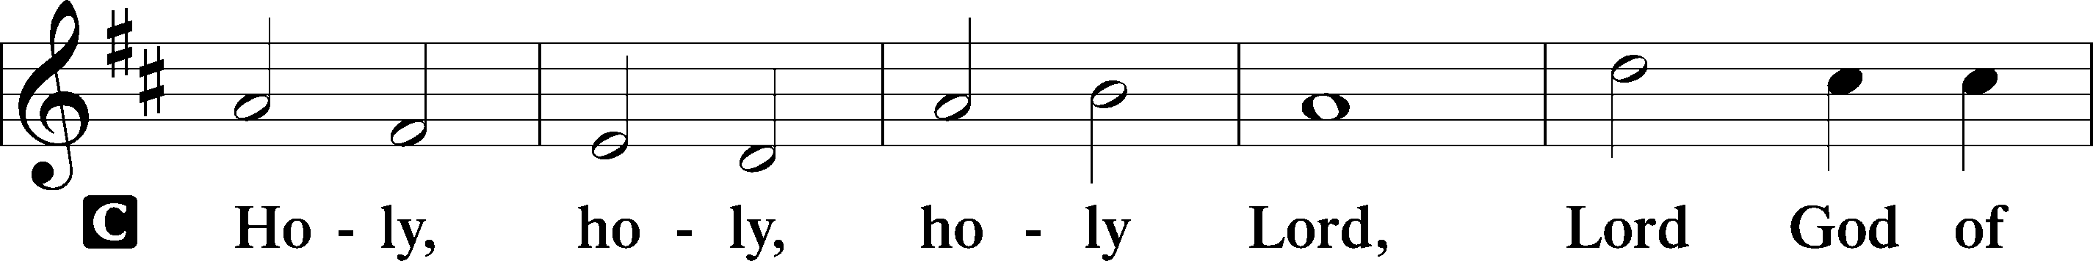
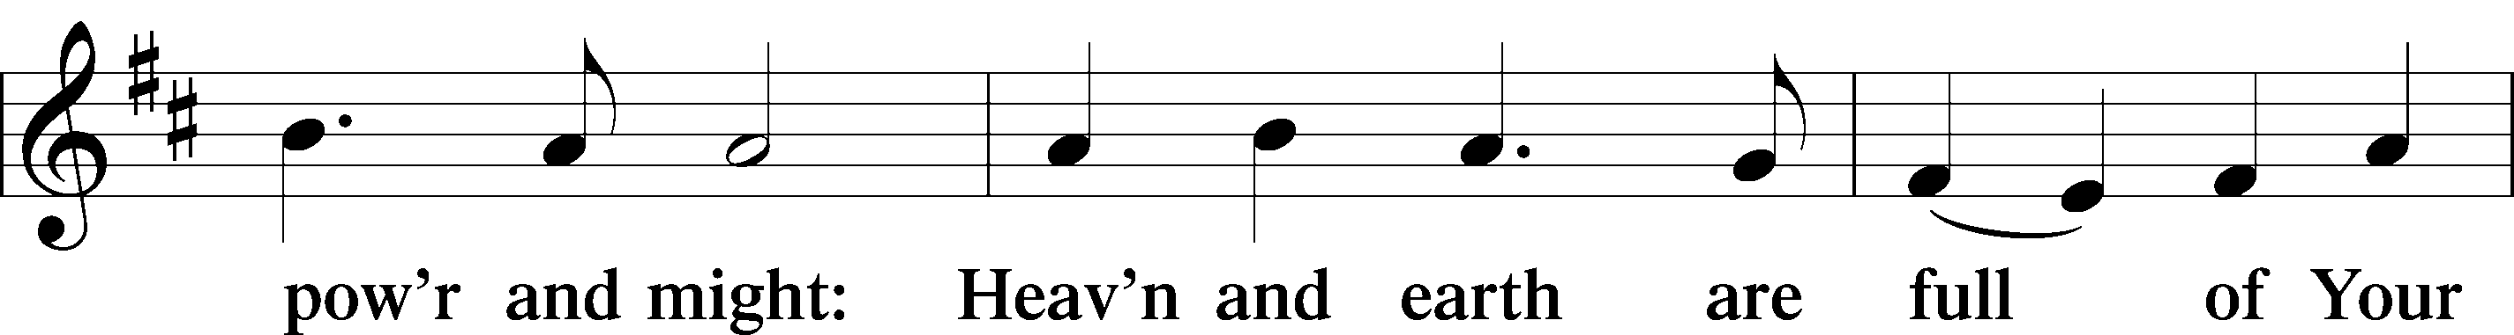
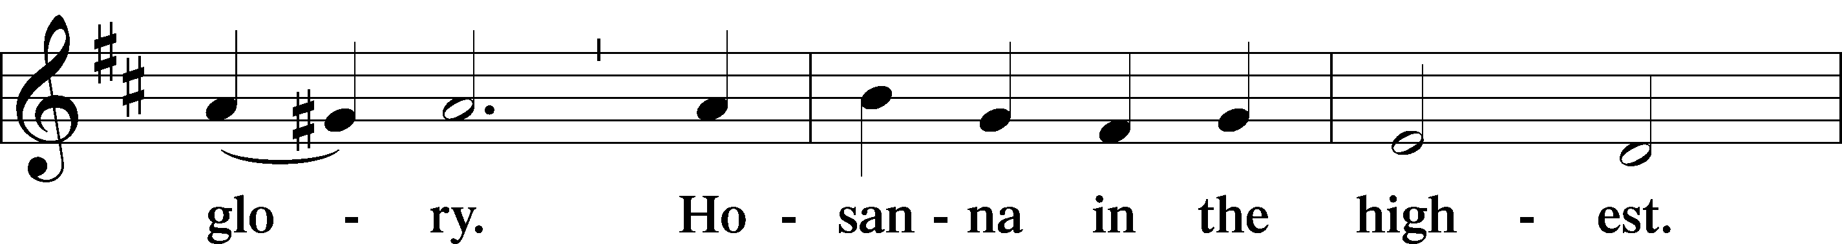
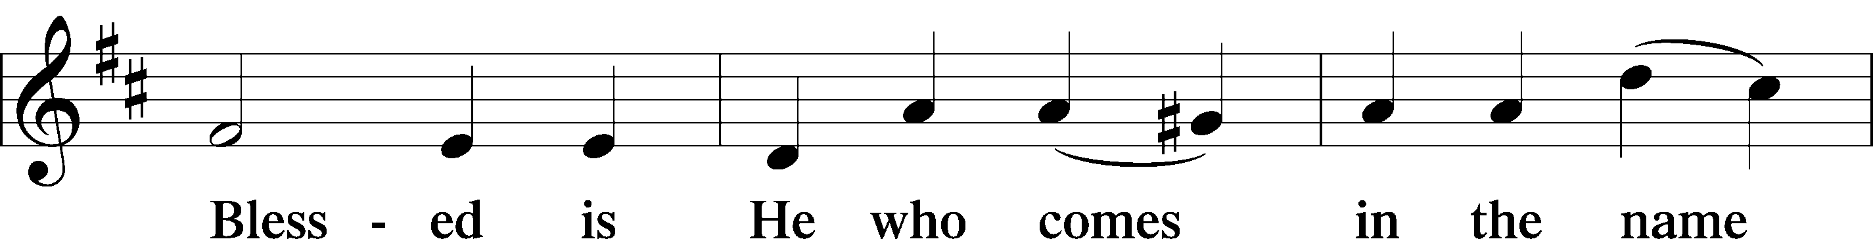
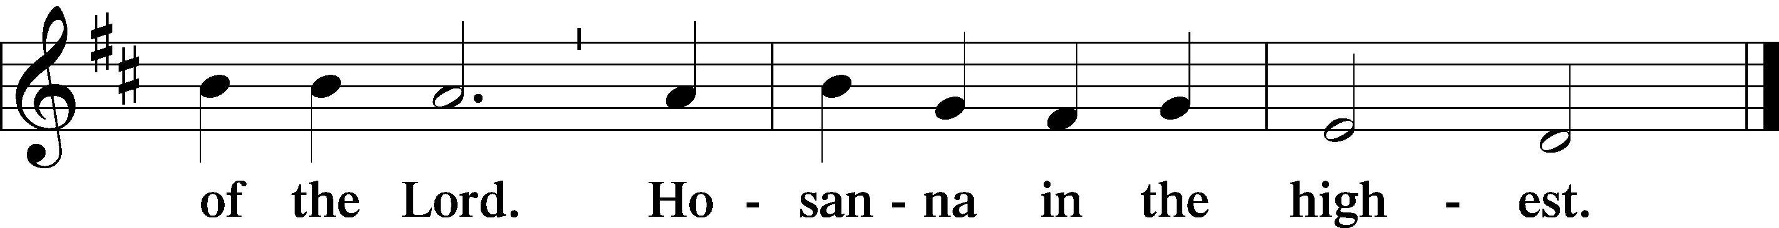

Prayer of Thanksgiving LSB 178
P Blessed are You, Lord of heaven and earth, for You have had mercy on those whom You created and sent Your only-begotten Son into our flesh to bear our sin and be our Savior. With repentant joy we receive the salvation accomplished for us by the all-availing sacrifice of His body and His blood on the cross.

Gathered in the name and the remembrance of Jesus, we beg You, O Lord, to forgive, renew, and strengthen us with Your Word and Spirit. Grant us faithfully to eat His body and drink His blood as He bids us do in His own testament. Gather us together, we pray, from the ends of the earth to celebrate with all the faithful the marriage feast of the Lamb in His kingdom, which has no end.

Graciously receive our prayers; deliver and preserve us. To You alone, O Father, be all glory, honor, and worship, with the Son and the Holy Spirit, one God, now and forever.
C Amen.

Lord's Prayer Matthew 6:9-13, LSB 179
P Lord, remember us in Your kingdom and teach us to pray:

C Our Father who art in heaven,
hallowed be Thy name,
Thy kingdom come,
Thy will be done on earth
as it is in heaven;
give us this day our daily bread;
and forgive us our trespasses
as we forgive those
who trespass against us;
and lead us not into temptation,
but deliver us from evil.
For Thine is the kingdom
and the power and the glory
forever and ever. Amen.

The Words of Our Lord LSB 179
P Our Lord Jesus Christ, on the night when He was betrayed, took bread, and when He had given thanks, He broke it and gave it to the disciples and said: “Take, eat; this is My  body, which is given for you. This do in remembrance of Me.”

P In the same way also He took the cup after supper, and when He had given thanks, He gave it to them, saying: “Drink of it, all of you; this cup is the new testament in My  blood, which is shed for you for the forgiveness of sins. This do, as often as you drink it, in remembrance of Me.”

Pax Domini John 20:19, LSB 180
P The peace of the Lord be with you
always.
C Amen.

Agnus Dei John 1:29, LSB 180
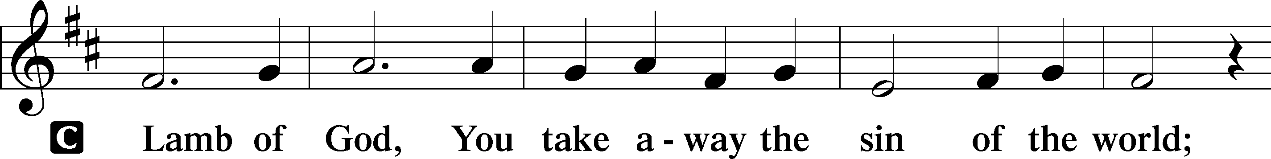
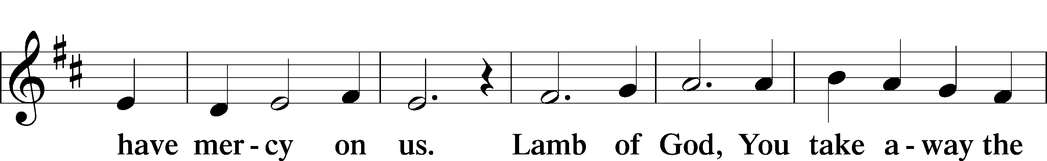
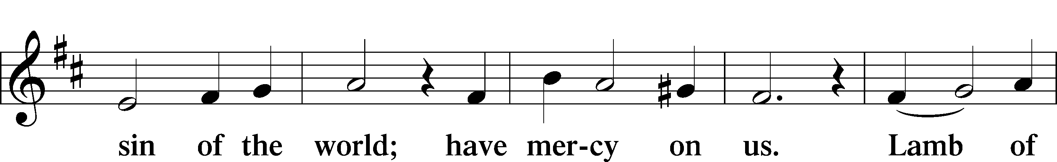
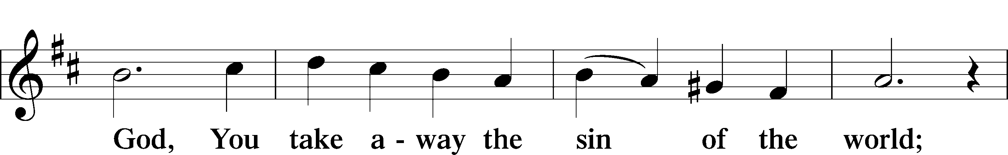
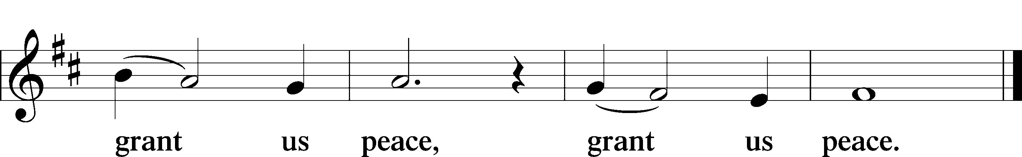

Sit

DISTRIBUTION

Distribution Hymn LSB 394 sts. 1-5
“Songs of Thankfulness and Praise”
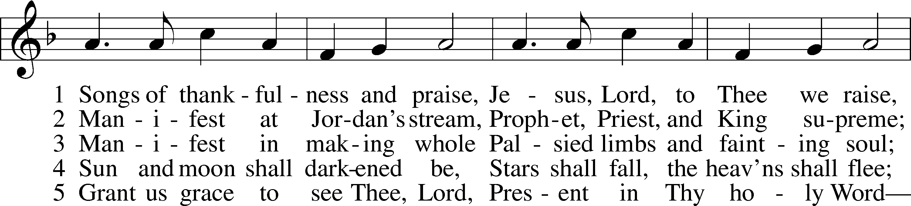
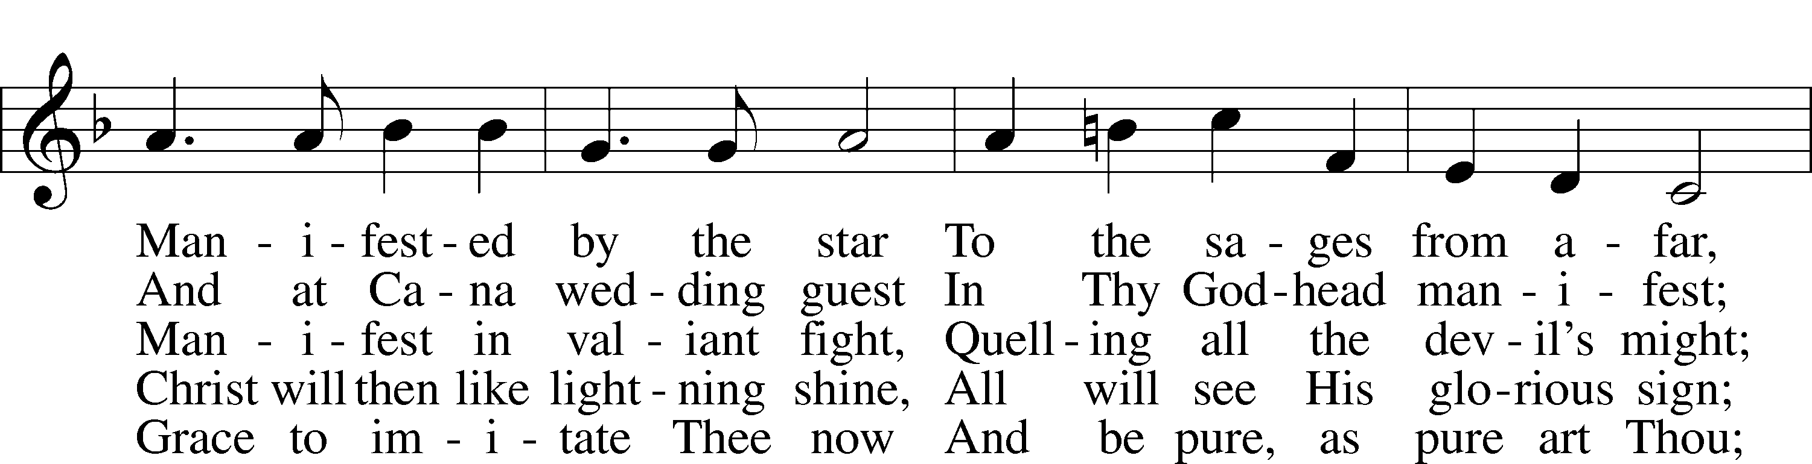
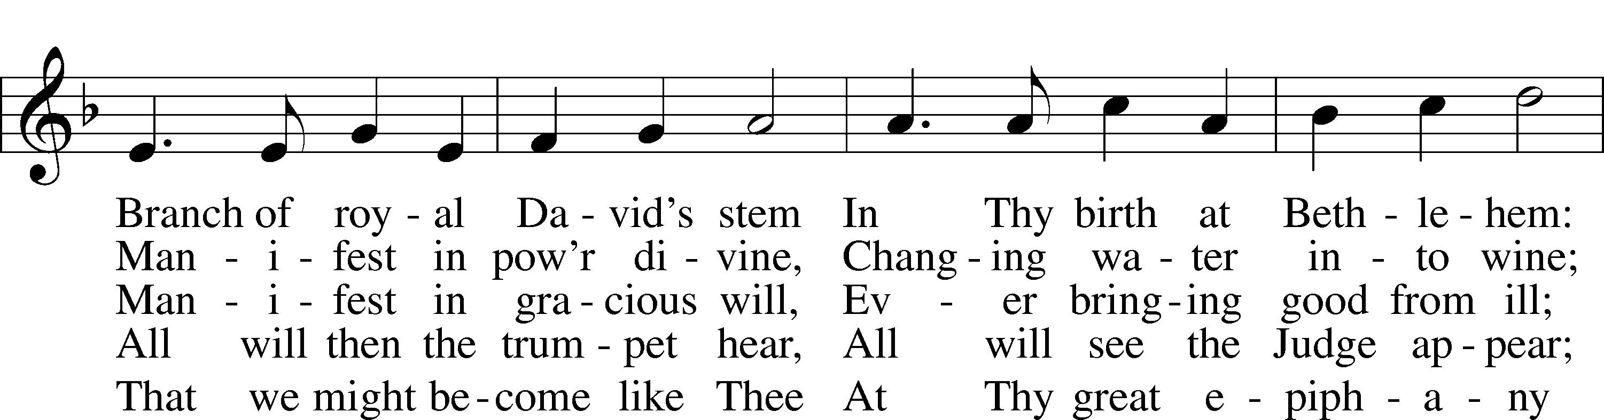
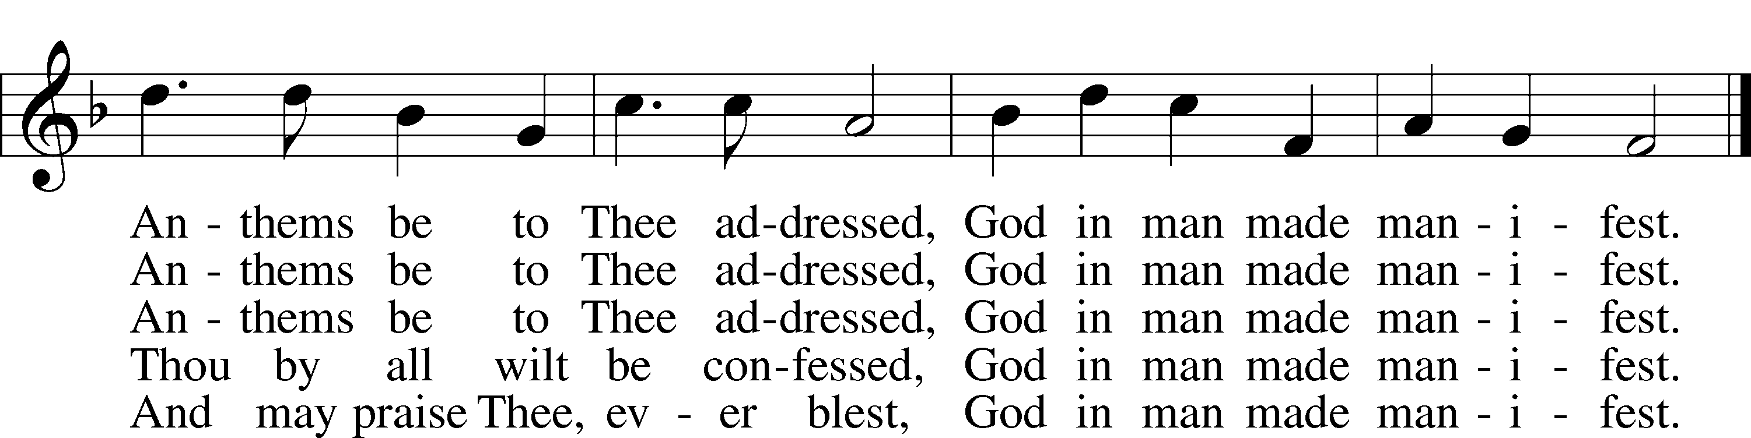

Public domain

Distribution Hymn LSB 411 sts. 1-3
“I Want to Walk as a Child of the Light”
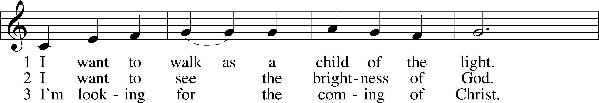
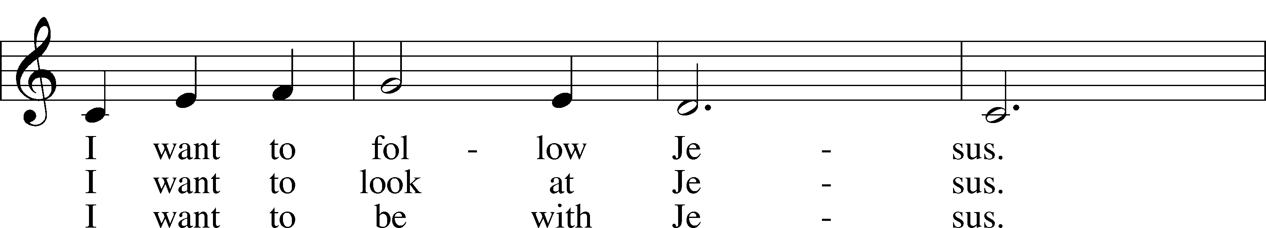
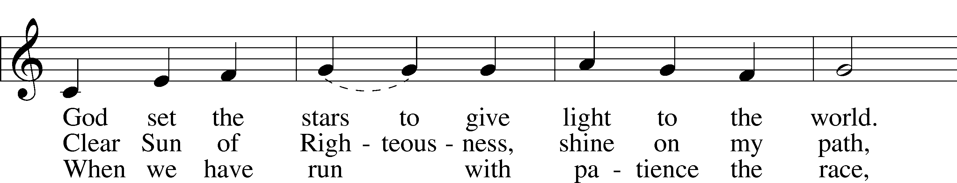
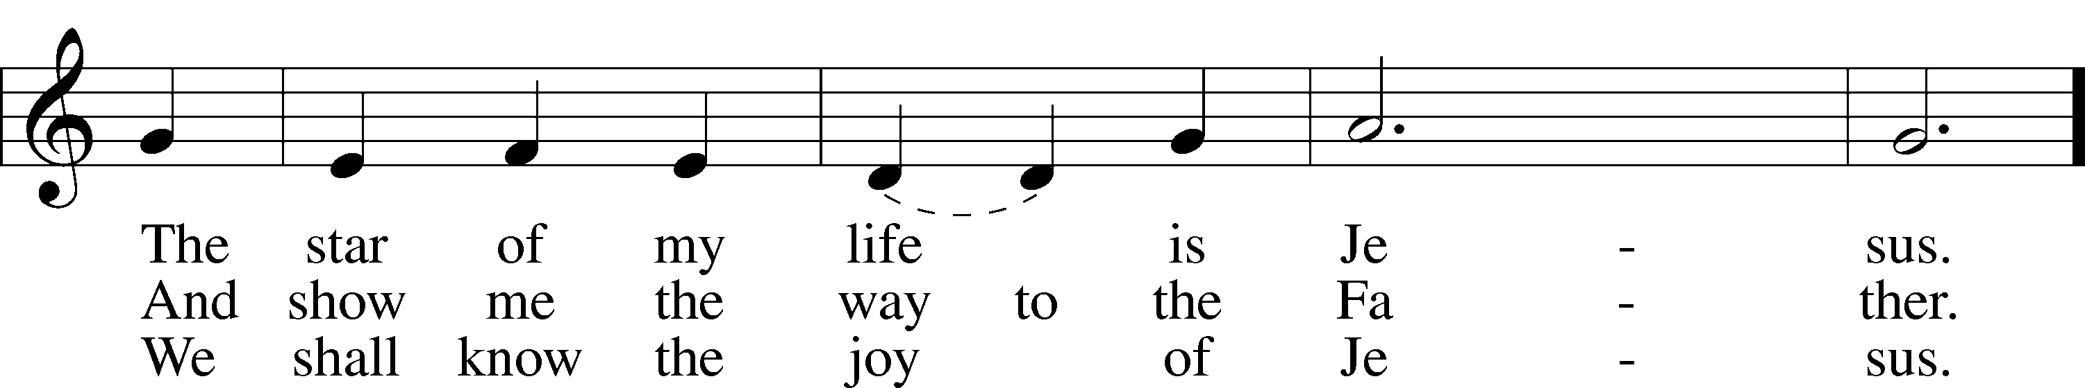
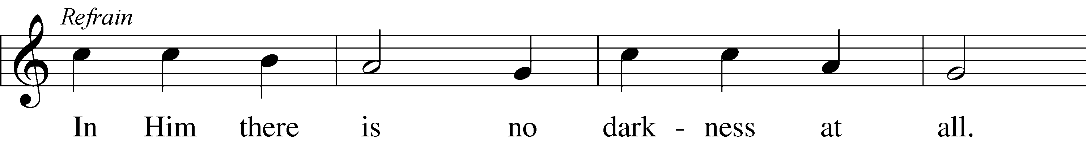
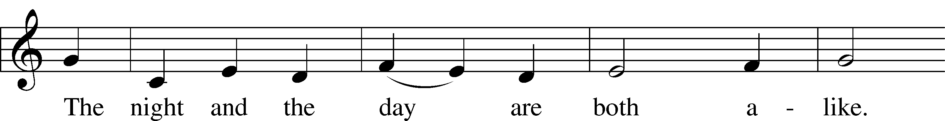
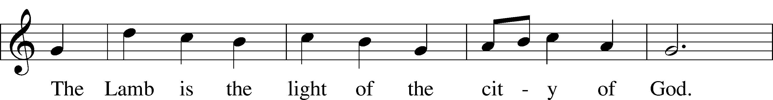
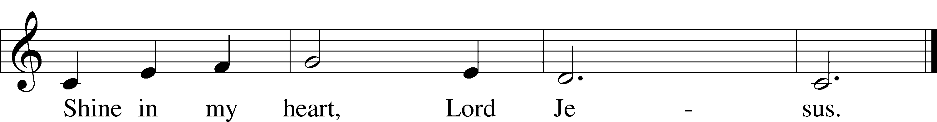
© 1970, 1975 Celebration. Used by permission: LSB Hymn License .NET, no. 100011462.

Stand
Post-Communion Canticle
Thank the Lord LSB 181
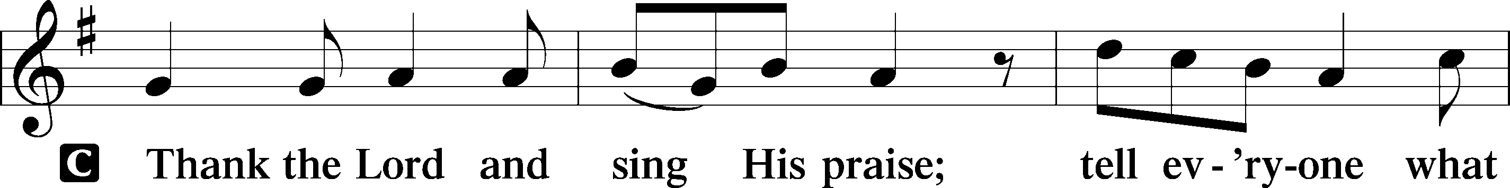
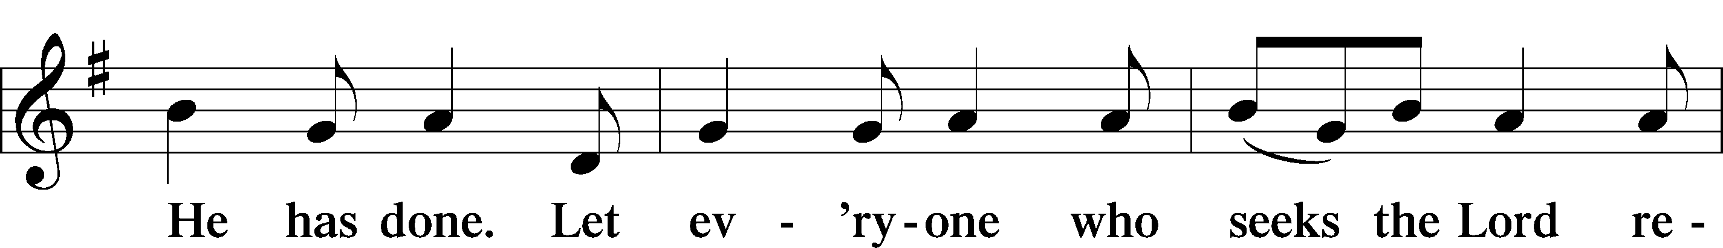
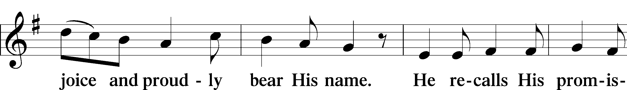
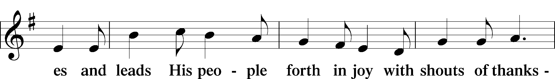
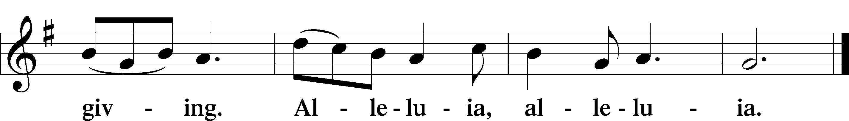

Post-Communion Collect LSB 183
P Let us pray.
P Gracious God, our heavenly Father, You have given us a foretaste of the feast to come in the Holy Supper of Your Son's body and blood. Keep us firm in the true faith throughout our days of pilgrimage that, on the day of His coming, we may, together with all Your saints, celebrate the marriage feast of the Lamb in His kingdom which has no end; through Jesus Christ, Your Son, our Lord, who lives and reigns with You and the Holy Spirit, one God, now and forever.
C Amen.

Benediction Numbers 6:24-26, LSB 183
P The Lord bless you and keep you. The Lord make His face shine on you and be gracious to you. The Lord look upon you with favor and  give you peace.
C Amen.

Closing Hymn LSB 506 sts. 1-2, 4
“Glory Be to God the Father”
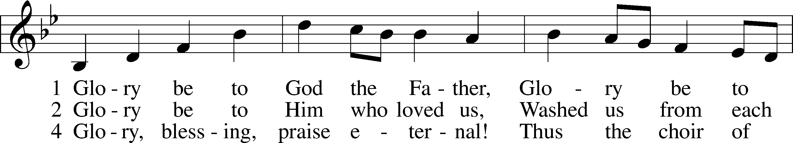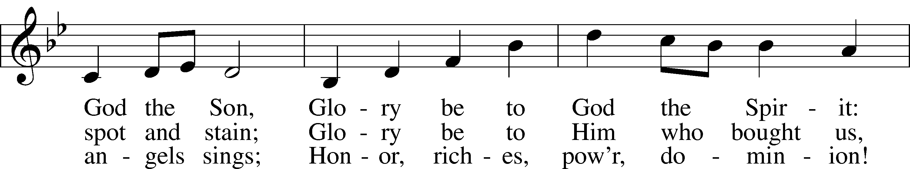
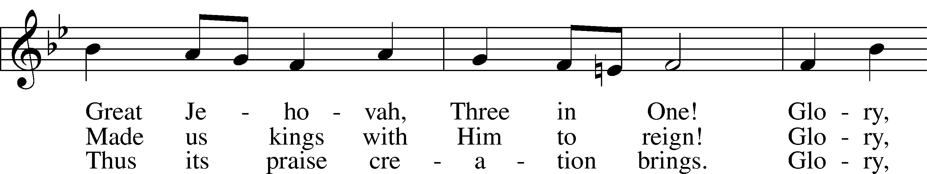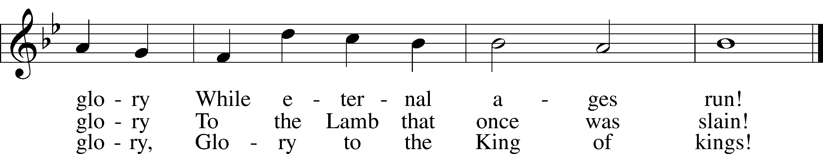

Public domain

