Zion Lutheran Church
‘Hearing, Sharing and Living the Gospel.’

Zion Lutheran Church
Our mission is to hear and share the good news of the risen Jesus and, with God’s help, to live the Gospel.

Fourth Sunday after Pentecost
June 28, 2020 10:30 a.m. Service

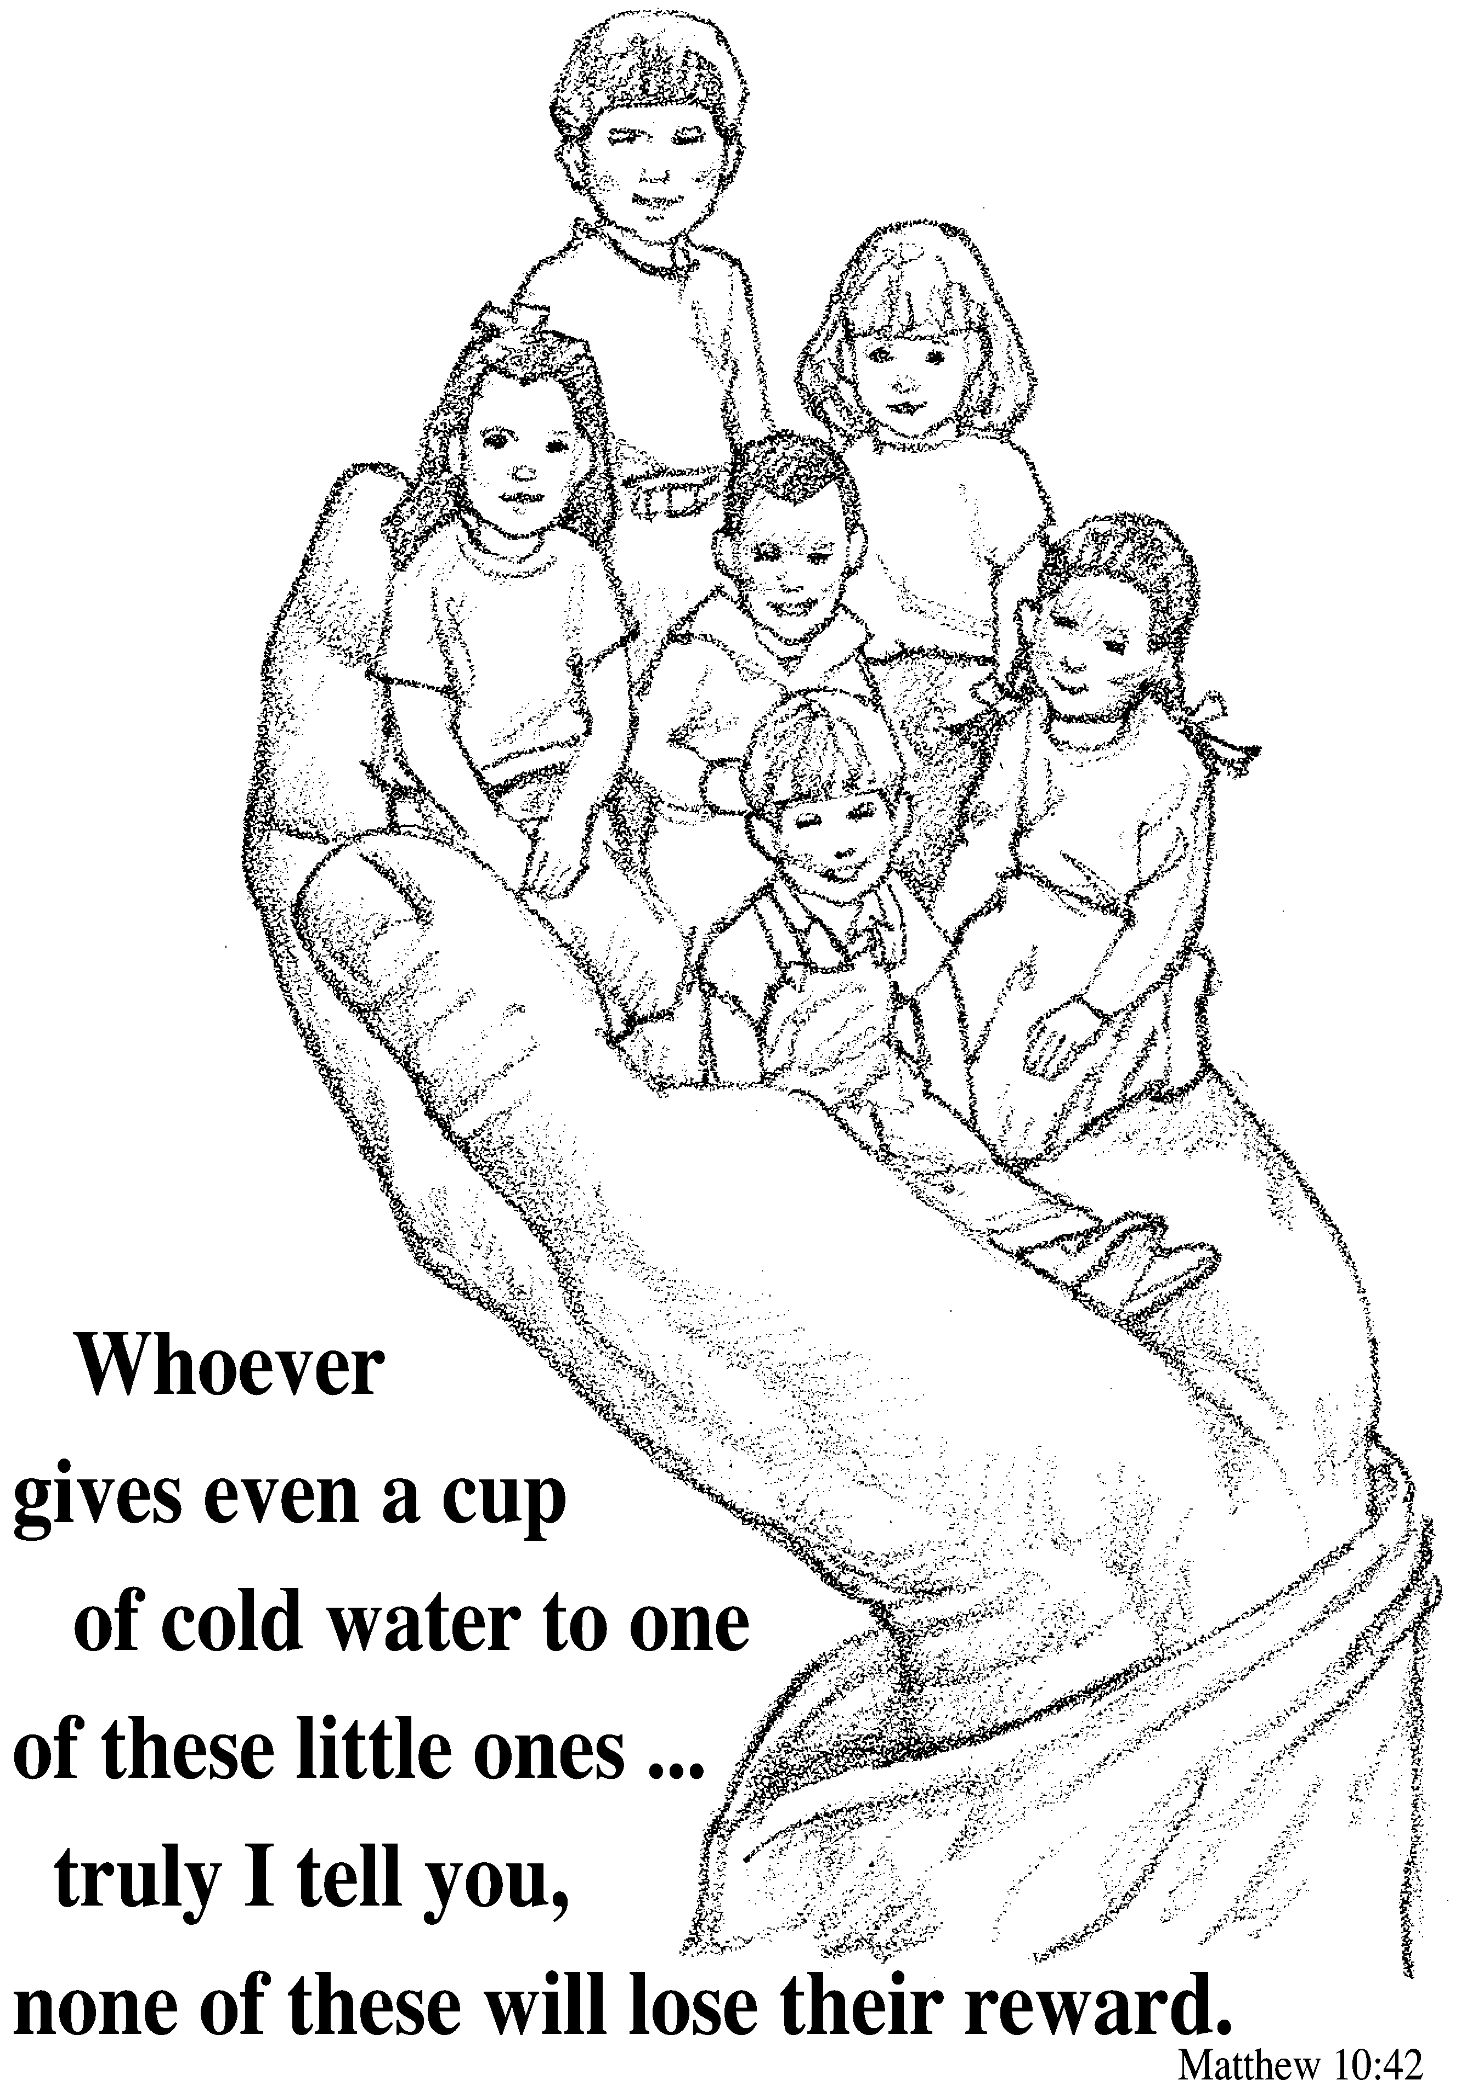

Zion Lutheran Church

‘Hearing, Sharing and Living the Gospel’
Rev. Thomas A. Rhodes, Pastor
PO Box 5 • 600 East Aldrich Road • Bolivar, MO 65613
Phone: 417-326-5506 • www.zionlutheranbolivar.org
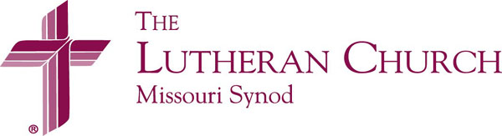
zionbolivar@windstream.net

Administrative Assistant – Sonya Gorman
You are invited to use the yellow Prayer Cards located in the pew for prayer requests. Please hand this card to an usher or place it in the offering plate.
* Please turn off cellphones*

FOURTH SUNDAY AFTER PENTECOST
Divine Service – Setting One
June 28, 2020 10:30 a.m.

Welcome & Announcements

+ INVOCATION + LSB 151
The sign of the cross may be made by all in remembrance of their Baptism.
P We begin in the name into which we are baptized; In the name of the Father and of the  Son and of the Holy Spirit.
C Amen.

Opening Hymn LSB 851 sts. 1-4
“Lord of Glory, You Have Bought Us”
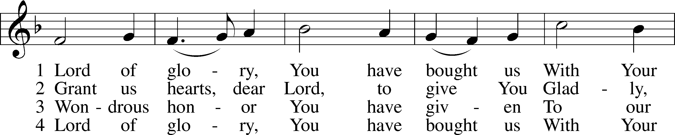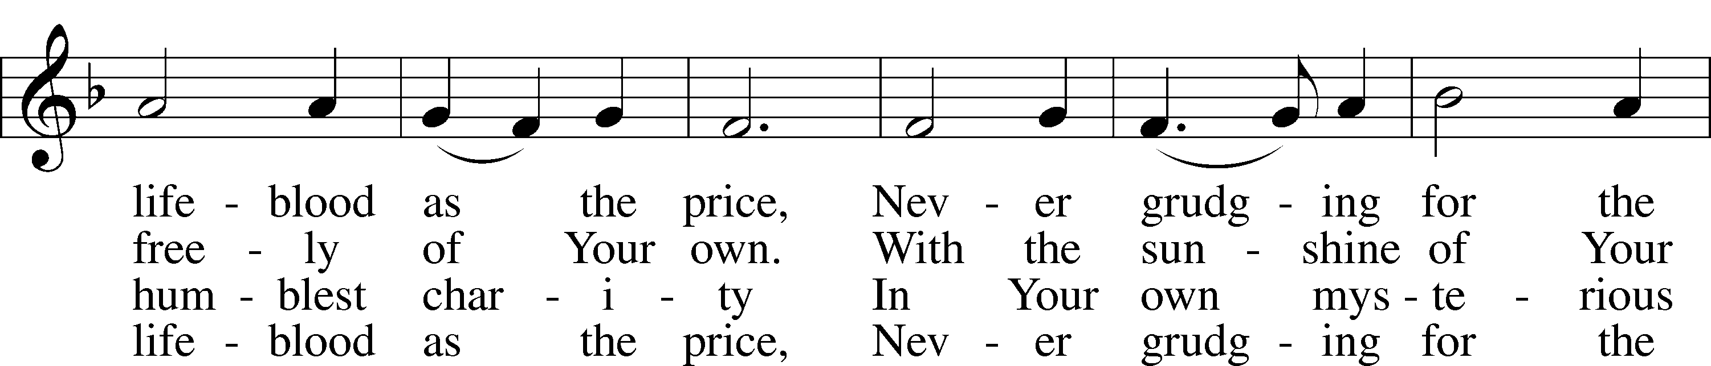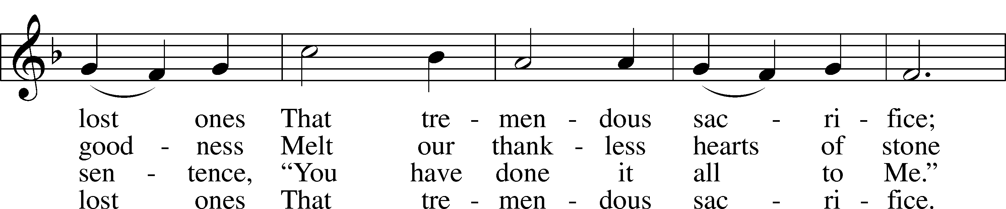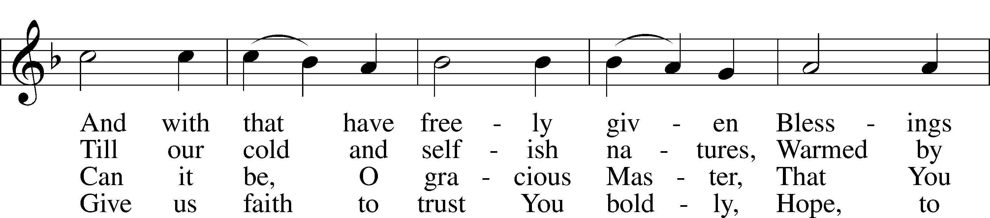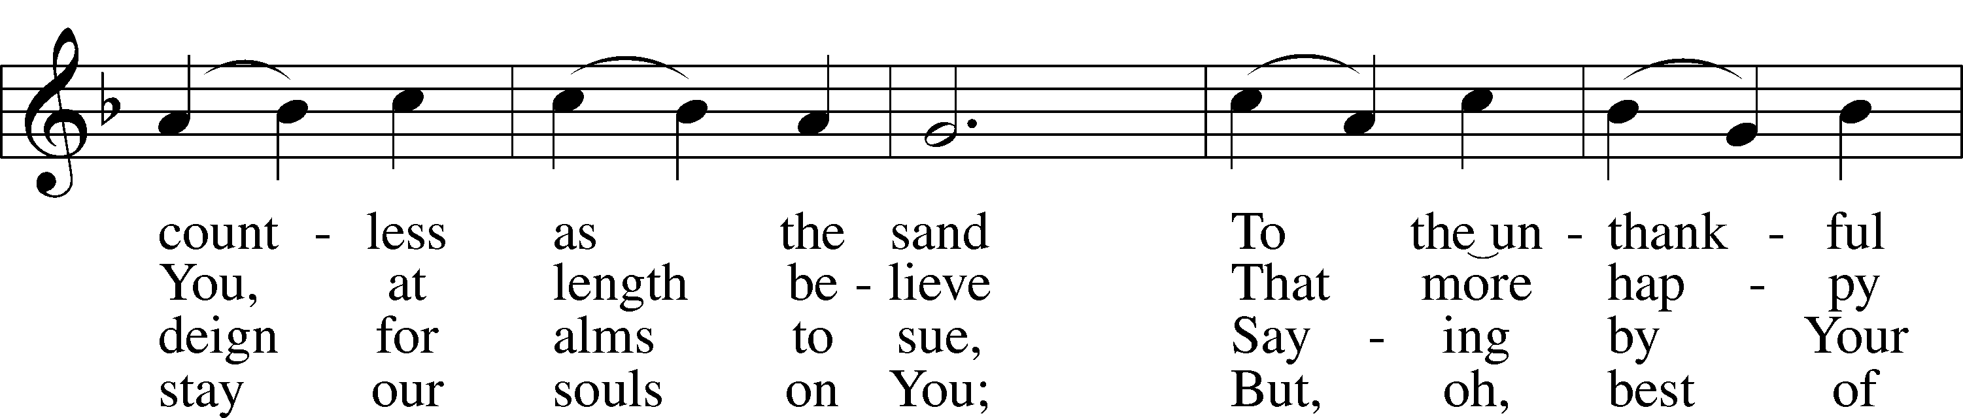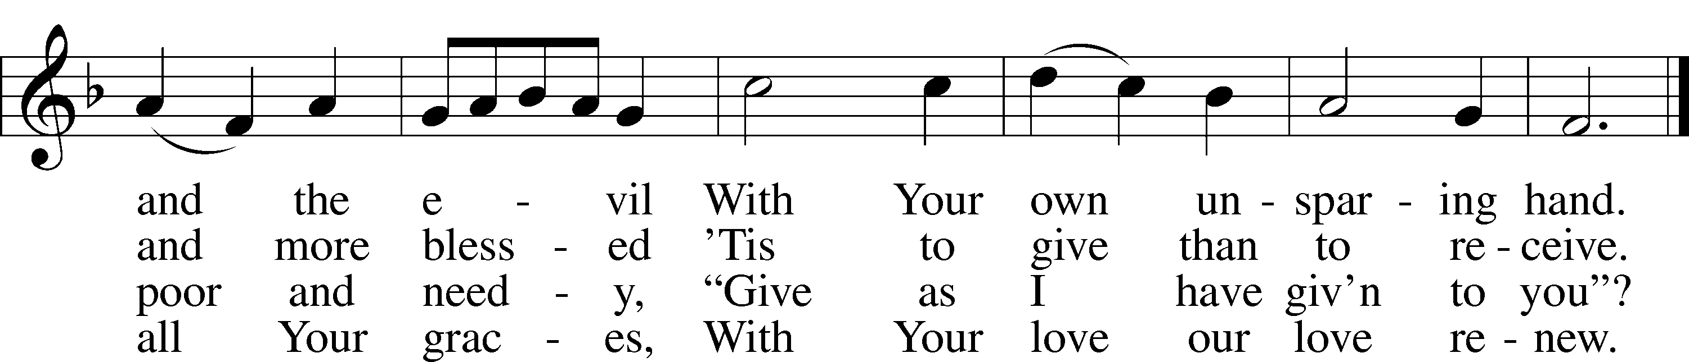
Public domain

Stand
+ CONFESSION AND ABSOLUTION + LSB 151
P If we say we have no sin, we deceive ourselves, and the truth is not in us.
C But if we confess our sins, God, who is faithful and just, will forgive our sins and cleanse us from all unrighteousness.

(Silence for reflection on God's Word and for self-examination in light of the Ten Commandments.)

P Let us then confess our sins to God our Father.
C Most merciful God, we confess that we are by nature sinful and unclean. We have sinned against You in thought, word, and deed, by what we have done and by what we have left undone. We have not loved You with our whole heart; we have not loved our neighbors as ourselves. We justly deserve Your present and eternal punishment. For the sake of Your Son, Jesus Christ, have mercy on us. Forgive us, renew us, and lead us, so that we may delight in Your will and walk in Your ways to the glory of Your holy name. Amen.
P God be merciful to you and strengthen your faith. LSB 292
C Amen.
P Do you believe that my forgiveness is God’s forgiveness?
C Yes. LSB 293
P Let it be done for you as you believe.
P Almighty God in His LSB 151
mercy has given His Son to
die for you and for His sake forgives you all your sins. As a called and ordained servant of Christ, and by His authority, I therefore forgive you all your sins in the name of the Father and of the  Son and of the Holy Spirit.
C Amen.

+ SERVICE OF THE WORD + LSB 152
Introit Ps. 89:15-18; antiphon: Ps.89:1
P I will sing of the steadfast love of the Lord, forever; with my mouth I will make known your faithfulness to all generations.
C Blessed are the people who know the festal shout, who walk, O Lord, in the light of your face,
P who exult in your name all the day and in your righteousness are exalted.
C For you are the glory of their strength; by your favor our horn is exalted.
P For our shield belongs to the Lord, our king to the Holy One of Israel.
P C Glory be to the Father and to the Son and to the Holy Spirit; as it was in the beginning, is now, and will be forever. Amen.
P I will sing of the steadfast love of the Lord, forever; with my mouth I will make known your faithfulness to all generations.

Kyrie LSB 152
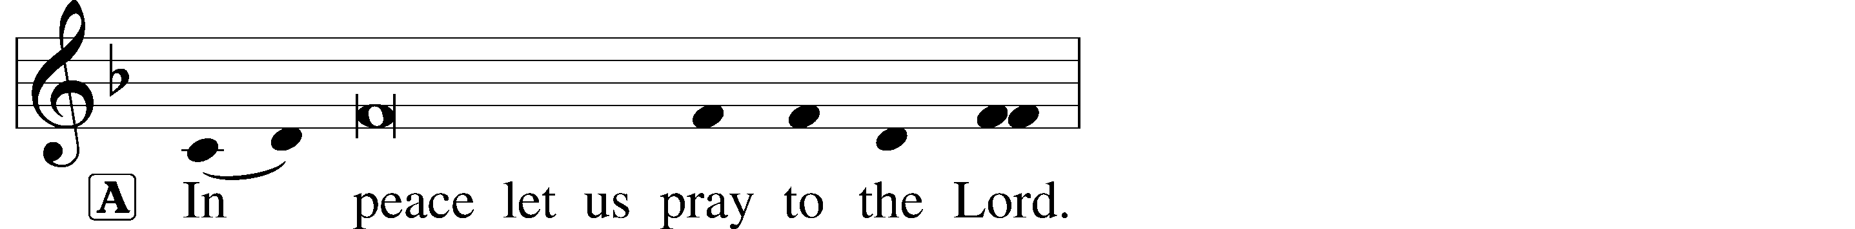
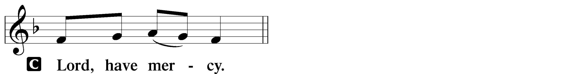
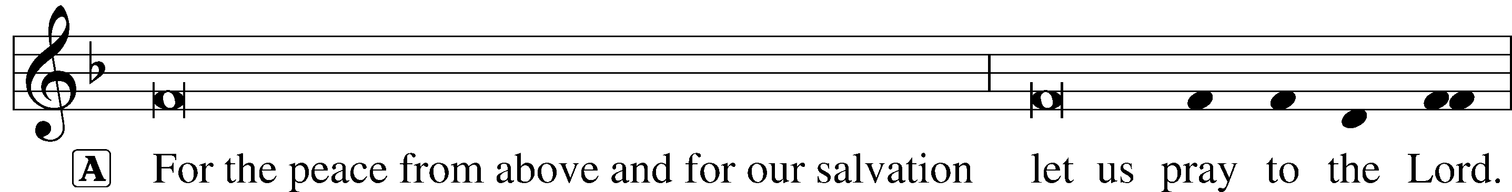
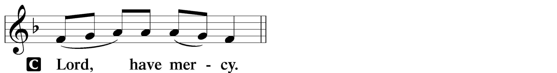
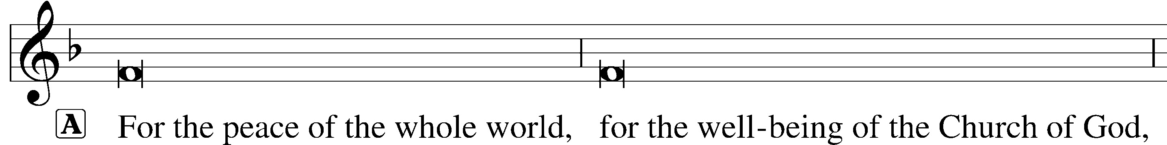

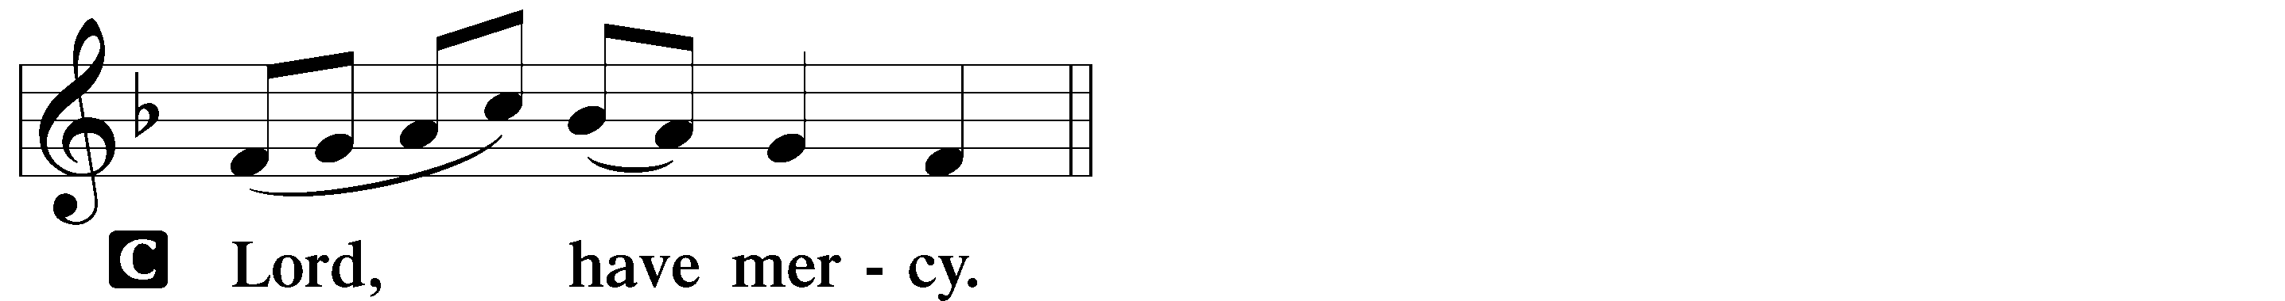
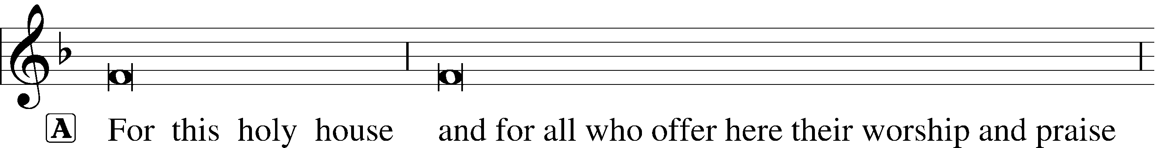
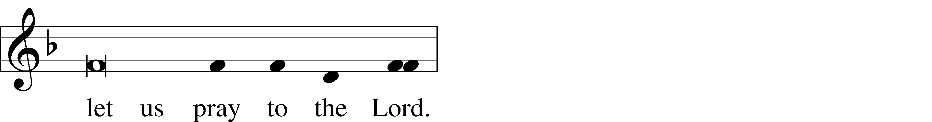
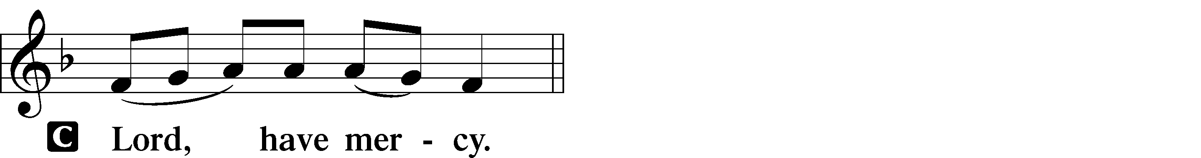
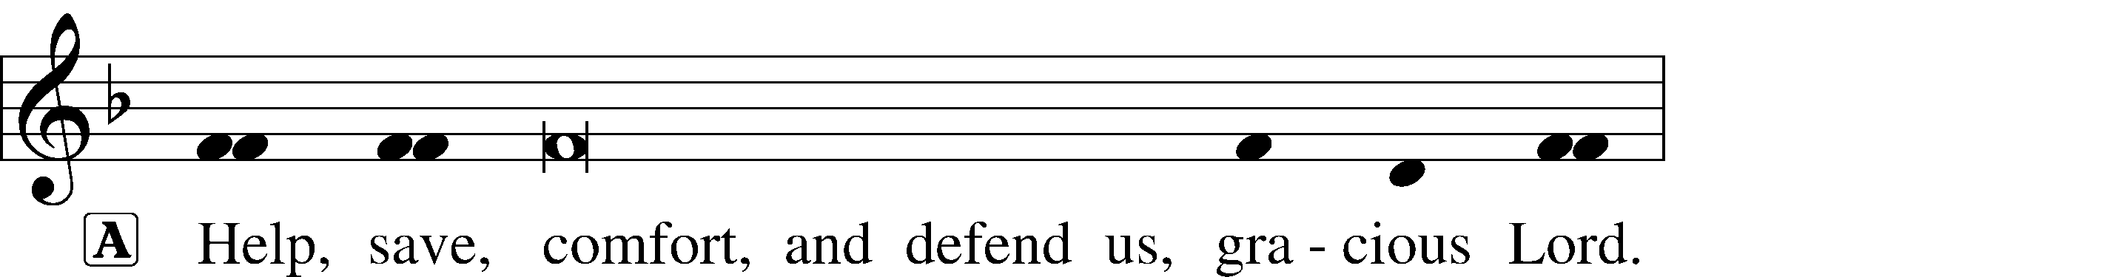


Hymn of Praise/Gloria in Excelsis LSB 154
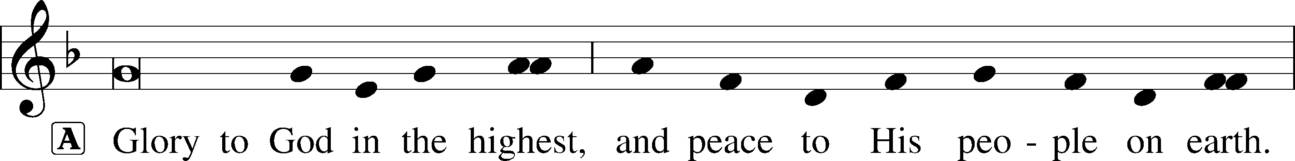
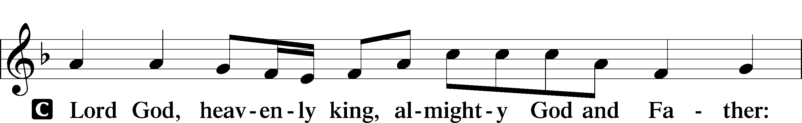
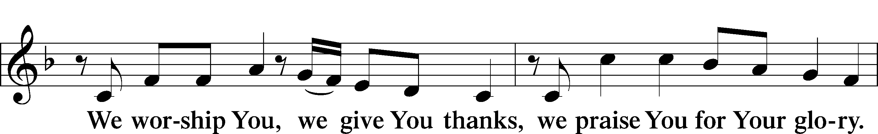
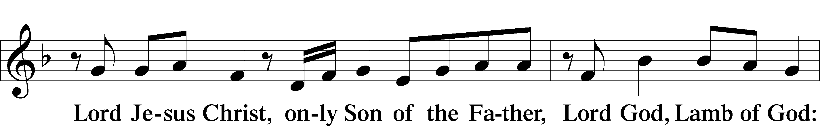
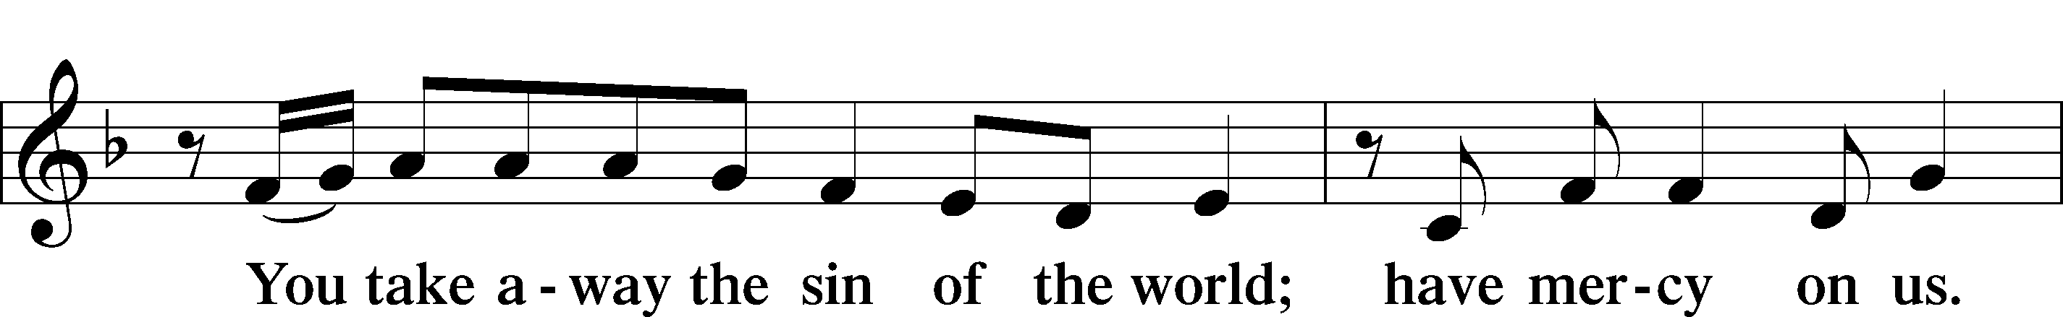
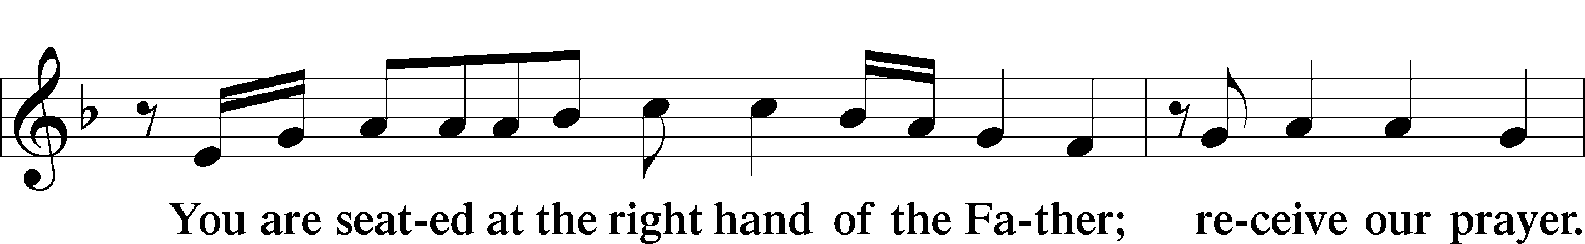
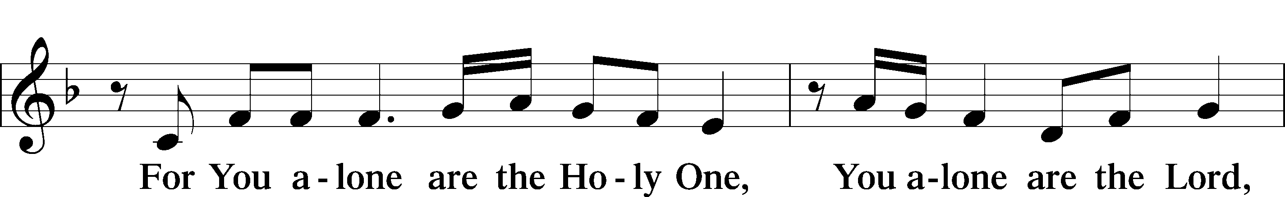
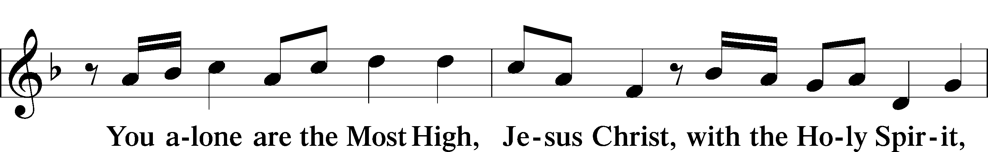
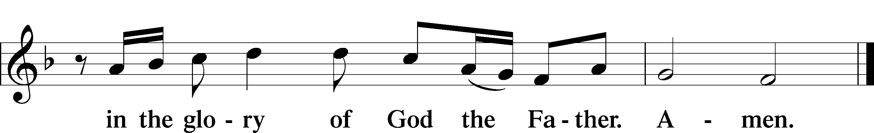

Salutation and Collect of the Day LSB 156
P The Lord be with you.
C And also with you.
P Let us pray. Almighty God, by the working of Your Holy Spirit, grant that we may gladly hear Your Word proclaimed among us and follow its directing; through Jesus Christ, Your Son, our Lord, who lives and reigns with You and the Holy Spirit, one God, now and forever.
C Amen.

Sit
Old Testament Reading Jeremiah 28:5-9
5 Then the prophet Jeremiah replied to the prophet Hananiah before the priests and all the people who were standing in the house of the Lord. 6 He said, “Amen! May the Lord do so! May the Lord fulfill the words you have prophesied by bringing the articles of the Lord’s house and all the exiles back to this place from Babylon. 7 Nevertheless, listen to what I have to say in your hearing and in the hearing of all the people: 8 From early times the prophets who preceded you and me have prophesied war, disaster and plague against many countries and great kingdoms. 9 But the prophet who prophesies peace will be recognized as one truly sent by the Lord only if his prediction comes true.”

A This is the Word of the Lord.
C Thanks be to God.

Gradual Rom. 11:33, 36
A C Oh, the depth of the riches and wisdom and knowledge of God! How unsearchable are his judgments and how inscrutable his ways! For from him and through him and to him are all things. To him be glory forever. Amen.

Epistle Reading Romans 7:1-13
7 Do you not know, brothers and sisters—for I am speaking to those who know the law—that the law has authority over someone only as long as that person lives? 2 For example, by law a married woman is bound to her husband as long as he is alive, but if her husband dies, she is released from the law that binds her to him. 3 So then, if she has sexual relations with another man while her husband is still alive, she is called an adulteress. But if her husband dies, she is released from that law and is not an adulteress if she marries another man.
4 So, my brothers and sisters, you also died to the law through the body of Christ, that you might belong to another, to him who was raised from the dead, in order that we might bear fruit for God. 5 For when we were in the realm of the flesh, the sinful passions aroused by the law were at work in us, so that we bore fruit for death. 6 But now, by dying to what once bound us, we have been released from the law so that we serve in the new way of the Spirit, and not in the old way of the written code.
7 What shall we say, then? Is the law sinful? Certainly not! Nevertheless, I would not have known what sin was had it not been for the law. For I would not have known what coveting really was if the law had not said, “You shall not covet.” 8 But sin, seizing the opportunity afforded by the commandment, produced in me every kind of coveting. For apart from the law, sin was dead. 9 Once I was alive apart from the law; but when the commandment came, sin sprang to life and I died. 10 I found that the very commandment that was intended to bring life actually brought death. 11 For sin, seizing the opportunity afforded by the commandment, deceived me, and through the commandment put me to death. 12 So then, the law is holy, and the commandment is holy, righteous and good.
13 Did that which is good, then, become death to me? By no means! Nevertheless, in order that sin might be recognized as sin, it used what is good to bring about my death, so that through the commandment sin might become utterly sinful.

A This is the Word of the Lord.
C Thanks be to God.

Hymn of Praise (requested) LSB 905 sts. 1-4
“Come, Thou Almighty King”
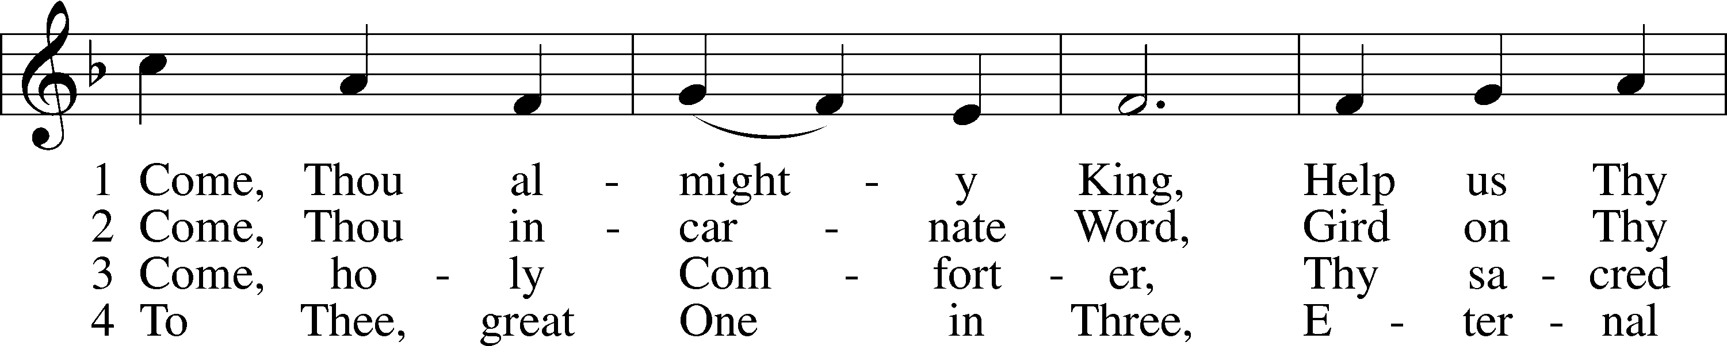
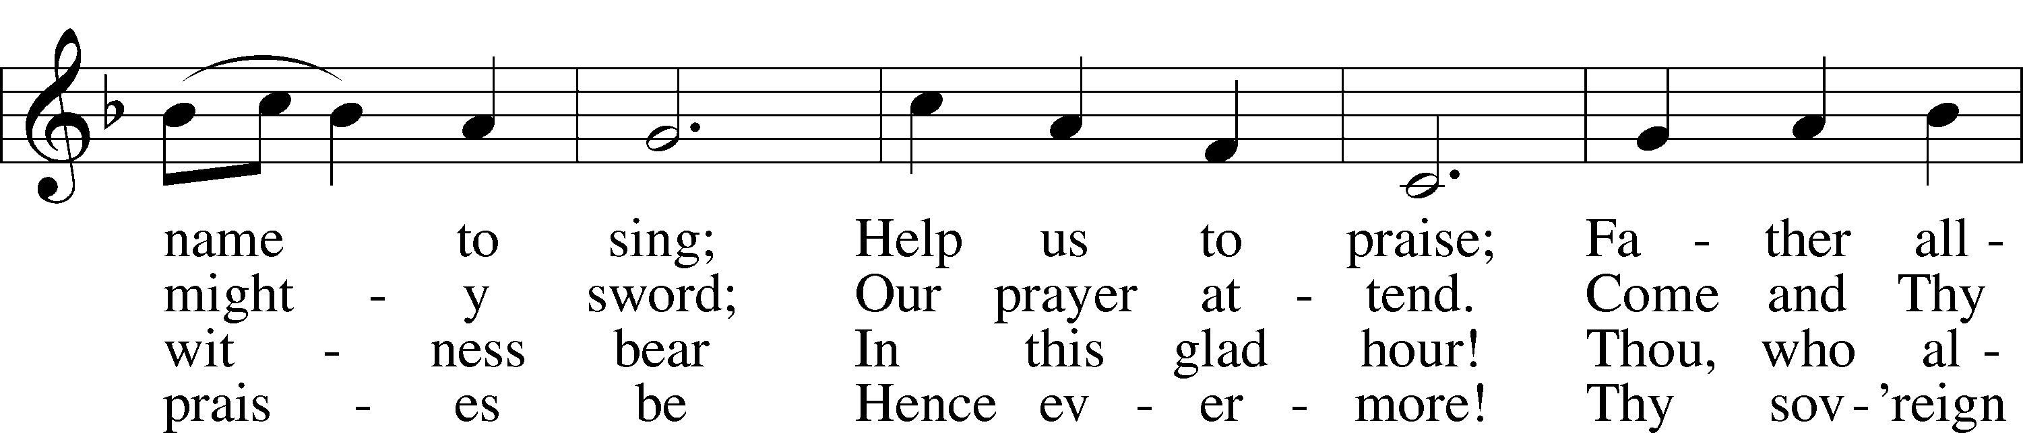
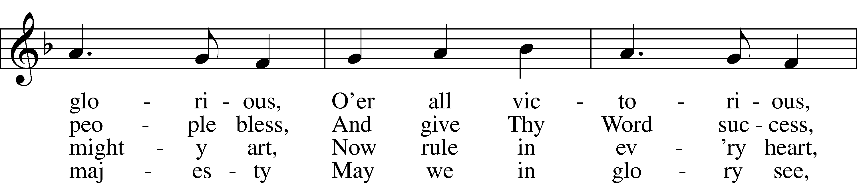
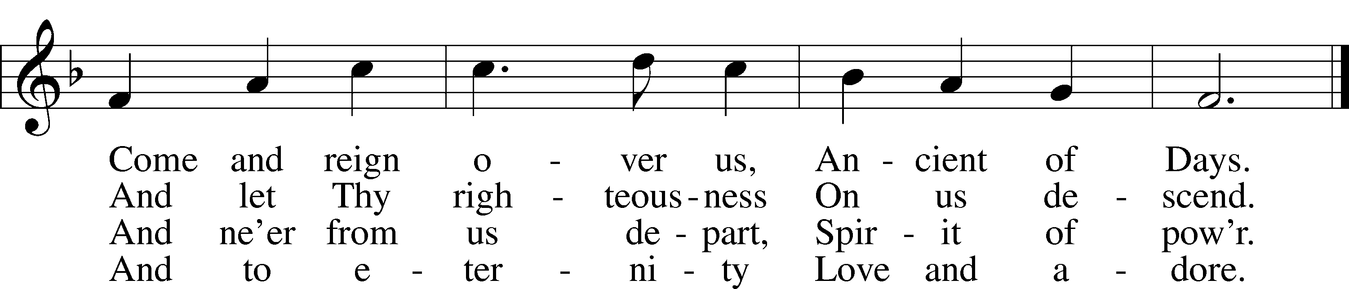

Public domain

Stand
Alleluia and Verse Matt. 10:39
P Alleluia.
P C Whoever finds his life will lose it, and whoever loses his life for my sake will find it. Alleluia.

Holy Gospel Matthew 10:34-42
P The Holy Gospel according to St. Matthew, the tenth chapter.
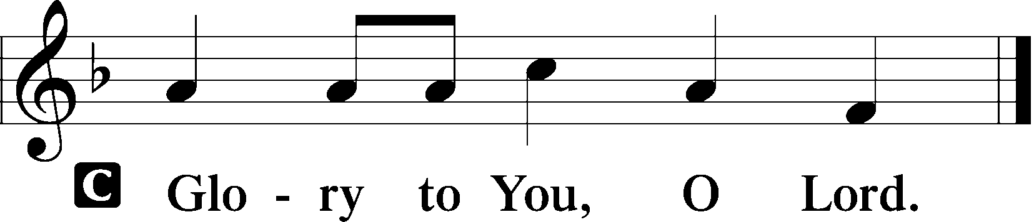

34 “Do not suppose that I have come to bring peace to the earth. I did not come to bring peace, but a sword. 35 For I have come to turn “‘a man against his father, a daughter against her mother, a daughter-in-law against her mother-in-law—
36 a man’s enemies will be the members of his own household.’
37 “Anyone who loves their father or mother more than me is not worthy of me; anyone who loves their son or daughter more than me is not worthy of me. 38 Whoever does not take up their cross and follow me is not worthy of me. 39 Whoever finds their life will lose it, and whoever loses their life for my sake will find it.
40 “Anyone who welcomes you welcomes me, and anyone who welcomes me welcomes the one who sent me. 41 Whoever welcomes a prophet as a prophet will receive a prophet’s reward, and whoever welcomes a righteous person as a righteous person will receive a righteous person’s reward. 42 And if anyone gives even a cup of cold water to one of these little ones who is my disciple, truly I tell you, that person will certainly not lose their reward.”

P This is the Gospel of the Lord.
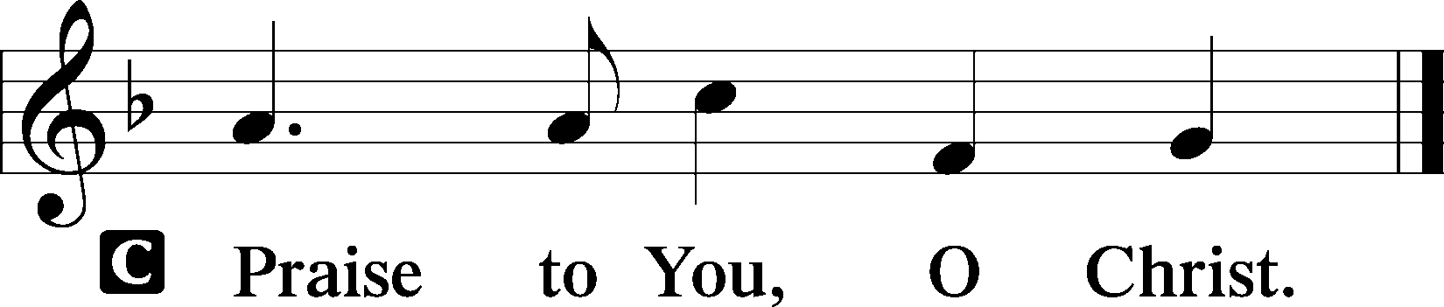

Sit
Hymn of the Day LSB 685 sts. 1-4
“Let Us Ever Walk with Jesus”
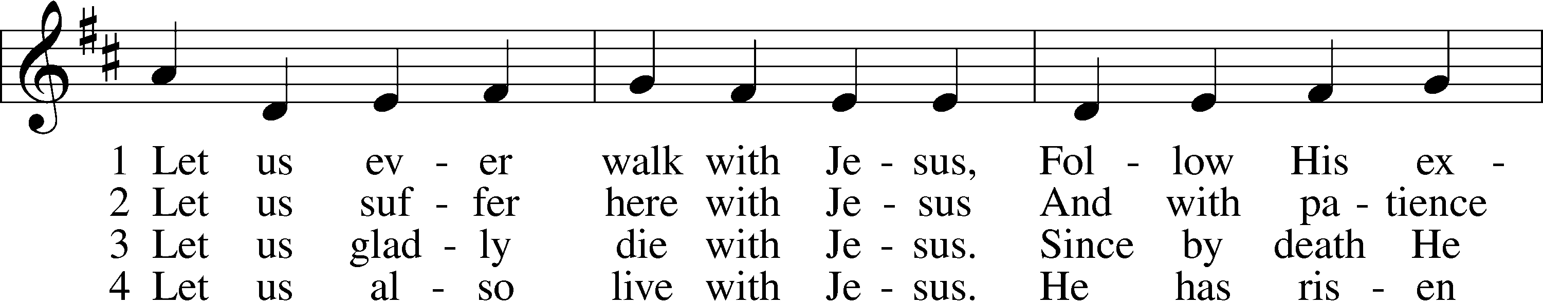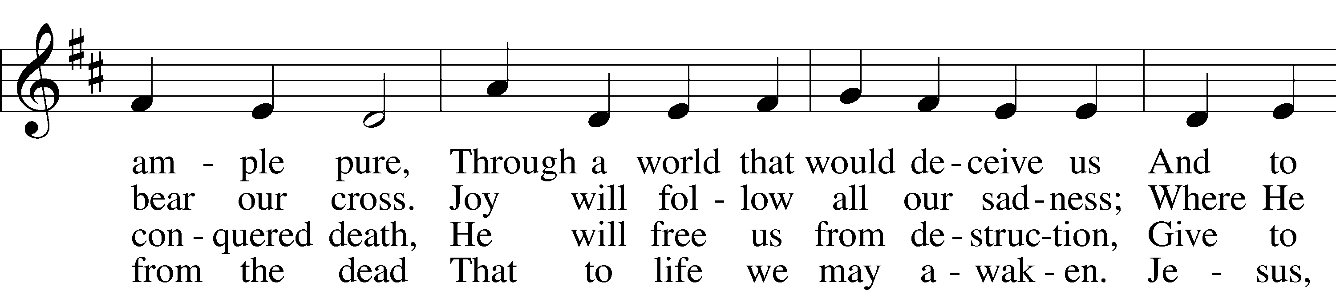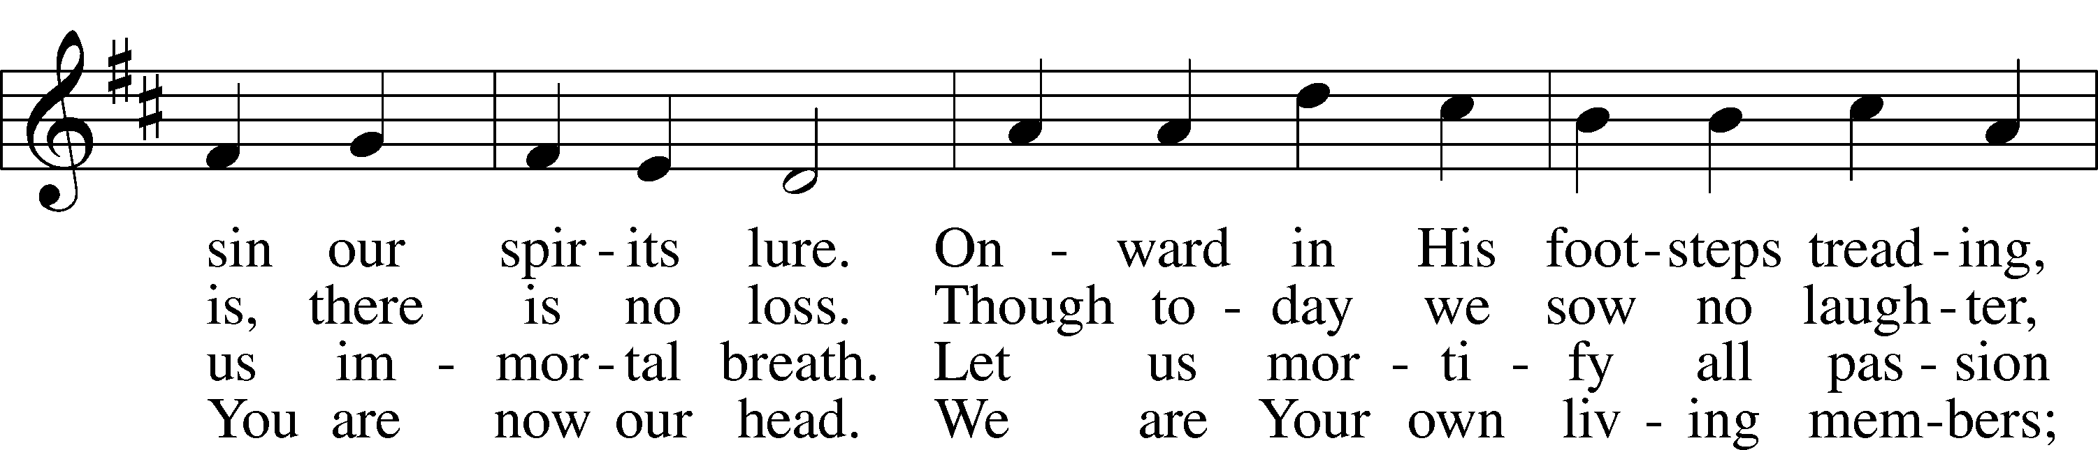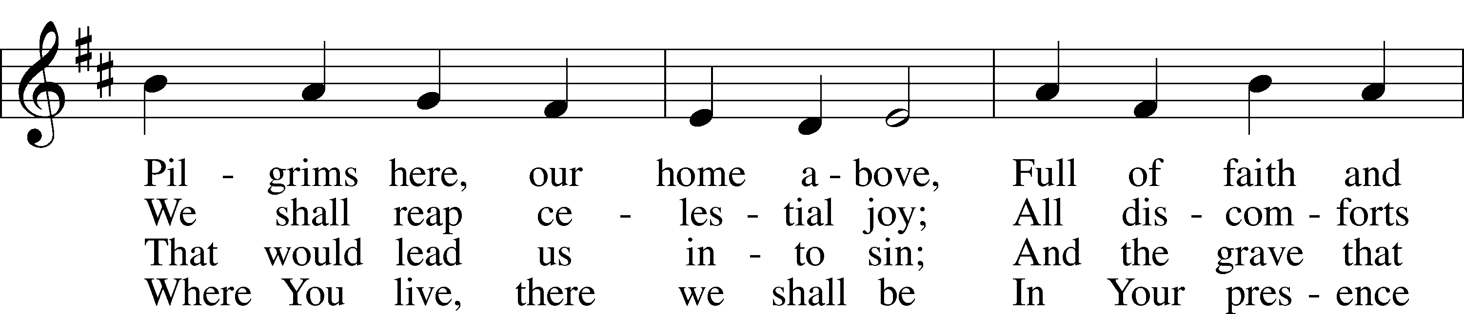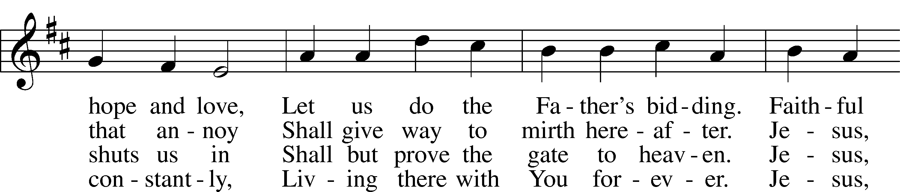
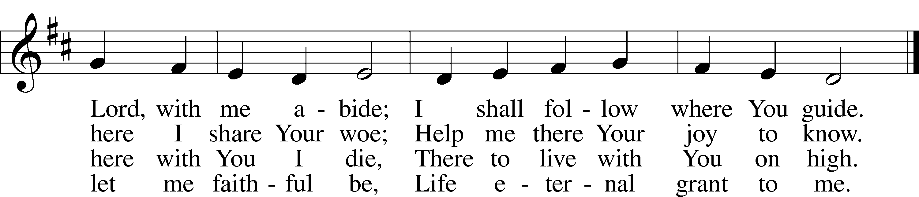

© 1978 Lutheran Book of Worship. Used by permission: LSB Hymn License .NET, no. 100011462.

Sermon “Faith 2-Ways”
Pastor Tom Rhodes

Stand
Apostles’ Creed LSB 159
P C I believe in God, the Father Almighty, maker of heaven and earth.

And in Jesus Christ, His only Son, our Lord,
who was conceived by the Holy Spirit,
born of the virgin Mary,
suffered under Pontius Pilate,
was crucified, died, and was buried.
He descended into hell.
The third day He rose again from the dead.
He ascended into heaven
and sits at the right hand of God the Father Almighty.
From thence He will come to judge the living and the dead.

I believe in the Holy Spirit,
the holy Christian Church,
the communion of saints,
the forgiveness of sins,
the resurrection of the body,
and the life  everlasting. Amen.

Prayer of the Church LSB 159
P Beloved in the Lord, let us draw near to the Lord’s throne of grace and pray as He has commanded us, trusting in the Lord to hear the prayers of His people and answer our petitions according to His mercy.

After each portion of the prayers:
P Lord, in Your mercy,
C hear our prayer.

The prayers conclude:
P All these things for which You would have us ask of You, we pray You to grant to us for the sake of the bitter sufferings and death of Jesus Christ, our Lord, through whom we are bold to call You Father and in whose name we pray, trusting in Your mercy and confident that You will give answer to our prayers; through Jesus Christ, our Lord.
C Amen.

Offering
In quiet devotion and responding in personal stewardship of God’s abundant provision to you, please use the offering plates in the back as you enter or exit. (This is just as it says: An offering to God through His church. As a reassurance to those in worship today, especially our guests - this is not an obligation - the good news of Jesus is free to all!)

Stewardship Prayer
P C Lord, You have daily and richly supplied us with all things for this body and life. Give us grateful hearts, that we may receive Your gifts with thanksgiving and bring to You our tithes and offerings. In Jesus name, Amen.

Offertory Psalm 116:12-13, 17-19; LSB 159
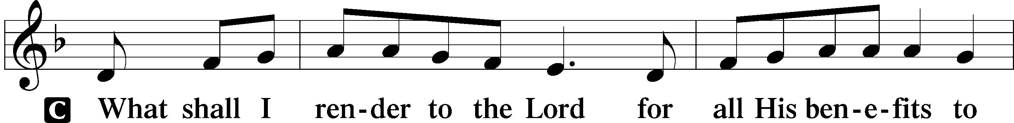
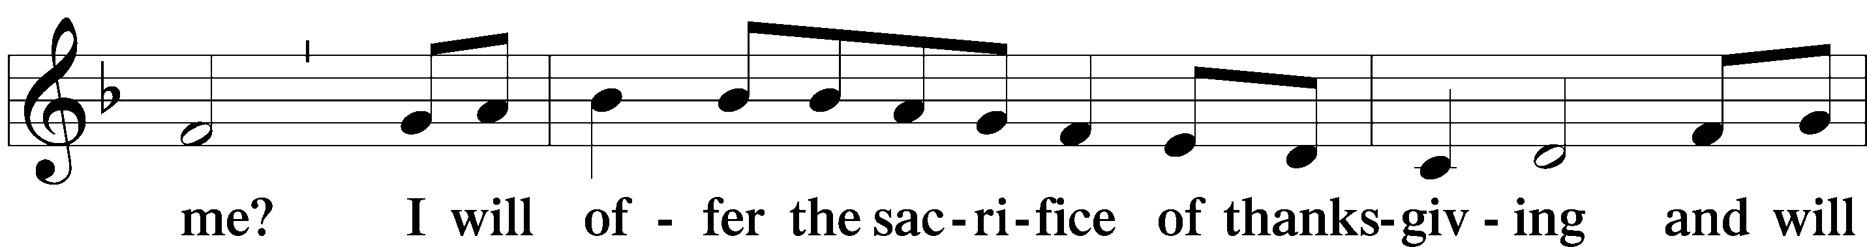
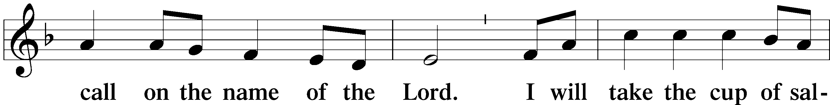
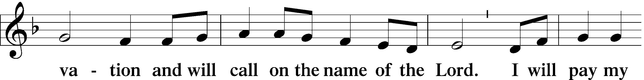
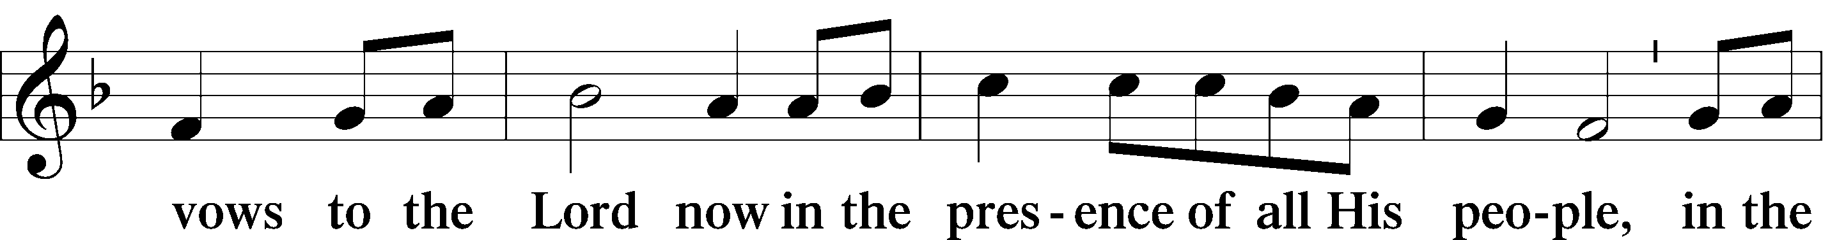
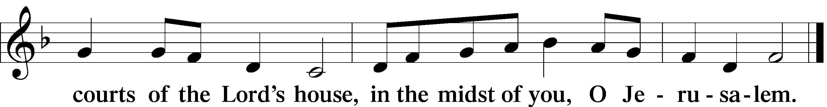

Lord's Prayer Matthew 6:9-13, LSB 162
P Lord, remember us in Your kingdom and teach us to pray:
C Our Father who art in heaven,
hallowed be Thy name,
Thy kingdom come,
Thy will be done on earth
as it is in heaven;
give us this day our daily bread;
and forgive us our trespasses
as we forgive those
who trespass against us;
and lead us not into temptation,
but deliver us from evil.
For Thine is the kingdom
and the power and the glory
forever and ever. Amen.

Benediction Numbers 6:24-26, LSB 166
P The Lord bless you and keep you. The Lord make His face shine on you and be gracious to you. The Lord look upon you with favor and  give you peace.
C Amen.

Sit
Closing Hymn (requested) sts. 1-3
(to the tune of LSB 856)
“This is My Father’s World”
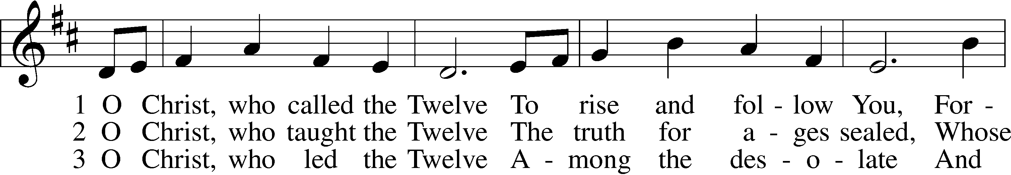
1 This is my Fa - ther's world, And to my list’ - ning ears All
2 This is my Fa - ther's world: The birds their ca - rols raise, The
3 This is my Fa - ther's world: O let me ne'er for - get That

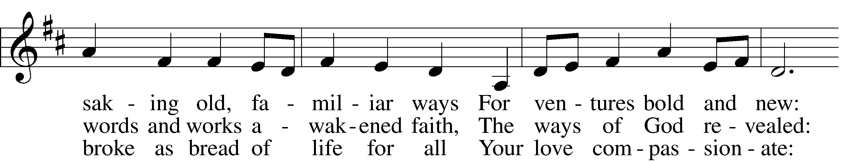
na - ture sings, and round me rings The mu - sic of the spheres.
mor - ning light, the li - ly white, De - clare their Ma - ker's praise.
though the wrong seems oft so strong, God is the Ru - ler yet.

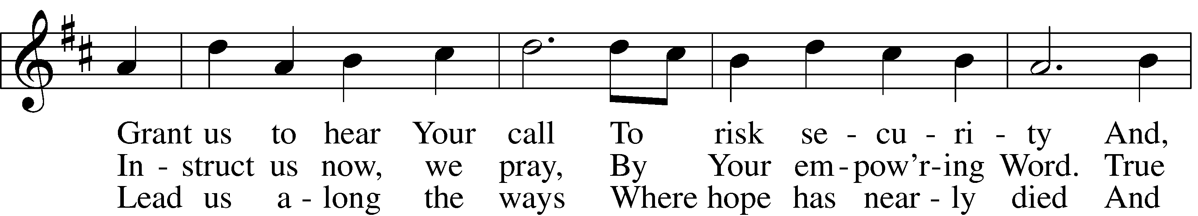
This is my Fa - ther's world: I rest me in the thought Of
This is my Fa - ther's world: He shines in all that's fair; In
This is my Fa - ther's world: Why should my heart be sad? The
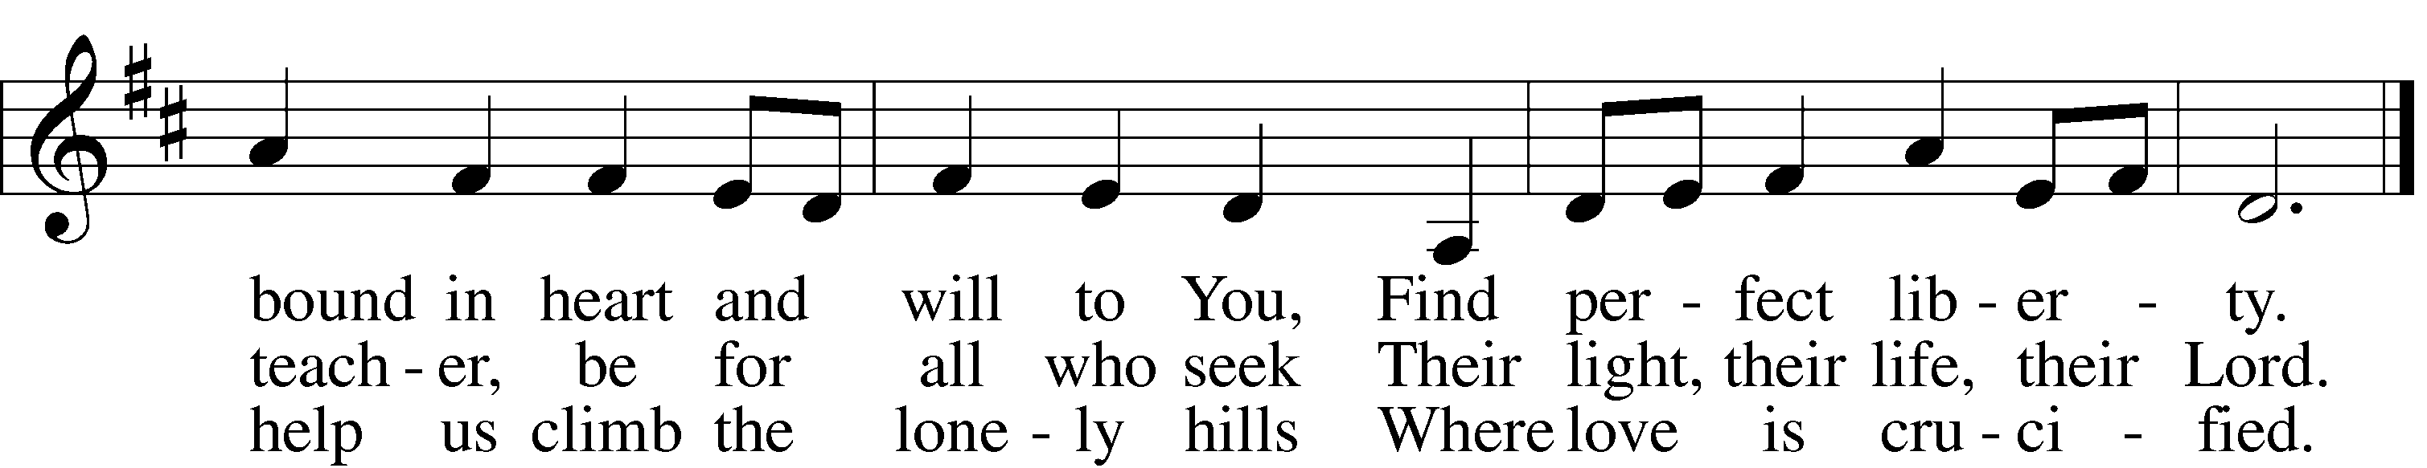
rocks and trees, of skies and seas - His hand the won - ders wrought.
the rust - ling grass I hear Him pass, He speaks to me ev’ry- where.
Lord is King: let the hea - vens ring! God reigns; let earth be glad!

© 1993 GIA Publications, Inc. Used by permission: LSB Hymn License .NET, no. 100011462. Public domain

