Zion Lutheran Church
‘Hearing, Sharing and Living the Gospel.’

Zion Lutheran Church
Our mission is to hear and share the good news of the risen Jesus and, with God’s help, to live the Gospel.

Eighth Sunday after Pentecost
July 26, 2020 10:30 a.m. Service

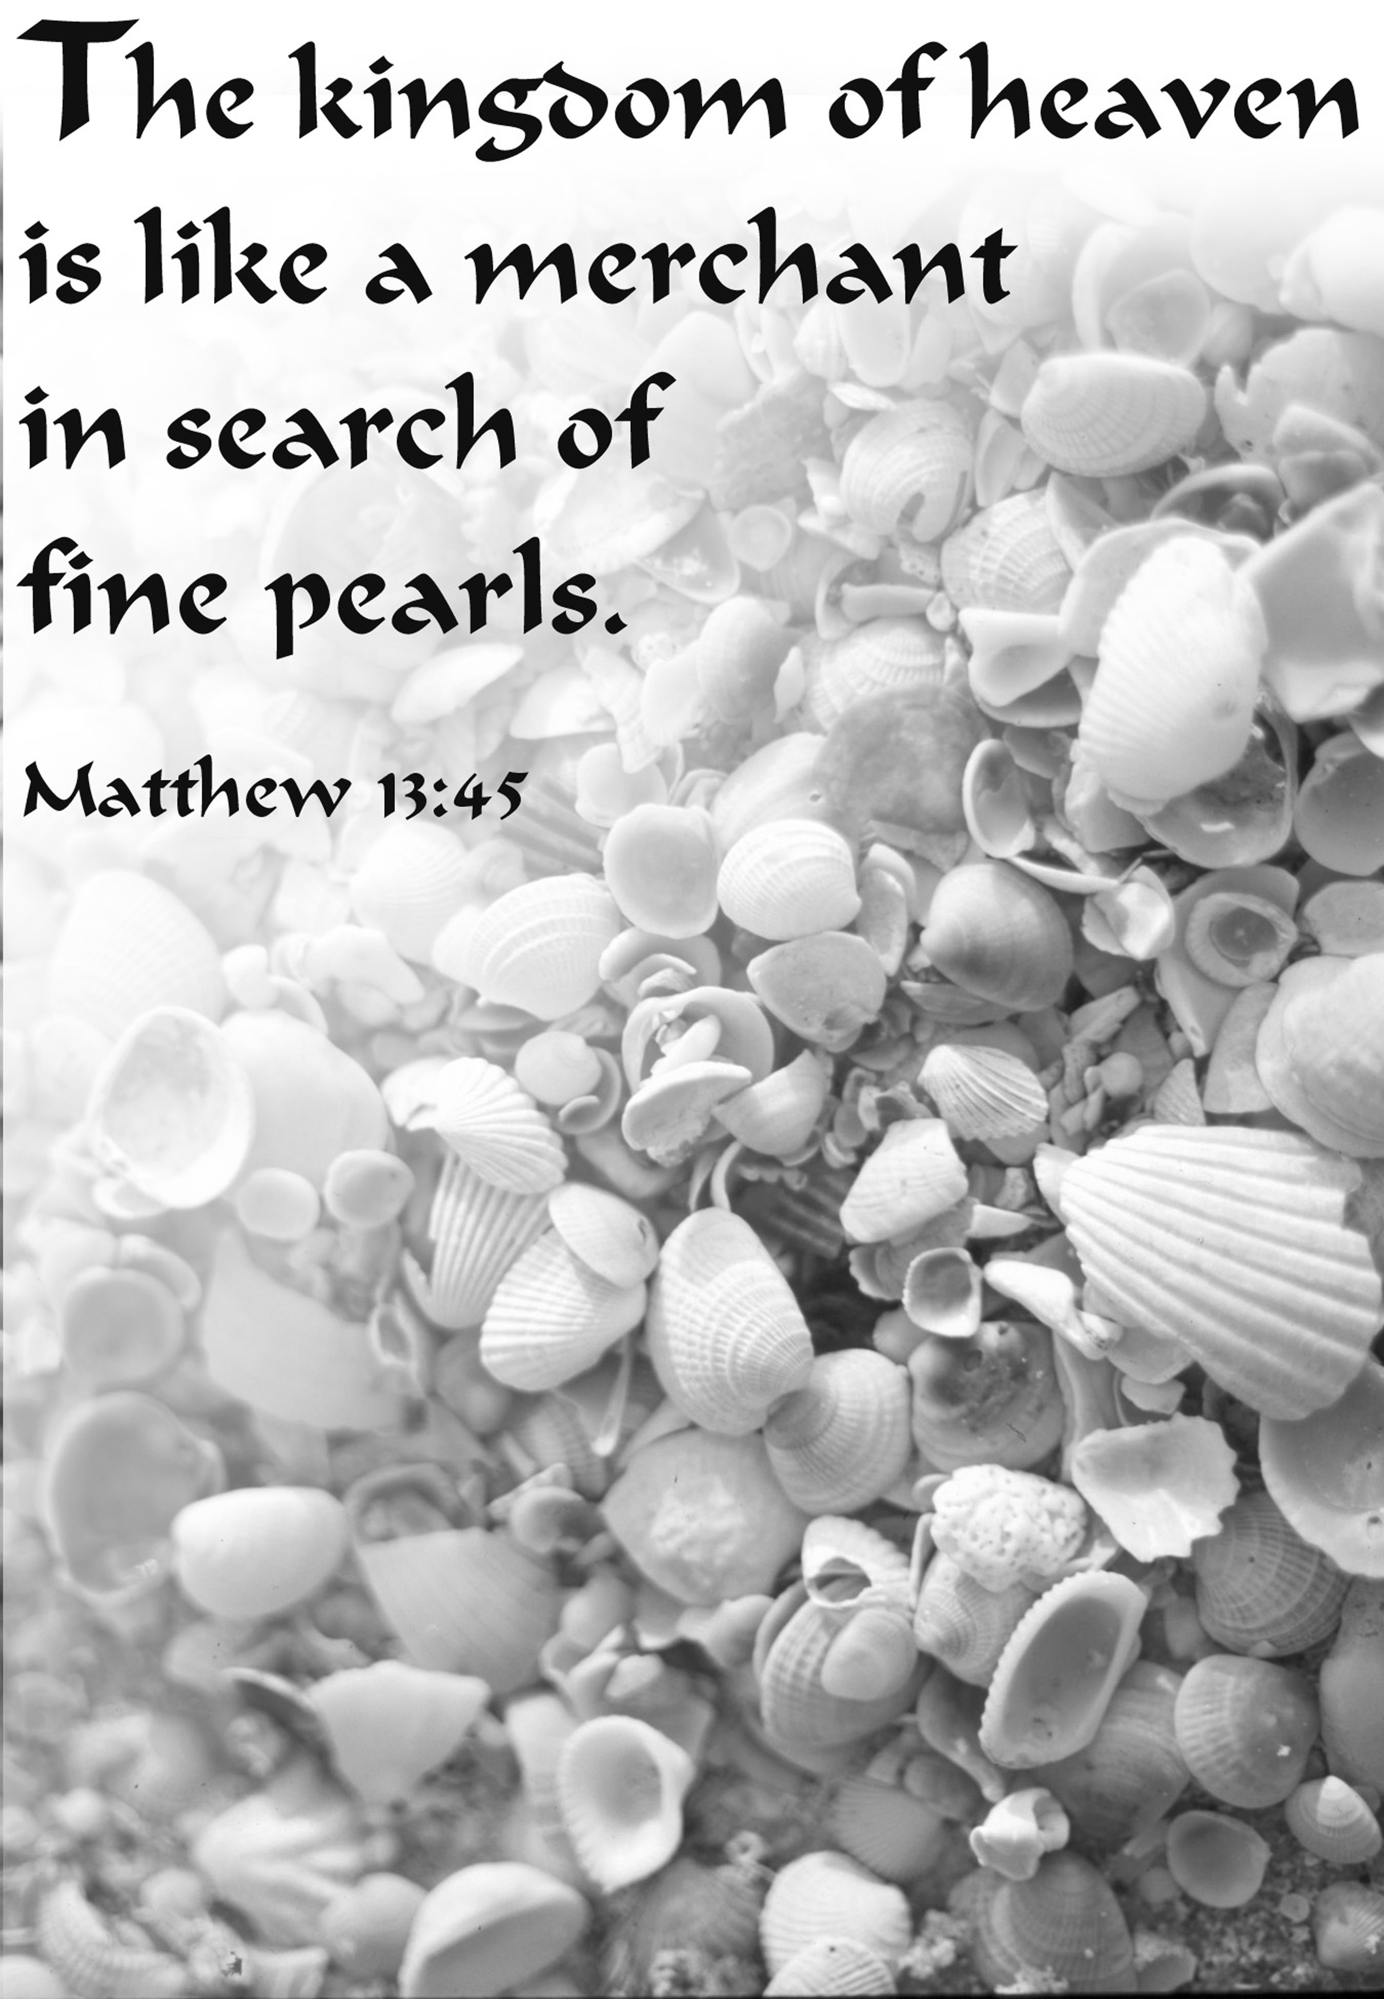

Zion Lutheran Church

‘Hearing, Sharing and Living the Gospel’
Rev. Thomas A. Rhodes, Pastor
PO Box 5 • 600 East Aldrich Road • Bolivar, MO 65613
Phone: 417-326-5506 • www.zionlutheranbolivar.org
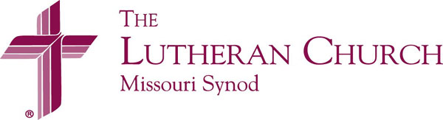
zionbolivar@windstream.net

Administrative Assistant – Sonya Gorman
You are invited to use the yellow Prayer Cards located in the pew for prayer requests. Please hand this card to an usher or place it in the offering plate.
* Please turn off cellphones*

Holy Communion is offered today:
The Lord’s Supper is a wonderful gift given to us by God. In the bread and wine, just as He says, Christ gives us His body and blood to forgive sins, renew faith, and cause Godly and brotherly love to grow. In this sacrament we proclaim Christ’s death on the cross to atone for the sins of the world and His triumphant resurrection over the grave, to the glory and praise of God. To receive this means of God's grace properly we should be able to positively answer the following: “Do I need forgiveness for sin?” “Do I believe the pastor’s forgiveness is God’s forgiveness?” “Do I believe in Christ as my Savior?” “Do I trust that Christ is truly present in the bread and wine?” “Do I desire to live anew to God and others in love and service?” In our ‘yes’ to these questions we join in a close and holy communion – a fellowship of faith.
Out of Pastoral concern and care, and taking to heart God's Word in 1 Corinthians 11:28-29:“A man ought to examine himself before he eats of the bread and drinks of the cup. For anyone who eats and drinks without recognizing the body of the Lord eats and drinks judgment on himself” – if you are unsure about what it means to take the Lord’s Supper, or if you are not certain you can confess these beliefs, please feel free to remain seated or speak to the Pastor or an Elder prior to the service.
If you need to receive the Sacrament at your seat, please tell an usher. For those who so desire, the cups in the center have water infused with a drop of wine. Also, non-communing children and adults are welcome to come forward and receive a blessing. (Please keep your hands folded to indicate this choice.)

EIGHTH SUNDAY AFTER PENTECOST
Divine Service – Setting One
July 26, 2020 10:30 a.m.

Welcome & Announcements

+ INVOCATION + LSB 151
The sign of the cross may be made by all in remembrance of their Baptism.
P We begin in the name into which we are baptized; In the name of the Father and of the  Son and of the Holy Spirit.
C Amen.

Opening Hymn LSB 573 sts. 1-3
“Lord, ‘Tis Not That I Did Choose Thee”
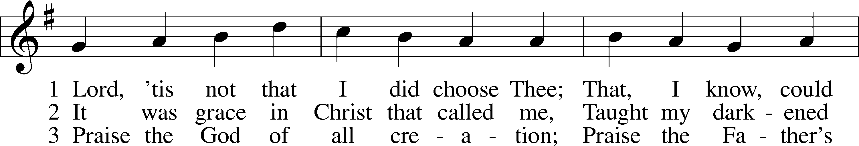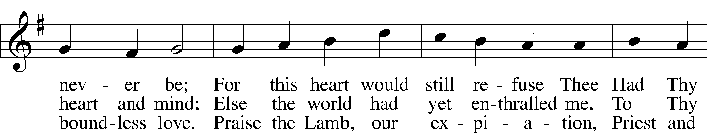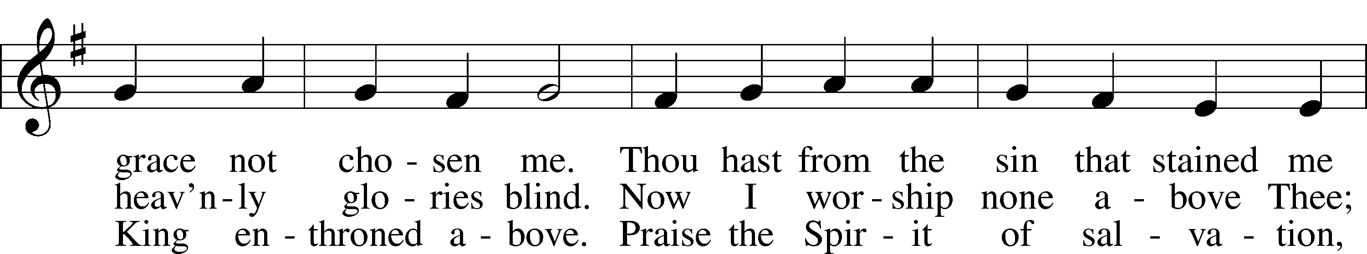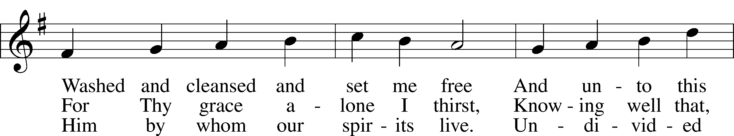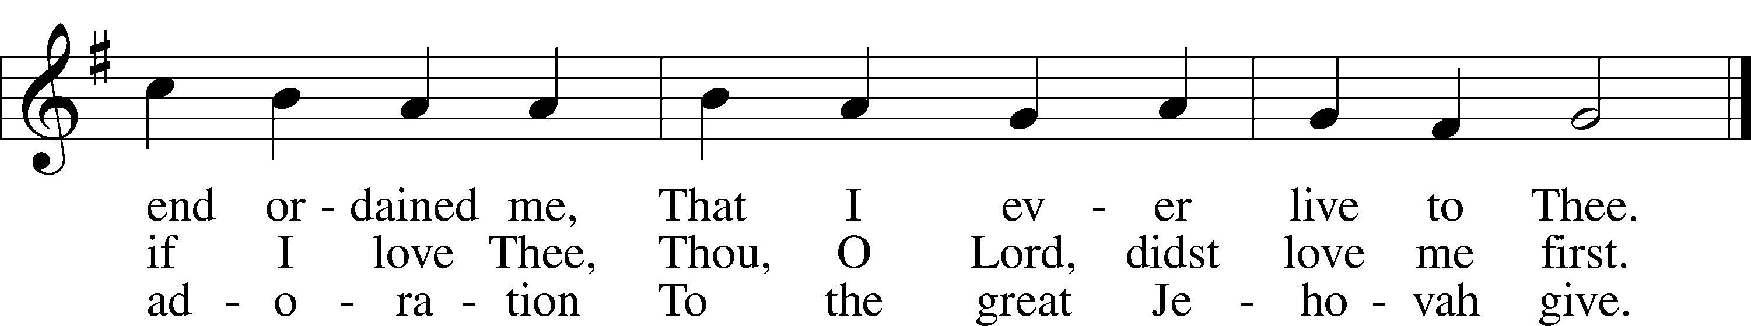
❒
Public domain

Stand
+ CONFESSION AND ABSOLUTION + LSB 151
P If we say we have no sin, we deceive ourselves, and the truth is not in us.
C But if we confess our sins, God, who is faithful and just, will forgive our sins and cleanse us from all unrighteousness.

(Silence for reflection on God's Word and for self-examination in light of the Ten Commandments.)

P Let us then confess our sins to God our Father.
C Most merciful God, we confess that we are by nature sinful and unclean. We have sinned against You in thought, word, and deed, by what we have done and by what we have left undone. We have not loved You with our whole heart; we have not loved our neighbors as ourselves. We justly deserve Your present and eternal punishment. For the sake of Your Son, Jesus Christ, have mercy on us. Forgive us, renew us, and lead us, so that we may delight in Your will and walk in Your ways to the glory of Your holy name. Amen.
P God be merciful to you and strengthen your faith. LSB 292
C Amen.
P Do you believe that my forgiveness is God’s forgiveness?
C Yes. LSB 293
P Let it be done for you as you believe.
P Almighty God in His LSB 151
mercy has given His Son to
die for you and for His sake forgives you all your sins. As a called and ordained servant of Christ, and by His authority, I therefore forgive you all your sins in the name of the Father and of the  Son and of the Holy Spirit.
C Amen.

+ SERVICE OF THE WORD + LSB 152
Introit Ps. 105:2-6; antiphon: Ps. 105:1
P Oh give thanks to the Lord; call upon his name; make known his deeds among the peoples!
C Sing to him, sing praises to him; tell of all his wondrous works!
P Glory in his holy name; let the hearts of those who seek the Lord rejoice!
C Seek the Lord and his strength; seek his presence continually!
P Remember the wondrous works that he has done, his miracles, and the judgments he uttered,
C O offspring of Abraham, his servant, children of Jacob, his chosen ones!
P C Glory be to the Father and to the Son and to the Holy Spirit; as it was in the beginning, is now, and will be forever. Amen.
P Oh give thanks to the Lord; call upon his name; make known his deeds among the peoples!

Kyrie LSB 152
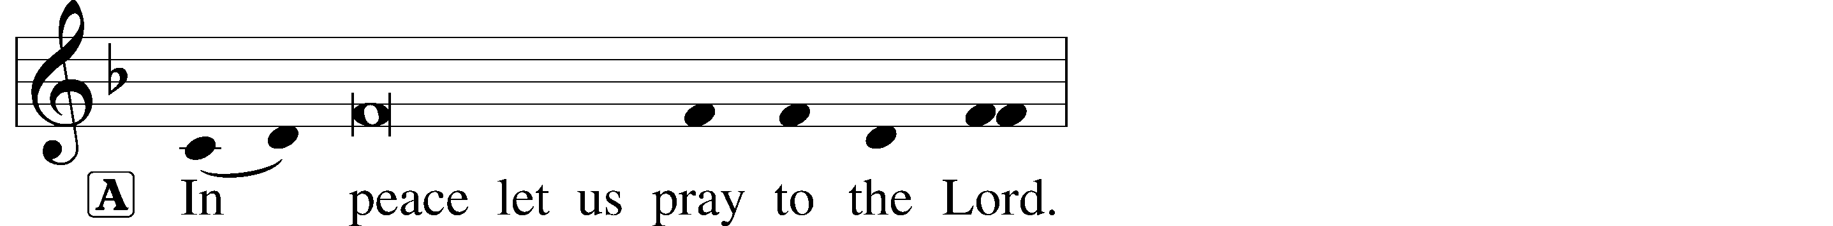
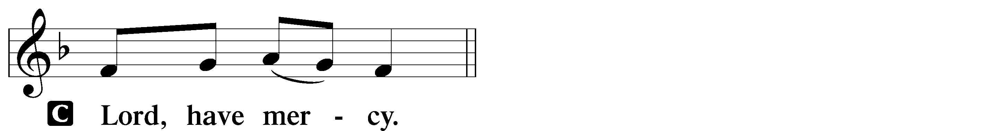
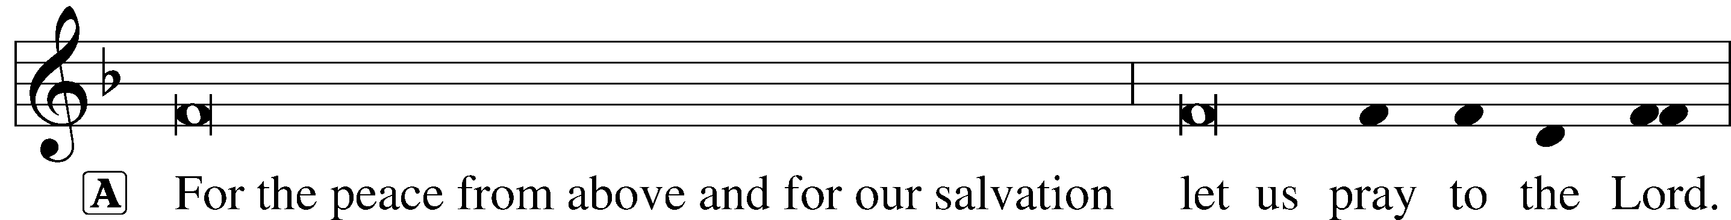
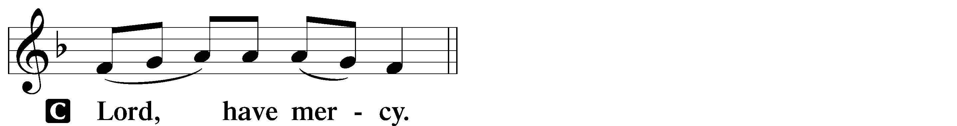
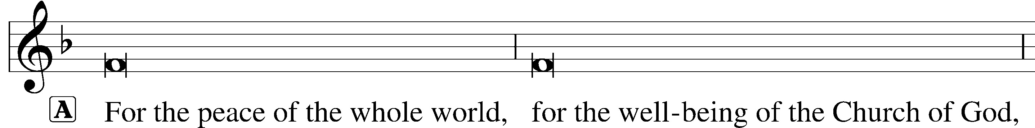

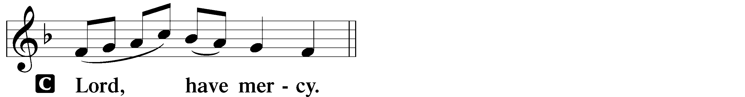
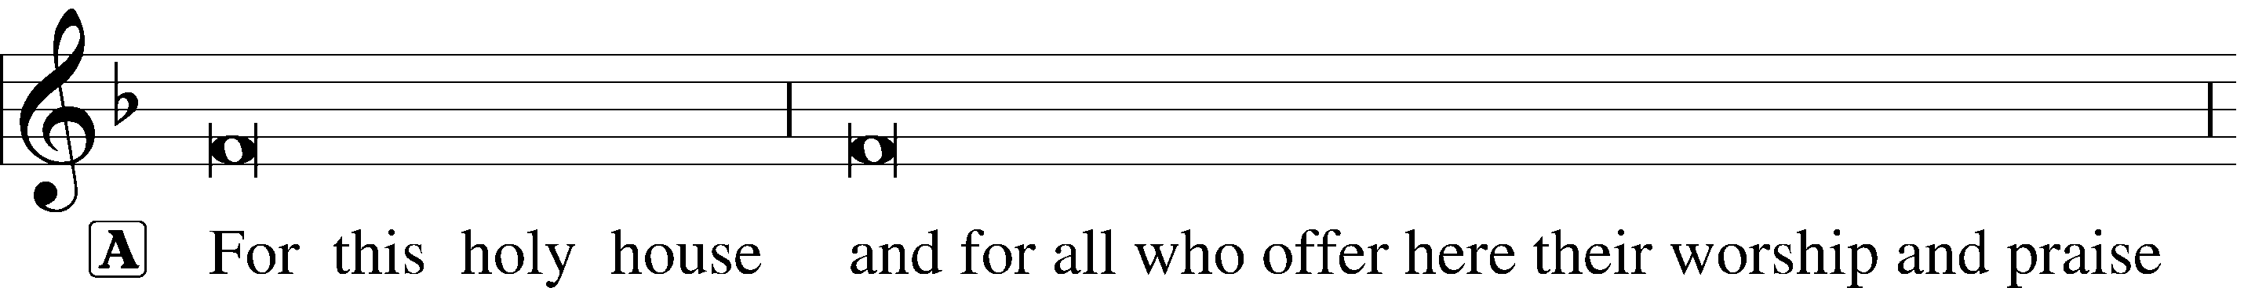

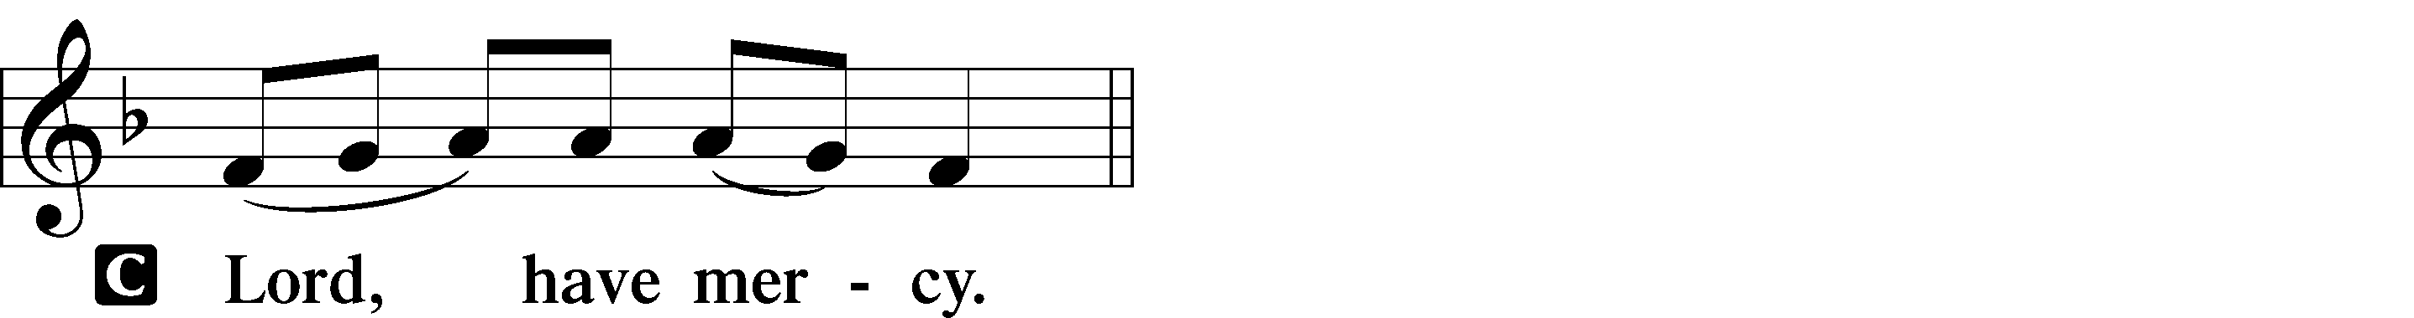
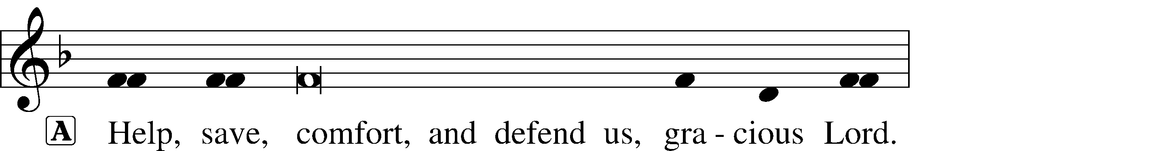


Hymn of Praise Revelation 5:12-13, 19:5-9; LSB 155
“This is the Feast”
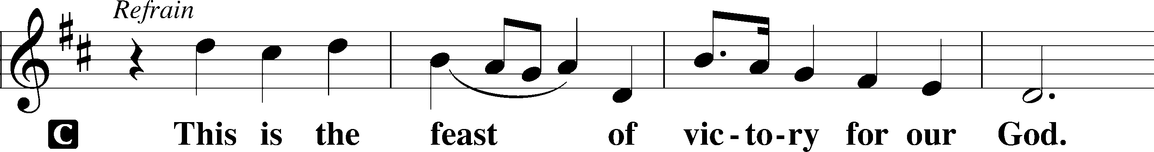
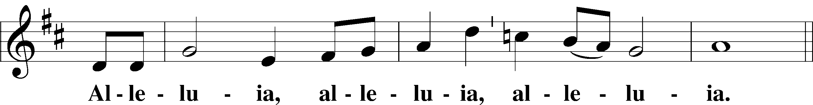
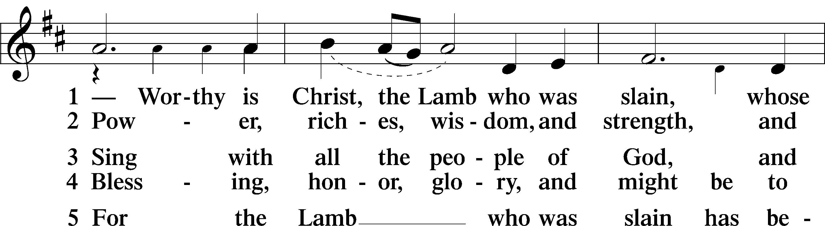
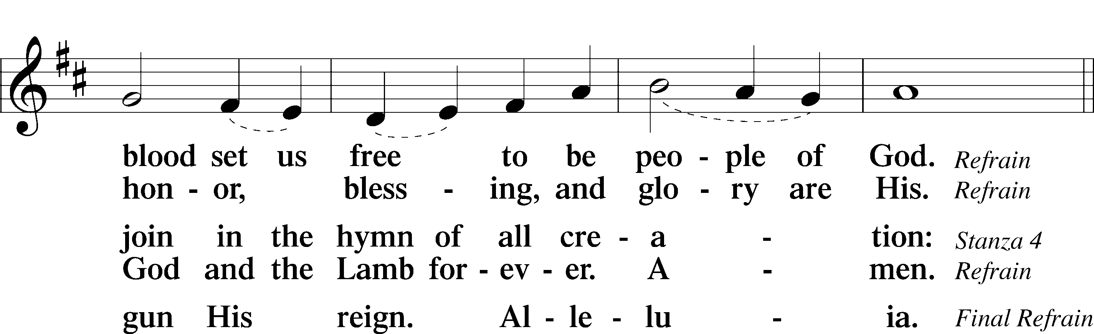
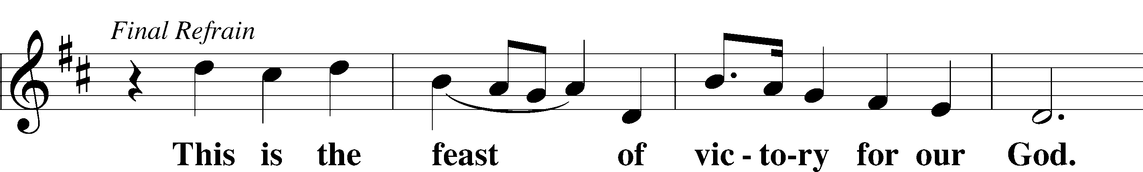
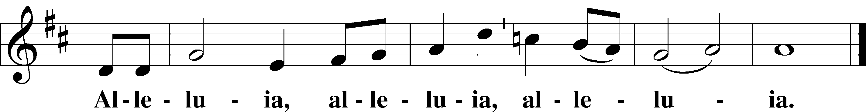

Salutation and Collect of the Day LSB 156
P The Lord be with you.
C And also with you.
P Let us pray. Almighty and everlasting God, give us an increase of faith, hope and love, that, receiving what You have promised, we may love what You have commanded; through Jesus Christ, Your Son, our Lord, who lives and reigns with You and the Holy Spirit, one God, now and forever.
C Amen.

Sit
Old Testament Reading Deuteronomy 7:6-9
6 For you are a people holy to the Lord your God. The Lord your God has chosen you out of all the peoples on the face of the earth to be his people, his treasured possession.
7 The Lord did not set his affection on you and choose you because you were more numerous than other peoples, for you were the fewest of all peoples.
8 But it was because the Lord loved you and kept the oath he swore to your ancestors that he brought you out with a mighty hand and redeemed you from the land of slavery, from the power of Pharaoh king of Egypt.
9 Know therefore that the Lord your God is God; he is the faithful God, keeping his covenant of love to a thousand generations of those who love him and keep his commandments.
A This is the Word of the Lord.
C Thanks be to God.

Gradual Rom. 11:33, 36
A C Oh, the depth of the riches and wisdom and knowledge of God! How unsearchable are his judgments and how inscrutable his ways! For from him and through him and to him are all things. To him be glory forever. Amen.

Epistle Reading Romans 8:28-39
28 And we know that in all things God works for the good of those who love him, who have been called according to his purpose. 29 For those God foreknew he also predestined to be conformed to the image of his Son, that he might be the firstborn among many brothers and sisters. 30 And those he predestined, he also called; those he called, he also justified; those he justified, he also glorified.
31 What, then, shall we say in response to these things? If God is for us, who can be against us? 32 He who did not spare his own Son, but gave him up for us all—how will he not also, along with him, graciously give us all things? 33 Who will bring any charge against those whom God has chosen? It is God who justifies. 34 Who then is the one who condemns? No one. Christ Jesus who died—more than that, who was raised to life—is at the right hand of God and is also interceding for us. 35 Who shall separate us from the love of Christ? Shall trouble or hardship or persecution or famine or nakedness or danger or sword? 36 As it is written:
“For your sake we face death all day long; we are considered as sheep to be slaughtered.”
37 No, in all these things we are more than conquerors through him who loved us. 38 For I am convinced that neither death nor life, neither angels nor demons, neither the present nor the future, nor any powers, 39 neither height nor depth, nor anything else in all creation, will be able to separate us from the love of God that is in Christ Jesus our Lord.
A This is the Word of the Lord.
C Thanks be to God.

Stand
Alleluia and Verse Matt. 13:35
P Alleluia.
P C I will open my mouth in parables; I will utter what has been hidden since the foundation of the world. Alleluia.

Holy Gospel Matthew 13:44-52
P The Holy Gospel according to St. Matthew, the thirteenth chapter.
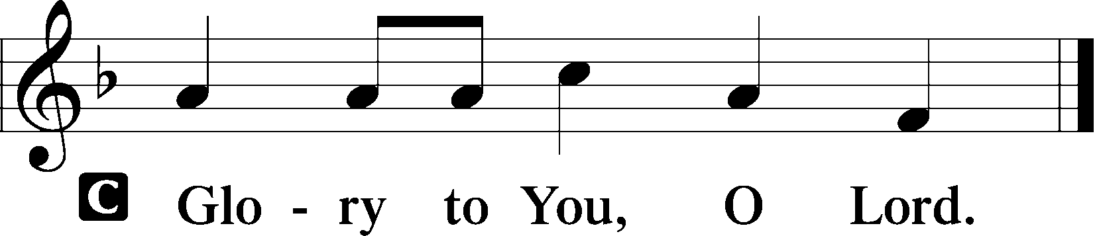
44 “The kingdom of heaven is like treasure hidden in a field. When a man found it, he hid it again, and then in his joy went and sold all he had and bought that field.
45 “Again, the kingdom of heaven is like a merchant looking for fine pearls. 46 When he found one of great value, he went away and sold everything he had and bought it.
47 “Once again, the kingdom of heaven is like a net that was let down into the lake and caught all kinds of fish. 48 When it was full, the fishermen pulled it up on the shore. Then they sat down and collected the good fish in baskets, but threw the bad away. 49 This is how it will be at the end of the age. The angels will come and separate the wicked from the righteous 50 and throw them into the blazing furnace, where there will be weeping and gnashing of teeth.
51 “Have you understood all these things?” Jesus asked.
“Yes,” they replied.
52 He said to them, “Therefore every teacher of the law who has become a disciple in the kingdom of heaven is like the owner of a house who brings out of his storeroom new treasures as well as old.”
P This is the Gospel of the Lord.
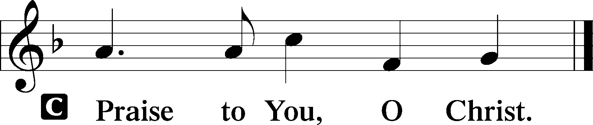

Sit
Hymn of the Day LSB 730 sts. 1-4
“What Is the World to Me”
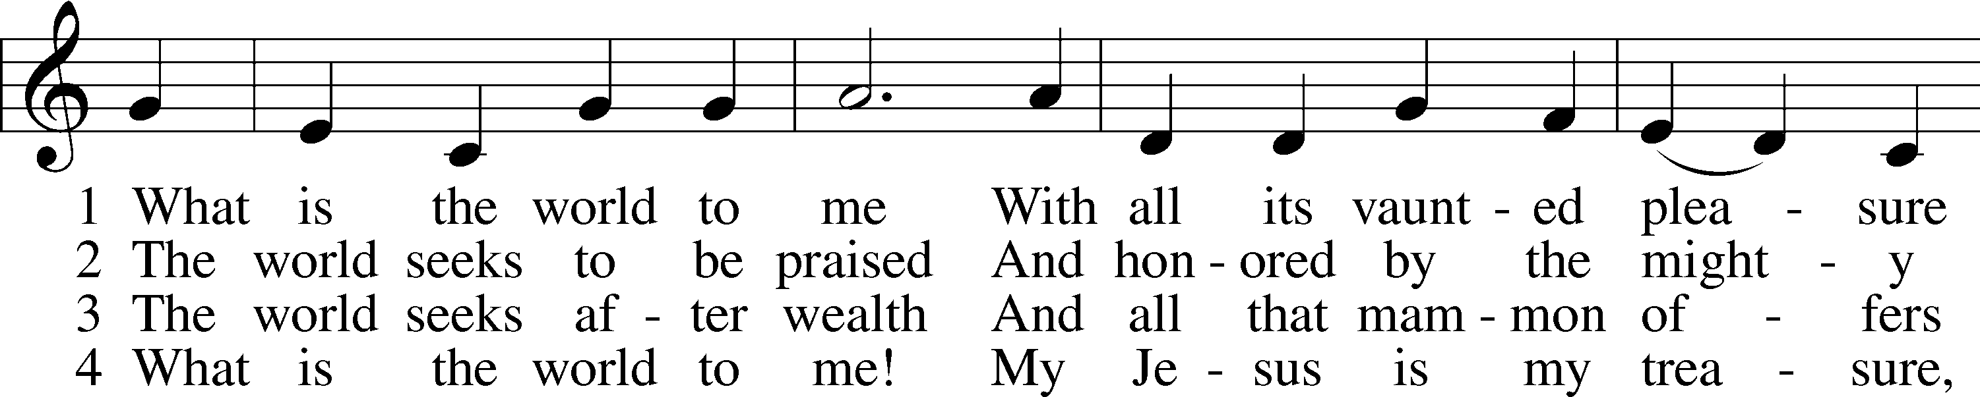
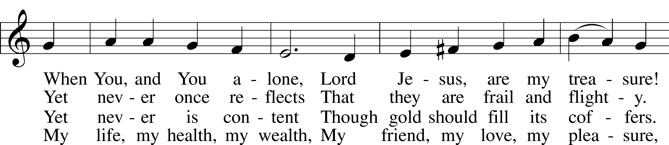
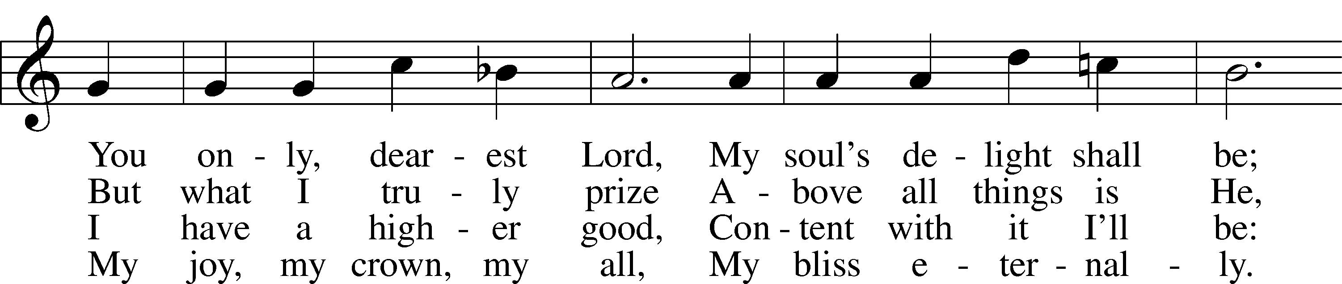
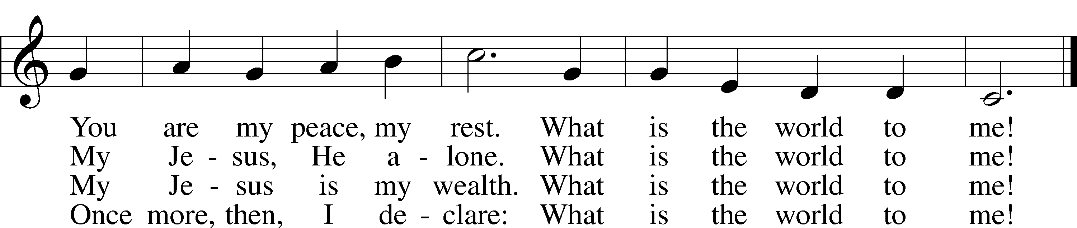

Public Domain

Sermon “Treasures Old and New”
Pastor Tom Rhodes
Stand
Together We Confess our Common Faith Using the Nicene Creed LSB 158
P C I believe in one God, the Father Almighty, maker of heaven and earth and of all things visible and invisible.

And in one Lord Jesus Christ,
the only-begotten Son of God,
begotten of His Father before all worlds,
God of God, Light of Light,
very God of very God,
begotten, not made,
being of one substance with the Father,
by whom all things were made;
who for us men and for our salvation
came down from heaven
and was incarnate by the Holy Spirit of
the virgin Mary and was made man;
and was crucified also for us under
Pontius Pilate.
He suffered and was buried.
And the third day He rose again
according to the Scriptures
and ascended into heaven
and sits at the right hand of the Father.
And He will come again with glory to
judge both the living and the dead,
whose kingdom will have no end.

And I believe in the Holy Spirit,
the Lord and giver of life,
who proceeds from the Father and the Son, who with the Father and the Son
together is worshiped and glorified,
who spoke by the prophets.
And I believe in one holy Christian and
apostolic Church,
I acknowledge one Baptism for the
remission of sins,
and I look for the resurrection of the dead
and the life  of the world to come. Amen.

Installation of LWML Officers

Prayer of the Church LSB 159
P O Lord, we are Your people, chosen by Your grace to be Your own treasured possession and granted mercy upon mercy. Hear Your people who cry to You in need, and remember us according to the genuine value You have showered upon us in Jesus Christ, our Lord.

Brief silence

P That the Church may prosper, the good news of Jesus Christ go forth unhindered, and the Spirit bring many into the fellowship of the redeemed, let us pray to the Lord:
C Lord, have mercy.

P That the Lord may grant to us good and faithful pastors to preach and teach the whole counsel of His Word, and that we may receive their words with joy and thanksgiving, let us pray to the Lord:
C Lord, have mercy.

P That we may remember our Baptism into Christ and live mindful that we are His precious children no matter the difficulties within families, neighborhoods and the world, let us pray to the Lord:
C Lord, have mercy.

P That the Lord may bless our nation and those who govern us, and that we may use the gift of freedom to live holy, upright and godly lives, to the praise of His glory, let us pray to the Lord:
C Lord, have mercy.

P That God’s people may recognize the true treasure of the cross and rejoice in the resurrection, pursuing with all their hearts, minds, bodies and souls the things of His kingdom, let us pray to the Lord:
C Lord, have mercy.

P That the sick may be healed, the troubled granted peace, the grieving comforted and the dying kept in peace, especially for those on our prayer list and cards, let us pray to the Lord:
C Lord, have mercy.

P That we may be steadfast and immovable, abiding in Christ and in His Word of truth, and that we would be kept from error and delivered from temptation, let us pray to the Lord:
C Lord, have mercy.

P That the Lord may watch over our comings and goings and deliver us safely into the arms of His mercy, in the blessed rest of the faithful, to receive with all the blessed dead in Christ the gift of life everlasting, let us pray to the Lord:
C Lord, have mercy.

P Holy God, mighty Lord, endless is Your gracious mercy and eternal Your Holy reign. Hear the prayers of Your people who cry to You in their need and who plead to You in the name of Jesus Christ, our Lord.
C Amen.

Sit
Offering
In quiet devotion and responding in personal stewardship of God’s abundant provision to you, please use the offering plates in the back as you enter or exit. (This is just as it says: An offering to God through His church. As a reassurance to those in worship today, especially our guests - this is not an obligation - the good news of Jesus is free to all!)

Stand
Stewardship Prayer
P C Lord grant us generous hearts so that we may honor You with the worship of our hearts and bring to You the tithes and offerings that support Your work among us and in this world. In Jesus name, Amen.

Offertory Psalm 116:12-13, 17-19; LSB 159
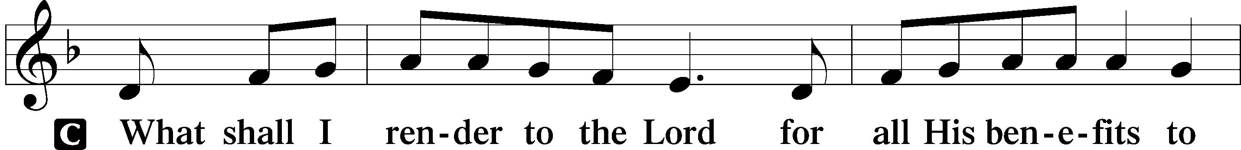
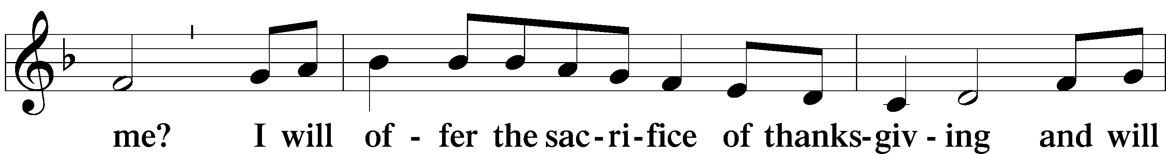
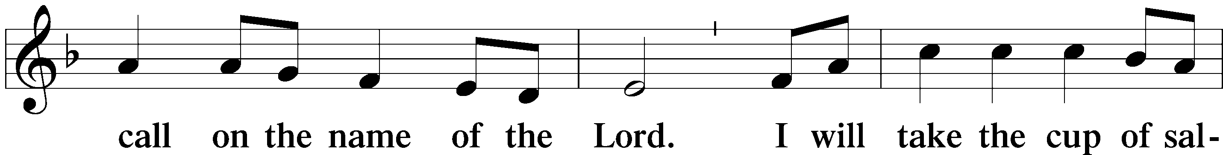
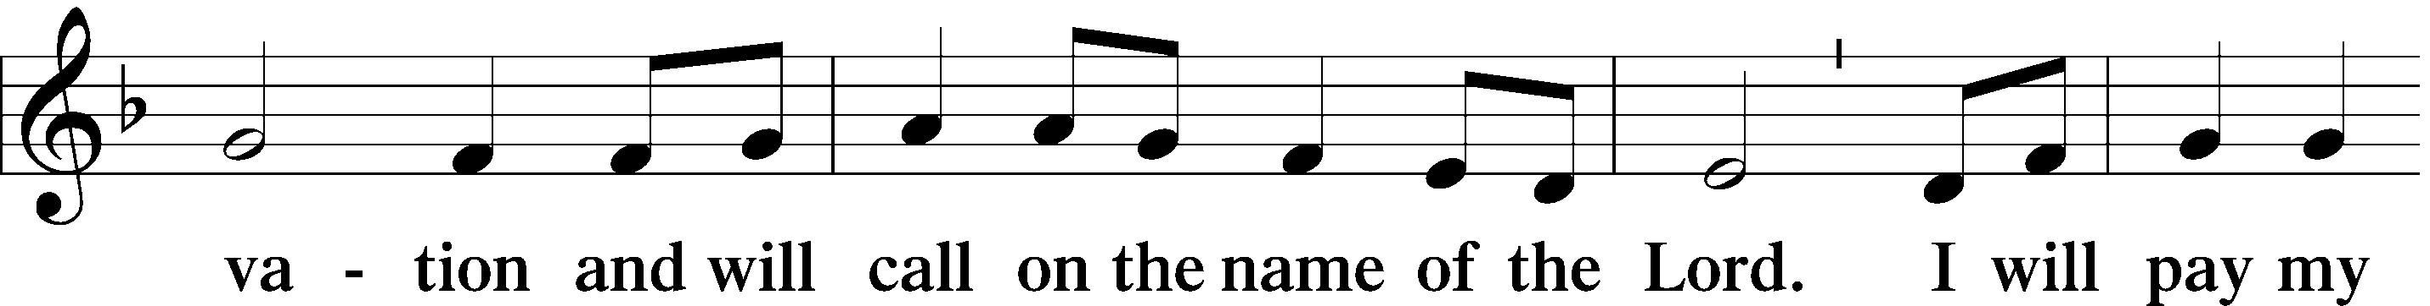
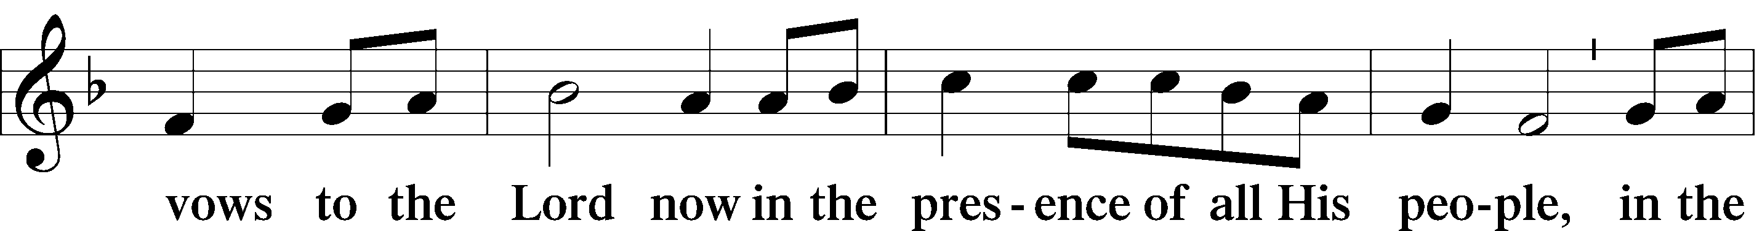
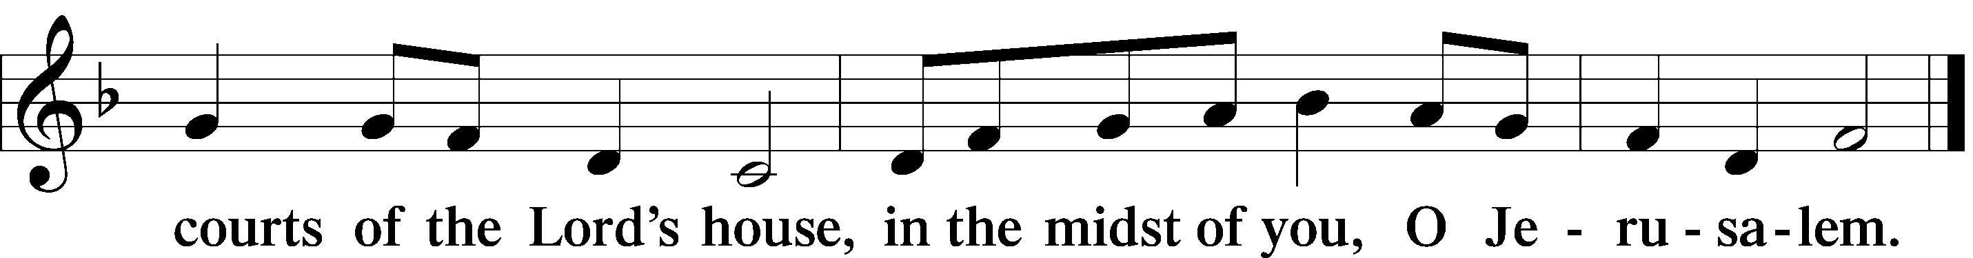

+ SERVICE OF THE SACRAMENT + LSB 160
Preface
P The Lord be with you.
C And also with you.
P Lift up your hearts.
C We lift them to the Lord.
P Let us give thanks to the Lord our God.
C It is right to give Him thanks and praise.
P It is truly good, right, and salutary that we should at all times and in all places give thanks to You, holy Lord, almighty Father, everlasting God, through Jesus Christ, our Lord, who, out of love for His fallen creation, humbled Himself by taking on the form of a servant, becoming obedient unto death, even death upon a cross. Risen from the dead, He has freed us from eternal death and given us life everlasting. Therefore with angels and archangels and all the company of heaven we laud and magnify Your glorious name, evermore praising You and saying:

Sanctus Isaiah 6:3, Matthew 21:9; LSB 161
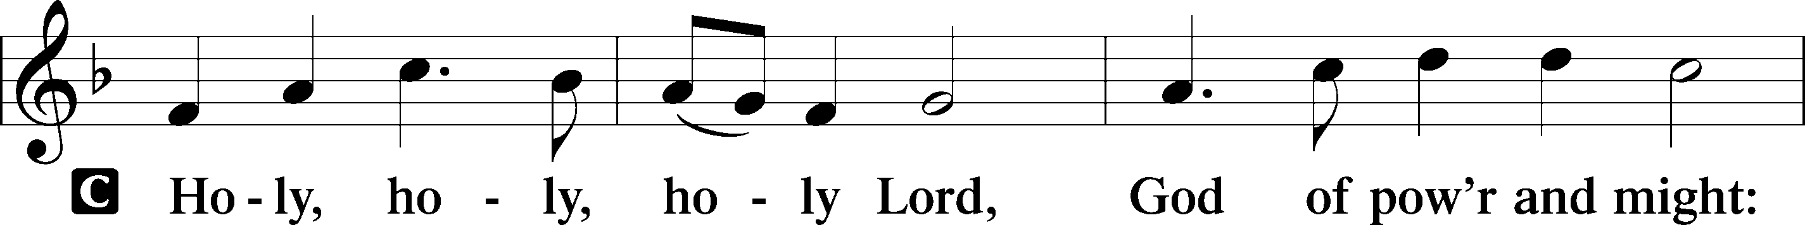
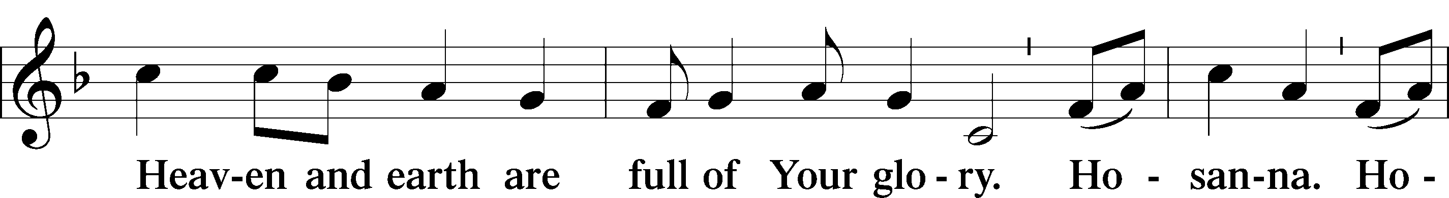
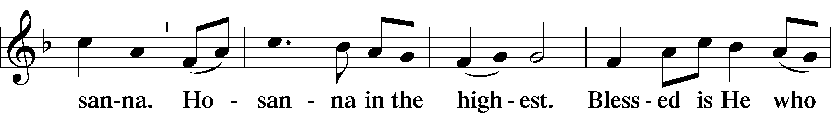
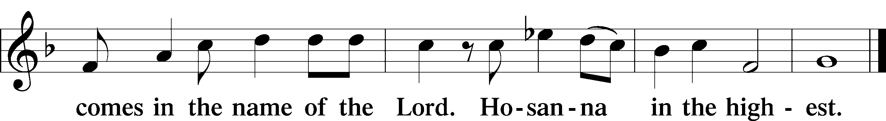

Prayer of Thanksgiving LSB 161
P Blessed are You, Lord of heaven and earth, for You have had mercy on those whom You created and sent Your only-begotten Son into our flesh to bear our sin and be our Savior. With repentant joy we receive the salvation accomplished for us by the all-availing sacrifice of His body and His blood on the cross.

Gathered in the name and the remembrance of Jesus, we beg You, O Lord, to forgive, renew, and strengthen us with Your Word and Spirit. Grant us faithfully to eat His body and drink His blood as He bids us do in His own testament. Gather us together, we pray, from the ends of the earth to celebrate with all the faithful the marriage feast of the Lamb in His kingdom, which has no end. Graciously receive our prayers; deliver and preserve us. To You alone, O Father, be all glory, honor, and worship, with the Son and the Holy Spirit, one God, now and forever.
C Amen.

Lord's Prayer Matthew 6:9-13; LSB 162
P Lord, remember us in Your kingdom and teach us to pray:
C Our Father who art in heaven,
hallowed be Thy name,
Thy kingdom come,
Thy will be done on earth
as it is in heaven;
give us this day our daily bread;
and forgive us our trespasses
as we forgive those who trespass
against us;
and lead us not into temptation,
but deliver us from evil.
For Thine is the kingdom
and the power and the glory
forever and ever. Amen.

The Words of Our Lord LSB 162
Matthew 26:26–28; Mark 14:22–24; Luke 22:19–20;
1 Corinthians 11:23–25
P Our Lord Jesus Christ, on the night when He was betrayed, took bread, and when He had given thanks, He broke it and gave it to the disciples and said: “Take, eat; this is My  body, which is given for you. This do in remembrance of Me.”

P In the same way also He took the cup after supper, and when He had given thanks, He gave it to them, saying: “Drink of it, all of you; this cup is the new testament in My  blood, which is shed for you for the forgiveness of sins. This do, as often as you drink it, in remembrance of Me.”

Pax Domini John 20:19; LSB 163
P The peace of the Lord be with you always.
C Amen.

Agnus Dei John 1:29; LSB 163
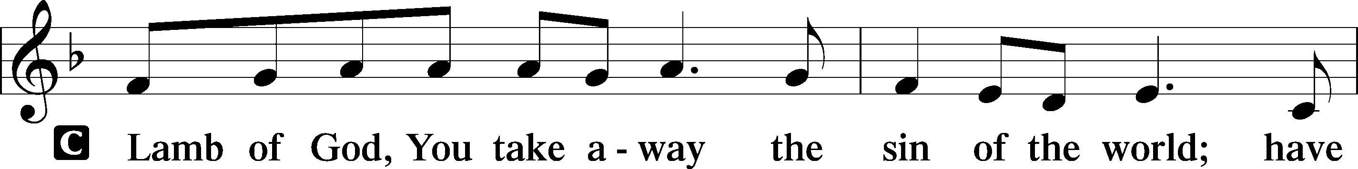
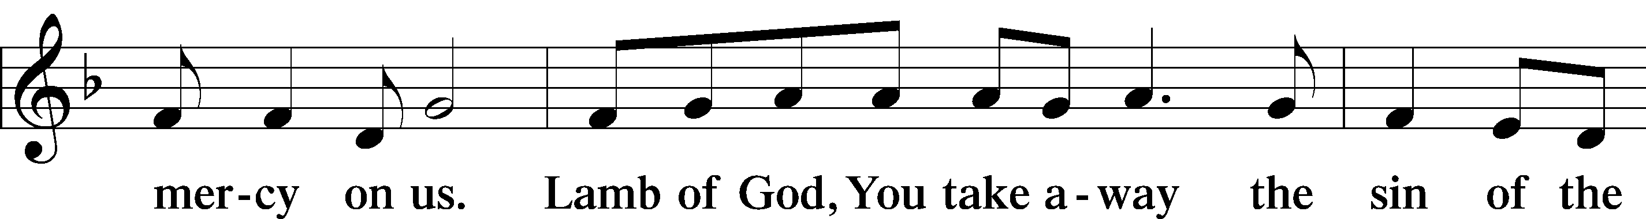
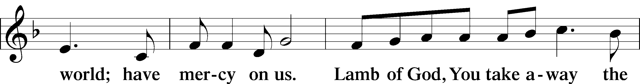
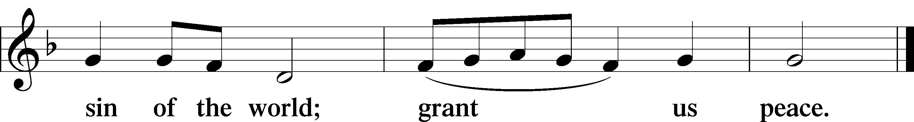

Sit

DISTRIBUTION

Distribution Hymn LSB 848 sts. 1-4
“Lord, Whose Love through Humble Service”
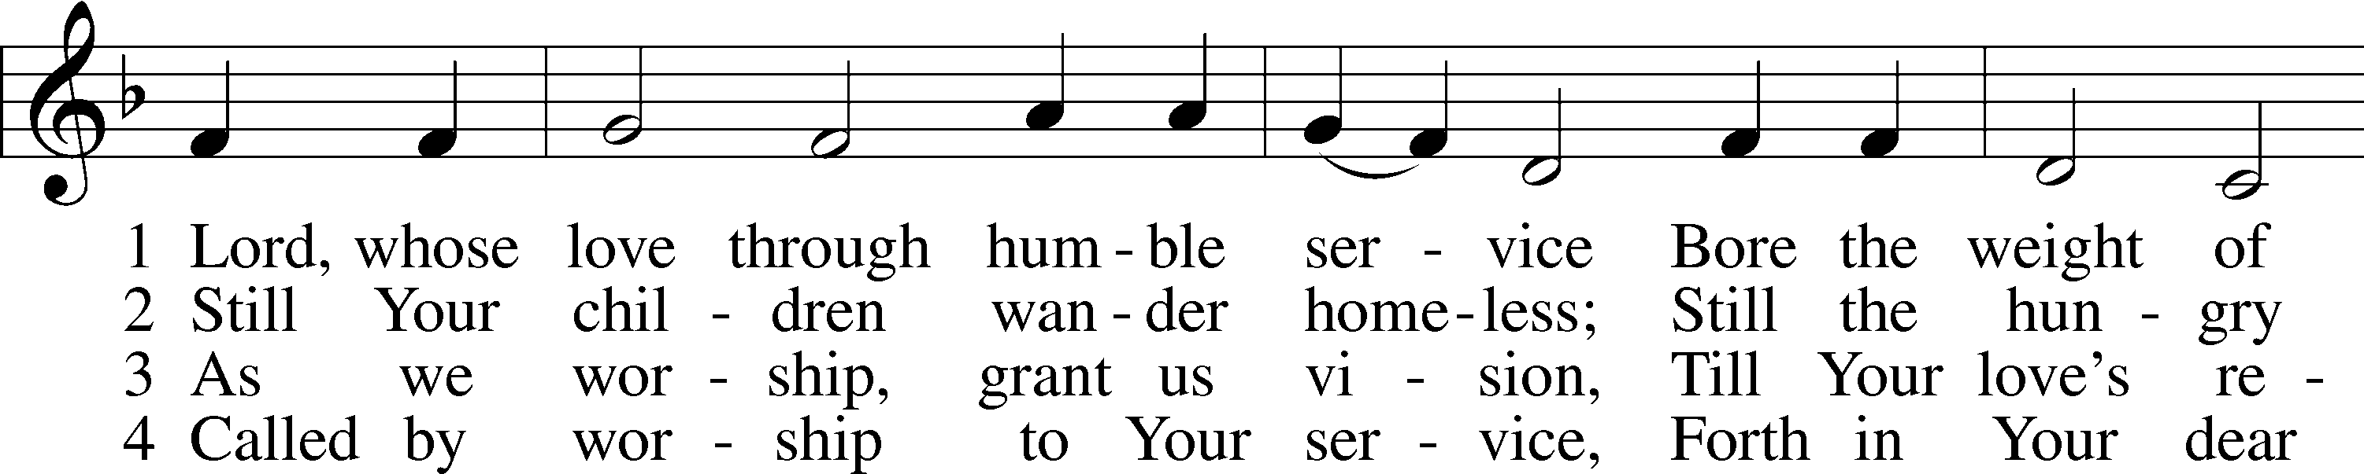
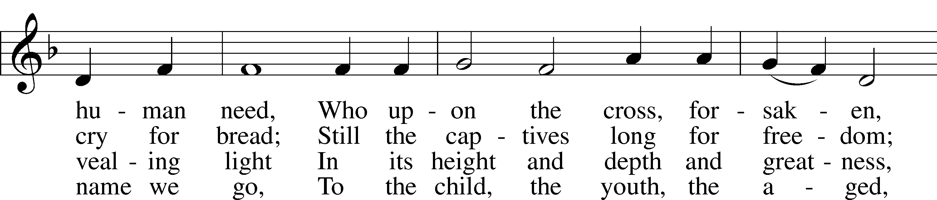
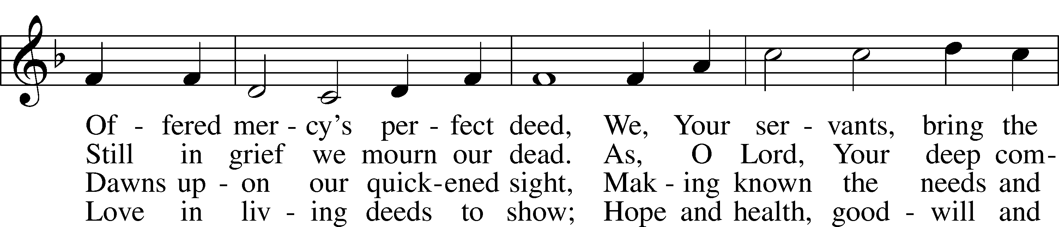
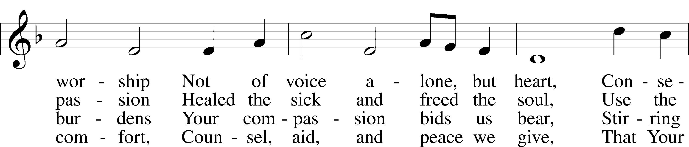
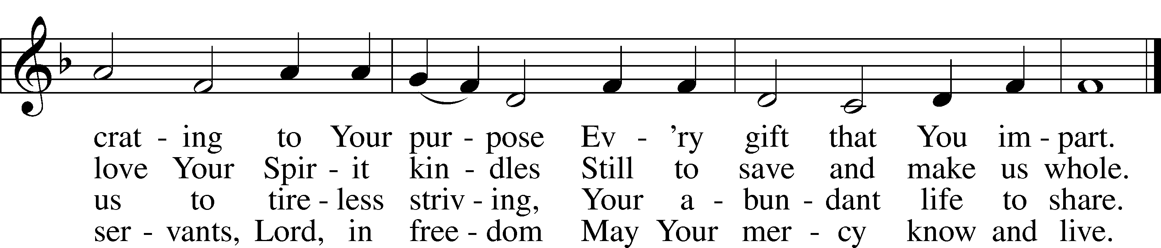

© Oxford University Press. Used by permission: LSB Hymn License .NET, no. 100011462.

Distribution Hymn LSB 688 sts. 1-5
“Come, Follow Me,” the Savior Spake
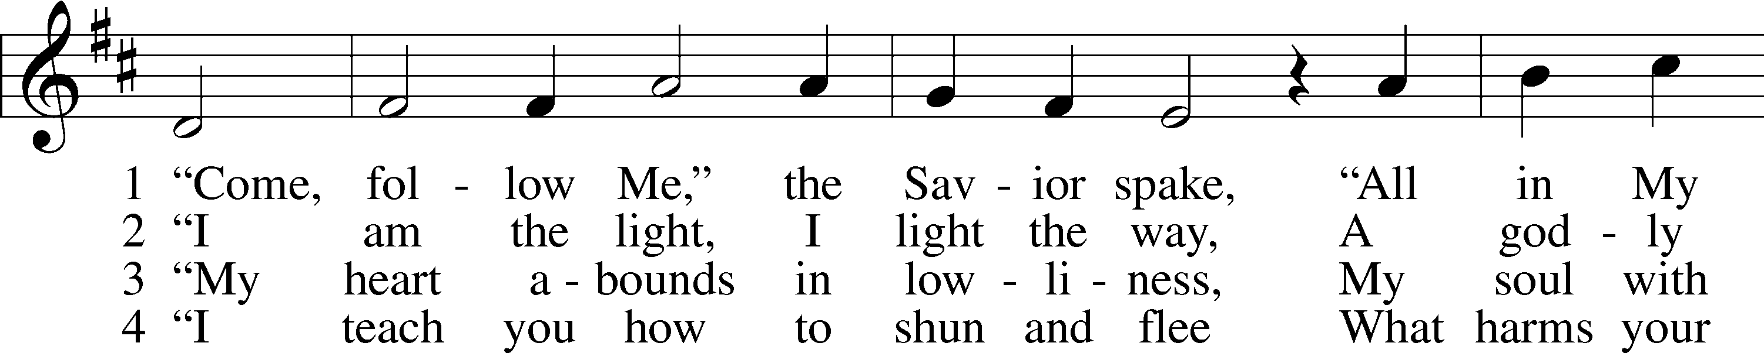
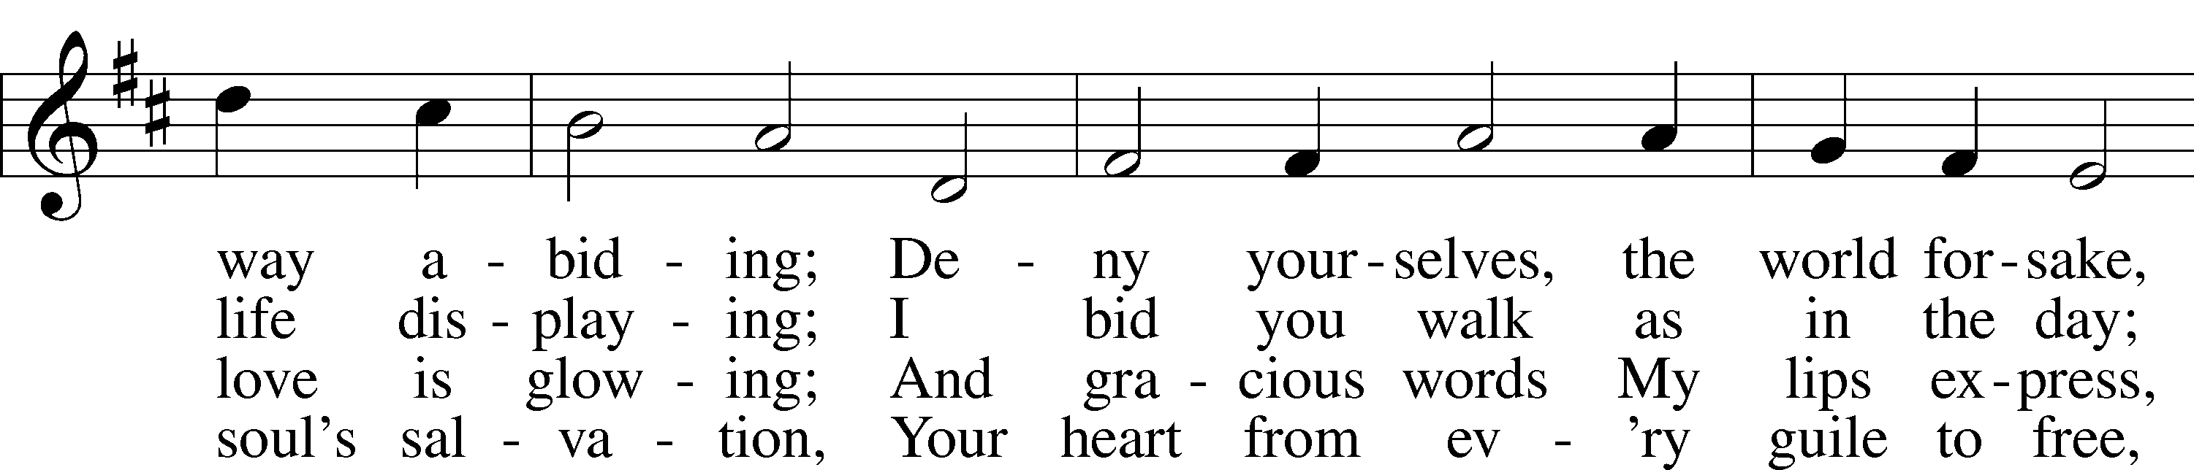
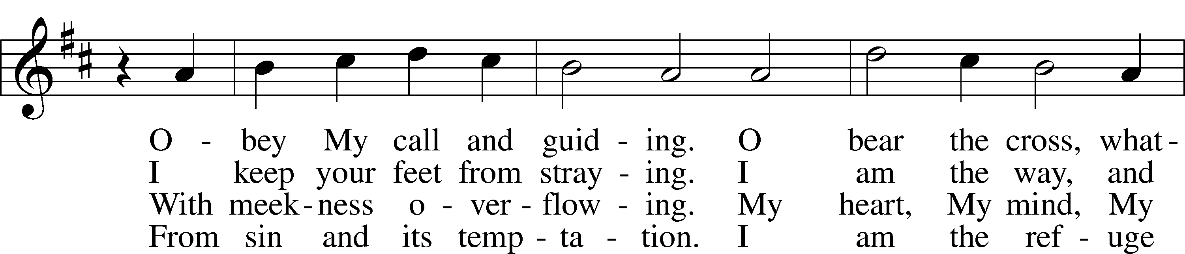
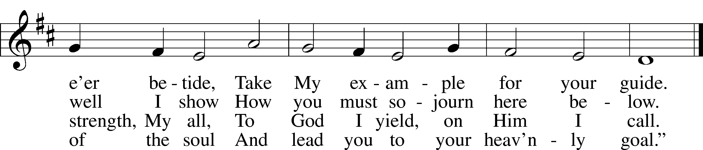

5 Then let us follow Christ, our Lord,
And take the cross appointed
And, firmly clinging to His Word,
In suff’ring be undaunted.
For those who bear the battle’s strain
The crown of heav’nly life obtain.
Public domain

Stand
Post-Communion Canticle LSB 164
Thank the Lord
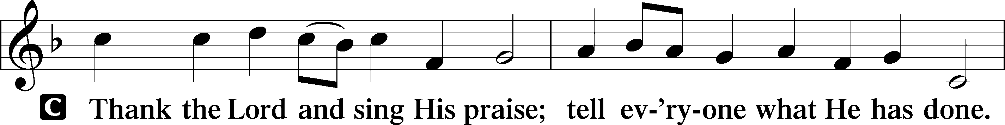
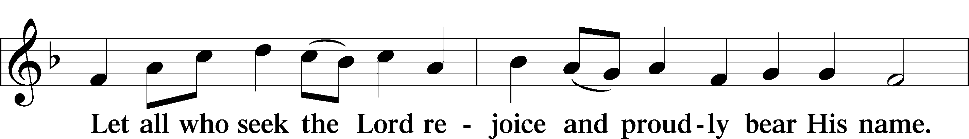
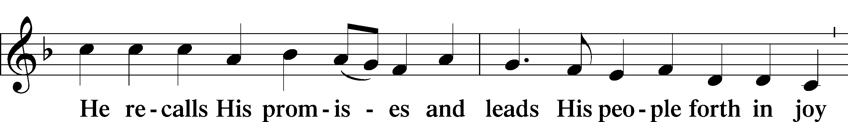
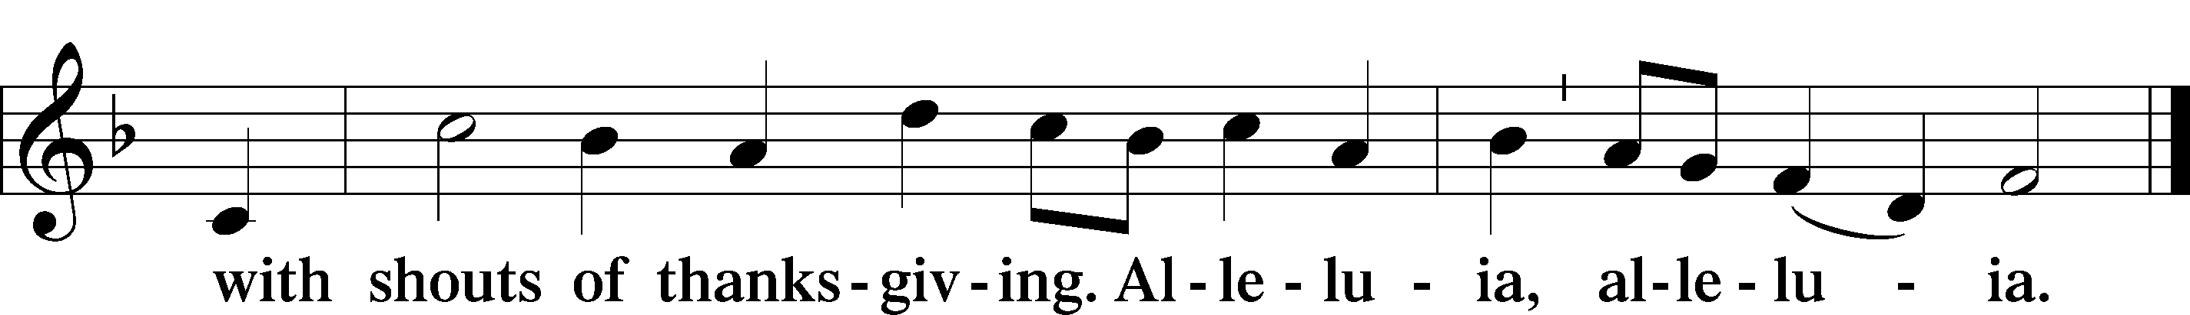

Post-Communion Collect LSB 166
P Let us pray.
P We give thanks to You, almighty God, that You have refreshed us through this
salutary gift, and we implore You that of Your mercy You would strengthen us
through the same in faith toward You and in fervent love toward one another;
through Jesus Christ, Your Son, our Lord, who lives and reigns with You and the
Holy Spirit, one God, now and forever..
C Amen.

Benediction Numbers 6:24-26, LSB 166
P The Lord bless you and keep you. The Lord make His face shine on you and be gracious to you. The Lord look upon you with favor and  give you peace.
C Amen.

Sit
Closing Hymn (requested) LSB 525 sts. 1, 3, & 4
“Crown Him with Many Crowns”
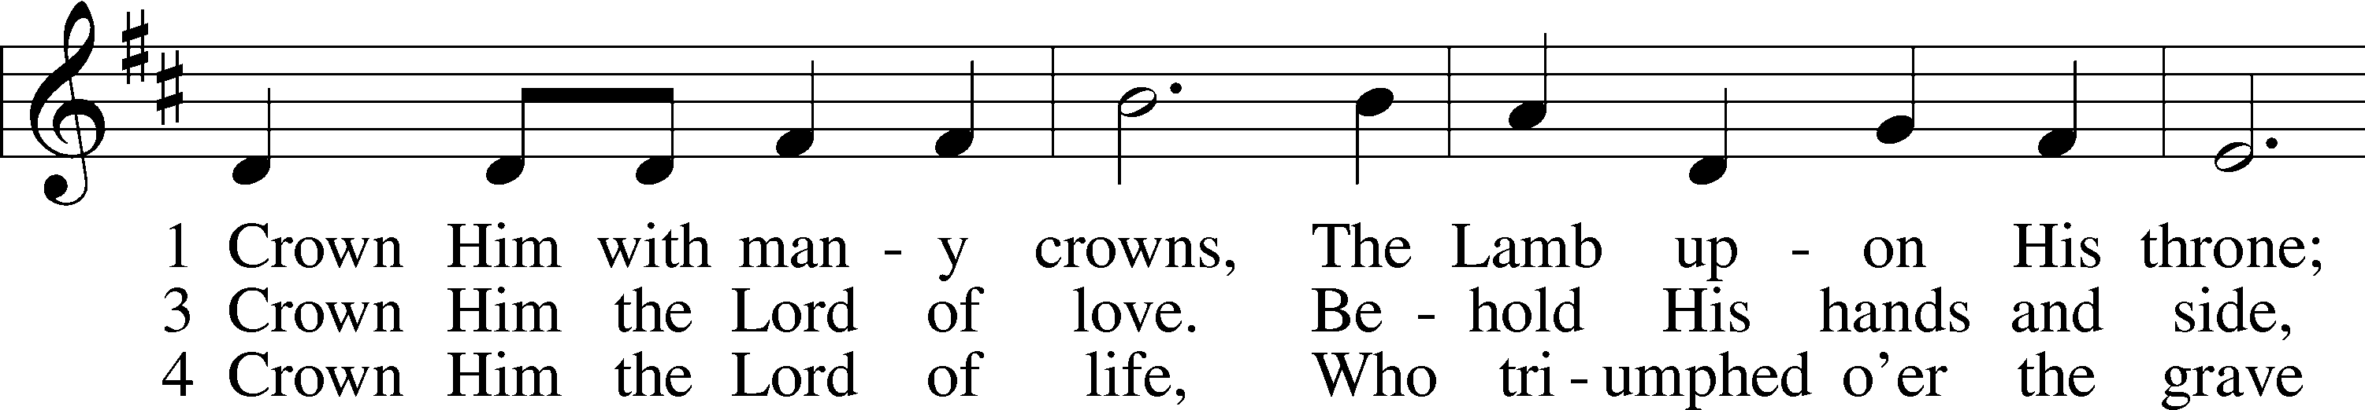
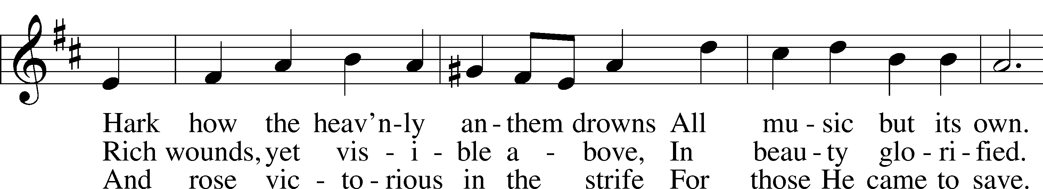
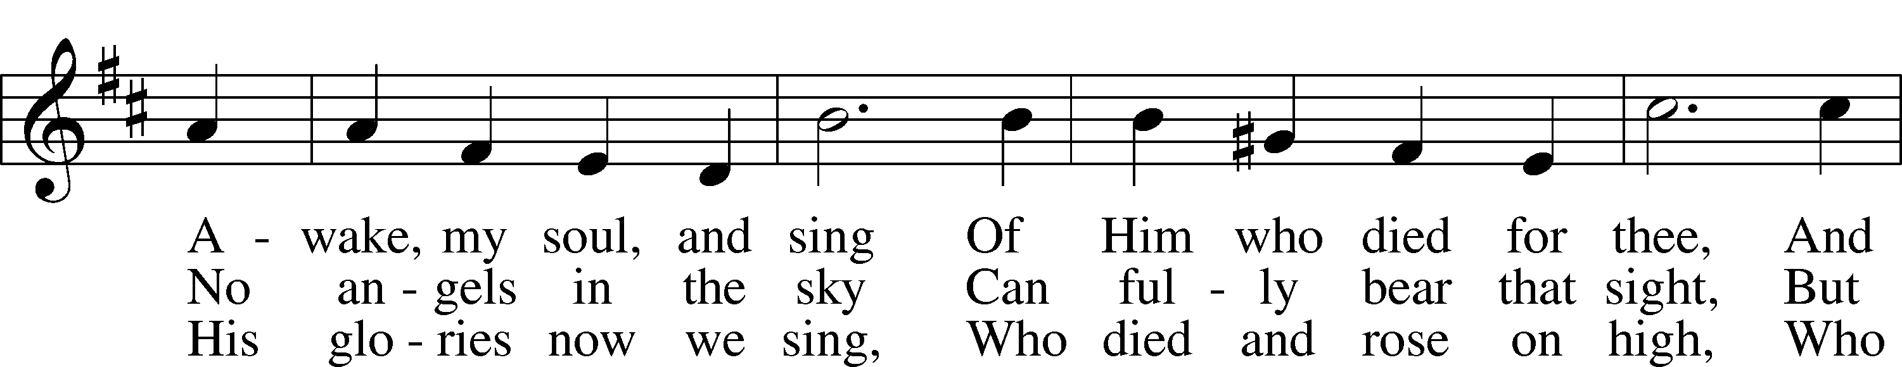
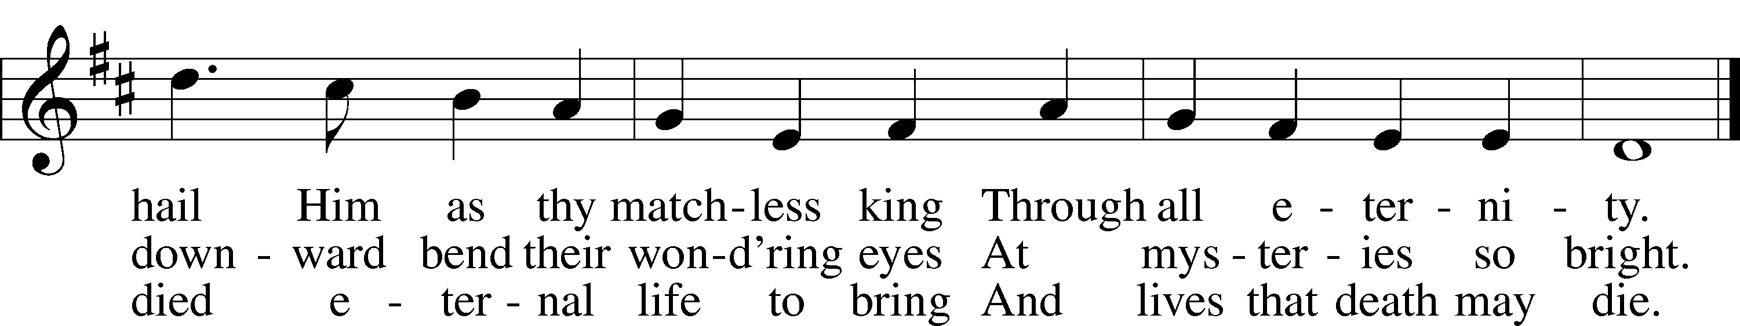

Public domain

