Zion Lutheran Church
‘Hearing, Sharing and Living the Gospel’

Zion Lutheran Church
Our mission is to hear and share the good news of the risen Jesus and, with God’s help, to live the Gospel.

Ninth Sunday after Pentecost
August 2, 2020 10:30 a.m. Service

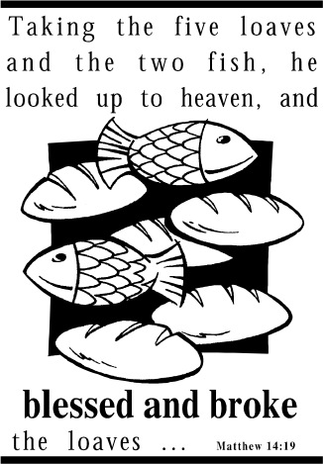

Zion Lutheran Church

‘Hearing, Sharing and Living the Gospel’
Rev. Thomas A. Rhodes, Pastor
PO Box 5 • 600 East Aldrich Road • Bolivar, MO 65613
Phone: 417-326-5506 • www.zionlutheranbolivar.org
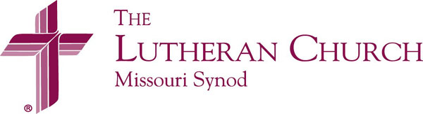
zionbolivar@windstream.net

Administrative Assistant – Sonya Gorman

You are invited to use the yellow Prayer Cards located in the pew for prayer requests. Please hand this card to an usher or place it in the offering plate.
* Please turn off cellphones*

NINTH SUNDAY AFTER PENTECOST
Divine Service – Setting Two
August 2, 2020 10:30 a.m.

Welcome & Announcements

+ INVOCATION + LSB 167
The sign of the cross may be made by all in remembrance of their Baptism.
P We begin in the name into which we are baptized; In the name of the Father and of the  Son and of the Holy Spirit.
C Amen.

Opening Hymn LSB 697 sts. 1-4
“Awake, O Sleeper, Rise from Death”
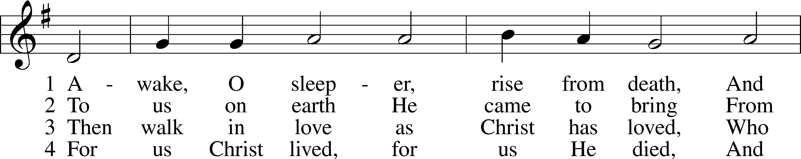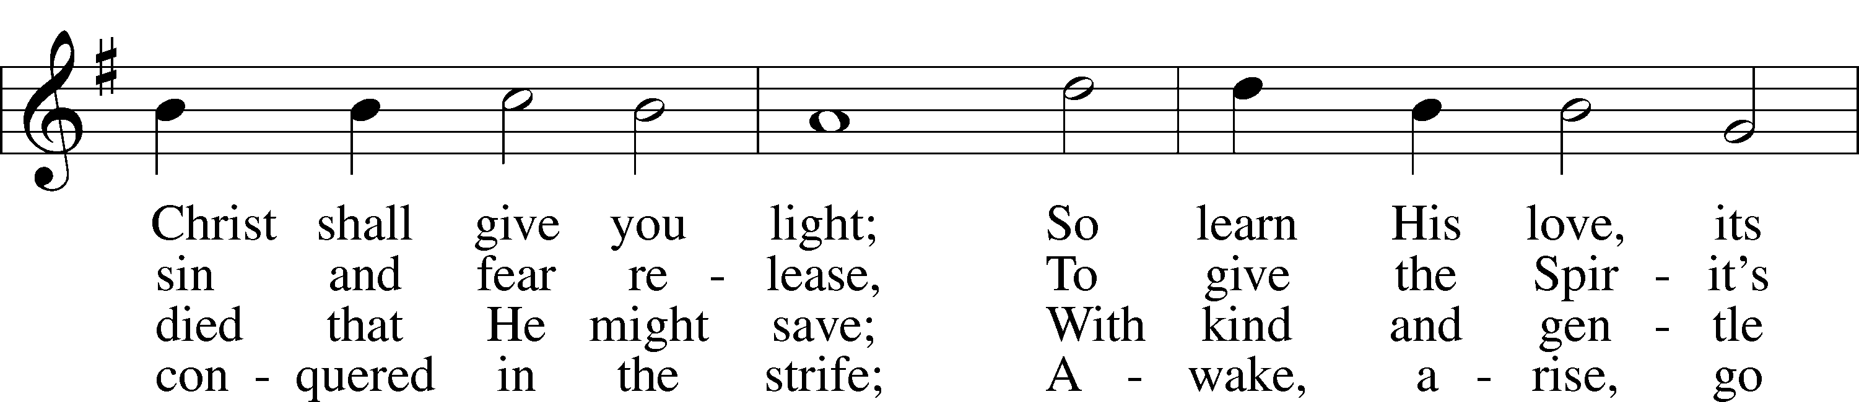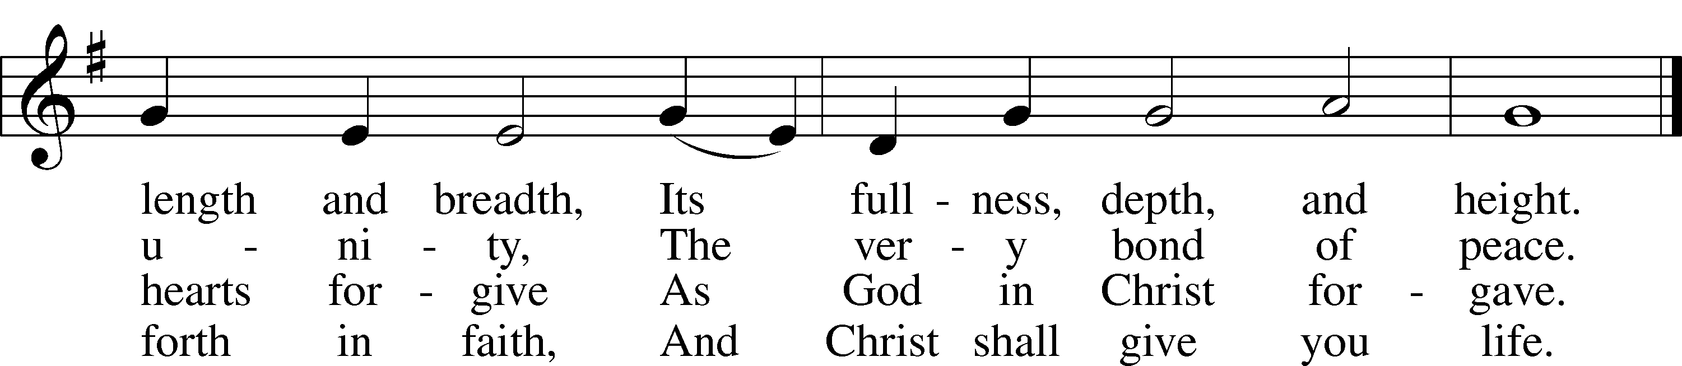

© 1984 Augsburg Publishing House. Used by permission: LSB Hymn License .NET, no. 100011462.

+ CONFESSION AND ABSOLUTION + LSB 167
P If we say we have no sin, we deceive ourselves, and the truth is not in us.
C But if we confess our sins, God, who is faithful and just, will forgive our sins and cleanse us from all unrighteousness.

(Silence for reflection on God's Word and for self-examination in light of the Ten Commandments.)

P Let us then confess our sins to God our Father.
C Most merciful God, we confess that we are by nature sinful and unclean. We have sinned against You in thought, word, and deed, by what we have done and by what we have left undone. We have not loved You with our whole heart; we have not loved our neighbors as ourselves. We justly deserve Your present and eternal punishment. For the sake of Your Son, Jesus Christ, have mercy on us. Forgive us, renew us, and lead us, so that we may delight in Your will and walk in Your ways to the glory of Your holy name. Amen.
P God be merciful to you and strengthen your faith. LSB 292
C Amen.
P Do you believe that my forgiveness is
God’s forgiveness?
C Yes. LSB 293
P Let it be done for you as you believe.
P Almighty God in His LSB 167
mercy has given His Son
to die for you and for His sake forgives you all your sins. As a called and ordained servant of Christ, and by His authority, I therefore forgive you all your sins in the name of the Father and of the  Son and of the Holy Spirit.
C Amen.

+ SERVICE OF THE WORD + LSB 168
Introit Ps. 105:39-43; antiphon: Ps. 105:1
P Oh give thanks to the Lord; call upon his name; make known his deeds among the peoples!
C He spread a cloud for a covering, and fire to give light by night.
P They asked, and he brought quail, and gave them bread from heaven in abundance.
C He opened the rock, and water gushed out; it flowed through the desert like a river.

P For he remembered his holy promise, and Abraham, his servant.
C So he brought his people out with joy, his chosen ones with singing.
P C Glory be to the Father and to the Son and to the Holy Spirit; as it was in the beginning, is now, and will be forever. Amen.
P Oh give thanks to the Lord; call upon his name; make known his deeds among the peoples!

Kyrie LSB 168
P In peace let us pray to the Lord.
C Lord, have mercy.
P For the peace from above and for our salvation let us pray to the Lord.
C Lord, have mercy.
P For the peace of the whole world, for the well-being of the Church of God, and for the unity of all let us pray to the Lord.
C Lord, have mercy.
P For this holy house and for all who offer here their worship and praise let us pray to the Lord.
C Lord, have mercy.
P Help, save, comfort, and defend us, gracious Lord.
C Amen.
Hymn of Praise LSB 171 sts. 1-4
“Rock of Ages, Cleft for Me”
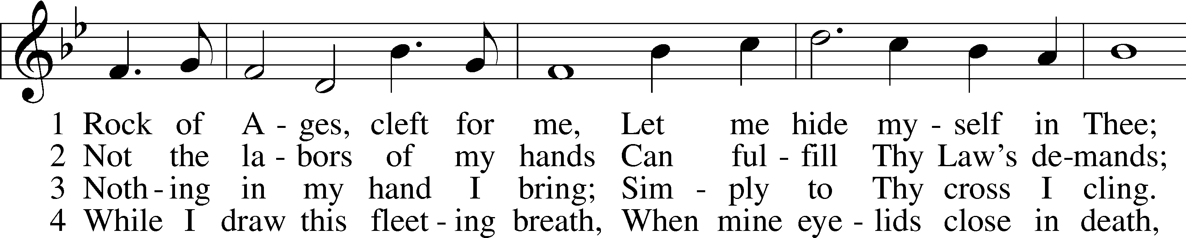
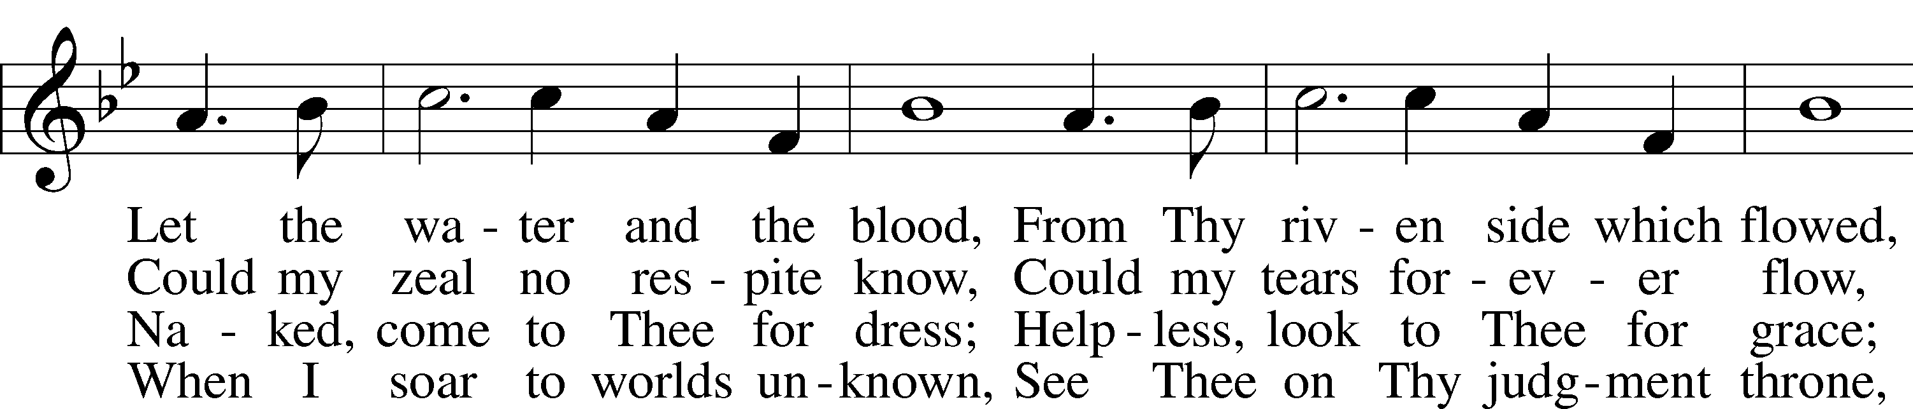
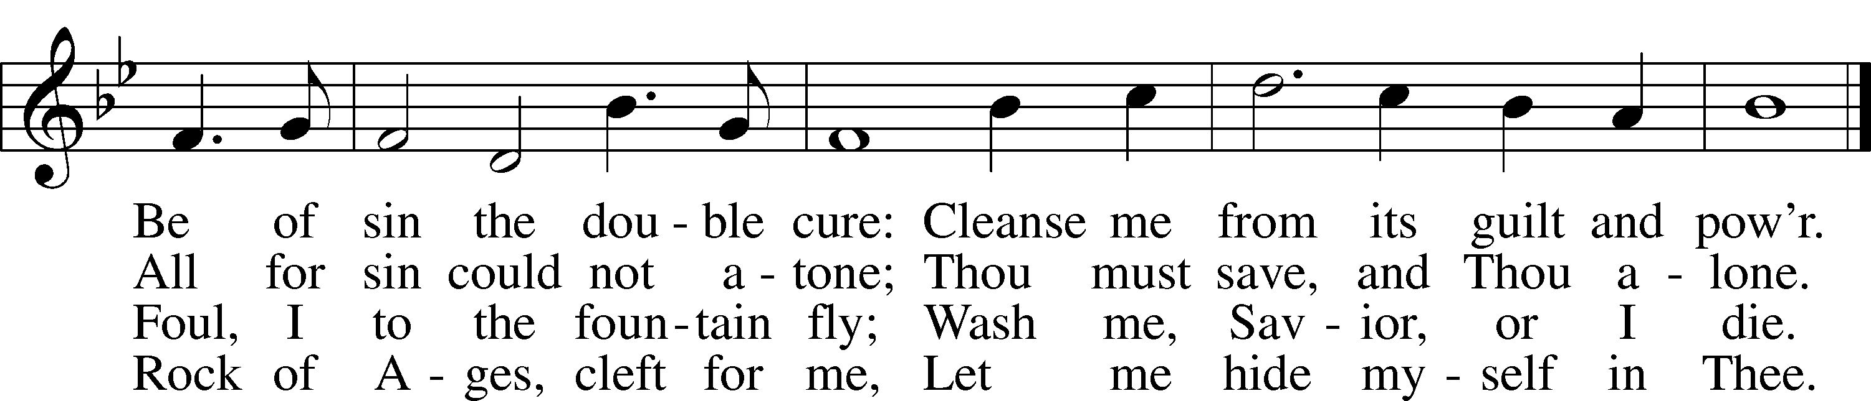
Public domain

Salutation and Collect of the Day LSB 172
P The Lord be with you.
C And also with you.
P Let us pray. Heavenly Father, though we do not deserve Your goodness, still You provide for all our needs of body and soul. Grant us Your Holy Spirit that we may acknowledge Your gifts, give thanks for all Your benefits, and serve You in willing obedience; through Jesus Christ, Your Son, our Lord, who lives and reigns with You and the Holy Spirit, one God, now and forever.
C Amen.

Sit
Old Testament Reading Isaiah 55:1-5
55 “Come, all you who are thirsty, come to the waters; and you who have no money, come, buy and eat! Come, buy wine and milk without money and without cost.
2 Why spend money on what is not bread, and your labor on what does not satisfy? Listen, listen to me, and eat what is good, and you will delight in the richest of fare.
3 Give ear and come to me; listen, that you may live. I will make an everlasting covenant with you, my faithful love promised to David.
4 See, I have made him a witness to the peoples, a ruler and commander of the peoples.
5 Surely you will summon nations you know not, and nations you do not know will come running to you, because of the Lord your God, the Holy One of Israel, for he has endowed you with splendor.”

A This is the Word of the Lord.
C Thanks be to God.

Gradual Rom. 11:33, 36
A C Oh, the depth of the riches and wisdom and knowledge of God! How unsearchable are his judgments and how inscrutable his ways! For from him and through him and to him are all things. To him be glory forever. Amen.

Epistle Reading Romans 9:1-13
9 I speak the truth in Christ—I am not lying, my conscience confirms it through the Holy Spirit— 2 I have great sorrow and unceasing anguish in my heart. 3 For I could wish that I myself were cursed and cut off from Christ for the sake of my people, those of my own race, 4 the people of Israel. Theirs is the adoption to sonship; theirs the divine glory, the covenants, the receiving of the law, the temple worship and the promises. 5 Theirs are the patriarchs, and from them is traced the human ancestry of the Messiah, who is God over all, forever praised! Amen.
6 It is not as though God’s word had failed. For not all who are descended from Israel are Israel. 7 Nor because they are his descendants are they all Abraham’s children. On the contrary, “It is through Isaac that your offspring will be reckoned.” 8 In other words, it is not the children by physical descent who are God’s children, but it is the children of the promise who are regarded as Abraham’s offspring.
9 For this was how the promise was stated: “At the appointed time I will return, and Sarah will have a son.” 10 Not only that, but Rebekah’s children were conceived at the same time by our father Isaac. 11 Yet, before the twins were born or had done anything good or bad—in order that God’s purpose in election might stand: 12 not by works but by him who calls—she was told, “The older will serve the younger.” 13 Just as it is written: “Jacob I loved, but Esau I hated.”

A This is the Word of the Lord.
C Thanks be to God.

Stand
Alleluia and Verse LSB 173
P C Alleluia. Lord, to whom shall we go? You have the words of eternal life. Alleluia.

Holy Gospel Matthew 14:13-21
P The Holy Gospel according to St. Matthew, the fourteenth chapter.
C Glory to You, O Lord.

13 When Jesus heard what had happened, he withdrew by boat privately to a solitary place. Hearing of this, the crowds followed him on foot from the towns. 14 When Jesus landed and saw a large crowd, he had compassion on them and healed their sick.
15 As evening approached, the disciples came to him and said, “This is a remote place, and it’s already getting late. Send the crowds away, so they can go to the villages and buy themselves some food.”
16 Jesus replied, “They do not need to go away. You give them something to eat.”
17 “We have here only five loaves of bread and two fish,” they answered.
18 “Bring them here to me,” he said.
19 And he directed the people to sit down on the grass. Taking the five loaves and the two fish and looking up to heaven, he gave thanks and broke the loaves. Then he gave them to the disciples, and the disciples gave them to the people.
20 They all ate and were satisfied, and the disciples picked up twelve basketfuls of broken pieces that were left over. 21 The number of those who ate was about five thousand men, besides women and children.

P This is the Gospel of the Lord.
C Praise to You, O Christ.

Sit
Hymn of the Day LSB 849 sts. 1-3
“Praise the One Who Breaks the Darkness”
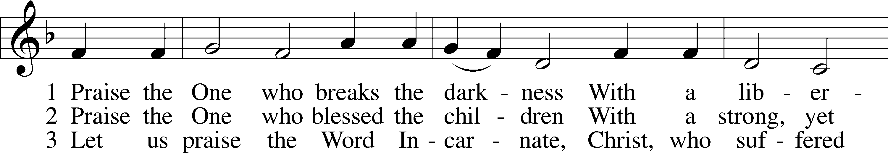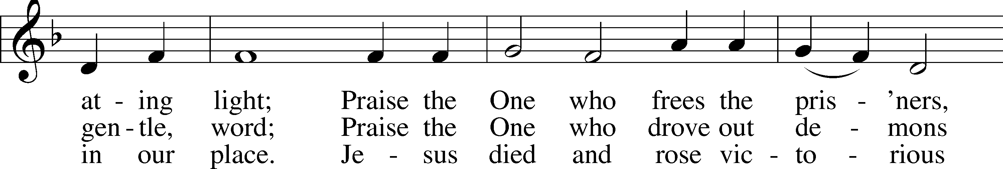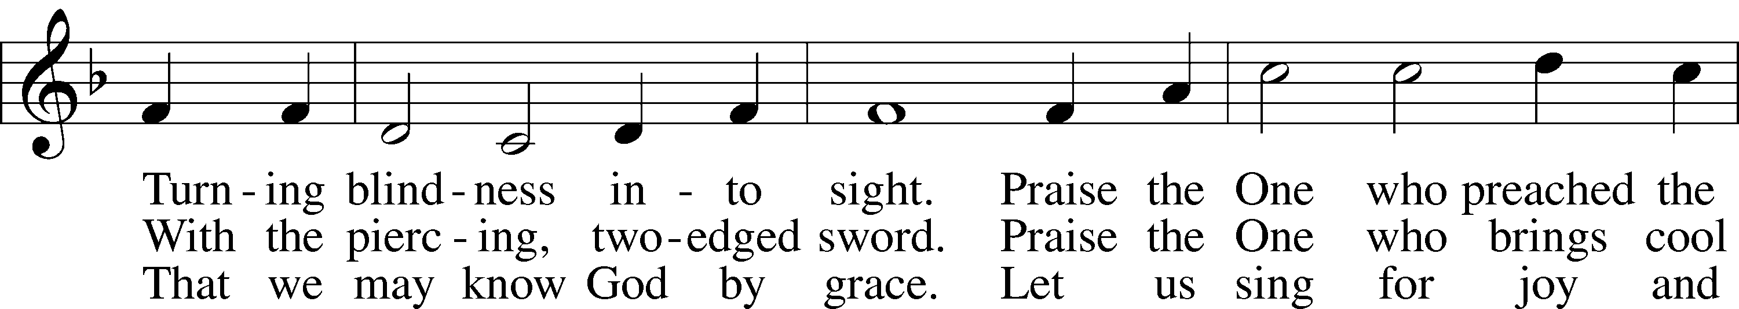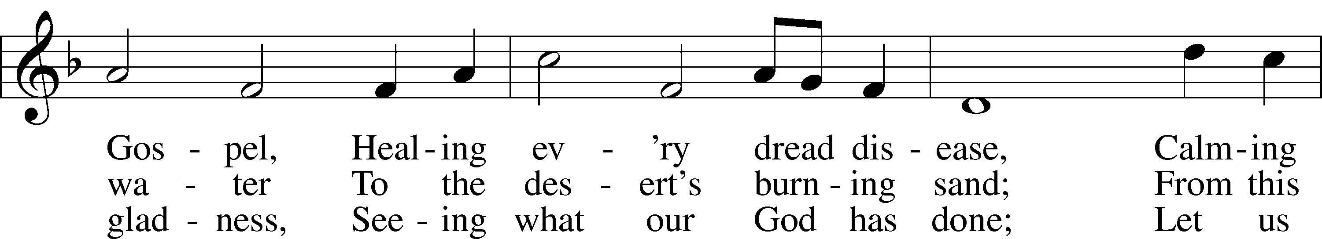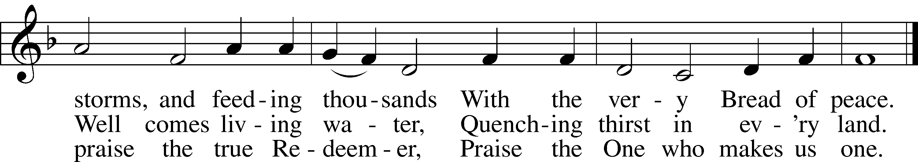
© 1987 Hope Publishing Co. Used by permission: LSB Hymn License .NET, no. 100011462.

Sermon “One Focus, One Supply”
Pastor Tom Rhodes

Stand
Apostles’ Creed LSB 175
P C I believe in God, the Father Almighty, maker of heaven and earth.

And in Jesus Christ, His only Son, our Lord,
who was conceived by the Holy Spirit,
born of the virgin Mary,
suffered under Pontius Pilate,
was crucified, died and was buried.
He descended into hell.
The third day He rose again from the dead.
He ascended into heaven
and sits at the right hand of God the Father Almighty.
From thence He will come to judge the living and the dead.

I believe in the Holy Spirit,
the holy Christian Church,
the communion of saints,
the forgiveness of sins,
the resurrection of the body,
and the life  everlasting. Amen.

Prayer of the Church LSB 175
P Lord, You have taught us to put all things into Your hands of mercy. Hear us as we heed Your call and turn to You in prayer, confident of Your promise to hear and answer us.

Brief silence

P Father, grant us Your Holy Spirit, that our hearts may be turned to Your Word, that we may hunger after Your grace, and that we may discern truth from error. Lord, in Your mercy,
C hear our prayer.

P Father, we give You thanks that You have blessed us beyond what we deserve and given to us Your Church. Guard our life together by Your Spirit, and strengthen our witness before the nations. Lord, in Your mercy,
C hear our prayer.

P Father, we too quickly focus on what we lack and not on Your unlimited grace. Bless all relief agencies and services of Your Church on behalf of the hungry, the homeless, the hurting and those who have lost hope. Open our hearts to help. Lord, in Your mercy,
C hear our prayer.

P Father, we are daily blessed to know abundance and freedom. Guard those who defend us from our enemies, who serve us in government and who protect us in our communities. Be with our president, the Congress, our governor, and our judges and magistrates, that they may be led by You to lead us with honor and integrity. Lord, in Your mercy,
C hear our prayer.

P Father, we suffer with all manner of ills and afflictions. Hear us and grant to us healing according to Your will, strength in time of trial and peace at the last. We pray especially for those on our prayer list and cards. Lord, in Your mercy,
C hear our prayer.

P Father, we know that Your steadfast love and mercy are forever, but our faith is daily tested and tempted. Give us strength and endurance, that we may not despair but have confidence in Your sufficient grace. Guide us to seek our consolation in Your Word. Lord, in Your mercy,
C hear our prayer.

P Father, we remember the saints who lived by Your mercy and died in Christ. We long for that day when all divisions will end and the Church in heaven and earth shall be one in Your presence, singing Your praise in Your kingdom without end. Lord, in Your mercy,
C hear our prayer.

P Father, we ask You to grant us all things needful and to keep from us all things harmful to us and to our salvation, for we trust Your wisdom and Your love; through Jesus Christ, our Lord.
C Amen.

Offering LSB 176
In quiet devotion and responding in personal stewardship of God’s abundant provision to you, please use the offering plates in the back as you enter or exit. (This is just as it says: An offering to God through His church. As a reassurance to those in worship today, especially our guests - this is not an obligation - the good news of Jesus is free to all!)

Stand
Stewardship Prayer
P C Father, we are daily and richly surrounded with Your love and care. Grant us eyes to see Your mercies new every morning and grateful hearts, that what we have received we may share with those in need and generously support the work of Your Church. In Jesus name, Amen.

Offertory
Psalm 116:12-13, 17-19; LSB 176
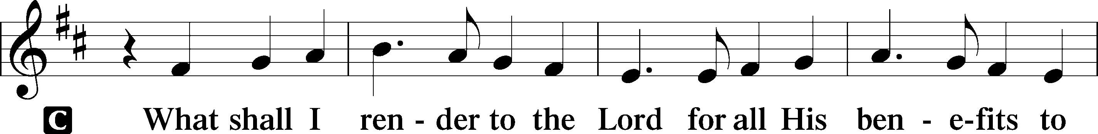
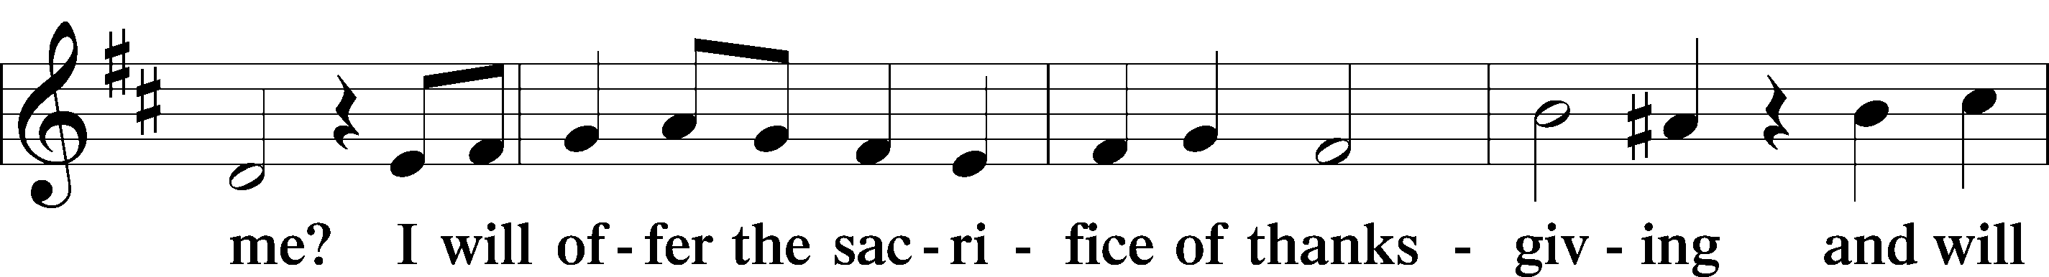
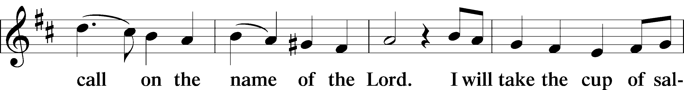
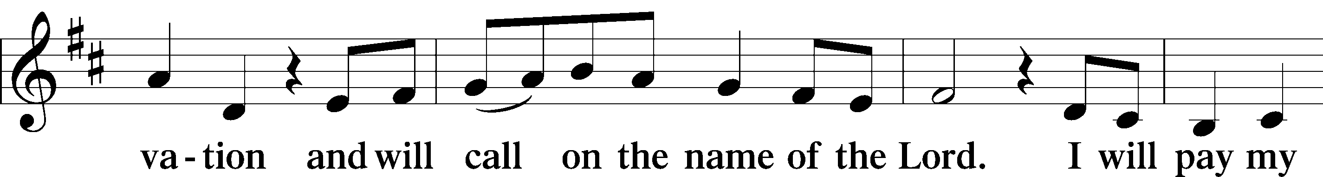
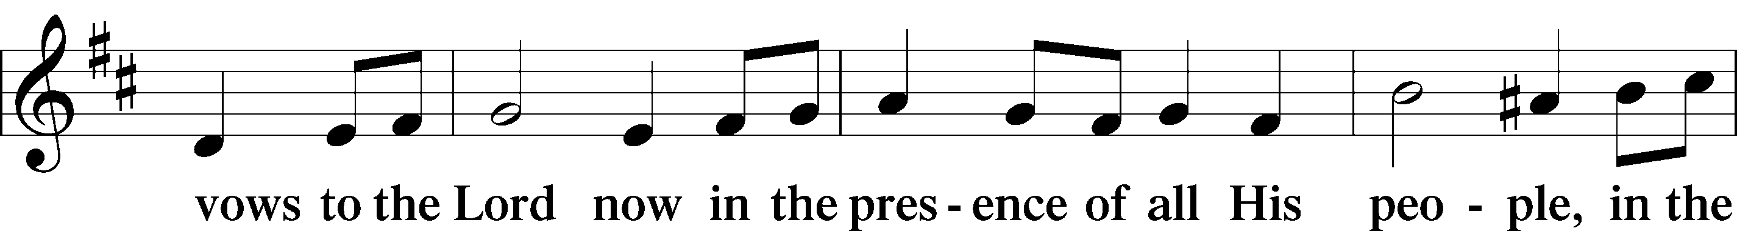
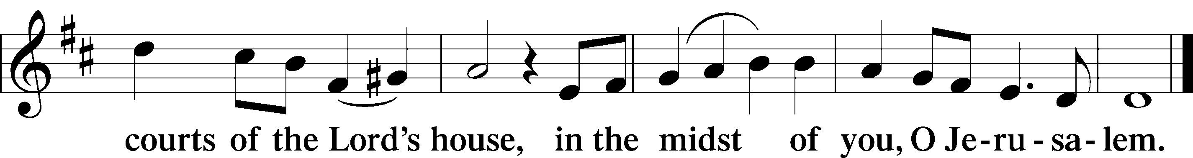

Lord's Prayer Matthew 6:9-13, LSB 179
P Lord, remember us in Your kingdom and teach us to pray:
C Our Father who art in heaven,
hallowed be Thy name,
Thy kingdom come,
Thy will be done on earth
as it is in heaven;
give us this day our daily bread;
and forgive us our trespasses
as we forgive those
who trespass against us;
and lead us not into temptation,
but deliver us from evil.
For Thine is the kingdom
and the power and the glory
forever and ever. Amen.

Benediction Numbers 6:24-26, LSB 183
P The Lord bless you and keep you. The Lord make His face shine on you and be gracious to you. The Lord look upon you with favor and  give you peace.
C Amen.

Closing Hymn LSB 895 sts. 1-3
“Now Thank We All Our God”
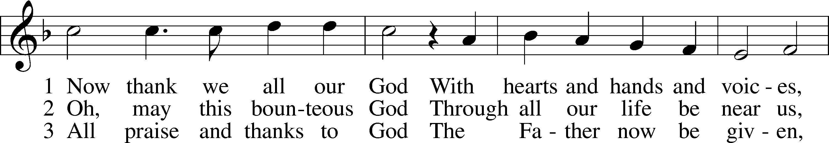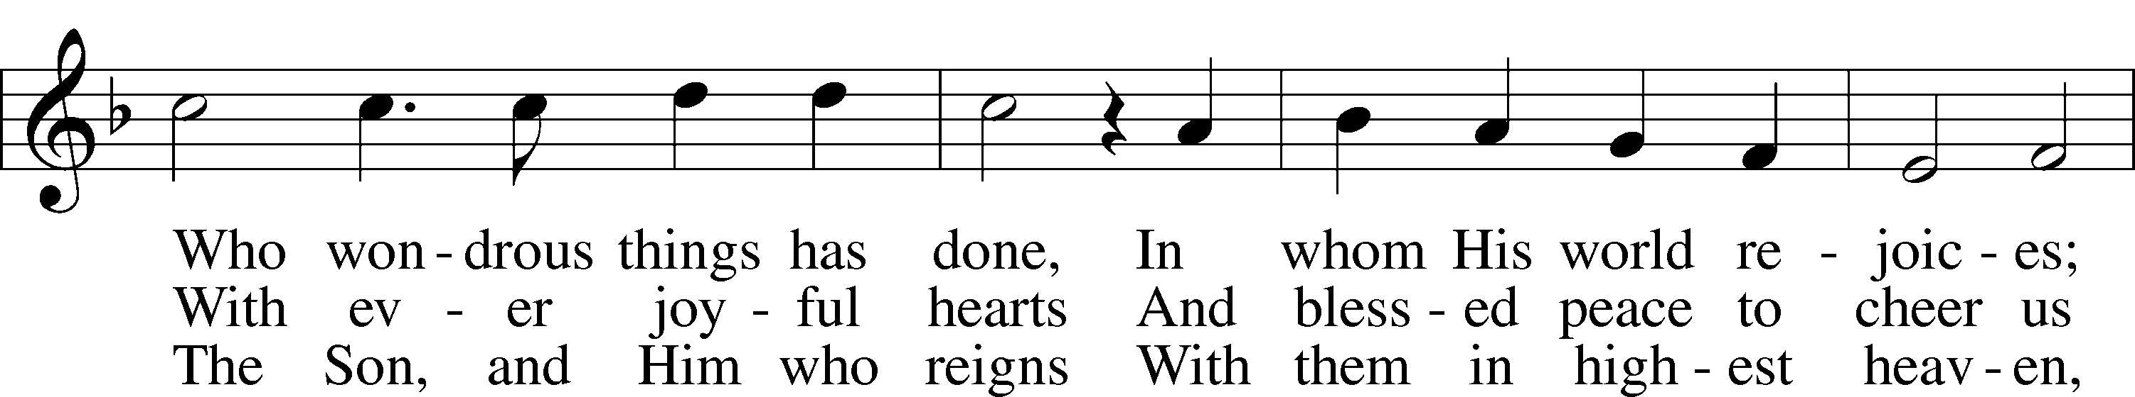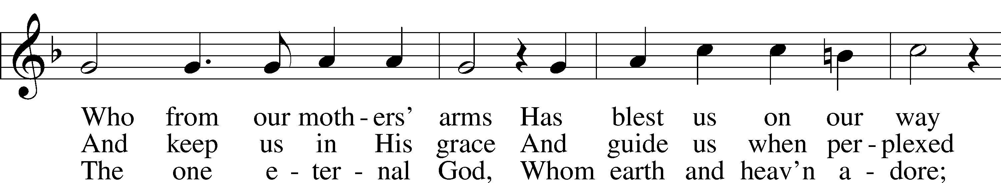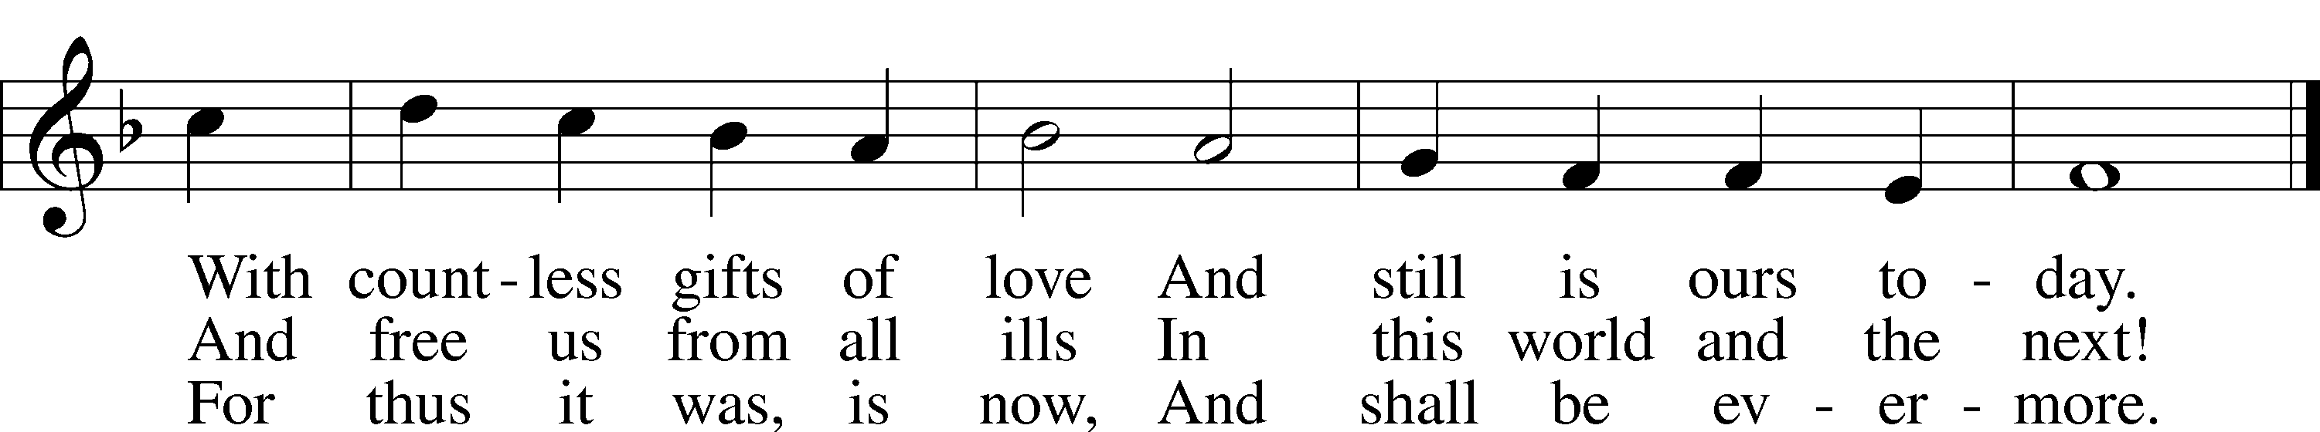

Public domain

