Zion Lutheran Church
‘Hearing, Sharing and Living the Gospel.’

Zion Lutheran Church
Our mission is to hear and share the good news of the risen Jesus and, with God’s help, to live the Gospel.

Nineteenth Sunday after Pentecost
October 11, 2020 10:30 a.m. Service

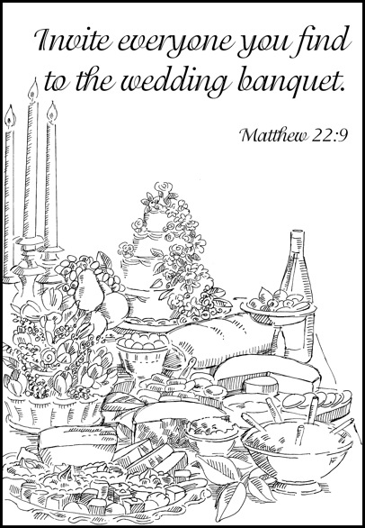

Zion Lutheran Church

‘Hearing, Sharing and Living the Gospel’
Rev. Thomas A. Rhodes, Pastor
PO Box 5 • 600 East Aldrich Road • Bolivar, MO 65613
Phone: 417-326-5506 • www.zionlutheranbolivar.org

zionbolivar@windstream.net


Administrative Assistant – Sonya Gorman
You are invited to use the yellow Prayer Cards located in the pew for prayer requests. Please hand this card to an usher or place it in the offering plate.
* Please turn off cellphones*

NINETEENTH SUNDAY AFTER PENTECOST
Divine Service – Setting Three
October 11, 2020 10:30 a.m.

Welcome & Announcements

+ INVOCATION + LSB 184
The sign of the cross may be made by all in remembrance of their Baptism.
P We begin in the name into which we are baptized; In the name of the Father and of the  Son and of the Holy Spirit.
C Amen.

Opening Hymn LSB 973 sts. 1-2
“Thy Word is a Lamp”
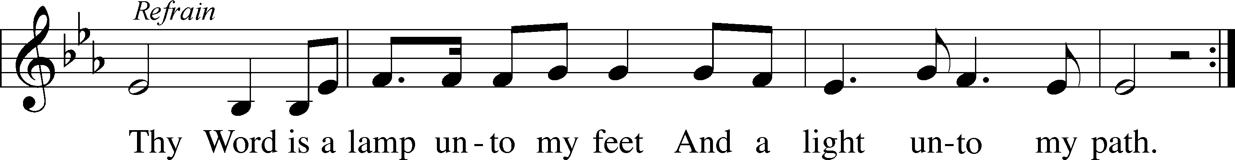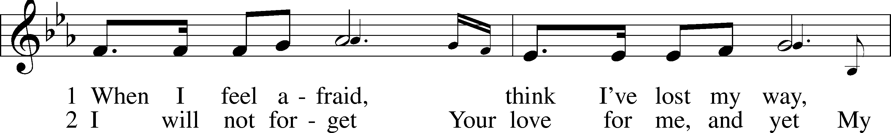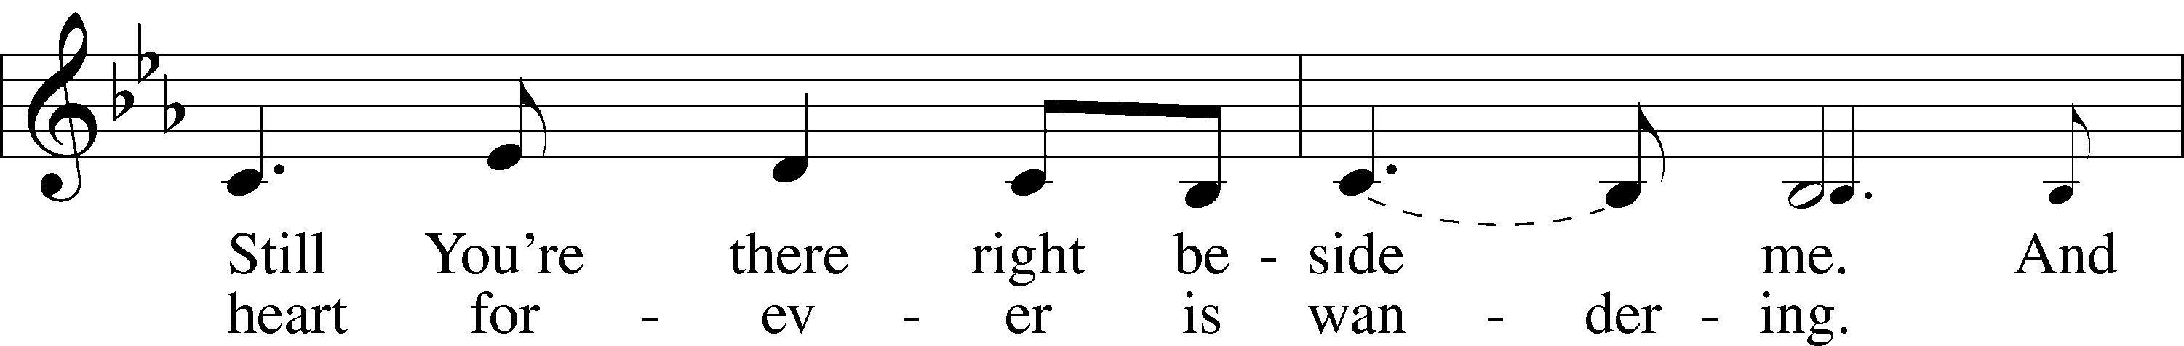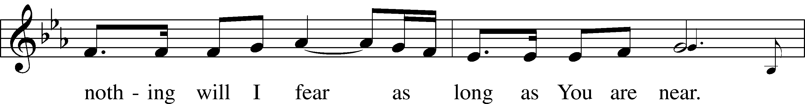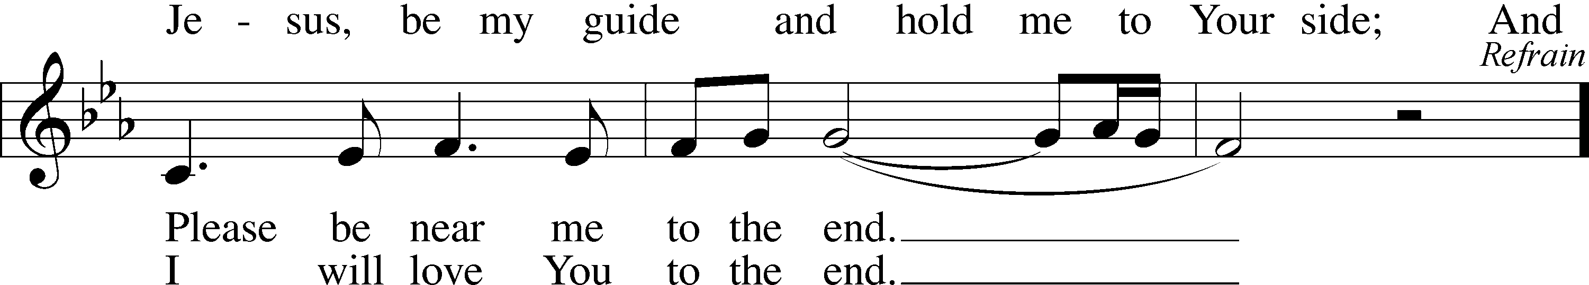
© 1984 Meadowgreen Music Company; admin EMI. Used by permission: LSB Hymn License .NET, number 100011462

+ CONFESSION AND ABSOLUTION + LSB 184
P Beloved in the Lord! Let us draw near with a true heart and confess our sins unto God our Father, beseeching Him in the name of our Lord Jesus Christ to grant us forgiveness.

P Our help is in the name of the Lord,
C who made heaven and earth.
P I said, I will confess my transgressions unto the Lord,
C and You forgave the iniquity of my sin.

(Silence for reflection on God's Word and for self-examination in light of the Ten Commandments.)

P Almighty God, our maker and redeemer, we poor sinners confess unto You that we are by nature sinful and unclean and that we have sinned against You by thought, word, and deed. Wherefore we flee for refuge to Your infinite mercy, seeking and imploring Your grace for the sake of our Lord Jesus Christ.
C O most merciful God, who has given Your only-begotten Son to die for us, have mercy upon us and for His sake grant us remission of all our sins; and by Your Holy Spirit increase in us true knowledge of You and of Your will and true obedience to Your Word, to the end that by Your grace we may come to everlasting life; through Jesus Christ, our Lord. Amen.
P God be merciful to you and strengthen your faith. LSB 292
C Amen.
P Do you believe that my forgiveness is God’s forgiveness? LSB 293
C Yes.
P Let it be done for you as you believe.
P Upon this your confession, LSB 185
I, by virtue of my office, as a called
and ordained servant of the Word, announce the grace of God unto all of you, and in the stead and by the command of my Lord Jesus Christ I forgive you all your sins in the name of the Father and of the  Son and of the Holy Spirit.
C Amen.

+ SERVICE OF THE WORD + LSB 186
Introit Is.61:10; antiphon: Ps. 146:2
P I will praise the Lord as long as I live; I will sing praises to my God while I have my being.
C I will greatly rejoice in the Lord; my soul shall exult in my God,
P for he has clothed me with the garments of salvation; he has covered me with the robe of righteousness,
C as a bridegroom decks himself like a priest with a beautiful headdress, and as a bride adorns herself with her jewels.
P C Glory be to the Father and to the Son and to the Holy Spirit; as it was in the beginning, is now, and will be forever. Amen.
P I will praise the Lord as long as I live; I will sing praises to my God while I have my being.

Gloria Patri LSB 186
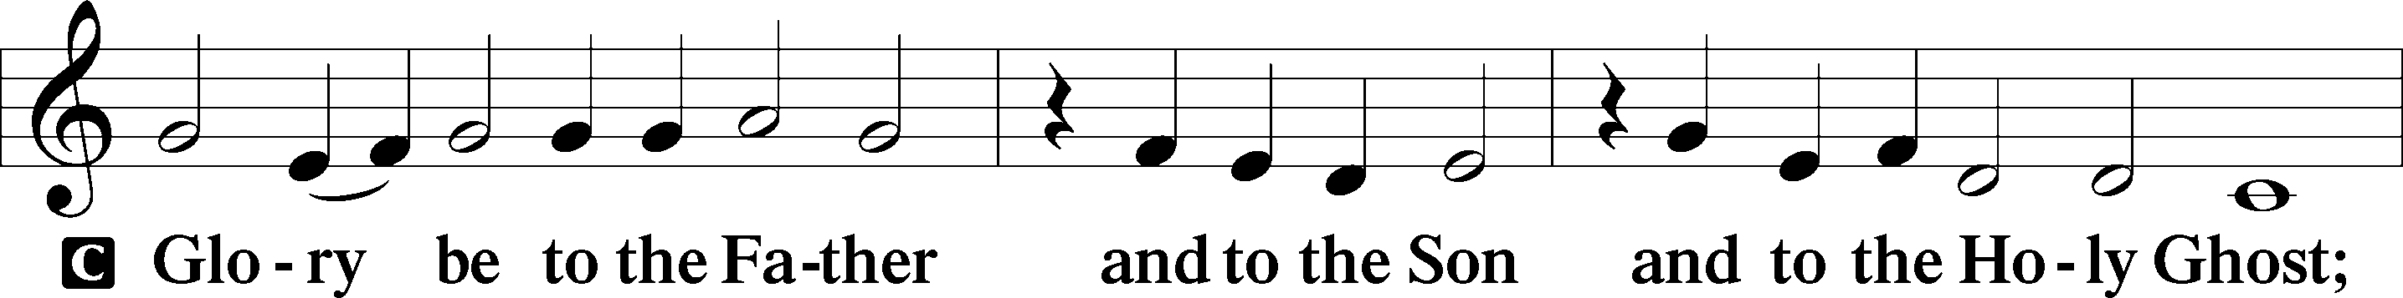
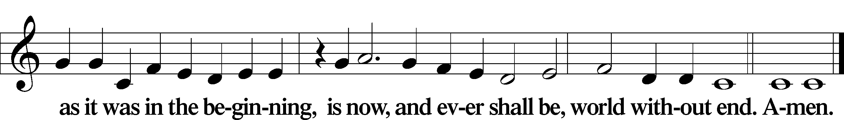

Kyrie Mark 10:47, LSB 186
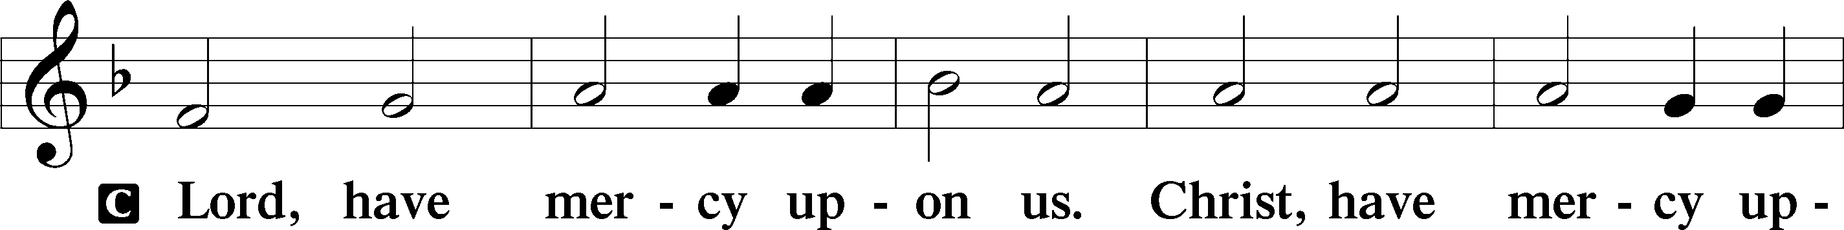
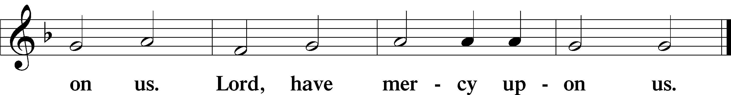

Hymn of Praise/Gloria in Excelsis LSB 187
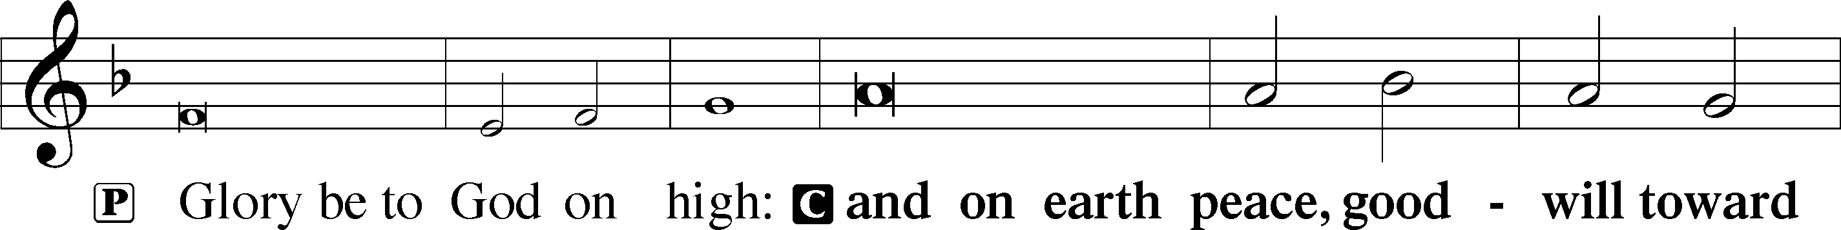
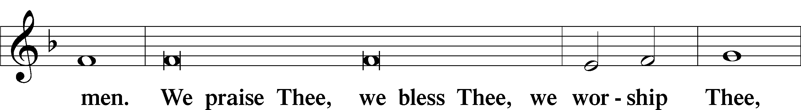
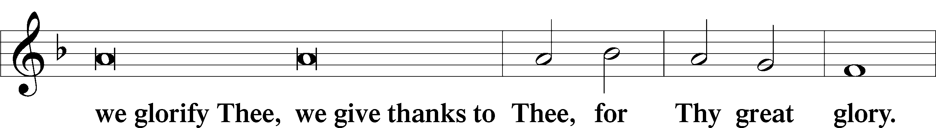
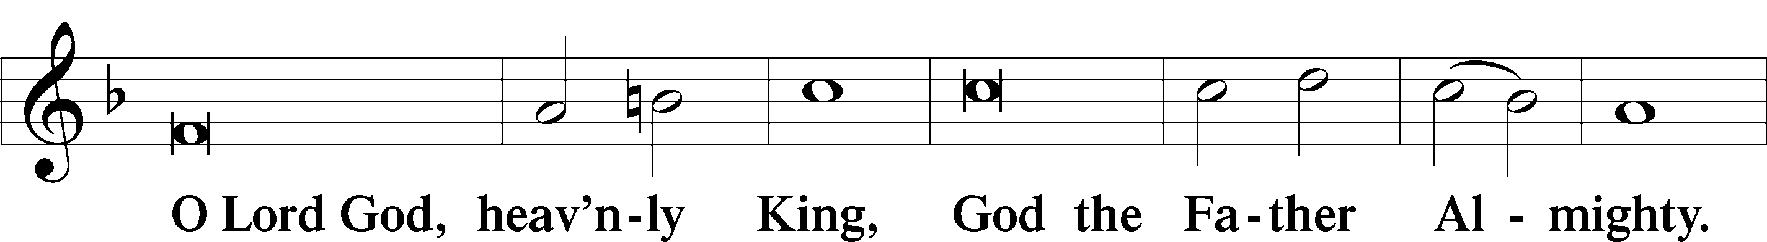
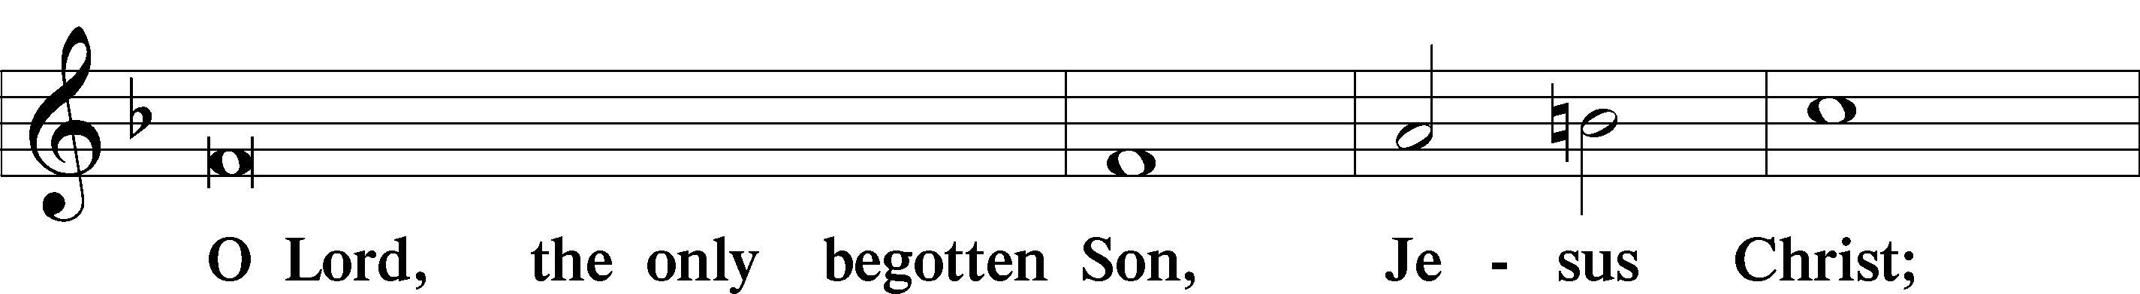
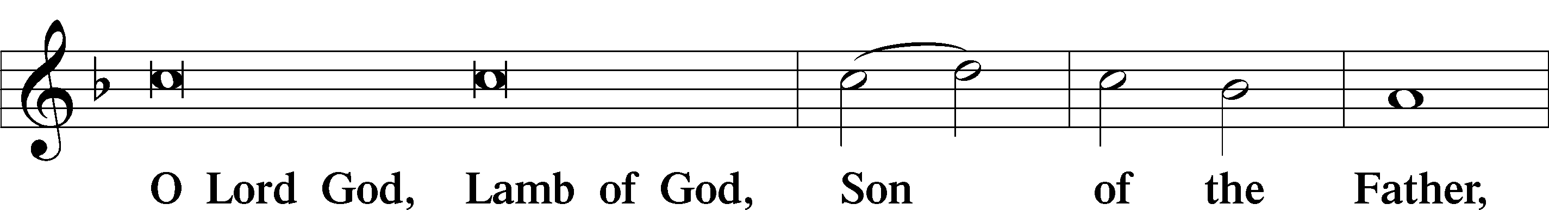
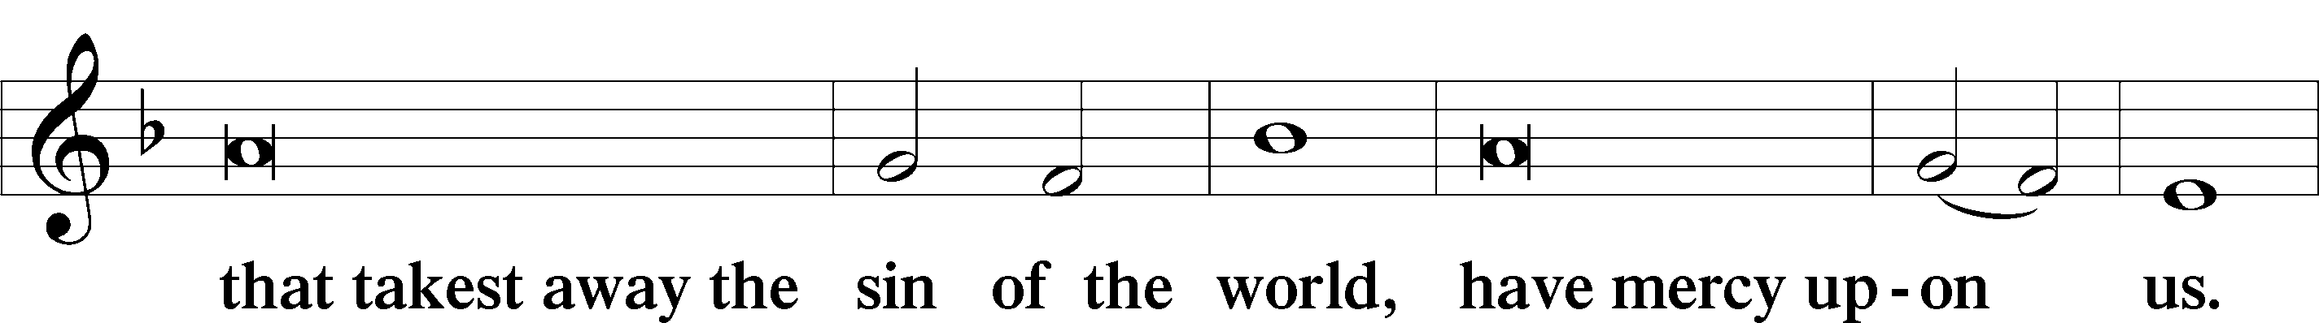
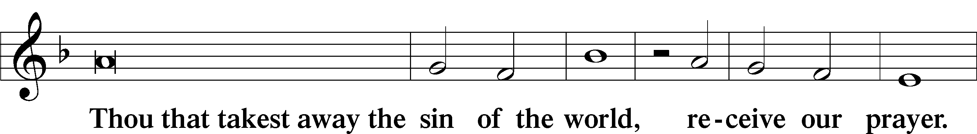
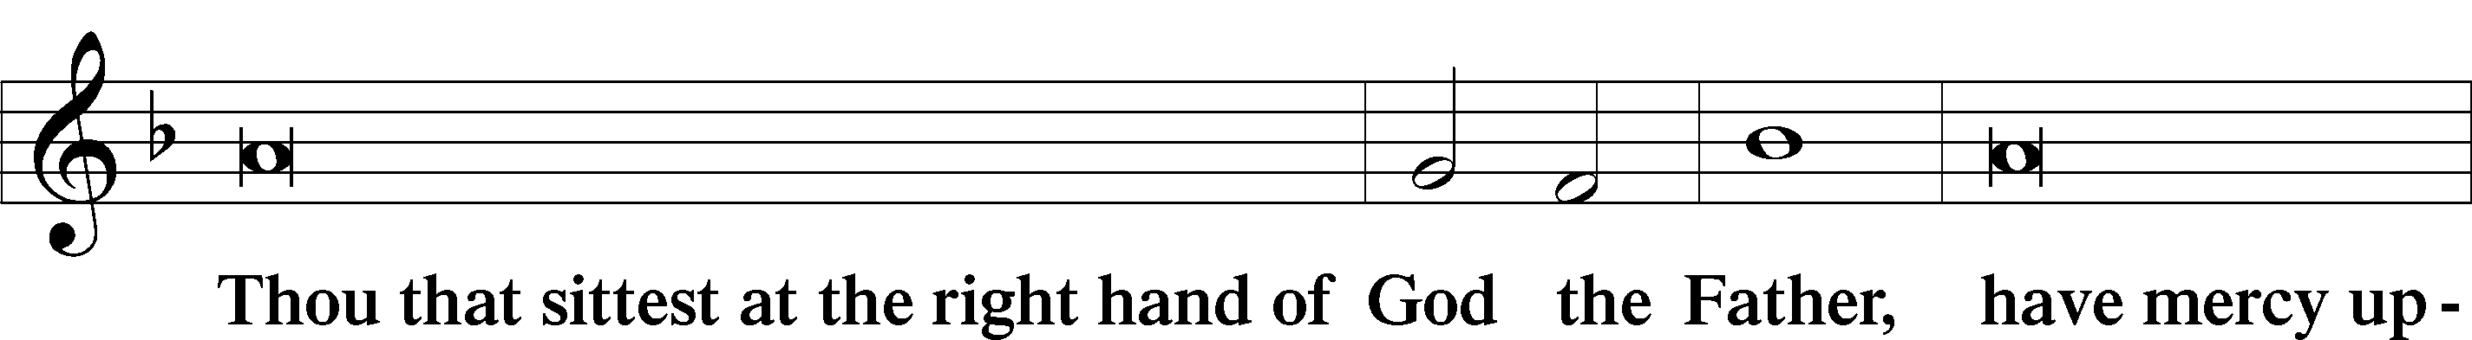
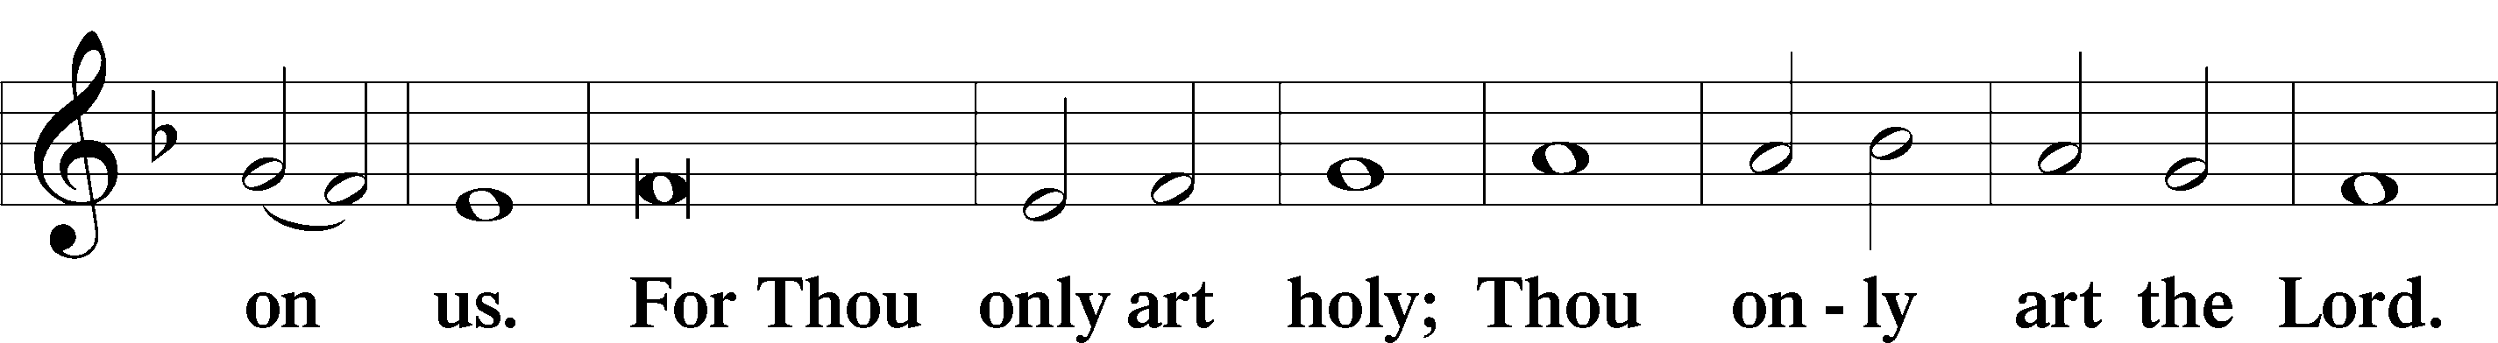
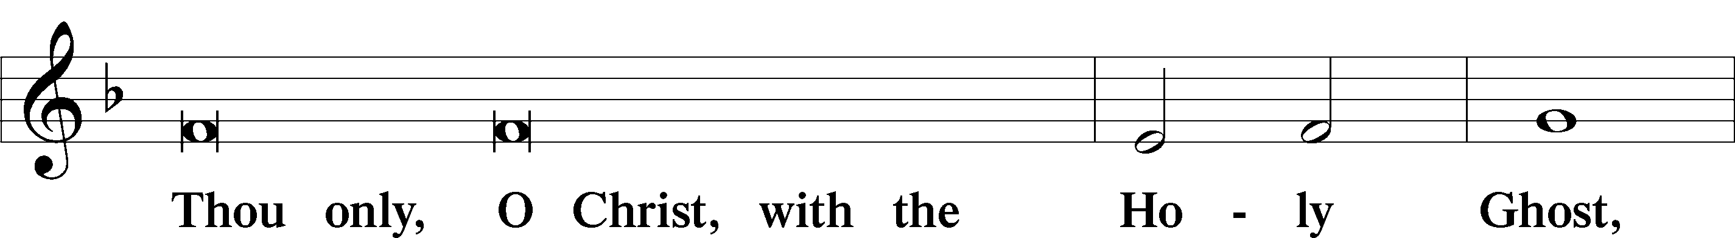
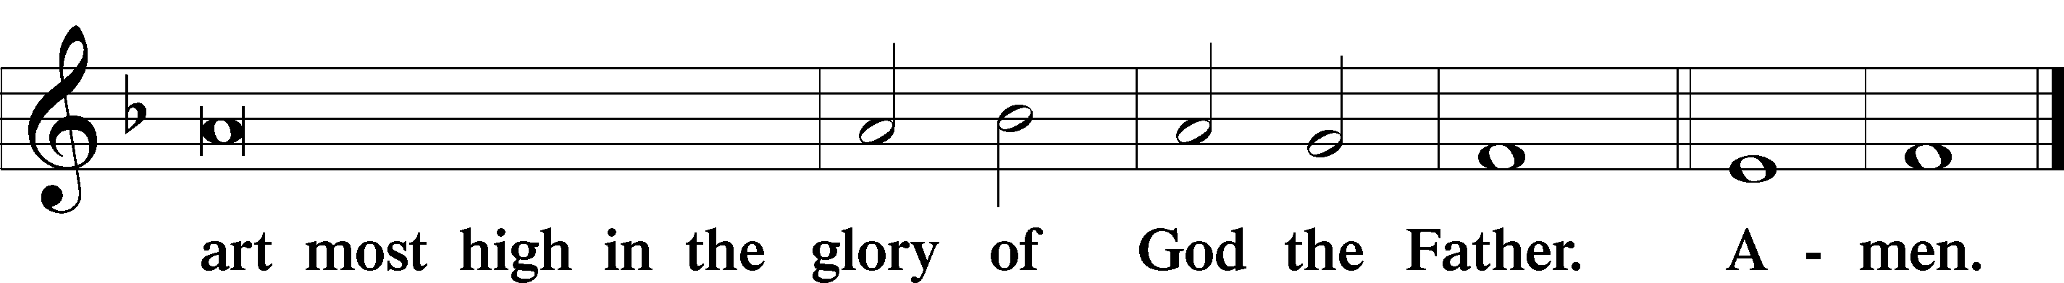
Salutation and Collect of the Day LSB 189
P The Lord be with you.
C And with thy spirit.
P Let us pray. Almighty God, You invite us to trust in You for our salvation. Deal with us not in the severity of Your judgment but by the greatness of Your mercy; through Jesus Christ, Your Son, our Lord, who lives and reigns with You and the Holy Spirit, one God, now and forever.
C Amen.

Sit
Old Testament Reading Isaiah 25:6-9
6 On this mountain the Lord Almighty will prepare a feast of rich food for all peoples, a banquet of aged wine —
the best of meats and the finest of wines.
7 On this mountain he will destroy the shroud that enfolds all peoples, the sheet that covers all nations;
8 he will swallow up death forever.
The Sovereign Lord will wipe away the tears from all faces; he will remove his people’s disgrace from all the earth.
The Lord has spoken.
9 In that day they will say, “Surely this is our God; we trusted in him, and he saved us.
This is the Lord, we trusted in him; let us rejoice and be glad in his salvation.”

A This is the Word of the Lord.
C Thanks be to God.

Gradual Ps.91:11, 103:1
A C He will command his angels concerning you to guard you in all your ways. Bless the Lord, O my soul, and all that is within me, bless his holy name!

Epistle Reading Philippians 4:4-13
4 Rejoice in the Lord always. I will say it again: Rejoice! 5 Let your gentleness be evident to all. The Lord is near. 6 Do not be anxious about anything, but in every situation, by prayer and petition, with thanksgiving, present your requests to God. 7 And the peace of God, which transcends all understanding, will guard your hearts and your minds in Christ Jesus.
8 Finally, brothers and sisters, whatever is true, whatever is noble, whatever is right, whatever is pure, whatever is lovely, whatever is admirable—if anything is excellent or praiseworthy—think about such things. 9 Whatever you have learned or received or heard from me, or seen in me—put it into practice. And the God of peace will be with you.
10 I rejoiced greatly in the Lord that at last you renewed your concern for me. Indeed, you were concerned, but you had no opportunity to show it. 11 I am not saying this because I am in need, for I have learned to be content whatever the circumstances. 12 I know what it is to be in need, and I know what it is to have plenty. I have learned the secret of being content in any and every situation, whether well fed or hungry, whether living in plenty or in want. 13 I can do all this through him who gives me strength.

A This is the Word of the Lord.
C Thanks be to God.

Hymn of Praise LSB 830 sts. 1-6
“Spread the Reign of God the Lord”
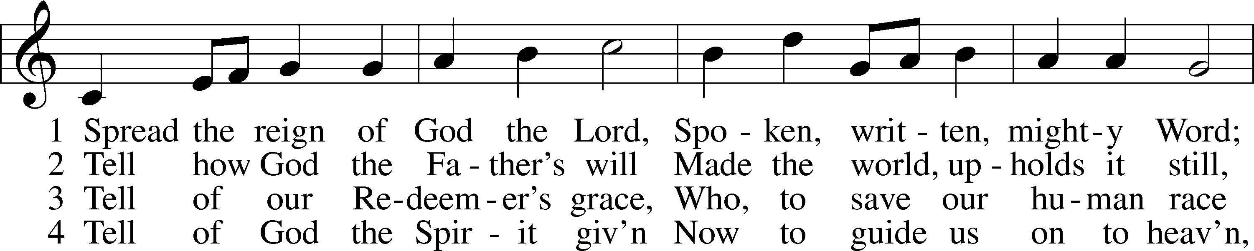
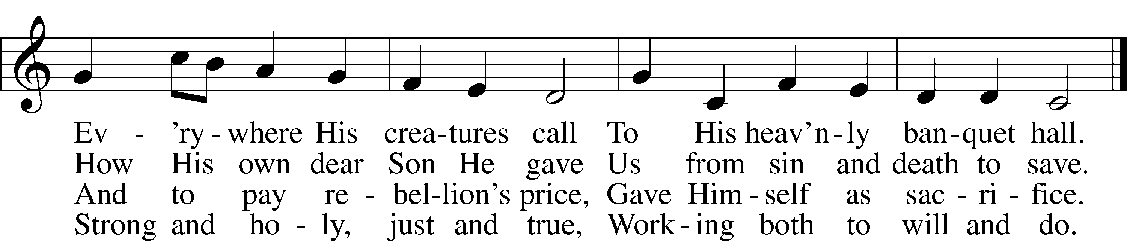

5 Enter, mighty Word, the field;
6 Lord of harvest, great and kind,
Rouse to action heart and mind;
Let the gath’ring nations all
See Your light and heed Your call.
Ripe the promise of its yield.
But the reapers, oh, how few
For the work there is to do!

Public domain

Stand
Alleluia and Verse Rev. 22:17
P Alleluia.
P C The Spirit and the Bride say, “Come.” Let the one who hears say, “Come.” Let the one who is thirsty come; let the one who desires take the water of life without price. Alleluia.

Holy Gospel Matthew 22:1-14
P The Holy Gospel according to St.
Matthew, the twenty-second chapter.
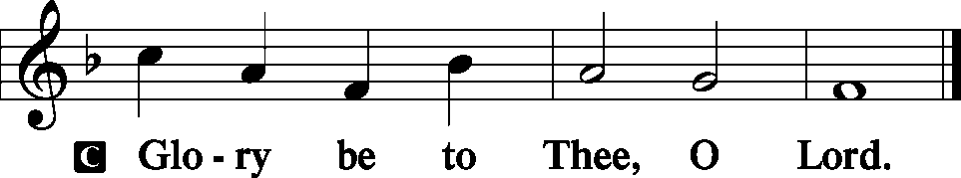 LSB 190

22 Jesus spoke to them again in parables, saying: 2 “The kingdom of heaven is like a king who prepared a wedding banquet for his son. 3 He sent his servants to those who had been invited to the banquet to tell them to come, but they refused to come.
4 “Then he sent some more servants and said, ‘Tell those who have been invited that I have prepared my dinner: My oxen and fattened cattle have been butchered, and everything is ready. Come to the wedding banquet.’
5 “But they paid no attention and went off—one to his field, another to his business. 6 The rest seized his servants, mistreated them and killed them. 7 The king was enraged. He sent his army and destroyed those murderers and burned their city.
8 “Then he said to his servants, ‘The wedding banquet is ready, but those I invited did not deserve to come. 9 So go to the street corners and invite to the banquet anyone you find.’ 10 So the servants went out into the streets and gathered all the people they could find, the bad as well as the good, and the wedding hall was filled with guests.
11 “But when the king came in to see the guests, he noticed a man there who was not wearing wedding clothes. 12 He asked, ‘How did you get in here without wedding clothes, friend?’ The man was speechless.
13 “Then the king told the attendants, ‘Tie him hand and foot, and throw him outside, into the darkness, where there will be weeping and gnashing of teeth.’
14 “For many are invited, but few are chosen.”

P This is the Gospel of the Lord.
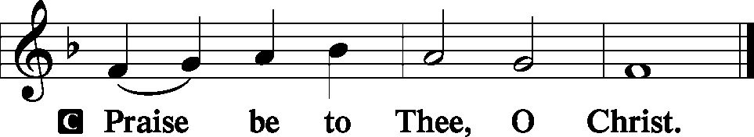 LSB 191

Sit
Hymn of the Day LSB 620 sts. 1-5
“Jesus Comes Today with Healing” 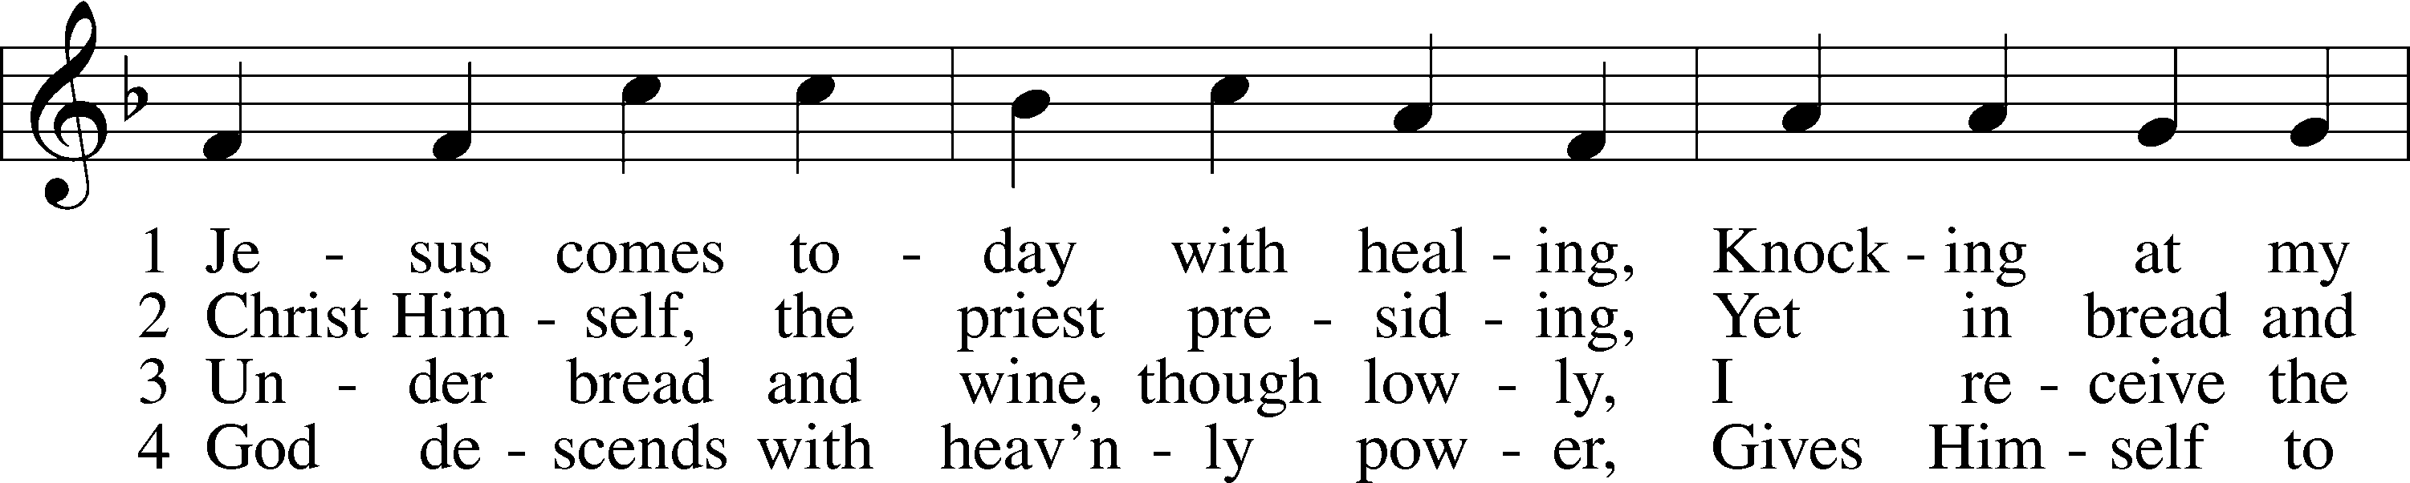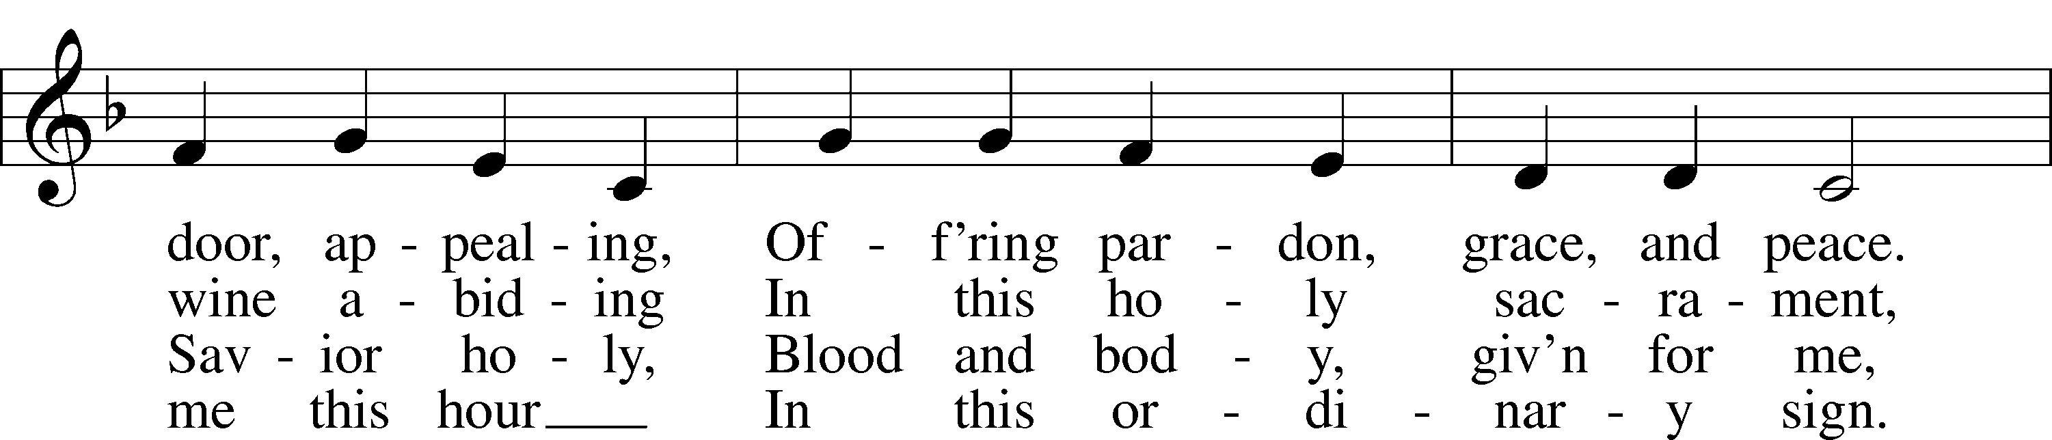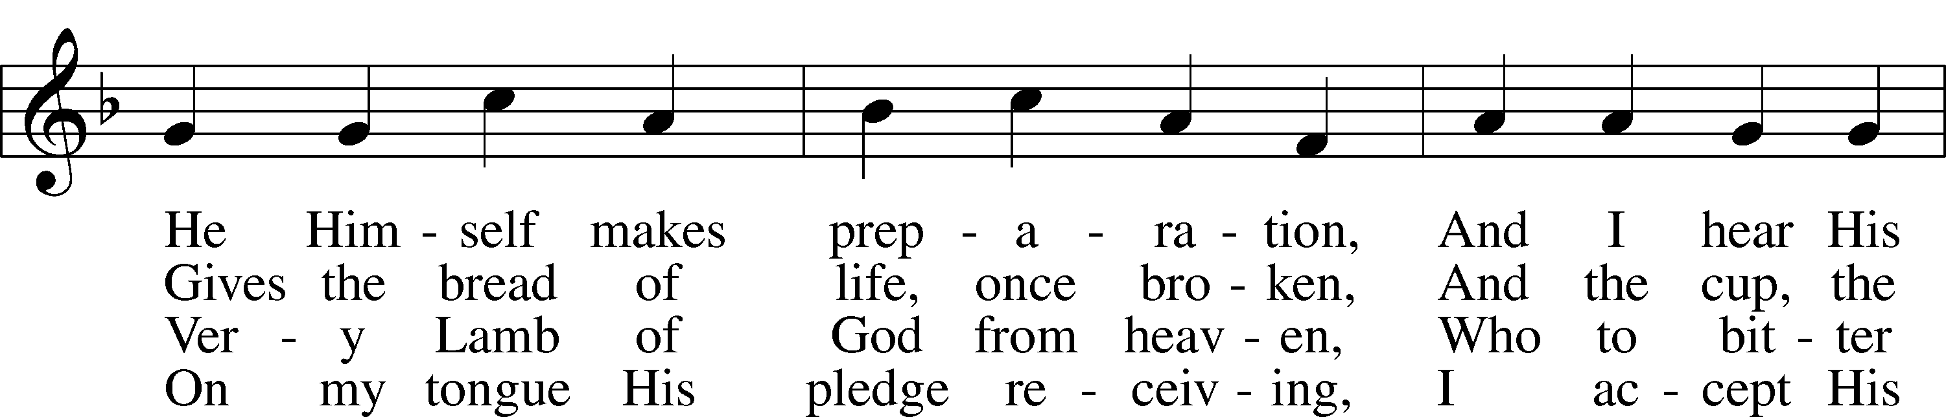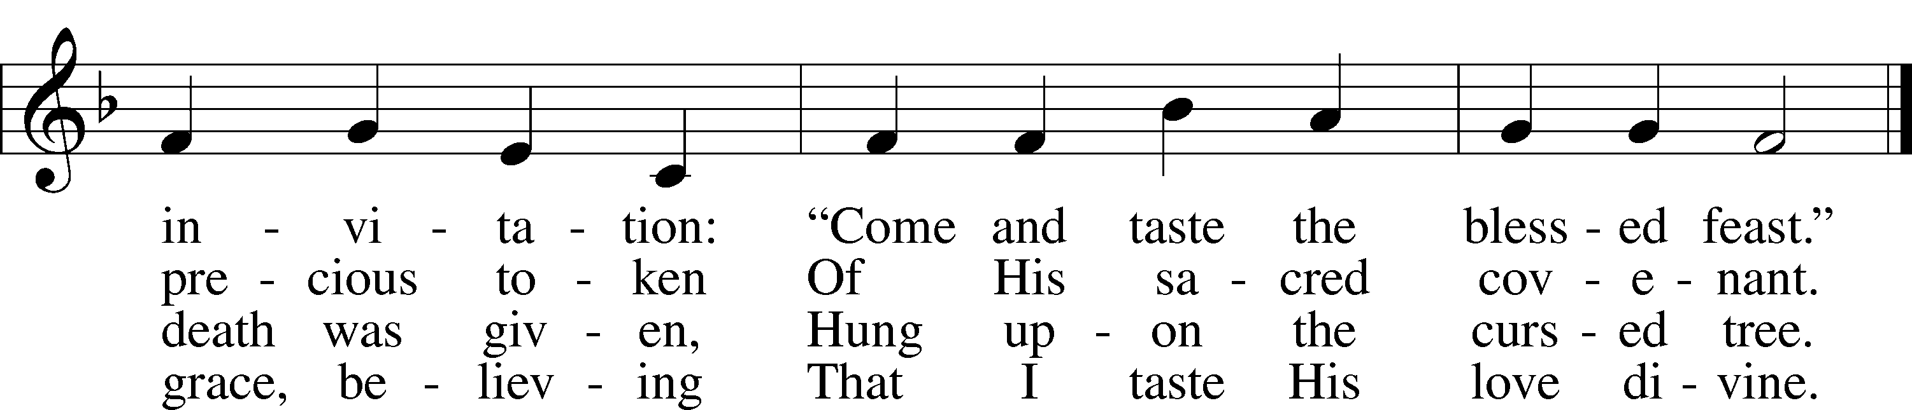

5 Let me praise God’s boundless favor,
Whose own feast of love I savor,
Bidden by His gracious call.
Wedding garments He provides me,
With a robe of white He hides me,
Fits me for the royal hall.

Text (sts. 1–6): © David W. Rogner Used by permission: LSB Hymn License .NET, number 100011462. Music: Public domain
Created by Lutheran Service Builder © 2006 Concordia Publishing House.
Sermon Pastor Tom Rhodes
“The Heavenly Wedding Feast”

Stand
Together We Confess our Common Faith Using the Apostle’s Creed LSB 192
P C I believe in God, the Father Almighty, maker of heaven and earth.

And in Jesus Christ, His only Son, our Lord,
who was conceived by the Holy Spirit,
born of the virgin Mary,
suffered under Pontius Pilate,
was crucified, died, and was buried.
He descended into hell.
The third day He rose again from the dead.
He ascended into heaven
and sits at the right hand of God the Father Almighty.
From thence He will come to judge the living and the dead.

I believe in the Holy Spirit,
the holy Christian Church,
the communion of saints,
the forgiveness of sins,
the resurrection of the body,
and the life  everlasting. Amen.

Offering
In quiet devotion and responding in personal stewardship of God’s abundant provision to you, please use the offering plates in the back as you enter or exit. This is just as it says: An offering to God through His church. As a reassurance to those in worship today, especially our guests - this is not an obligation - the good news of Jesus is free to all!

Stewardship Prayer
P C In gratitude of receiving the Lord’s gifts and blessings, for guiding us to generously share with those in need His blessings and the resources we’ve been given, and for the tithes and offerings to support the work of the Kingdom in this place, we give thanks and praise to God. In Jesus’ name, Amen.

Offertory LSB 192
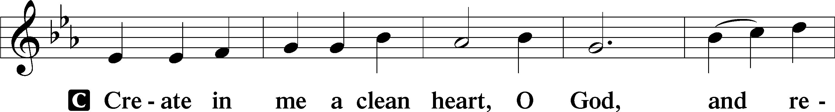
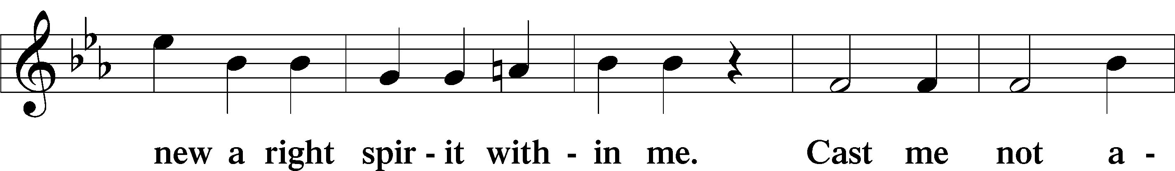
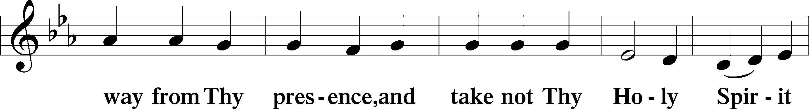
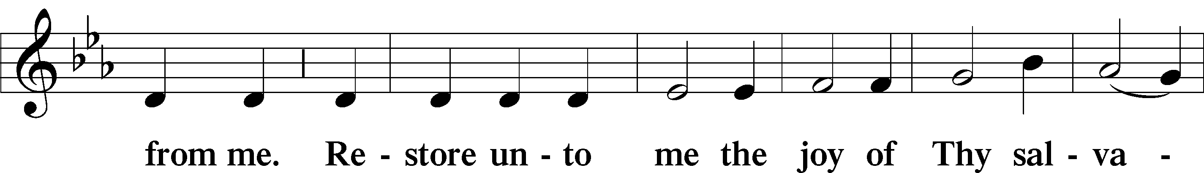
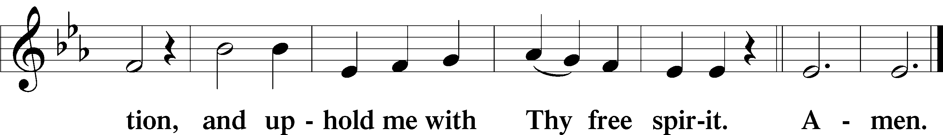

Prayer of the Church LSB 193
P Invited by God’s Word and encouraged by His promise of mercy, let us pray to the Lord:
C Lord, have mercy.

P For grace, that we may hear and heed the invitation of our Lord and joyfully wear the garment of His righteousness poured out on us through His mercy, let us pray to the Lord:
C Lord, have mercy.

P For the Church, for the leaders of the Church, for all pastors and missionaries, for those preparing for church vocations, and for we who hear and receive God’s word and sacraments: let us pray to the Lord:
C Lord, have mercy.

P For a welcoming spirit in our congregation, for boldness in our invitation to those without a church home and to the stranger whose lives cross our paths, to come and receive the Lord’s free gift of wedding clothes, let us pray to the Lord:
C Lord, have mercy.

P For compassion toward the sick and those who suffer, for our care of those who need our assistance, for the hospitalized and those recovering, and especially for those on our prayer list and cards and those we name in our hearts, that God may grant them healing, comfort, strength and peace, let us pray to the Lord:
C Lord, have mercy.

P For all elected and appointed civil servants, for all judges and magistrates, for all emergency personnel, for all medical providers, for all members of the armed forces, and for all of us as citizens and neighbors, let us pray to the Lord:
C Lord, have mercy.

P For the dawn of God’s eternal day, for an end to death and sorrow, for the comfort of those who grieve, and for strength for those facing death, let us pray to the Lord:
C Lord, have mercy.

P For our catechumens, and for the places where we gather to teach and learn God’s Word, let us pray to the Lord:
C Lord, have mercy.

P All these things, Lord, we pray You to grant us according to Your mercy in Jesus Christ and to fill us with contentment, that trusting in Your gracious will for all things, our hearts may enjoy perfect rest and peace; through Jesus Christ, our Lord, who lives and reigns with You and the Holy Spirit, one God, now and forever.
C Amen.

Lord's Prayer Matthew 6:9-13, LSB 196
P Lord, remember us in Your kingdom and teach us to pray:
C Our Father who art in heaven,
hallowed be Thy name,
Thy kingdom come,
Thy will be done on earth
as it is in heaven;
give us this day our daily bread;
and forgive us our trespasses
as we forgive those
who trespass against us;
and lead us not into temptation,
but deliver us from evil.
For Thine is the kingdom
and the power and the glory
forever and ever. Amen.

Salutation and Benedicamus LSB 201
P The Lord be with you.
C And with thy spirit.
P Bless we the Lord.
C Thanks be to God.

Benediction Numbers 6:24-26, LSB 202
P The Lord bless you and keep you.
The Lord make His face shine on you and be gracious to you.
The Lord look upon you with favor and  give you peace.
C Amen.

Sit
Closing Hymn LSB 924 sts. 1-3
“Lord, Dismiss Us with Your Blessing”
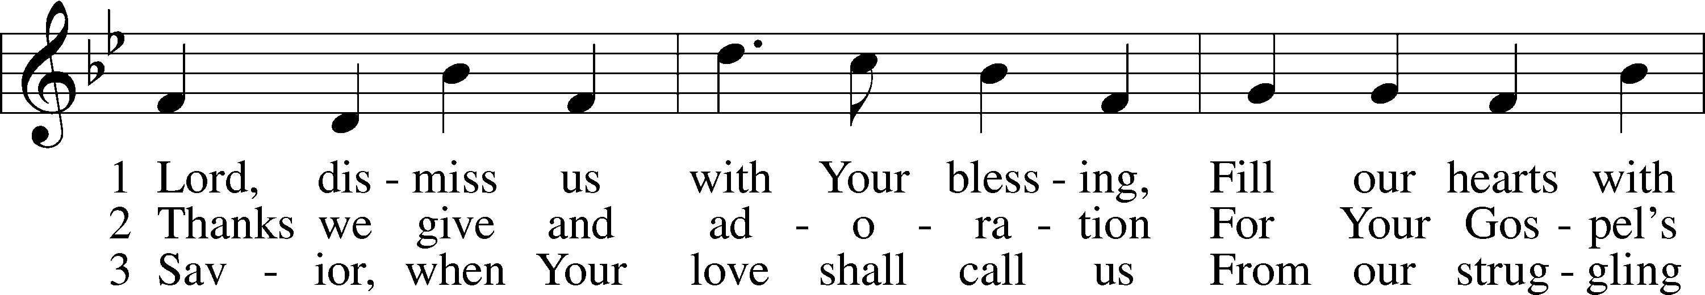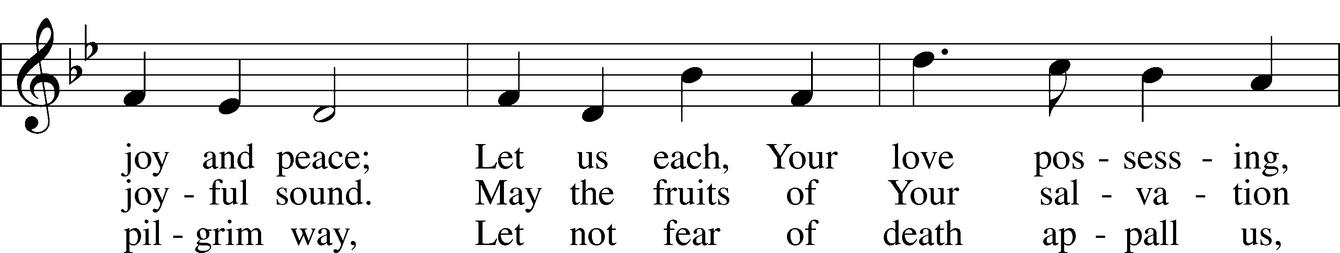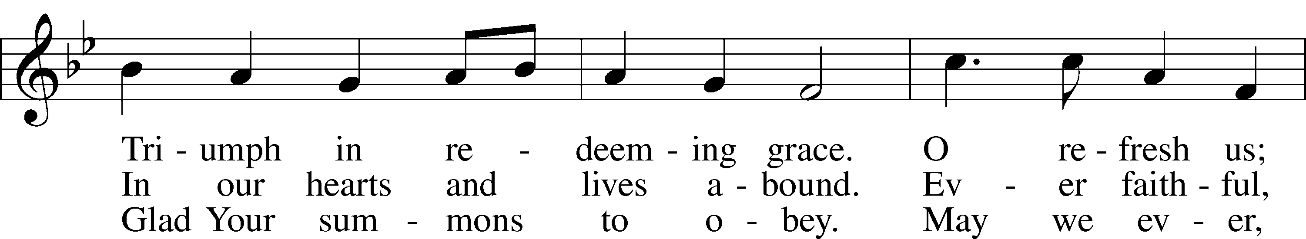
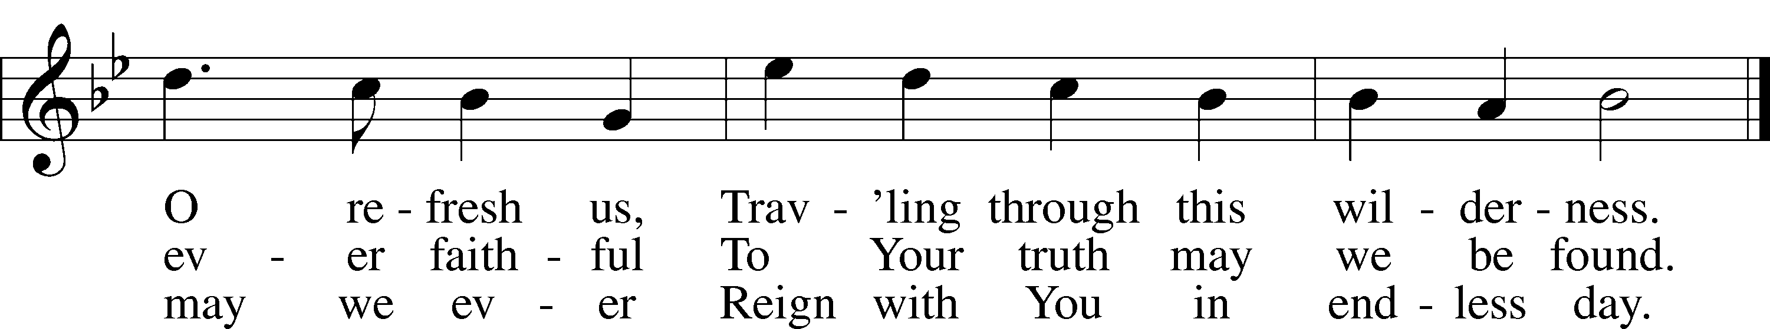

Public domain

