Zion Lutheran Church
‘Hearing, Sharing and Living the Gospel.’

Zion Lutheran Church
Our mission is to hear and share the good news of the risen Jesus and, with God’s help, to live the Gospel.

Twenty-Third Sunday after Pentecost
November 8, 2020 10:30 a.m. Service

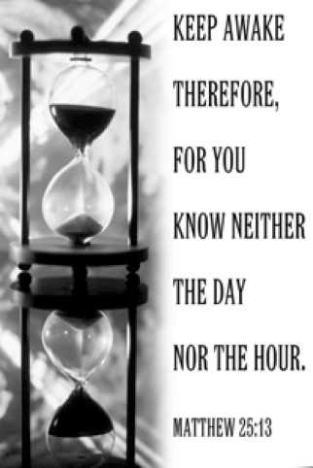

Zion Lutheran Church

‘Hearing, Sharing and Living the Gospel’
Rev. Thomas A. Rhodes, Pastor
PO Box 5 • 600 East Aldrich Road • Bolivar, MO 65613
Phone: 417-326-5506 • www.zionlutheranbolivar.org

zionbolivar@windstream.net


Administrative Assistant – Sonya Gorman
You are invited to use the yellow Prayer Cards located in the pew for prayer requests. Please hand this card to an usher or place it in the offering plate.
* Please turn off cellphones*

TWENTY-THIRD SUNDAY AFTER PENTECOST
Divine Service – Setting Three
November 8, 2020 10:30 a.m.

Welcome & Announcements

+ INVOCATION + LSB 184
The sign of the cross may be made by all in remembrance of their Baptism.
L We begin in the name into which we are baptized; In the name of the Father and of the  Son and of the Holy Spirit. Matthew 28:19b; [18:20]
C Amen.

Opening Hymn LSB 496 sts. 1-5
“Holy Spirit, Light Divine”
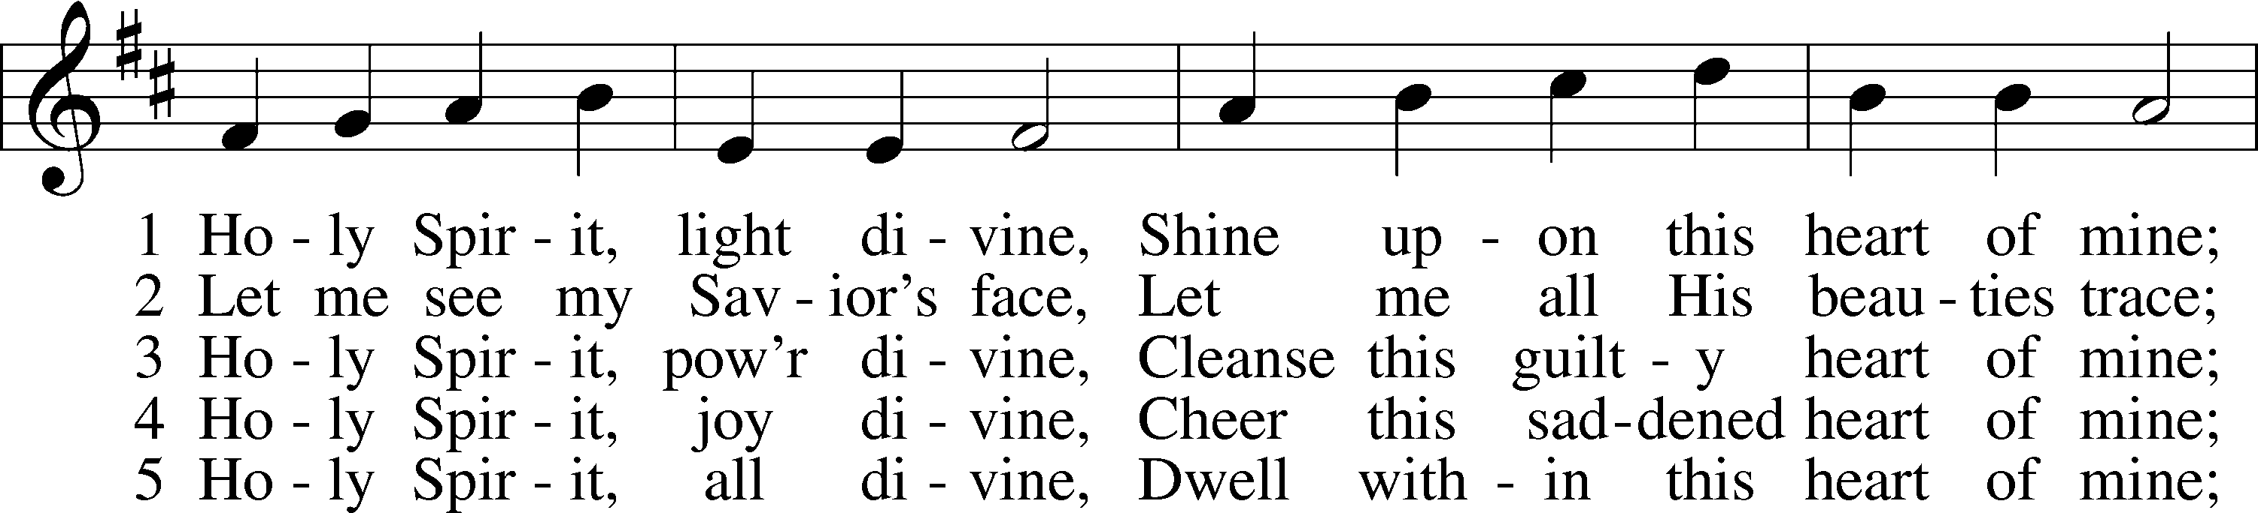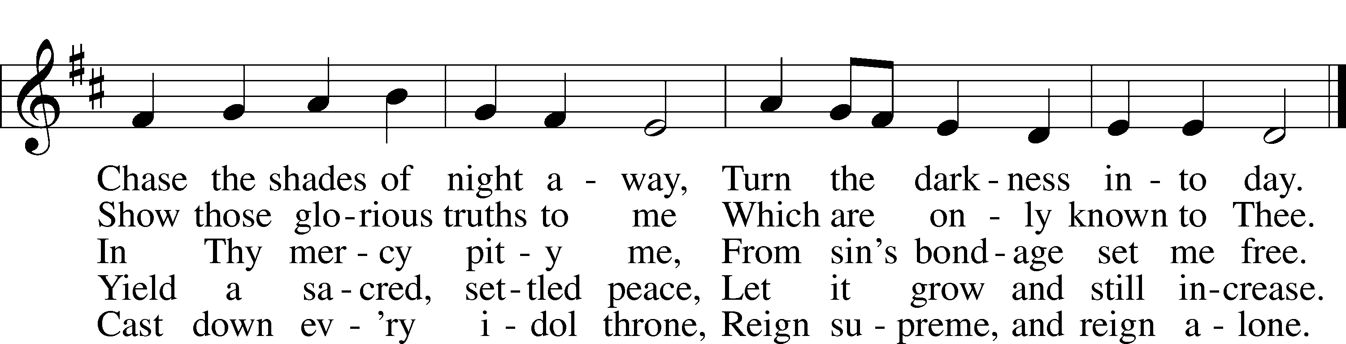
Public Domain

+ CONFESSION AND ABSOLUTION + LSB 184
L Beloved in the Lord! Let us draw near with a true heart and confess our sins unto God our Father, beseeching Him in the name of our Lord Jesus Christ to grant us forgiveness. Hebrews 10:22
L Our help is in the name of the Lord,
C who made heaven and earth. Psalm 124:8
L I said, I will confess my transgressions unto the Lord,
C and You forgave the iniquity of my sin.
Psalm 32:5

(Silence for reflection on God's Word and for self-examination in light of the Ten Commandments.)

L Almighty God, our maker and redeemer, we poor sinners confess unto You that we are by nature sinful and unclean and that we have sinned against You by thought, word, and deed. Wherefore we flee for refuge to Your infinite mercy, seeking and imploring Your grace for the sake of our Lord Jesus Christ.
C O most merciful God, who has given Your only-begotten Son to die for us, have mercy upon us and for His sake grant us remission of all our sins; and by Your Holy Spirit increase in us true knowledge of You and of Your will and true obedience to Your Word, to the end that by Your grace we may come to everlasting life; through Jesus Christ, our Lord. Amen.

L Almighty God, LSB 185
our heavenly Father, has
had mercy upon us and has given His only Son to die for us and for His sake forgives us all our sins. To those who believe on His name He gives power to become the children of God and has promised them His Holy Spirit. He that believes and is baptized shall be saved. Grant this, Lord, unto us all.
C Amen.

+ SERVICE OF THE WORD + LSB 186
Introit Ps. 84:1, 9-12; antiphon: Ps. 84:3
L Even the sparrow finds a home, and the swallow a nest for herself, where she may lay her young, at your altars, O Lord of hosts, my King and my God.
C How lovely is your dwelling place, O Lord of hosts!
L Behold our shield, O God; look on the face of your anointed!
C For a day in your courts is better than a thousand elsewhere. I would rather be a doorkeeper in the house of my God than dwell in the tents of wickedness.
L For the Lord God is a sun and shield; the Lord bestows favor and honor. No good things does he withhold from those who walk uprightly.
C O Lord of hosts, blessed is the one who trusts in you.
L C Glory be to the Father and to the Son and to the Holy Spirit; as it was in the beginning, is now, and will be forever. Amen.
L Even the sparrow finds a home, and the swallow a nest for herself, where she may lay her young, at your altars, O Lord of hosts, my King and my God.

Gloria Patri LSB 186
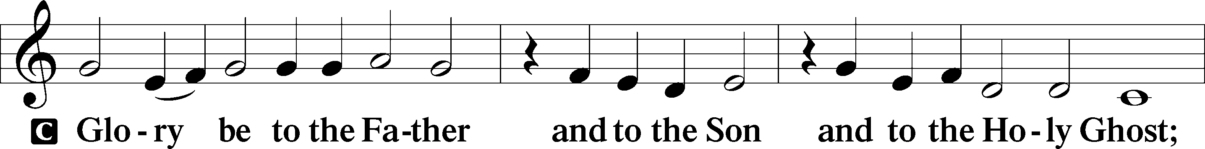
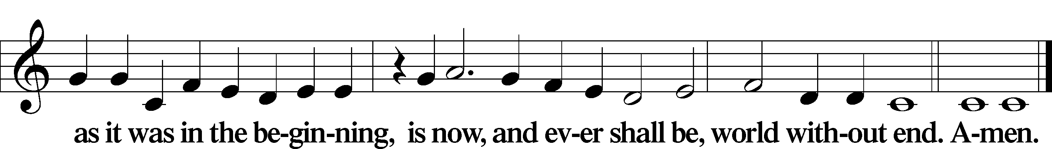

Kyrie Mark 10:47, LSB 186
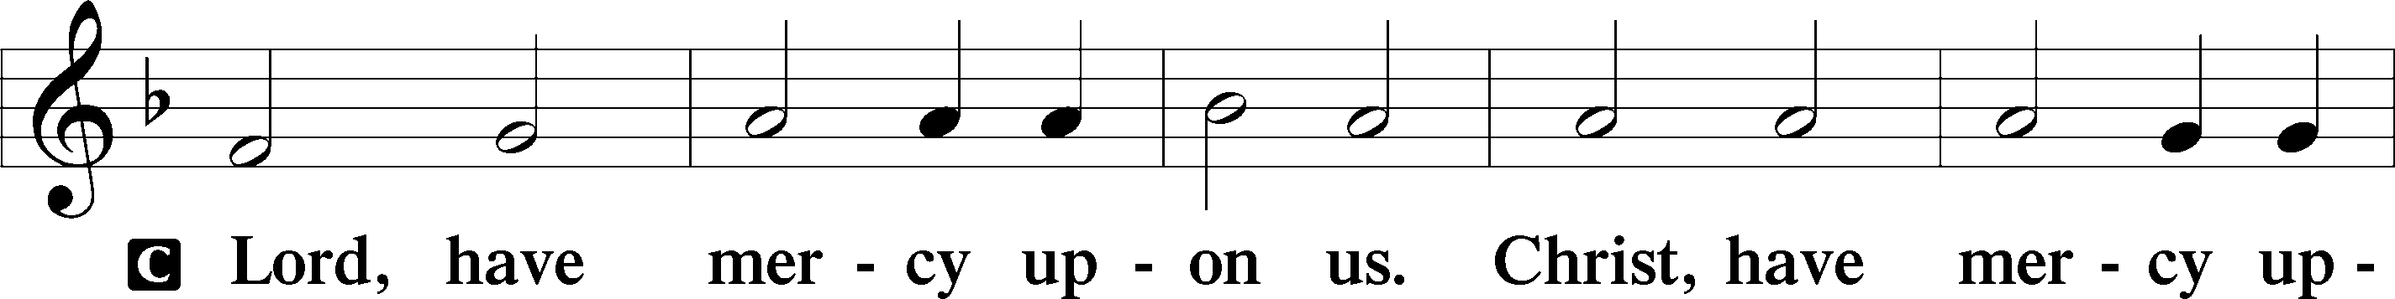
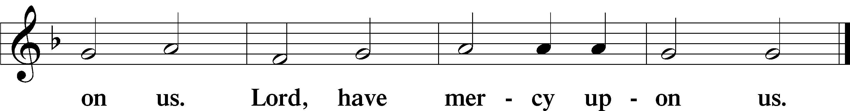

Hymn of Praise/Gloria in Excelsis LSB 187
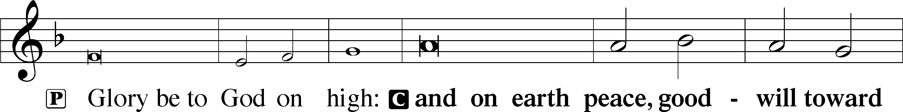
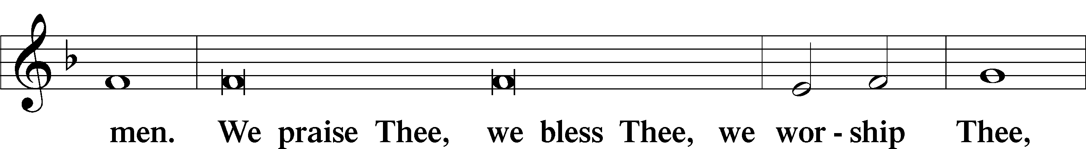
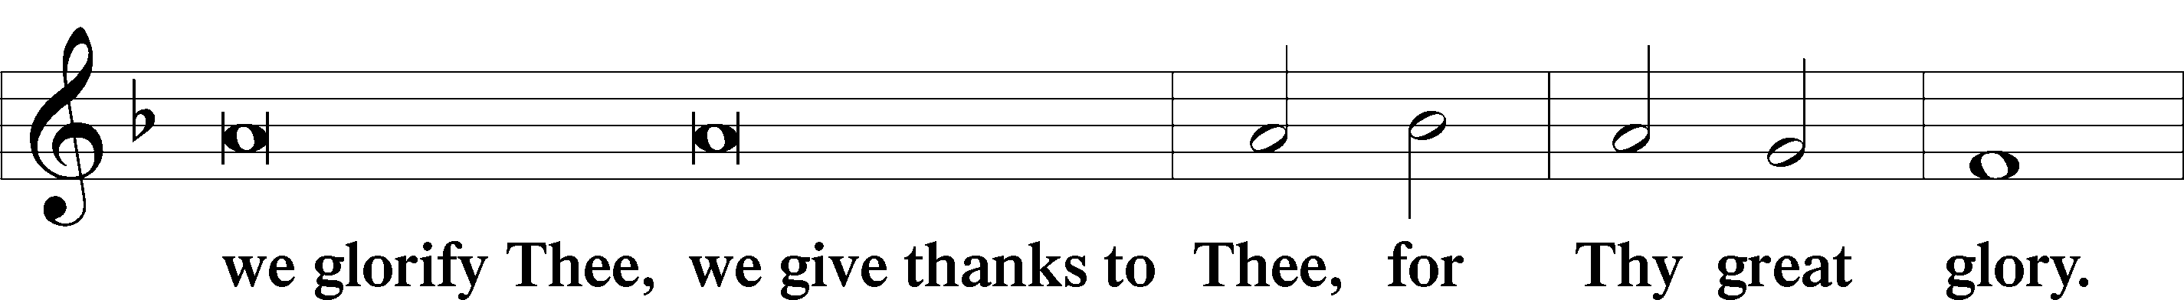
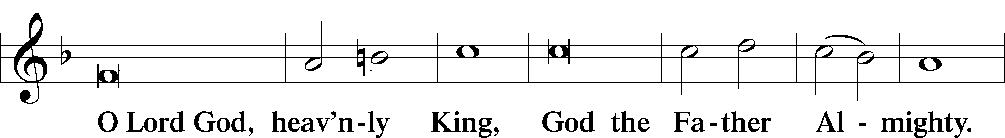
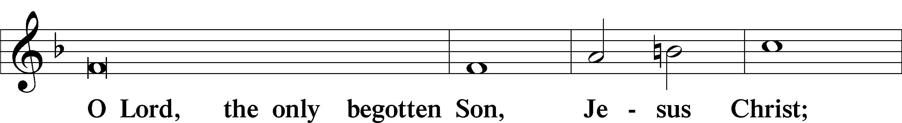
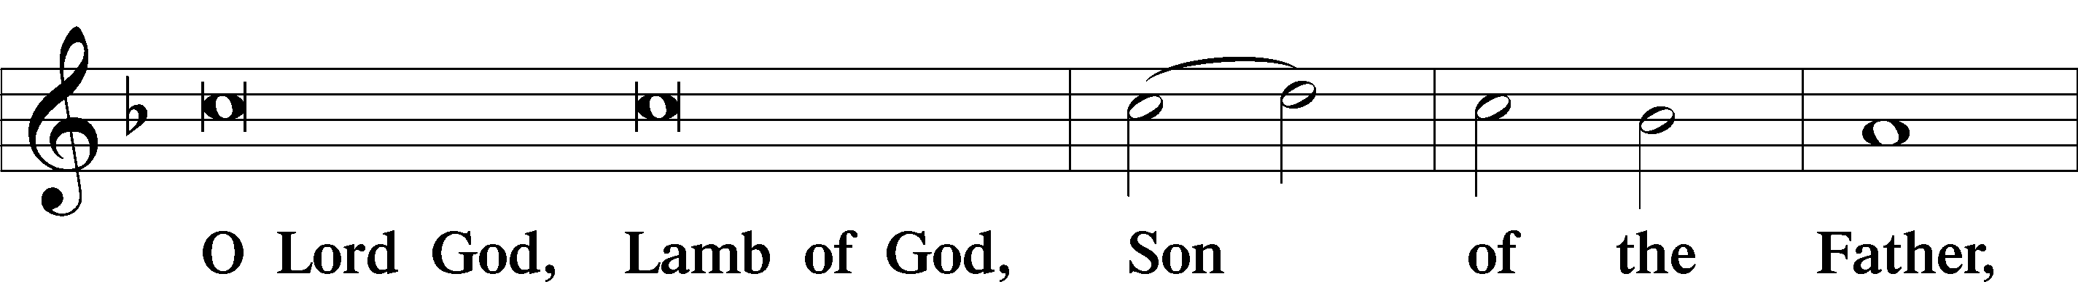
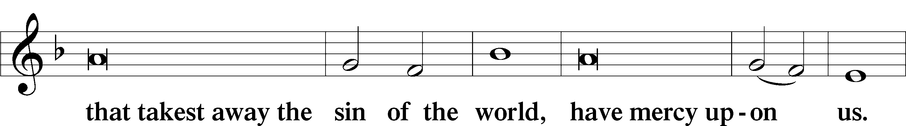
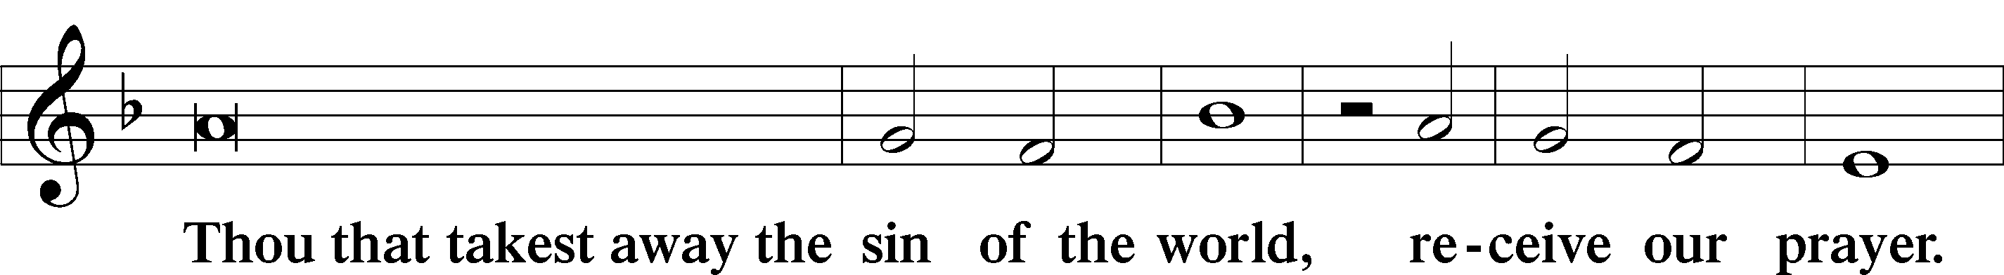
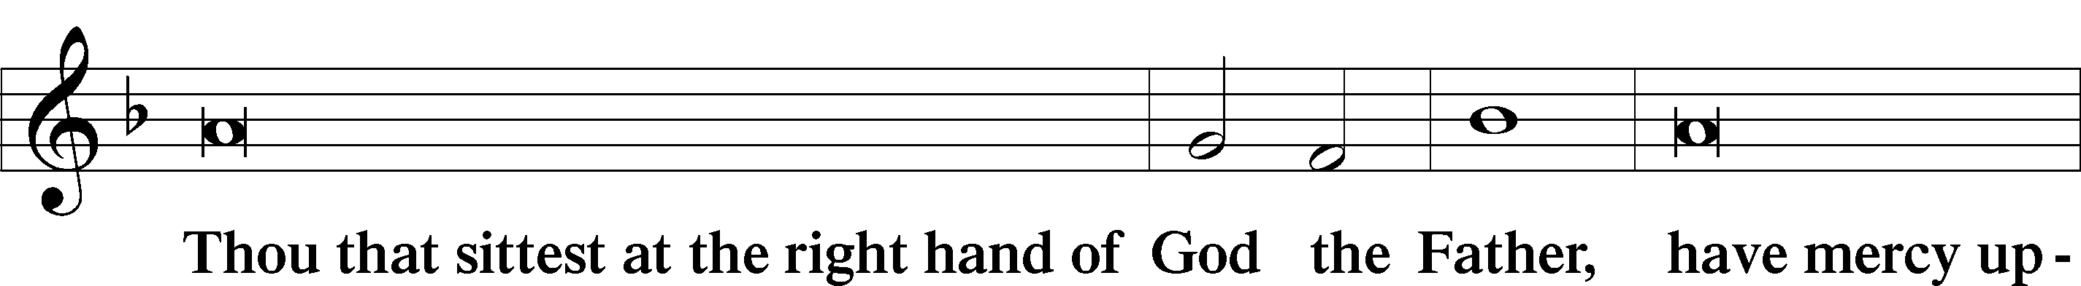
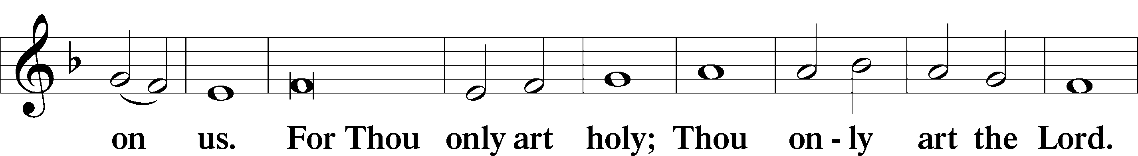
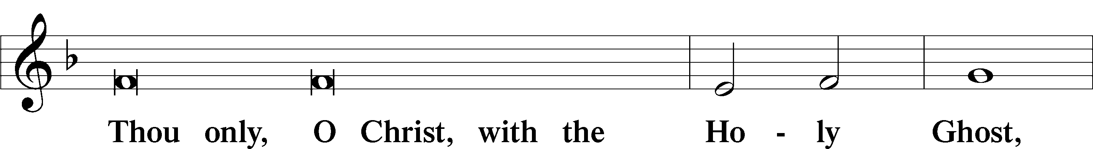
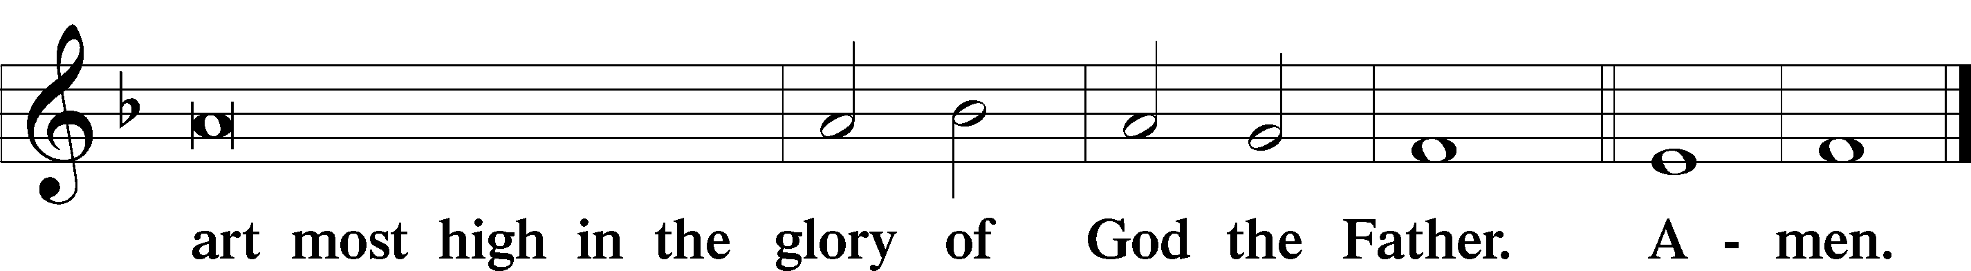

Salutation and Collect of the Day LSB 189
L The Lord be with you.
C And with thy spirit.
L Let us pray. Lord God, heavenly Father, send forth Your Son to lead home His bride, the Church, that with all the company of the redeemed we may finally enter into His eternal wedding feast; through the same Jesus Christ, our Lord, who lives and reigns with You and the Holy Spirit, one God, now and forever.
C Amen.

Sit
Old Testament Reading Amos 5:18-24
18 Woe to you who long for the day of the Lord! Why do you long for the day of the Lord? That day will be darkness, not light.
19 It will be as though a man fled from a lion only to meet a bear, as though he entered his house and rested his hand on the wall only to have a snake bite him.
20 Will not the day of the Lord be darkness, not light—pitch-dark, without a ray of brightness?
21 “I hate, I despise your religious festivals; your assemblies are a stench to me.
22 Even though you bring me burnt offerings and grain offerings, I will not accept them. Though you bring choice fellowship offerings, I will have no regard for them.
23 Away with the noise of your songs! I will not listen to the music of your harps.
24 But let justice roll on like a river, righteousness like a never-failing stream!

A This is the Word of the Lord.
C Thanks be to God.

Gradual Rev. 7:14b; Ps. 84:5
A C These are the ones coming out of the great tribulation. They have washed their robes and made them white in the blood of the Lamb. Blessed are those whose strength is in you, in whose heart are the highways to Zion.

Epistle Reading 1 Thessalonians 4:13-18
13 Brothers and sisters, we do not want you to be uninformed about those who sleep in death, so that you do not grieve like the rest of mankind, who have no hope. 14 For we believe that Jesus died and rose again, and so we believe that God will bring with Jesus those who have fallen asleep in him. 15 According to the Lord’s word, we tell you that we who are still alive, who are left until the coming of the Lord, will certainly not precede those who have fallen asleep. 16 For the Lord himself will come down from heaven, with a loud command, with the voice of the archangel and with the trumpet call of God, and the dead in Christ will rise first. 17 After that, we who are still alive and are left will be caught up together with them in the clouds to meet the Lord in the air. And so we will be with the Lord forever. 18 Therefore encourage one another with these words.

A This is the Word of the Lord.
C Thanks be to God.

Hymn of Praise LSB 514 sts. 1-4
(to the tune of LSB 906)
“The Bridegroom Will Soon Call Us”
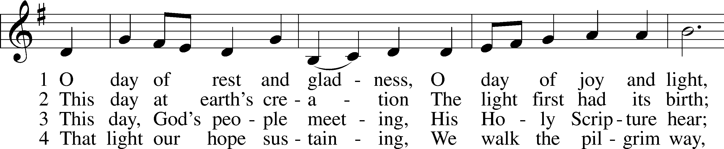
1 The Bride - groom soon will call us, “Come to the wed - ding feast.”
2 There shall we see in glo - ry Our dear Re - deem - er’s face;
3 There God shall from all e - vil For - ev - er make us free,
4 In that fair home shall nev - er Be si - lent mu - sic’s voice;

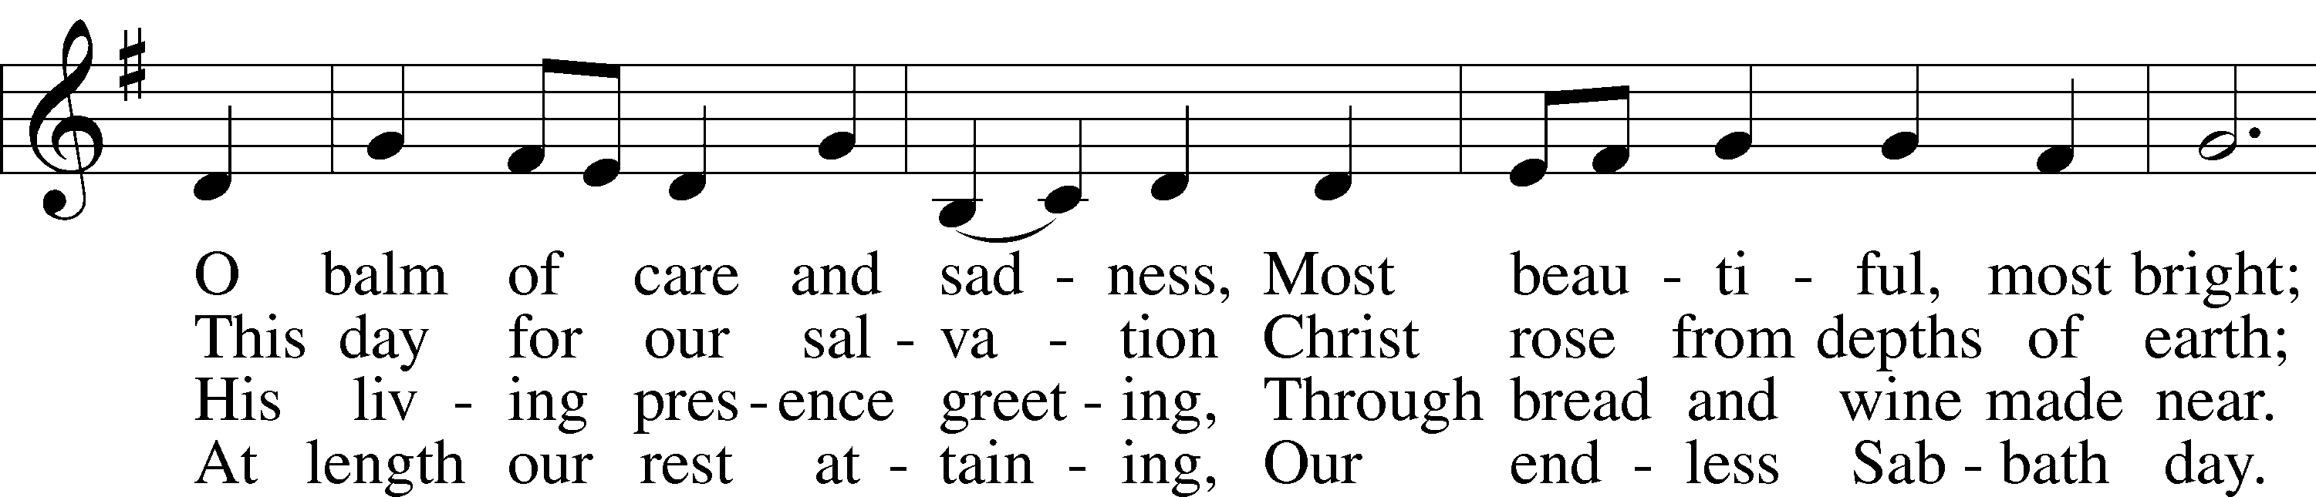
May slum - ber not be - fall us Nor watch - ful - ness de - crease.
The long - a - wait - ed sto - ry Of heav’n - ly joy takes place:
From sin and from the dev - il, From all ad - ver - si - ty,
With hearts and lips for - ev - er We shall in God re - joice,

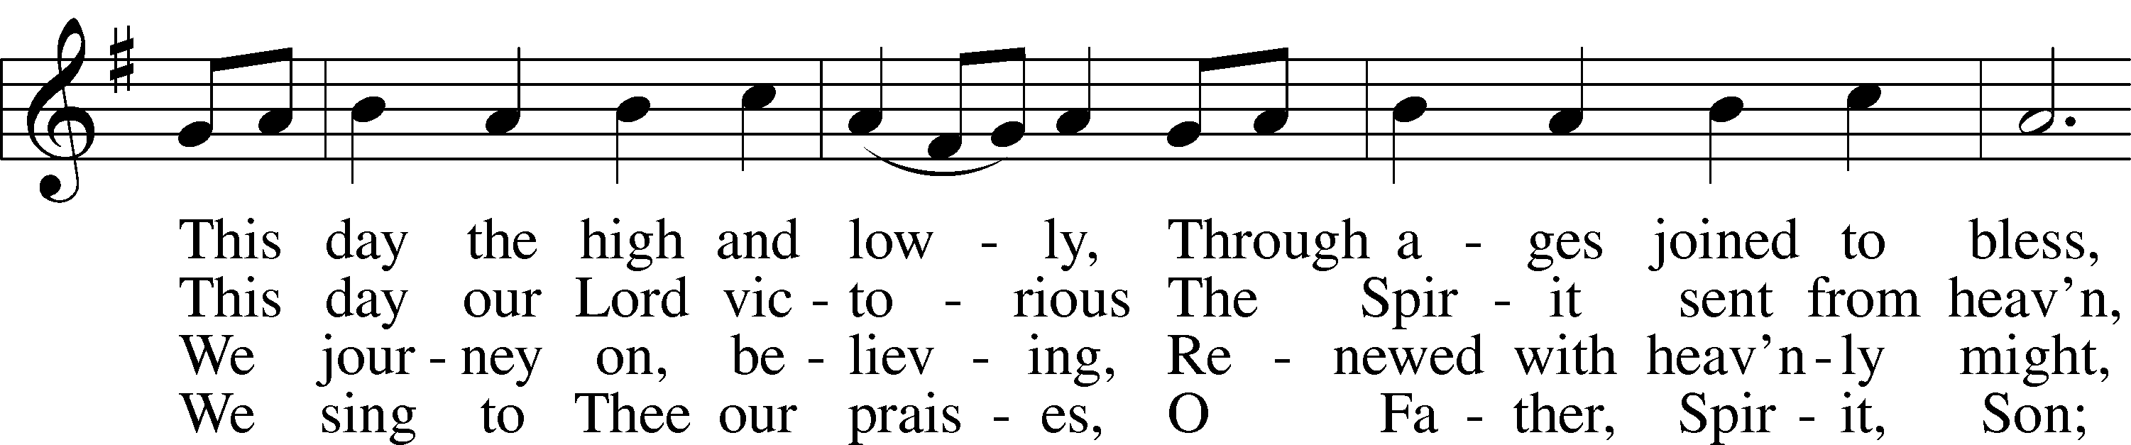
May all our lamps be burn - ing With oil e - nough and more
The pa - tri - archs shall meet us, The proph - ets’ ho - ly band;
From sick - ness, pain, and sad - ness, From trou - bles, cares, and fears,
While an - gel hosts are rais - ing With saints from great to least

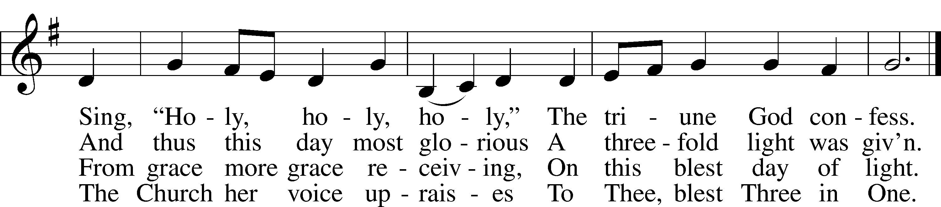
That we, with Him re - turn - ing, May find an o - pen door!
A - pos - tles, mar - tyrs greet us In that ce - les - tial land.
And grant us heav’n - ly glad - ness And wipe a - way our tears.
A might - y hymn for prais - ing The Giv - er of the feast.

Text: © 1982 Concordia Publishing House. Used by permission: LSB Hymn License .NET, no. 100011462.
Music: © 1982 Charles P. Price. Used by permission: LSB Hymn License .NET, no. 100011462.; © 1985 The Church Pension Fund. Used by permission: LSB Hymn License .NET, no. 100011462.
Public domain

Stand
Alleluia and Verse Matt. 25:13
L Alleluia.
L C Watch therefore, for you know
neither the day nor the hour. Alleluia.

Holy Gospel Matthew 25:1-13
L The Holy Gospel according to St.
Matthew, the twenty-fifth chapter.
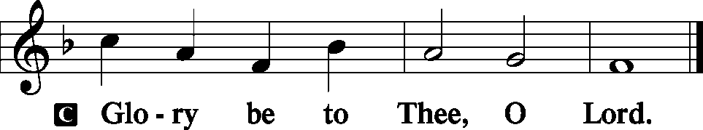 LSB 190

25 “At that time the kingdom of heaven will be like ten virgins who took their lamps and went out to meet the bridegroom. 2 Five of them were foolish and five were wise. 3 The foolish ones took their lamps but did not take any oil with them. 4 The wise ones, however, took oil in jars along with their lamps. 5 The bridegroom was a long time in coming, and they all became drowsy and fell asleep.
6 “At midnight the cry rang out: ‘Here’s the bridegroom! Come out to meet him!’
7 “Then all the virgins woke up and trimmed their lamps. 8 The foolish ones said to the wise, ‘Give us some of your oil; our lamps are going out.’
9 “‘No,’ they replied, ‘there may not be enough for both us and you. Instead, go to those who sell oil and buy some for yourselves.’
10 “But while they were on their way to buy the oil, the bridegroom arrived. The virgins who were ready went in with him to the wedding banquet. And the door was shut.
11 “Later the others also came. ‘Lord, Lord,’ they said, ‘open the door for us!’
12 “But he replied, ‘Truly I tell you, I don’t know you.’
13 “Therefore keep watch, because you do not know the day or the hour.

L This is the Gospel of the Lord.
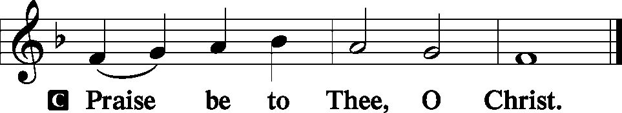 LSB 191

Sit
Hymn of the Day LSB 516 sts. 1-3
“Wake, Awake, for Night Is Flying”
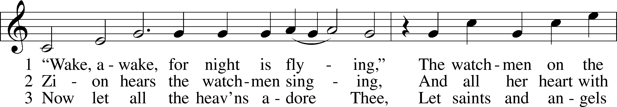
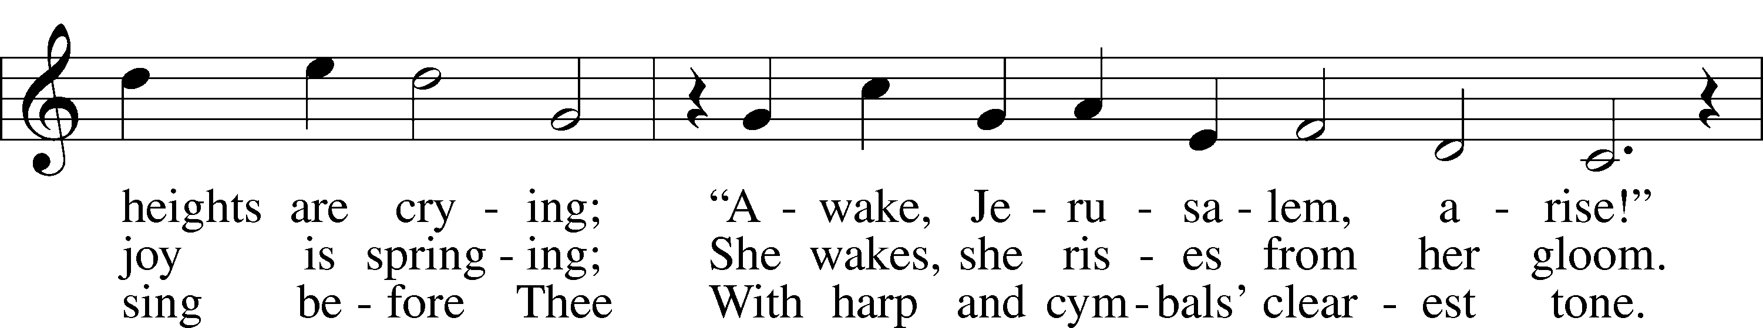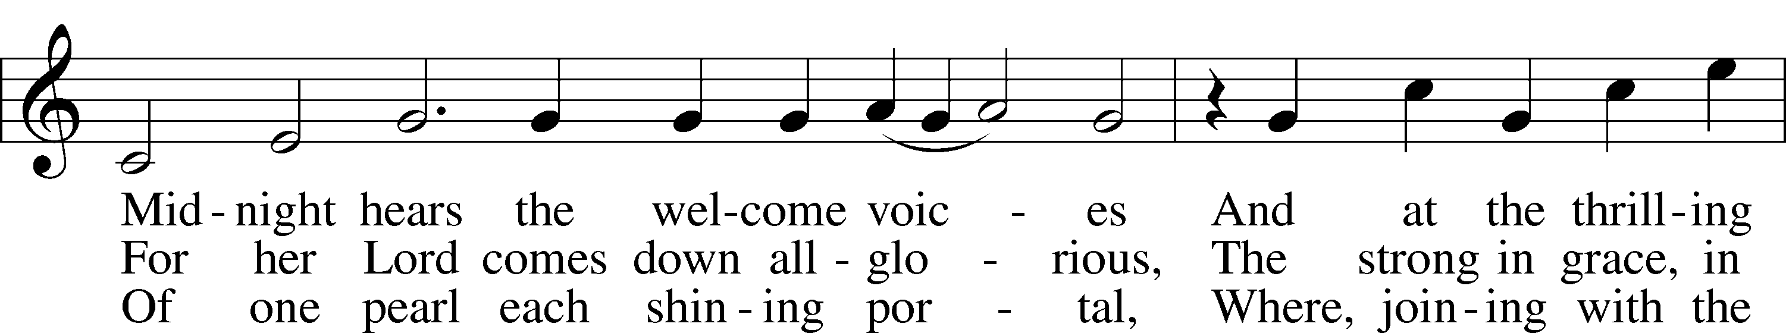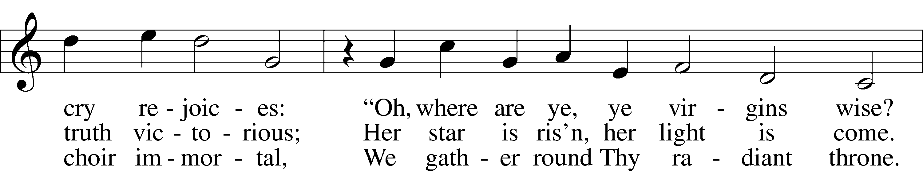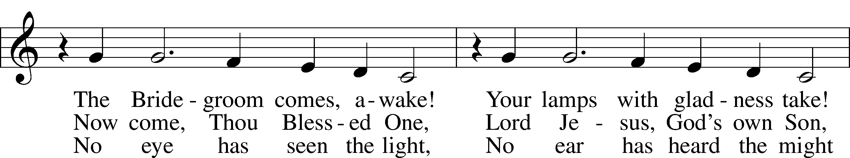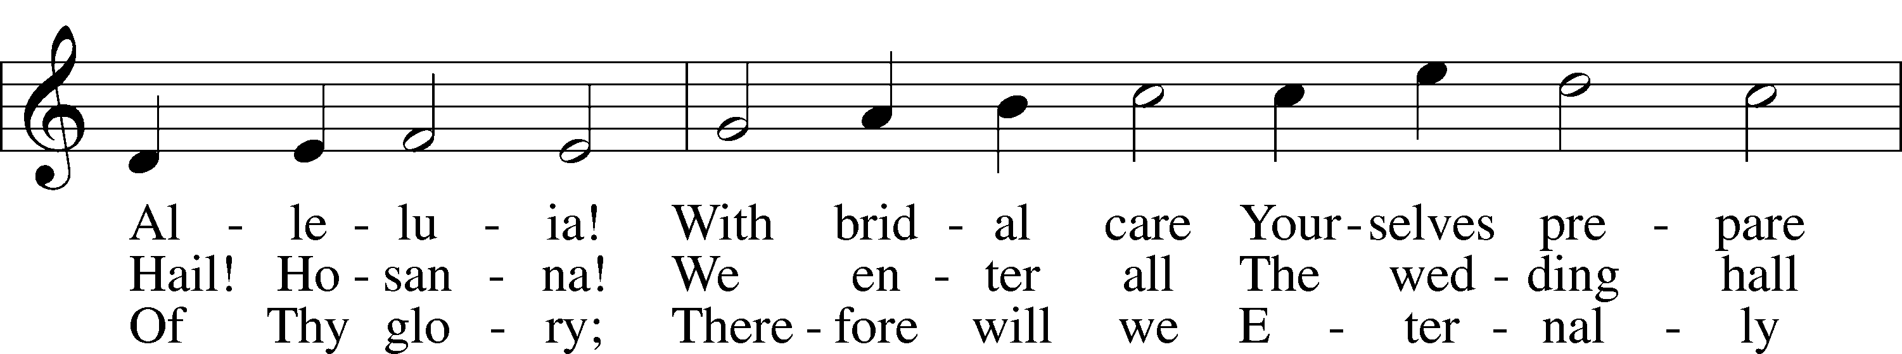
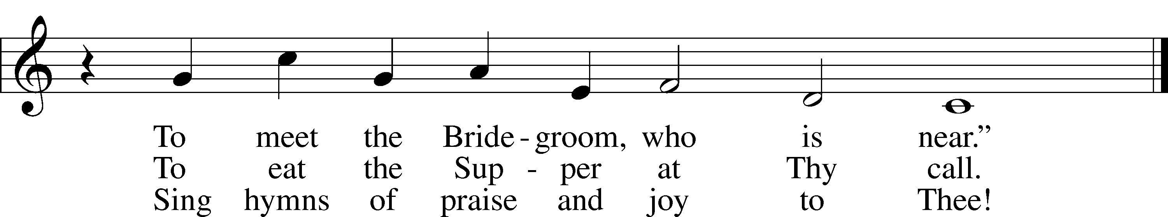

Public domain

Sermon “Perfect Preparation”
Pastor Tom Rhodes (On Screen)

Stand
Together We Confess our Common Faith Using the Apostle’s Creed LSB 192
L C I believe in God, the Father Almighty, maker of heaven and earth.

And in Jesus Christ, His only Son, our Lord,
who was conceived by the Holy Spirit,
born of the virgin Mary,
suffered under Pontius Pilate,
was crucified, died, and was buried.
He descended into hell.
The third day He rose again from the dead.
He ascended into heaven
and sits at the right hand of God the Father Almighty.
From thence He will come to judge the living and the dead.

I believe in the Holy Spirit,
the holy Christian Church,
the communion of saints,
the forgiveness of sins,
the resurrection of the body,
and the life  everlasting. Amen.

Offering
In quiet devotion and responding in personal stewardship of God’s abundant provision to you, please use the offering plates in the back as you enter or exit. This is just as it says: An offering to God through His church. As a reassurance to those in worship today, especially our guests - this is not an obligation - the good news of Jesus is free to all!

Stewardship Prayer
L C In gratitude of receiving the Lord’s gifts and blessings, for guiding us to generously share with those in need His blessings and the resources we’ve been given, and for the tithes and offerings to support the work of the Kingdom in this place, we give thanks and praise to God. In Jesus’ name, Amen.

Offertory LSB 192
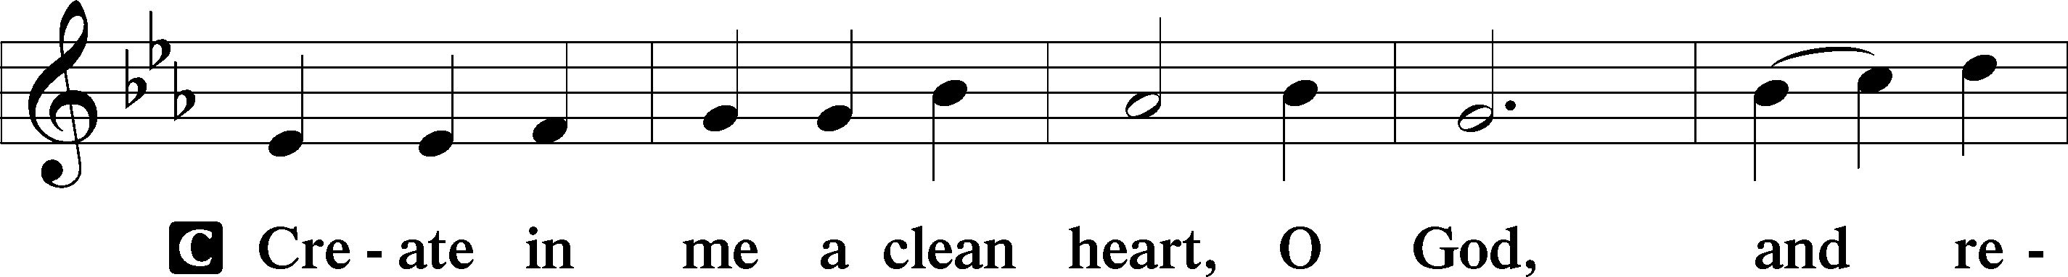
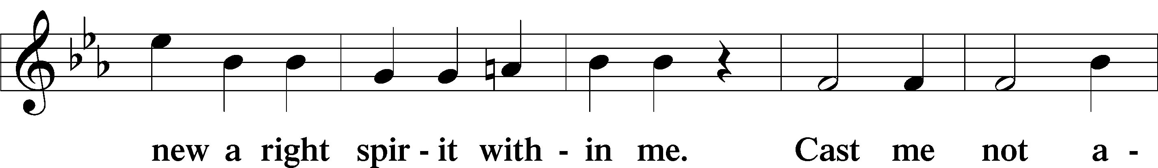
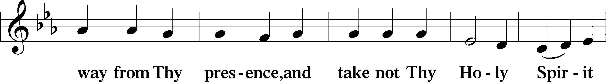
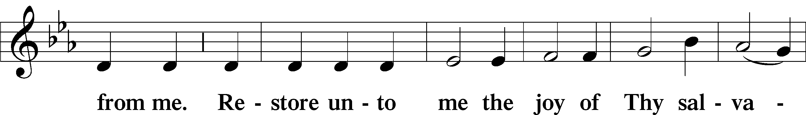
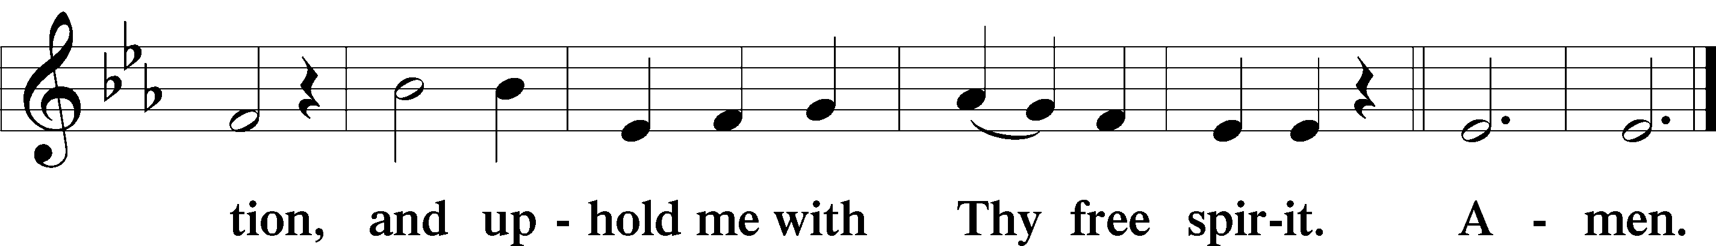

Prayer of the Church LSB 193
L Lord, You are our light and our preparer unto life eternal and to You we bring the prayers and petitions of Your people, that You may grant to us all things good and needful and guard us against all things evil and harmful.

Brief silence

L That the Lord would rule over the darkness and shine His light over all the earth, that those from many nations may be united as one people and live together in faith, by the power of the Holy Spirit, let us pray to the Lord:
C Lord, have mercy.

L That the Lord would grant us wisdom and courage, that we may be prepared at all times to receive Him when He comes in His glory and that we may not be distracted by earthly glories that fade away, let us pray to the Lord:
C Lord, have mercy.

L That the Lord would give courage to all those who hear the Word proclaimed that we may believe, and that believing, we may live in righteousness and godliness before the world and be kept to the day when Christ returns as Lord and Judge of all, let us pray to the Lord:
C Lord, have mercy.

L That the governments of the world and our leaders would act justly and with mercy, that we may be spared war and violence, and that for the Lord’s glory we may use His gift of liberty and the abundant blessings He has poured out on our land, let us pray to the Lord:
C Lord, have mercy.

L That the Lord would give aid and comfort to the sick, the suffering and those in their last days, that He may grant healing according to His will and strength to bear up under the weight of loneliness or affliction, and especially for those on our prayer list and cards, let us pray to the Lord:
C Lord, have mercy.

L That we may not grieve as those who have no hope, that we may rejoice in the promise of the resurrection to life everlasting, and that we may encourage one another with these words, let us pray to the Lord:
C Lord, have mercy.

L That we may be ready to receive the Lord when He comes again in glory, that the Lord may open the hearts of those who have wandered away from the faith, and that the Lord may restore those caught up in error’s ways, let us pray to the Lord:
C Lord, have mercy.

L That the Lord may hear and answer the prayers of His people and that we may be content with His answer, trusting in His Fatherly will and wisdom to grant us all that we need and all that will profit our salvation, let us pray in the name of our Savior, Jesus Christ, our Lord.
C Amen.

Lord's Prayer Matthew 6:9-13, LSB 196
L Lord, remember us in Your kingdom and teach us to pray:

C Our Father who art in heaven,
hallowed be Thy name,
Thy kingdom come,
Thy will be done on earth
as it is in heaven;
give us this day our daily bread;
and forgive us our trespasses
as we forgive those
who trespass against us;
and lead us not into temptation,
but deliver us from evil.
For Thine is the kingdom
and the power and the glory
forever and ever. Amen.

Salutation and Benedicamus LSB 201
L The Lord be with you. 2 Timothy 4:22
C And with thy spirit.
L Bless we the Lord. Psalm 103:1
C Thanks be to God.
Benediction Numbers 6:24-26, LSB 202
L The Lord bless you and keep you.
The Lord make His face shine on you and be gracious to you.
The Lord look upon you with favor and  give you peace.
C Amen.

Sit
Closing Hymn LSB 966 sts. 1, 2, 5
“Before You, Lord, We Bow”
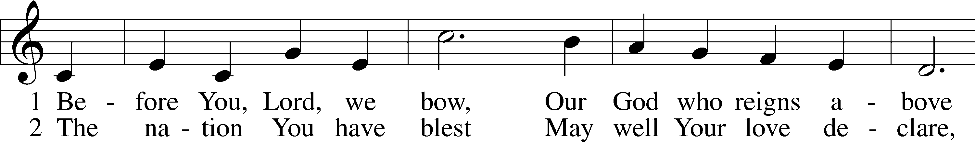
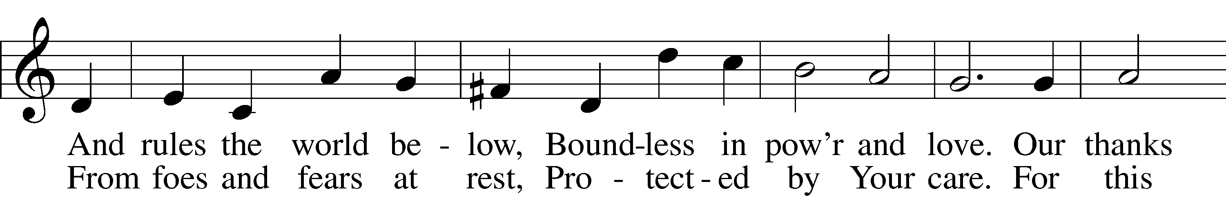
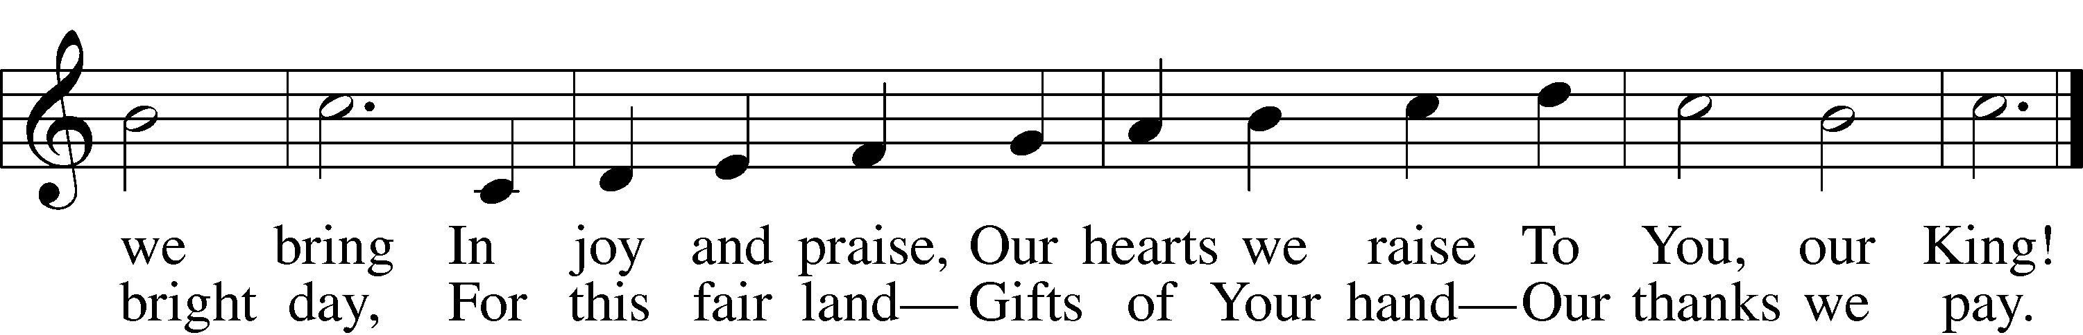
A countless throng,
With joy to sing
To heav’n’s high King
Salvation’s song!
5 And when in pow’r He comes,
Oh, may our native land
From all its rending tombs
Send forth a glorious band,
Public domain

