Zion Lutheran Church
‘Hearing, Sharing and Living the Gospel.’

Twenty-Fourth Sunday after Pentecost
November 15, 2020 10:30 a.m. Service

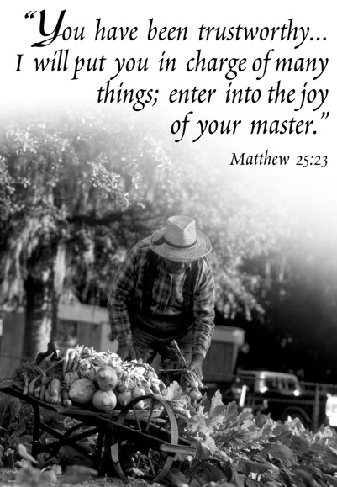

Zion Lutheran Church

‘Hearing, Sharing and Living the Gospel’
Rev. Thomas A. Rhodes, Pastor
PO Box 5 • 600 East Aldrich Road • Bolivar, MO 65613
Phone: 417-326-5506 • www.zionlutheranbolivar.org

zionbolivar@windstream.net


Administrative Assistant – Sonya Gorman
You are invited to use the yellow Prayer Cards located in the pew for prayer requests. Please hand this card to an usher or place it in the offering plate.
* Please turn off cellphones*

Holy Communion is offered today:
The Lord’s Supper is a wonderful gift given to us by God. In the bread and wine, just as He says, Christ gives us His body and blood to forgive sins, renew faith, and cause Godly and brotherly love to grow. In this sacrament we proclaim Christ’s death on the cross to atone for the sins of the world and His triumphant resurrection over the grave, to the glory and praise of God. To receive this means of God's grace properly we should be able to positively answer the following: “Do I need forgiveness for sin?” “Do I believe the pastor’s forgiveness is God’s forgiveness?” “Do I believe in Christ as my Savior?” “Do I trust that Christ is truly present in the bread and wine?” “Do I desire to live anew to God and others in love and service?” In our ‘yes’ to these questions we join in a close and holy communion – a fellowship of faith.
Out of Pastoral concern and care, and taking to heart God's Word in 1 Corinthians 11:28-29:“A man ought to examine himself before he eats of the bread and drinks of the cup. For anyone who eats and drinks without recognizing the body of the Lord eats and drinks judgment on himself” – if you are unsure of what it means to recognize the body of the Lord in the Lord’s Supper, or if you cannot confess these beliefs, please feel free to remain seated or speak to the Pastor or an Elder prior to the service.
If you need to receive the Sacrament at your seat, please tell an usher. For those who so desire, the cups in the center have water infused with a drop of wine. Also, non-communing children and adults are welcome to come to the altar rail and receive a blessing. (Please keep your hands folded to indicate this choice.)

TWENTY-FOURTH SUNDAY AFTER PENTECOST
Divine Service – Setting Four
November 15, 2020 10:30 a.m.

Welcome & Announcements

+ INVOCATION + LSB 203
The sign of the cross may be made by all in remembrance of their Baptism.
P We begin in the name into which we are baptized; In the name of the Father and of the  Son and of the Holy Spirit.
C Amen. Matthew 28:19b; [18:20]

Opening Hymn LSB 508 sts. 1, 4-5, 7
(to the tune of LSB 556)
“The Day Is Surely Drawing Near”
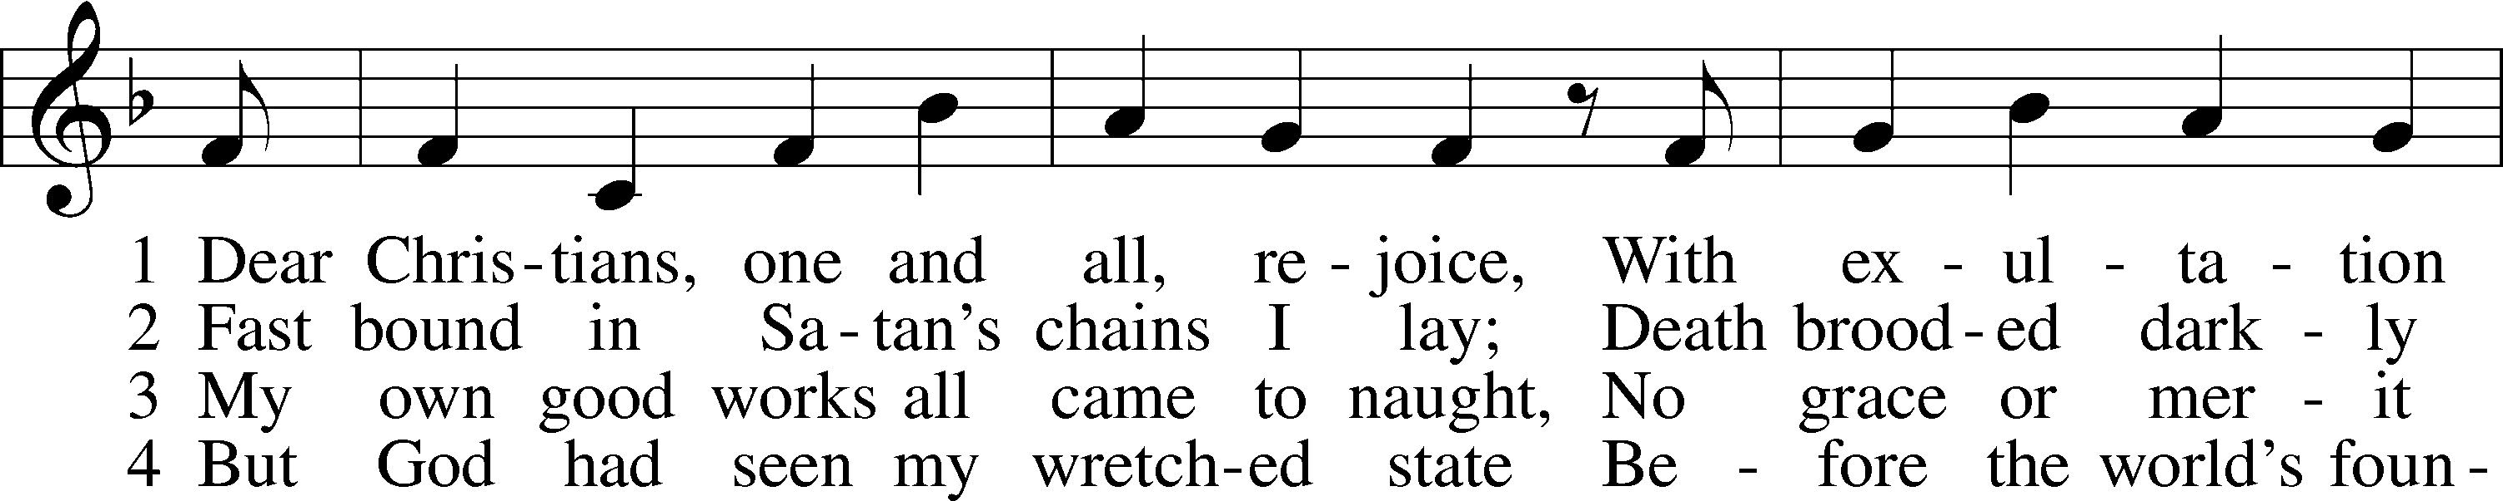
1 The day is sure - ly draw - ing near When Je - sus, God’s a-
4 Then woe to those who scorned the Lord And sought but car - nal
5 My Sav - ior paid the debt I owe And for my sin was
7 O Je - sus Christ, do not de - lay, But has - ten our sal -

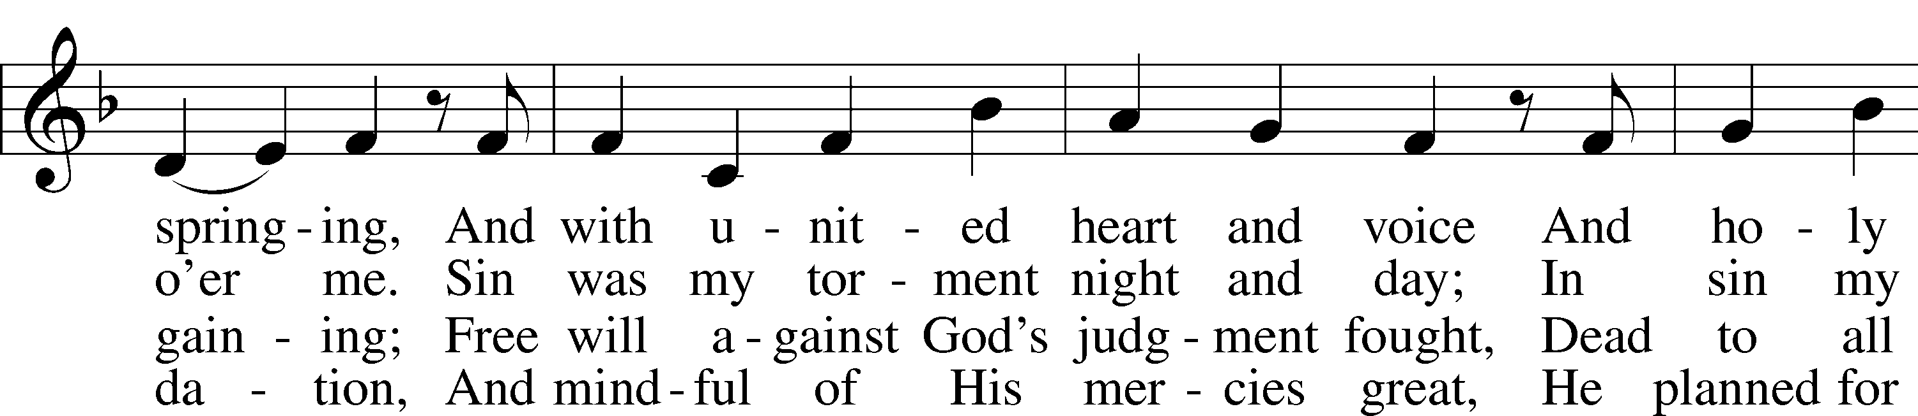
noint - ed, In all His pow - er shall ap - pear As judge whom
pleas - ures, Who here de - spised His pre - cious Word And loved their
smit - ten; With - in the Book of Life I know My name has
va - tion; We of - ten trem - ble on our way In fear and

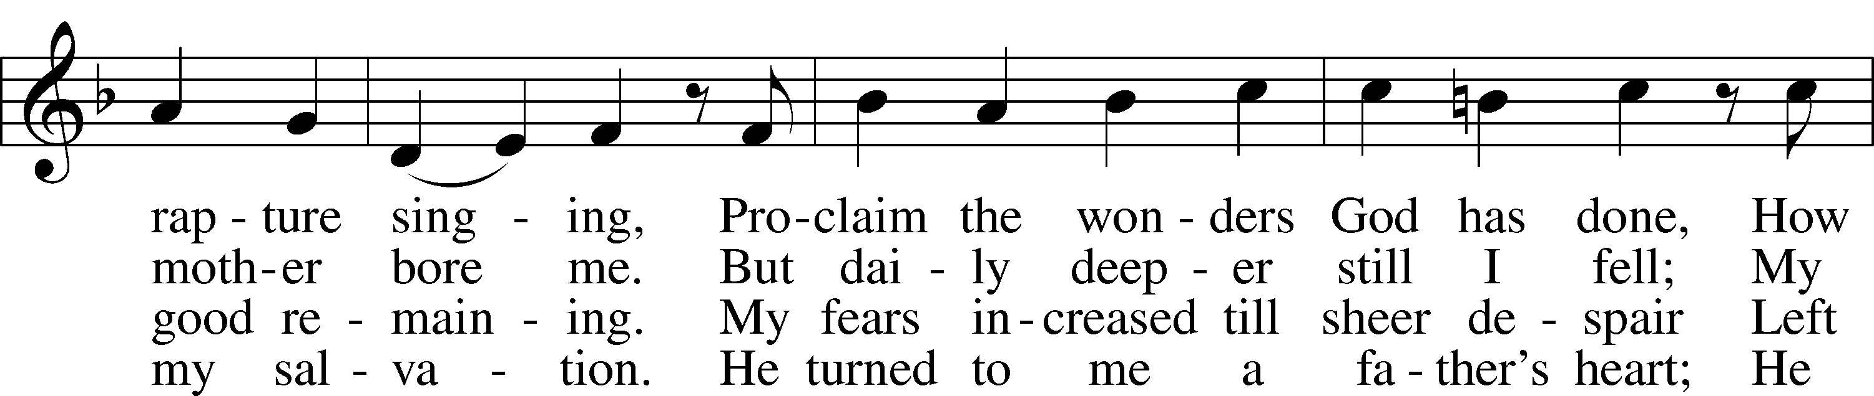
God ap - point - ed. Then fright shall ban - ish i - dle mirth, And
earth - ly treas - ures! With shame and trem - bling they will stand And
now been writ - ten. I will not doubt, for I am free, And
trib - u - la - tion. O hear and grant our fer - vent plea: Come

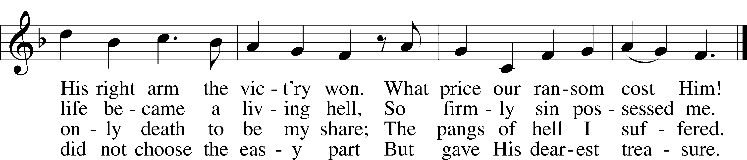
flames on flames shall rav - age earth As Scrip - ture long has warned us.
at the judg - e’s stern com - mand To Sa - tan be de - liv - ered.
Sa - tan can - not threat - en me; There is no con - dem - na - tion!
might - y judge, and set us free From death and ev - ’ry ev - il.

Public domain

Stand
+ CONFESSION AND ABSOLUTION + LSB 203
P Our help is in the name of the Lord,
C who made heaven and earth. Psalm 124:8

P If You, O Lord, kept a record of sins, O Lord, who could stand?
C But with You there is forgiveness; therefore You are feared.

P Since we are gathered to hear God’s Word, call upon Him in prayer and praise, and receive the body and blood of our Lord Jesus Christ in the fellowship of this altar, let us first consider our unworthiness and confess before God and one another that we have sinned in thought, word, and deed, and that we cannot free ourselves from our sinful condition.

(Silence for reflection on God's Word and for self-examination in light of the Ten Commandments.)

How have we allowed our sinful past to hold us hostage and draw us back to our old dead ways? We come to Confession and Absolution to receive healing and wholeness in God’s forgiveness.

Together as His people let us take refuge in the infinite mercy of God, our heavenly Father, seeking His grace for the sake of Christ, and saying: Luke 18:13
C God, be merciful to me, a sinner. Almighty God, have mercy upon us, forgive us our sins, and lead us to everlasting life. Amen.
P God be merciful to you and strengthen your faith. LSB 292
C Amen.
P Do you believe that my forgiveness is God’s forgiveness?
C Yes. LSB 293
P Let it be done for you as you believe.
P Almighty God in His LSB 203
mercy has given His Son to die for
you and for His sake forgives you all your sins. As a called and ordained servant of Christ, and by His authority, I therefore forgive you all your sins, in the name of the Father and of the  Son and of the Holy Spirit.
C Amen.

+ SERVICE OF THE WORD + LSB 204
Introit Ps. 143:2, 5-6, 10-11; antiphon: Ps. 143:1
P Hear my prayer, O Lord; give ear to my pleas for mercy! In your faithfulness answer me, in your righteousness!
C Enter not into judgment with your servant, for no one living is righteous before you.
P I remember the days of old; I meditate on all that you have done; I ponder the work of your hands.
C I stretch out my hands to you; my soul thirsts for you like a parched land.
P Teach me to do your will, for you are my God! Let your good Spirit lead me on level ground!
C For your name’s sake, O Lord, preserve my life! In your righteousness bring my soul out of trouble!
P C Glory be to the Father and to the Son and to the Holy Spirit; as it was in the beginning, is now, and will be forever. Amen.
P Hear my prayer, O Lord; give ear to my pleas for mercy! In your faithfulness answer me, in your righteousness!

Kyrie Mark 10:47, LSB 204
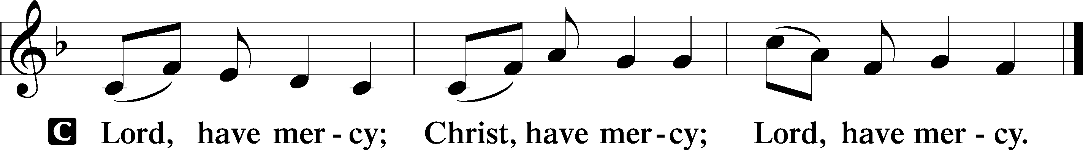

Hymn of Praise/Gloria in Excelsis LSB 204
Luke 2:14, John 1:29
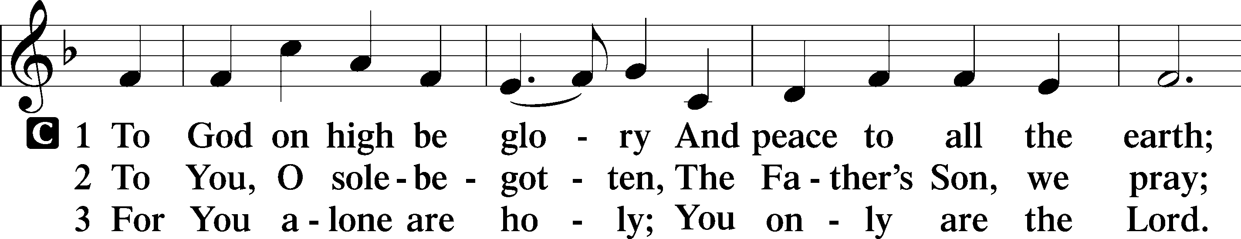
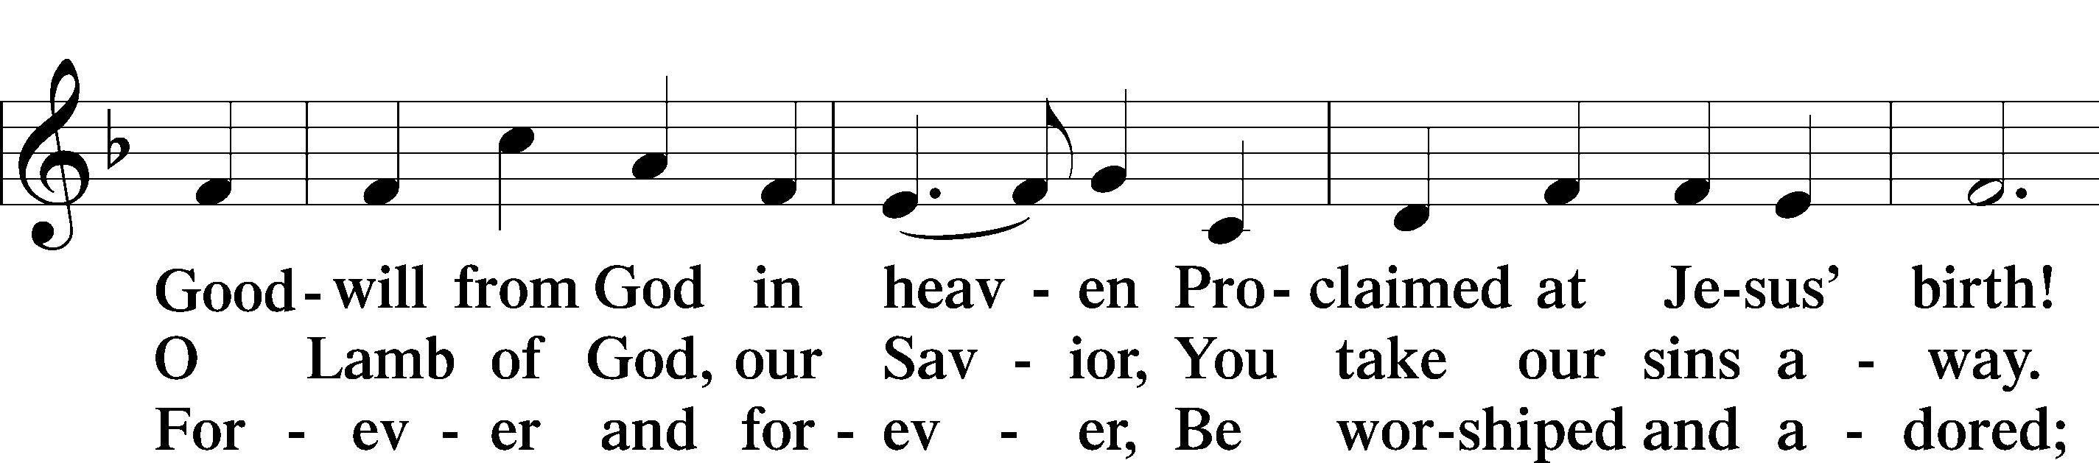
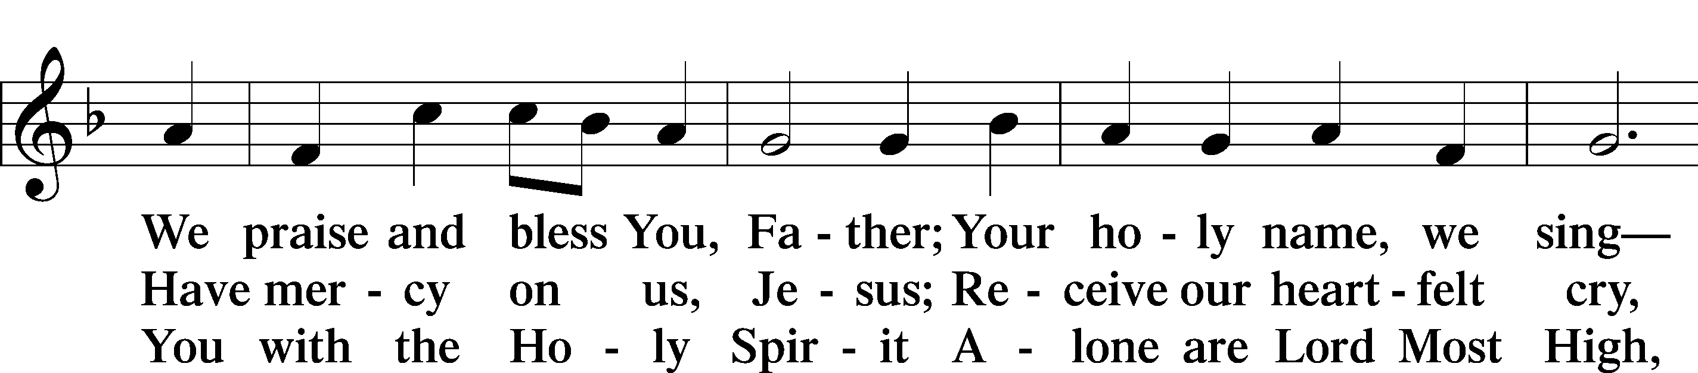
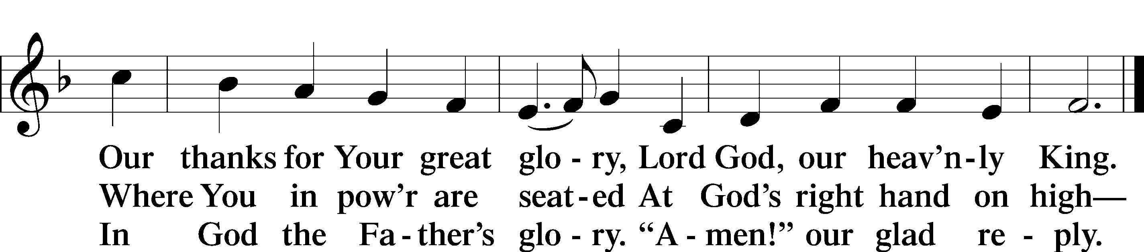

Salutation and Collect of the Day LSB 205
P The Lord be with you. 2 Timothy 4:22
C And also with you.
P Let us pray. Almighty and ever-living God, You have given exceedingly great and precious promises to those who trust in You. Dispel from us the works of darkness and grant us to live in the light of Your Son, Jesus Christ, that our faith may never be found wanting; through the same Jesus Christ, our Lord, who lives and reigns with You and the Holy Spirit, one God, now and forever.
C Amen.

Sit
Old Testament Reading
Zephaniah 1:10, 12, 14-16
10 “On that day,” declares the Lord, “a cry will go up from the Fish Gate, wailing from the New Quarter, and a loud crash from the hills…12 At that time I will search Jerusalem with lamps and punish those who are complacent, who are like wine left on its dregs, who think, ‘The Lord will do nothing, either good or bad.’… 14 The great day of the Lord is near— near and coming quickly. The cry on the day of the Lord is bitter; the Mighty Warrior shouts his battle cry. 15 That day will be a day of wrath— a day of distress and anguish, a day of trouble and ruin, a day of darkness and gloom, a day of clouds and blackness- 16 a day of trumpet and battle cry against the fortified cities and against the corner towers.
A This is the Word of the Lord.
C Thanks be to God.

Gradual Rev. 7:14b; Ps. 84:5
A C These are the ones coming out of the great tribulation. They have washed their robes and made them white in the blood of the Lamb. Blessed are those whose strength is in you, in whose heart are the highways to Zion.

Epistle Reading 1 Thessalonians 5:1-3, 9-11
5 Now, brothers, about times and dates we do not need to write to you, 2 for you know very well that the day of the Lord will come like a thief in the night. 3 While people are saying, “Peace and safety,” destruction will come on them suddenly, as labor pains on a pregnant woman, and they will not escape…
9 For God did not appoint us to suffer wrath but to receive salvation through our Lord Jesus Christ. 10 He died for us so that, whether we are awake or asleep, we may live together with him. 11 Therefore encourage one another and build each other up, just as in fact you are doing.
A This is the Word of the Lord.
C Thanks be to God.

Stand
Alleluia and Verse John 20:31, LSB 205
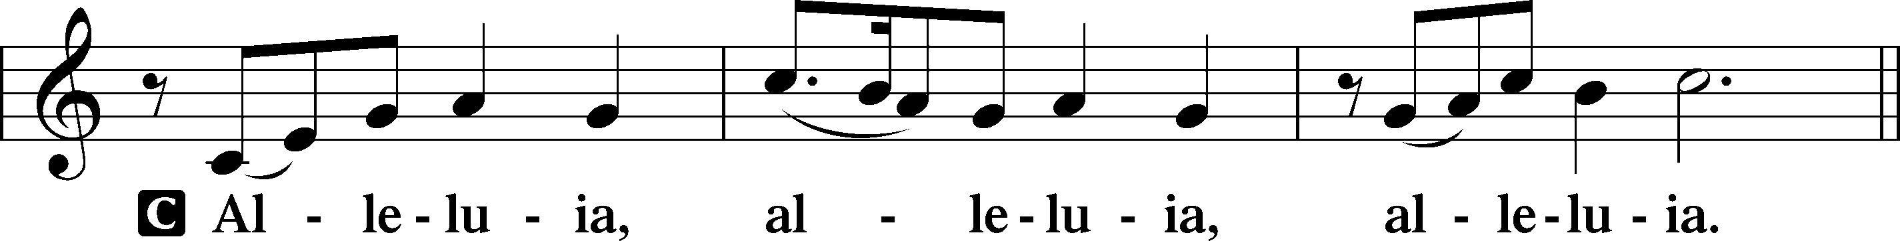
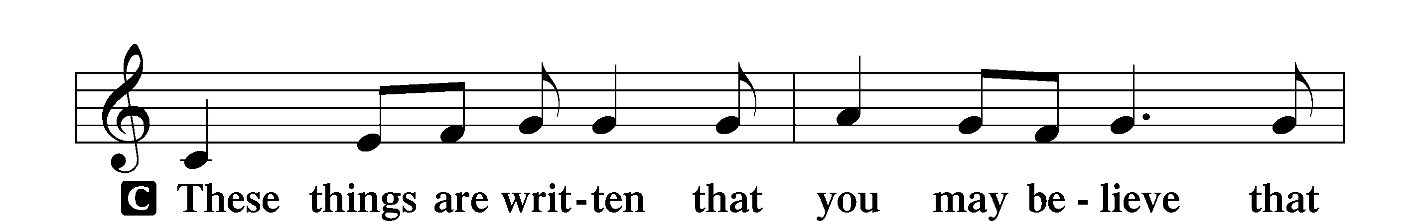
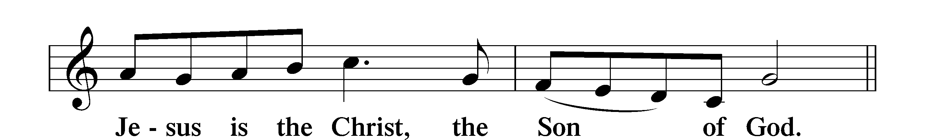
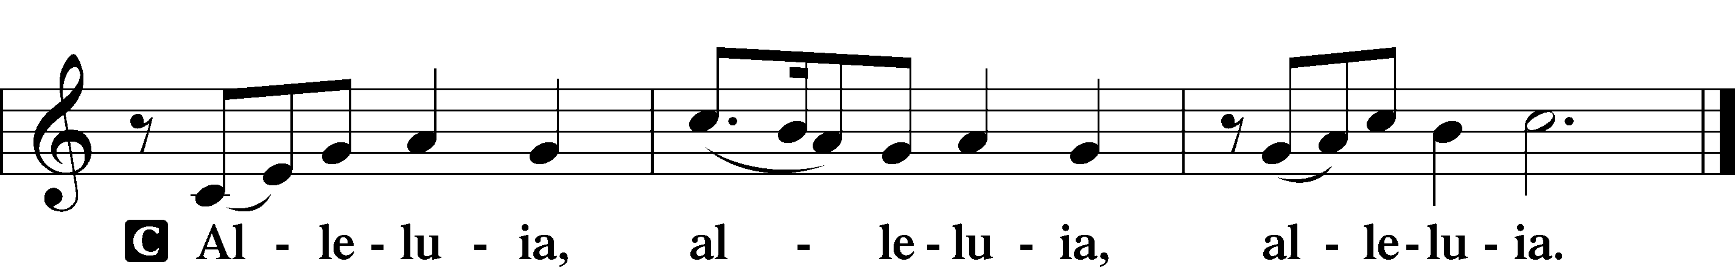

Holy Gospel Matthew 25:14-30
P The Holy Gospel according to St. Matthew, the twenty-fifth chapter.
C Glory to You, O Lord.

14 “Again, it will be like a man going on a journey, who called his servants and entrusted his property to them. 15 To one he gave five talents of money, to another two talents, and to another one talent, each according to his ability. Then he went on his journey. 16 The man who had received the five talents went at once and put his money to work and gained five more. 17 So also, the one with the two talents gained two more. 18 But the man who had received the one talent went off, dug a hole in the ground and hid his master’s money.
19 “After a long time the master of those servants returned and settled accounts with them.
20 The man who had received the five talents brought the other five. ‘Master,’ he said, ‘you entrusted me with five talents. See, I have gained five more.’
21 “His master replied, ‘Well done, good and faithful servant! You have been faithful with a few things; I will put you in charge of many things. Come and share your master’s happiness!’
22 “The man with the two talents also came. ‘Master,’ he said, ‘you entrusted me with two talents; see, I have gained two more.’
23 “His master replied, ‘Well done, good and faithful servant! You have been faithful with a few things; I will put you in charge of many things. Come and share your master’s happiness!’
24 “Then the man who had received the one talent came. ‘Master,’ he said, ‘I knew that you are a hard man, harvesting where you have not sown and gathering where you have not scattered seed. 25 So I was afraid and went out and hid your talent in the ground. See, here is what belongs to you.’
26 “His master replied, ‘You wicked, lazy servant! So you knew that I harvest where I have not sown and gather where I have not scattered seed? 27 Well then, you should have put my money on deposit with the bankers, so that when I returned I would have received it back with interest.
28 “ ‘Take the talent from him and give it to the one who has the ten talents. 29 For everyone who has will be given more, and he will have an abundance. Whoever does not have, even what he has will be taken from him. 30 And throw that worthless servant outside, into the darkness, where there will be weeping and gnashing of teeth.

P This is the Gospel of the Lord.
C Praise to You, O Christ.

Sit
Hymn of the Day LSB 667 sts. 1, 4-5 & repeat st. 1
“Saints, See the Cloud of Witnesses”
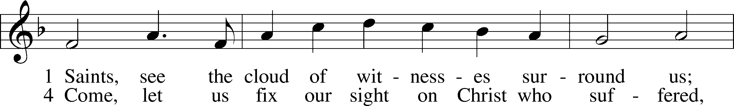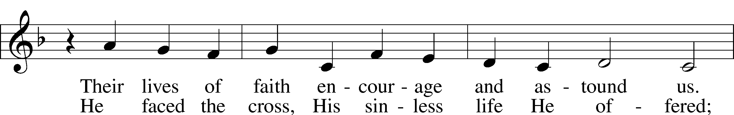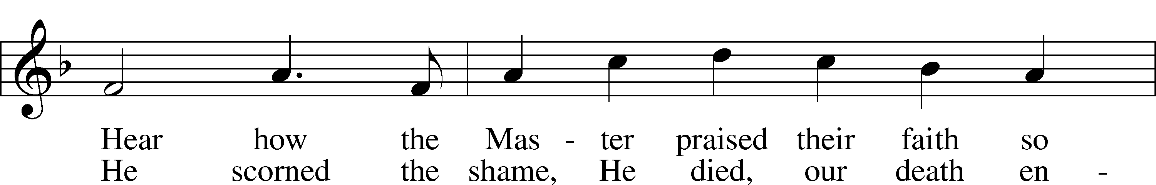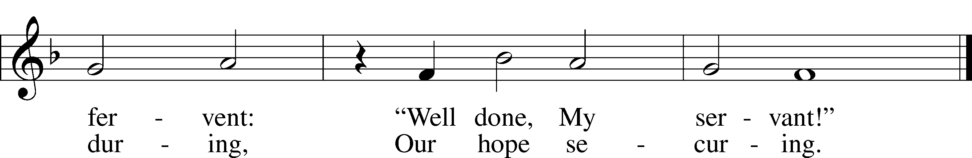

5 Lord, give us faith to walk where You are sending,
On paths unmarked, eyes blind as to their ending;
Not knowing where we go, but that You lead us—
With grace precede us.

1 Saints, see the cloud of witnesses surround us;
Their lives of faith encourage and astound us.
Hear how the Master praised their faith so fervent:
“Well done, My servant!”

© 1997 Stephen P. Starke. Used by permission: LSB Hymn License .NET, no. 100011462.

Sermon “Today!” Pastor Tom Rhodes

Stand
Together We Confess our Common Faith Using the Nicene Creed LSB 206
P C I believe in one God, the Father Almighty, maker of heaven and earth and of all things visible and invisible.

And in one Lord Jesus Christ,
the only-begotten Son of God,
begotten of His Father before all worlds,
God of God, Light of Light,
very God of very God,
begotten, not made,
being of one substance with the Father,
by whom all things were made;
who for us men and for our salvation
came down from heaven
and was incarnate by the Holy Spirit of
the virgin Mary and was made man;
and was crucified also for us under
Pontius Pilate.
He suffered and was buried.
And the third day He rose again
according to the Scriptures
and ascended into heaven
and sits at the right hand of the Father.
And He will come again with glory to
judge both the living and the dead,
whose kingdom will have no end.

And I believe in the Holy Spirit,
the Lord and giver of life,
who proceeds from the Father and the Son, who with the Father and the Son together is worshiped and glorified,
who spoke by the prophets.
And I believe in one holy Christian and
apostolic Church,
I acknowledge one Baptism for the
remission of sins,
and I look for the resurrection of the dead and the life  of the world to come. Amen.

Offering
In quiet devotion and responding in personal stewardship of God’s abundant provision to you, please use the offering plates in the back as you enter or exit. (This is just as it says: An offering to God through His church. As a reassurance to those in worship today, especially our guests - this is not an obligation - the good news of Jesus is free to all!)
Stewardship Prayer
P C O Lord we pray for our stewardship of Your creation, that today we be faithful in the use of all Your gifts, and for grateful hearts, that we may honor You with our words and with our works. In Jesus’ name we pray, Amen.

Offertory LSB 781 sts. 1-2
We Give Thee But Thine Own
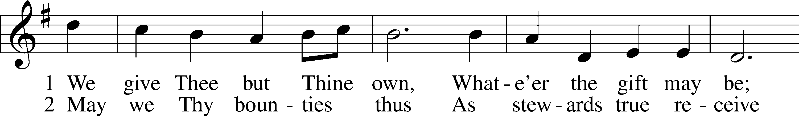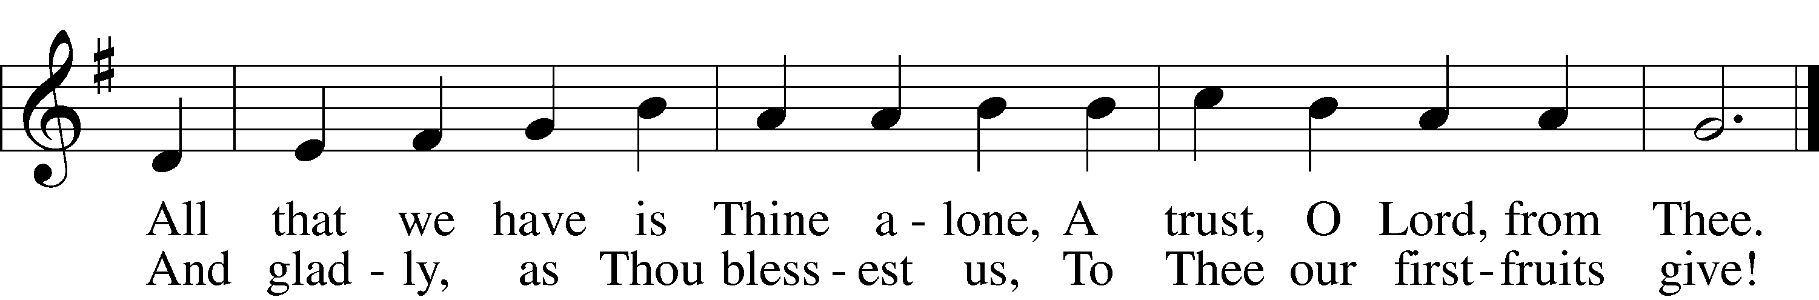

Public domain

Prayer of the Church LSB 207
P Let us pray for the whole people of God in Christ Jesus and for all people according to their needs.

Brief silence

P Almighty Father, as the great “today” of the Lord draws ever nearer, when Your Son will return to judge the living and the dead, we pray that You would grant Your people to remain faithful to the end. Give us leaders in government who discharge their calling to Your honor and allows your faithful followers to share Your Gospel in peace. Lord, in Your mercy,
C hear our prayer.

P Gracious Lord, though we do not know the day or hour of Your Son’s appearing, grant that we would always be prepared by sending us faithful pastors and teachers who will boldly proclaim Your Word of Law and Gospel to us, that we may be constantly encouraged and built up in the faith. Lord, in Your mercy,
C hear our prayer.

P Lord God, by the power of Your Holy Spirit, grant us each day to be generous in speaking of the salvation that You provide for all through Your Son. Lord, in Your mercy,
C hear our prayer.

P Merciful Lord, we pray that You would grant healing and relief to all who are afflicted in mind, body or soul, especially those on our prayer list and cards. Give them the peace and comfort that only comes through Christ. Lord, in Your mercy,
C hear our prayer.

P Blessed Lord, we give thanks to You for all the faithful departed. Grant comfort to all who mourn, that they may find peace and hope in the resurrection of the dead. Lord, in Your mercy,
C hear our prayer.

P Into Your hands, O Lord, we commend all for whom we pray, trusting in Your mercy, through Jesus Christ, Your Son, our Lord, who lives and reigns with You and the Holy Spirit, one God, now and forever.
C Amen.

+ SERVICE OF THE SACRAMENT + LSB 208
Preface
P The Lord be with you.
C And also with you.
P Lift up your hearts.
C We lift them to the Lord.
P Let us give thanks to the Lord our God.
C It is right to give Him thanks and praise.
P It is truly good, right, and salutary that we should at all times and in all places give thanks to You, holy Lord, almighty Father, everlasting God, through Jesus Christ, our Lord, who, having created all things, took on human flesh and was born of the virgin Mary. For our sake He died on the cross and rose from the dead to put an end to death, thus fulfilling Your will and gaining for You a holy people. Therefore with angels and archangels and with all the company of heaven we laud and magnify Your glorious name, evermore praising You and saying:

Sanctus Isaiah 6:3, Matthew 21:9; LSB 208
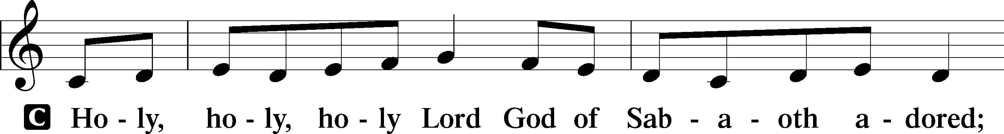
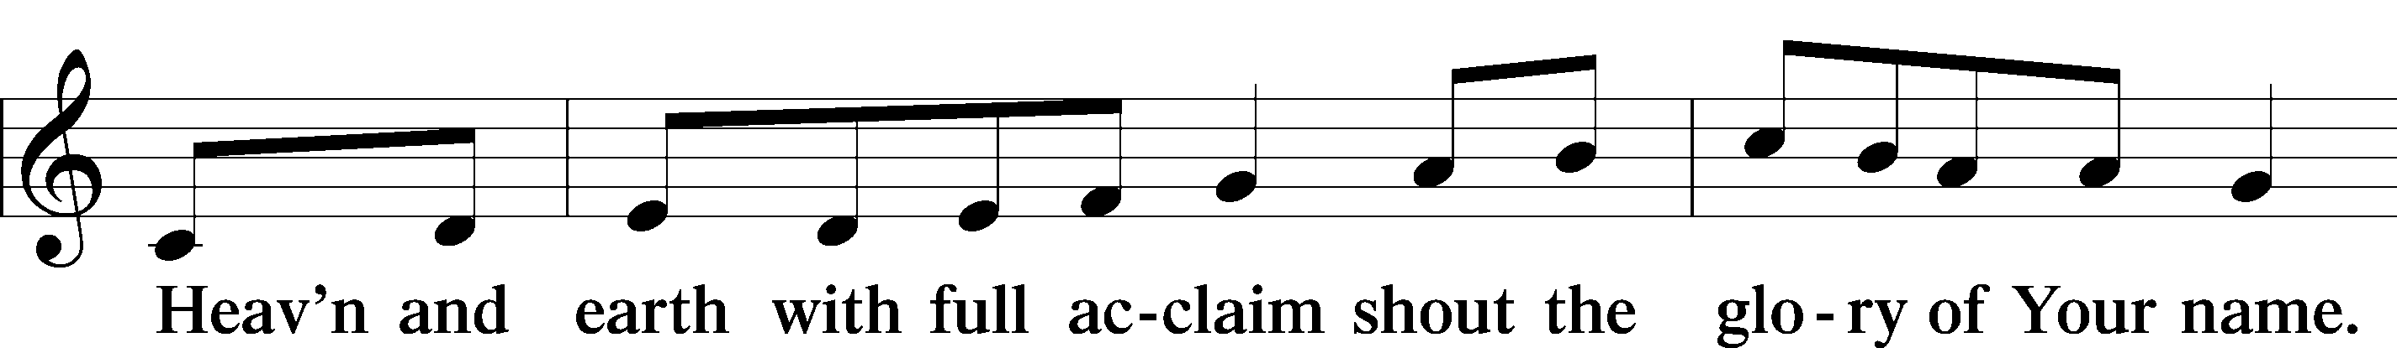
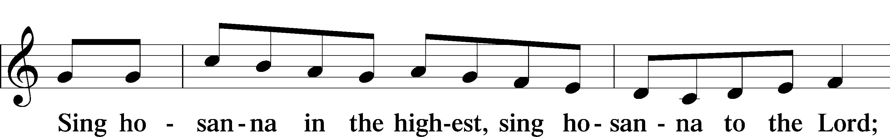
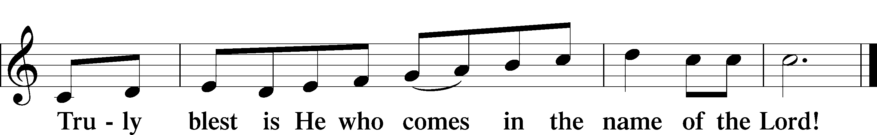

Prayer of Thanksgiving LSB 209
P Blessed are You, O Lord our God, king of all creation, for You have had mercy on us and given Your only-begotten Son that whoever believes in Him should not perish but have eternal life.

In Your righteous judgment You condemned the sin of Adam and Eve, who ate the forbidden fruit, and You justly barred them and all their children from the tree of life. Yet, in Your great mercy, You promised salvation by a second Adam, Your Son, Jesus Christ, our Lord, and made His cross a life-giving tree for all who trust in Him.

We give You thanks for the redemption You have prepared for us through Jesus Christ. Grant us Your Holy Spirit that we may faithfully eat and drink of the fruits of His cross and receive the blessings of forgiveness, life, and salvation that come to us in His body and blood.

Hear us as we pray in His name and as He has taught us:
Lord's Prayer Matthew 6:9-13
C Our Father who art in heaven,
hallowed be Thy name,
Thy kingdom come,
Thy will be done on earth
as it is in heaven;
give us this day our daily bread;
and forgive us our trespasses
as we forgive those
who trespass against us;
and lead us not into temptation,
but deliver us from evil.
For Thine is the kingdom
and the power and the glory
forever and ever. Amen.

The Words of Our Lord LSB 209
Matthew 26:26–28; Mark 14:22–24; Luke 22:19–20; 1 Corinthians 11:23–25
P Our Lord Jesus Christ, on the night when He was betrayed, took bread, and when He had given thanks, He broke it and gave it to the disciples and said: “Take, eat; this is My  body, which is given for you. This do in remembrance of Me.”

P In the same way also He took the cup after supper, and when He had given thanks, He gave it to them, saying: “Drink of it, all of you; this cup is the new testament in My  blood, which is shed for you for the forgiveness of sins. This do, as often as you drink it, in remembrance of Me.”

Pax Domini John 20:19, LSB 209
P The peace of the Lord be with you always.
C Amen.

Agnus Dei John 1:29, LSB 210
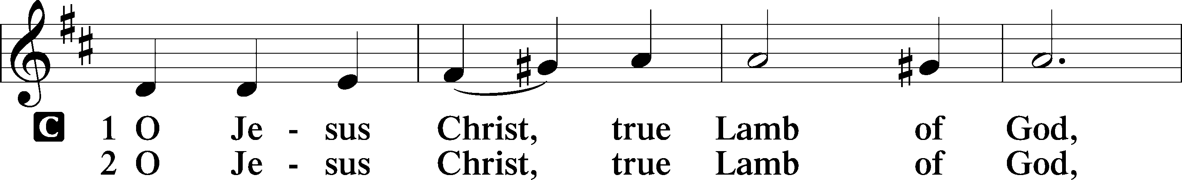
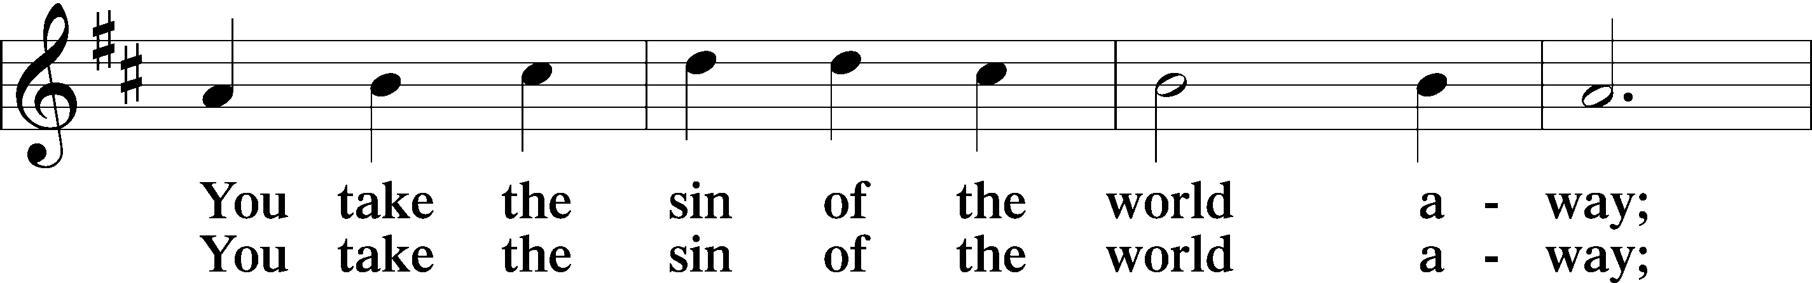
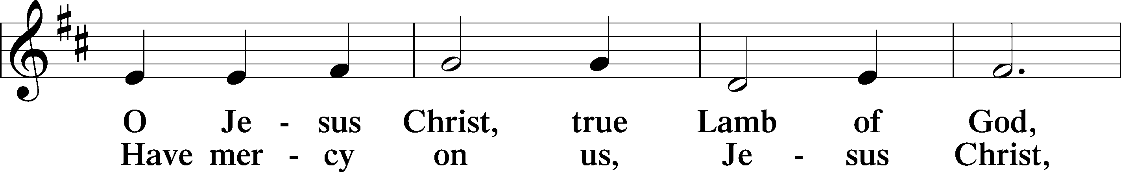
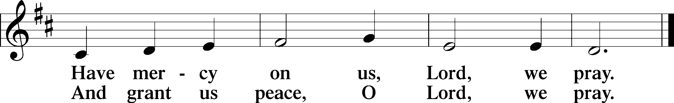

Sit

DISTRIBUTION

Distribution Hymn LSB 619 sts. 1-5
“Thy Body, Given for Me, O Savior”
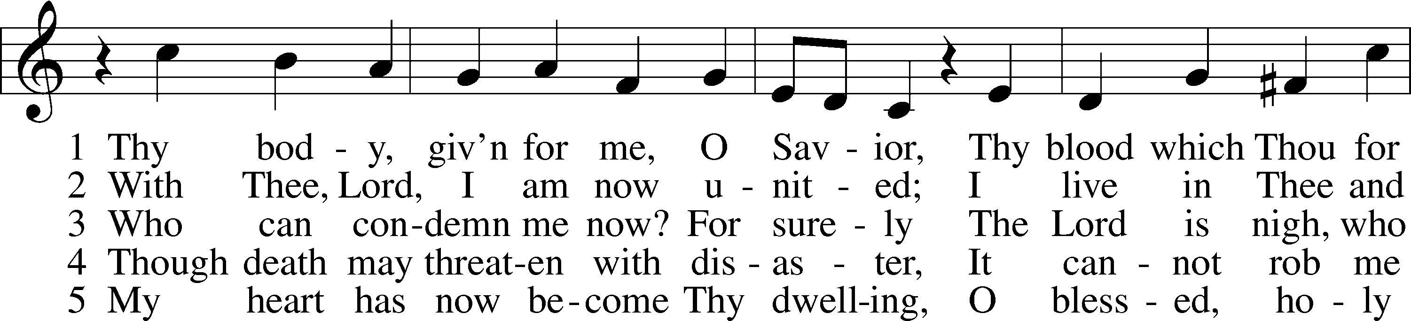
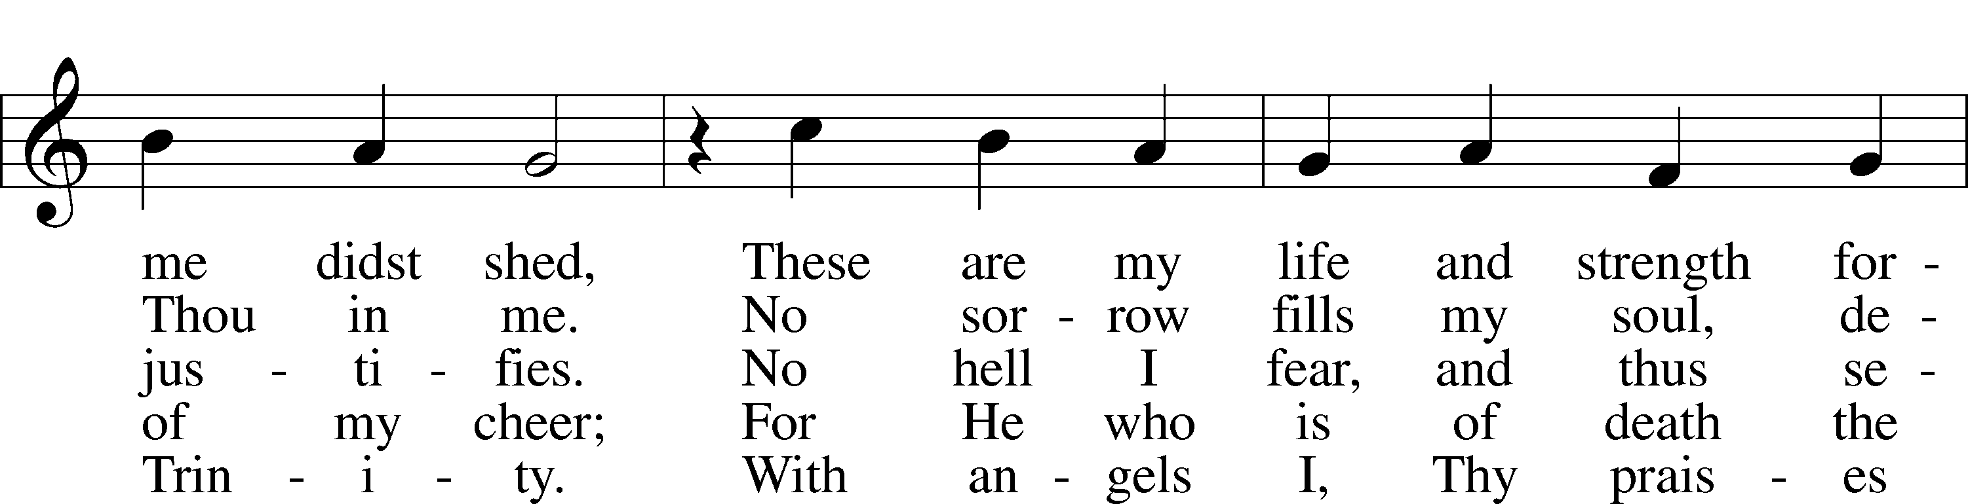
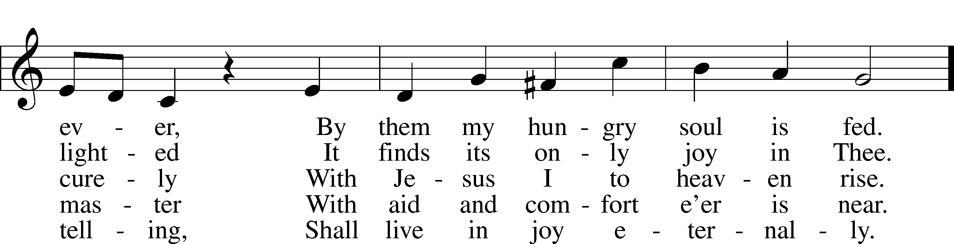
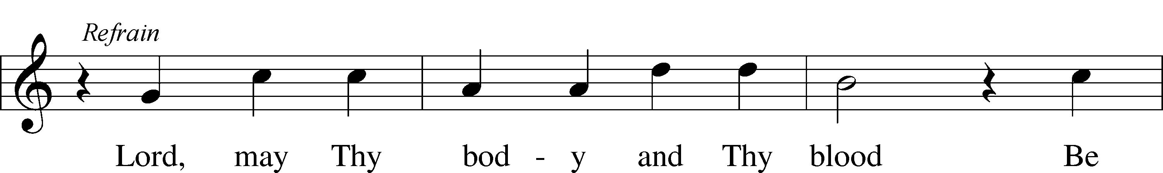
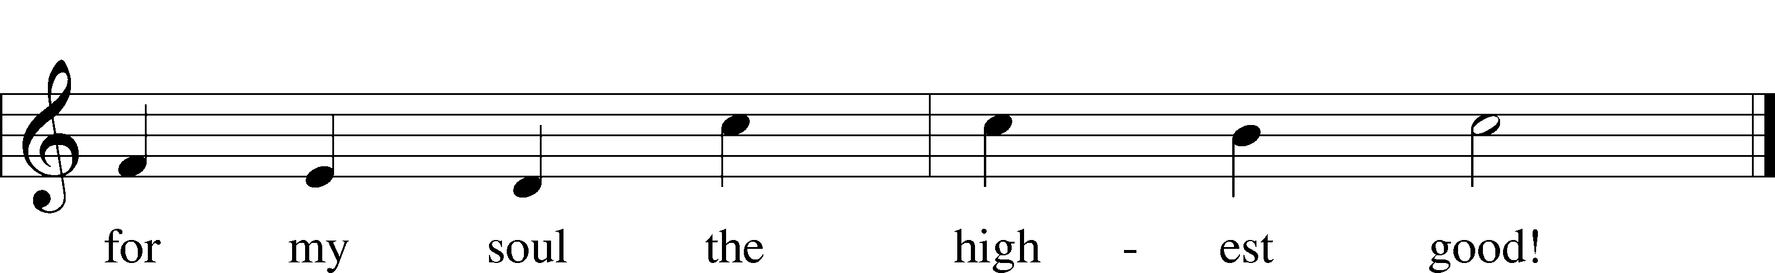
© 1941 Concordia Publishing House. Used by permission: LSB Hymn License .NET, no. 100011462. Public domain

Distribution Hymn LSB 783 sts. 1-6
“Take My Life and Let It Be”
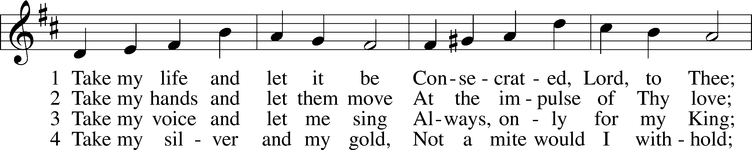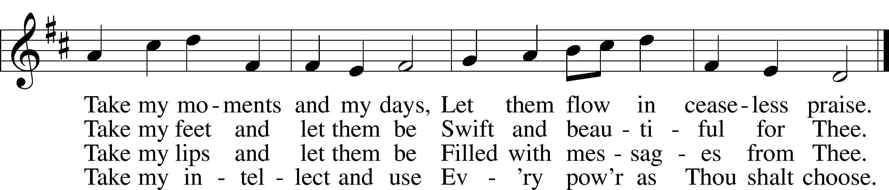
5 Take my will and make it Thine, 6 Take my love, my Lord, I pour
It shall be no longer mine; At Thy feet its treasure store;
Take my heart, it is Thine own, Take myself, and I will be
It shall be Thy royal throne. Ever, only, all for Thee.

Public domain

Stand
Nunc Dimittis Luke 2:29-32, LSB 211
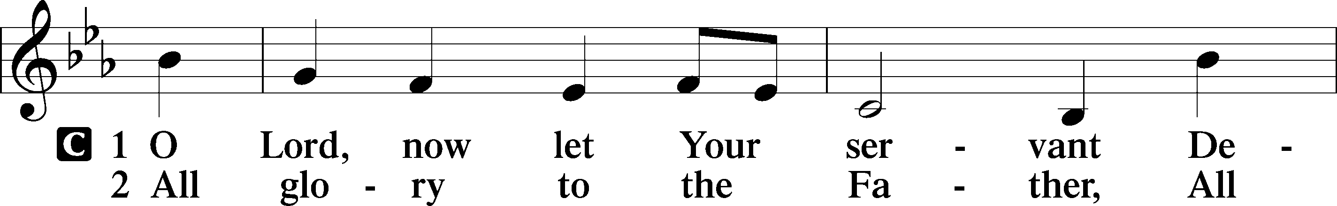
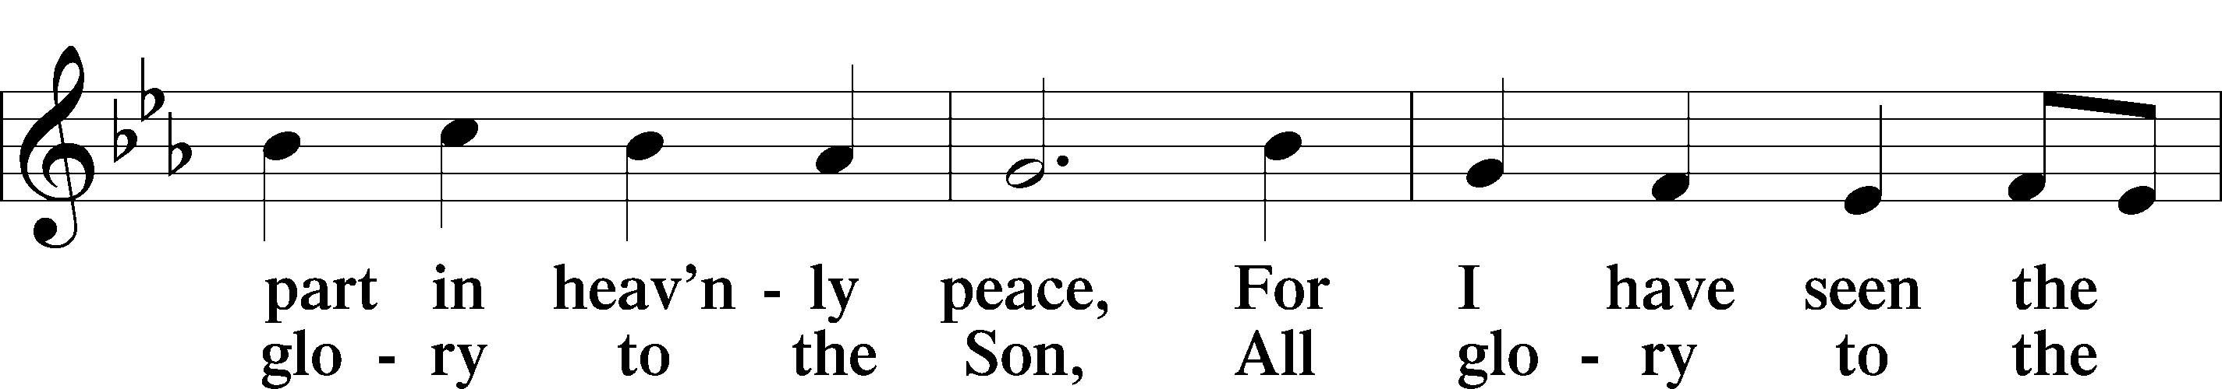
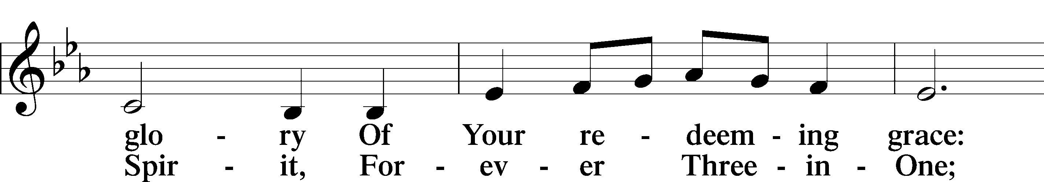
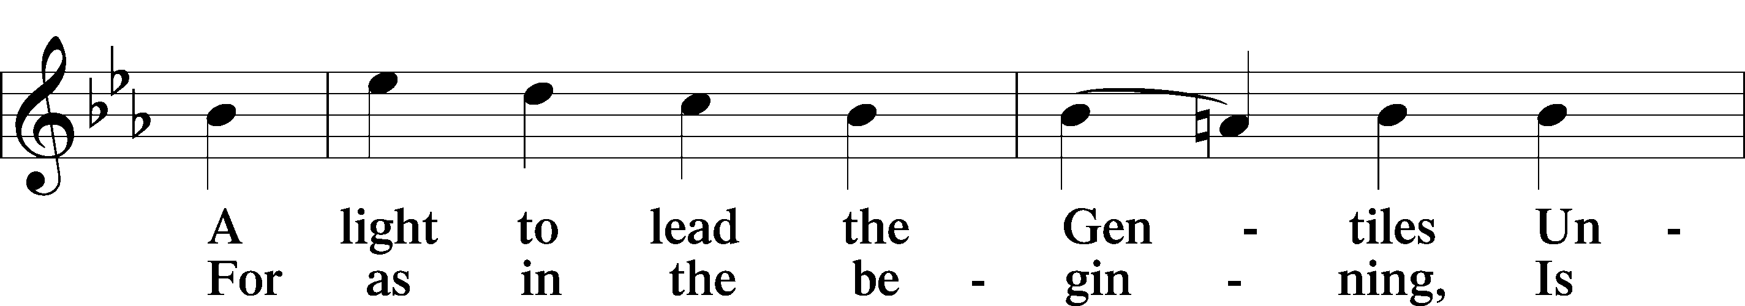
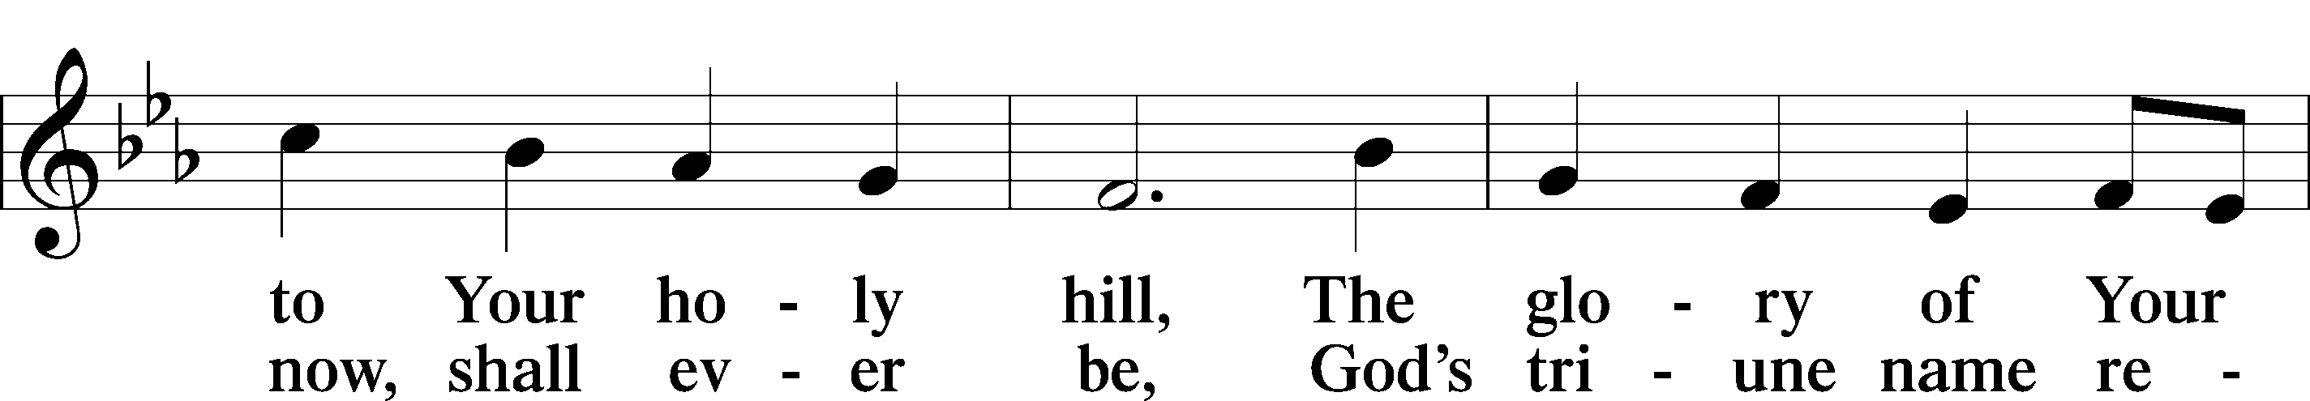
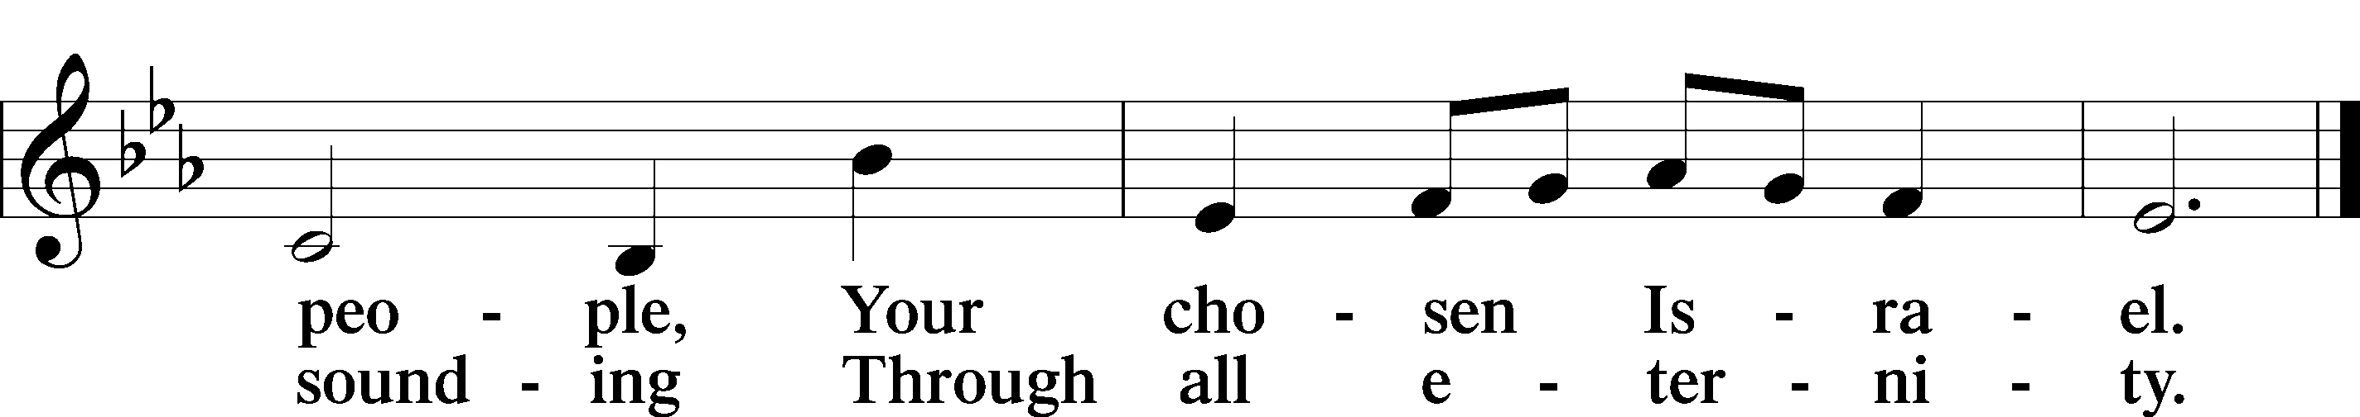

Post-Communion Collect LSB 212
P Let us pray.
P Gracious God, our heavenly Father, You have given us a foretaste of the feast to come in the Holy Supper of Your Son’s body and blood. Keep us firm in the true faith throughout our days of pilgrimage that, on the day of His coming, we may, together with all Your saints, celebrate the marriage feast of the Lamb in His kingdom which has no end; through Jesus Christ, Your Son, our Lord, who lives and reigns with You and the Holy Spirit, one God, now and forever.
C Amen.

Benedicamus and Benediction LSB 212
P Let us bless the Lord.
C Thanks be to God.
P The Lord bless you and keep you.
The Lord make His face shine on you and be gracious to you. The Lord look upon you with favor and  give you peace. Numbers 6:24-26
C Amen.

Sit
Closing Hymn LSB 781 sts. 1, 4-6
“We Give Thee But Thine Own”
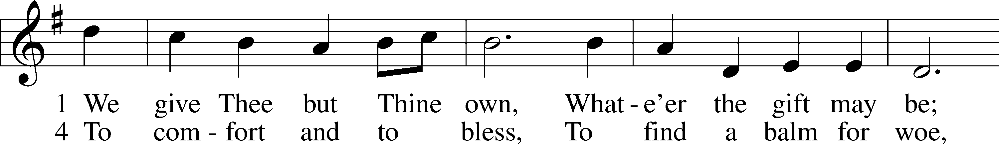
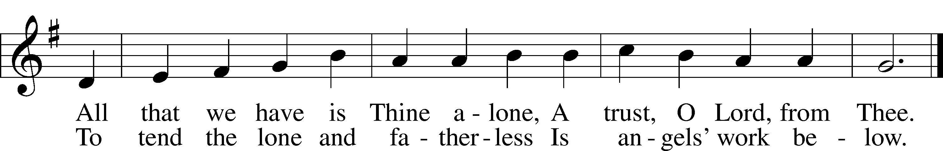
6 And we believe Thy Word,
Though dim our faith may be:
Whate’er for Thine we do, O Lord,
We do it unto Thee.
5 The captive to release,
To God the lost to bring,
To teach the way of life and peace,
It is a Christ-like thing.
Public domain

